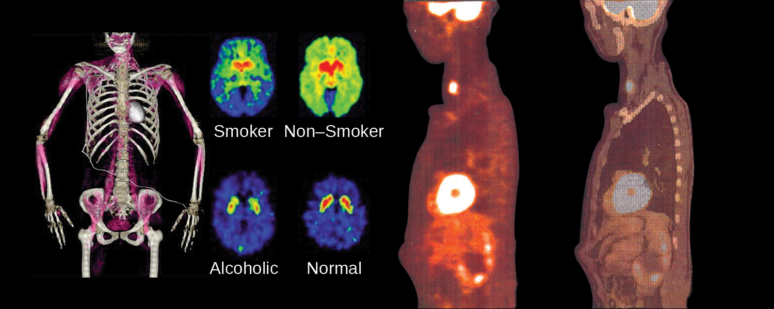
Figure 21.1 Nuclear chemistry provides the basis for many useful diagnostic and therapeutic methods in medicine, such as these positron emission tomography (PET) scans. The PET/computed tomography scan on the left shows muscle activity. The brain scans in the center show chemical differences in dopamine signaling in the brains of addicts and nonaddicts. The images on the right show an oncological application of PET scans to identify lymph node metastasis.

Chapter Outline
21.1 Nuclear Structure and Stability
21.2 Nuclear Equations
21.3 Radioactive Decay
21.4 Transmutation and Nuclear Energy
21.5 Uses of Radioisotopes
21.6 Biological Effects of Radiation

Introduction
The chemical reactions that we have considered in previous chapters involve changes in the electronic structure of the species involved, that is, the arrangement of the electrons around atoms, ions, or molecules. Nuclear structure, the numbers of protons and neutrons within the nuclei of the atoms involved, remains unchanged during chemical reactions.
This chapter will introduce the topic of nuclear chemistry, which began with the discovery of radioactivity in 1896 by French physicist Antoine Becquerel and has become increasingly important during the twentieth and twenty-first centuries, providing the basis for various technologies related to energy, medicine, geology, and many other areas.

