8.1 Valence Bond Theory

Learning Objectives
By the end of this section, you will be able to:
- Describe the formation of covalent bonds in terms of atomic orbital overlap
- Define and give examples of σ and π bonds
As we know, a scientific theory is a strongly supported explanation for observed natural laws or large bodies of experimental data. For a theory to be accepted, it must explain experimental data and be able to predict behavior. For example, VSEPR theory has gained widespread acceptance because it predicts three-dimensional molecular shapes that are consistent with experimental data collected for thousands of different molecules. However, VSEPR theory does not provide an explanation of chemical bonding.
There are successful theories that describe the electronic structure of atoms. We can use quantum mechanics to predict the specific regions around an atom where electrons are likely to be located: A spherical shape for an s orbital, a dumbbell shape for a p orbital, and so forth. However, these predictions only describe the orbitals around free atoms. When atoms bond to form molecules, atomic orbitals are not sufficient to describe the regions where electrons will be located in the molecule. A more complete understanding of electron distributions requires a model that can account for the electronic structure of molecules. One popular theory holds that a covalent bond forms when a pair of electrons is shared by two atoms and is simultaneously attracted by the nuclei of both atoms. In the following sections, we will discuss how such bonds are described by valence bond theory and hybridization.
Valence bond theory describes a covalent bond as the overlap of half-filled atomic orbitals (each containing a single electron) that yield a pair of electrons shared between the two bonded atoms. We say that orbitals on two different atoms overlap when a portion of one orbital and a portion of a second orbital occupy the same region of space. According to valence bond theory, a covalent bond results when two conditions are met: (1) an orbital on one atom overlaps an orbital on a second atom and (2) the single electrons in each orbital combine to form an electron pair. The mutual attraction between this negatively charged electron pair and the two atoms’ positively charged nuclei serves to physically link the two atoms through a force we define as a covalent bond. The strength of a covalent bond depends on the extent of overlap of the orbitals involved. Orbitals that overlap extensively form bonds that are stronger than those that have less overlap.
The energy of the system depends on how much the orbitals overlap. Figure 8.2 illustrates how the sum of the energies of two hydrogen atoms (the colored curve) changes as they approach each other. When the atoms are far apart there is no overlap, and by convention we set the sum of the energies at zero. As the atoms move together, their orbitals begin to overlap. Each electron begins to feel the attraction of the nucleus in the other atom. In addition, the electrons begin to repel each other, as do the nuclei. While the atoms are still widely separated, the attractions are slightly stronger than the repulsions, and the energy of the system decreases. (A bond begins to form.) As the atoms move closer together, the overlap increases, so the attraction of the nuclei for the electrons continues to increase (as do the repulsions among electrons and between the nuclei). At some specific distance between the atoms, which varies depending on the atoms involved, the energy reaches its lowest (most stable) value. This optimum distance between the two bonded nuclei is the bond distance between the two atoms. The bond is stable because at this point, the attractive and repulsive forces combine to create the lowest possible energy configuration. If the distance between the nuclei were to decrease further, the repulsions between nuclei and the repulsions as electrons are confined in closer proximity to each other would become stronger than the attractive forces. The energy of the system would then rise (making the system destabilized), as shown at the far left of Figure 8.2.
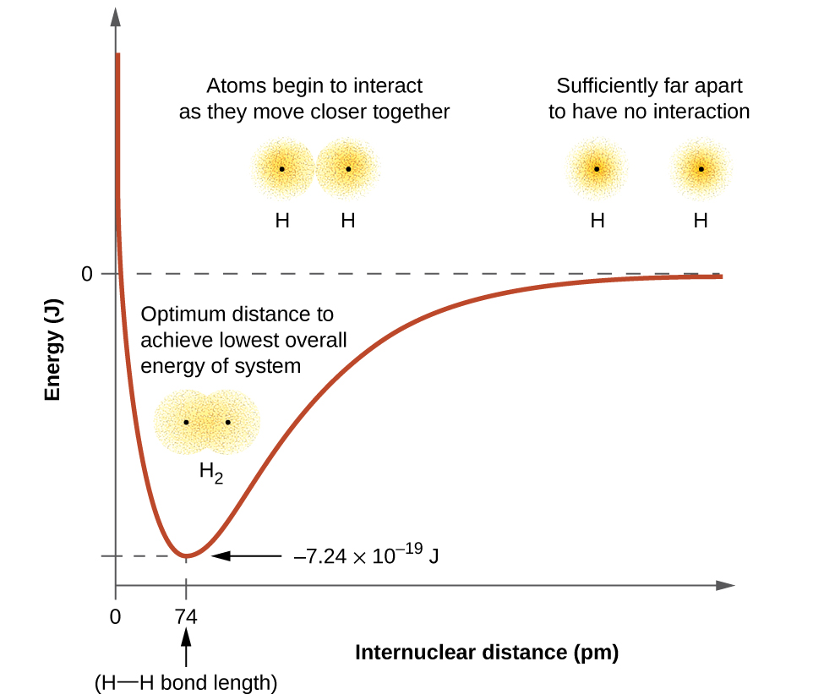
Figure 8.2 (a) The interaction of two hydrogen atoms changes as a function of distance. (b) The energy of the system changes as the atoms interact. The lowest (most stable) energy occurs at a distance of 74 pm, which is the bond length observed for the H₂ molecule.
The bond energy is the difference between the energy minimum (which occurs at the bond distance) and the energy of the two separated atoms. This is the quantity of energy released when the bond is formed. Conversely, the same amount of energy is required to break the bond. For the H₂ molecule shown in Figure 8.2, at the bond distance of 74 pm the system is 7.24 $×$ 10⁻¹⁹ J lower in energy than the two separated hydrogen atoms. This may seem like a small number. However, we know from our earlier description of thermochemistry that bond energies are often discussed on a per-mole basis. For example, it requires 7.24 $×$ 10⁻¹⁹ J to break one H–H bond, but it takes 4.36 $×$ 10⁵ J to break 1 mole of H–H bonds. A comparison of some bond lengths and energies is shown in Table 8.1. We can find many of these bonds in a variety of molecules, and this table provides average values. For example, breaking the first C–H bond in CH₄ requires 439.3 kJ/mol, while breaking the first C–H bond in H–CH₂C₆H₅ (a common paint thinner) requires 375.5 kJ/mol.
Representative Bond Energies and Lengths
Bond | Length (pm) | Energy (kJ/mol) | Bond | Length (pm) | Energy (kJ/mol)
H–H | 74 | 436 | C–O | 140.1 | 358
H–C | 106.8 | 413 | $\text{C}=\text{O}$ | 119.7 | 745
H–N | 101.5 | 391 | $\text{C}≡\text{O}$ | 113.7 | 1072
H–O | 97.5 | 467 | H–Cl | 127.5 | 431
C–C | 150.6 | 347 | H–Br | 141.4 | 366
$\text{C}=\text{C}$ | 133.5 | 614 | H–I | 160.9 | 298
$\text{C}≡\text{C}$ | 120.8 | 839 | O–O | 148 | 146
C–N | 142.1 | 305 | $\text{O}=\text{O}$ | 120.8 | 498
$\text{C}=\text{N}$ | 130.0 | 615 | F–F | 141.2 | 159
$\text{C}≡\text{N}$ | 116.1 | 891 | Cl–Cl | 198.8 | 243
Table 8.1
In addition to the distance between two orbitals, the orientation of orbitals also affects their overlap (other than for two s orbitals, which are spherically symmetric). Greater overlap is possible when orbitals are oriented such that they overlap on a direct line between the two nuclei. Figure 8.3 illustrates this for two p orbitals from different atoms; the overlap is greater when the orbitals overlap end to end rather than at an angle.
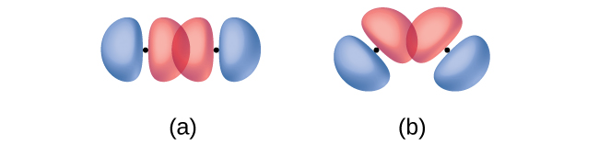
Figure 8.3 (a) The overlap of two p orbitals is greatest when the orbitals are directed end to end. (b) Any other arrangement results in less overlap. The dots indicate the locations of the nuclei.
The overlap of two s orbitals (as in H₂), the overlap of an s orbital and a p orbital (as in HCl), and the end-to-end overlap of two p orbitals (as in Cl₂) all produce sigma bonds (σ bonds), as illustrated in Figure 8.4. A σ bond is a covalent bond in which the electron density is concentrated in the region along the internuclear axis; that is, a line between the nuclei would pass through the center of the overlap region. Single bonds in Lewis structures are described as σ bonds in valence bond theory.
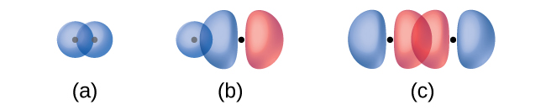
Figure 8.4 Sigma (σ) bonds form from the overlap of the following: (a) two s orbitals, (b) an s orbital and a p orbital, and (c) two p orbitals. The dots indicate the locations of the nuclei.
A pi bond (π bond) is a type of covalent bond that results from the side-by-side overlap of two p orbitals, as illustrated in Figure 8.5. In a π bond, the regions of orbital overlap lie on opposite sides of the internuclear axis. Along the axis itself, there is a node, that is, a plane with no probability of finding an electron.

Figure 8.5 Pi (π) bonds form from the side-by-side overlap of two p orbitals. The dots indicate the location of the nuclei.
While all single bonds are σ bonds, multiple bonds consist of both σ and π bonds. As the Lewis structures below suggest, O₂ contains a double bond, and N₂ contains a triple bond. The double bond consists of one σ bond and one π bond, and the triple bond consists of one σ bond and two π bonds. Between any two atoms, the first bond formed will always be a σ bond, but there can only be one σ bond in any one location. In any multiple bond, there will be one σ bond, and the remaining one or two bonds will be π bonds. These bonds are described in more detail later in this chapter.
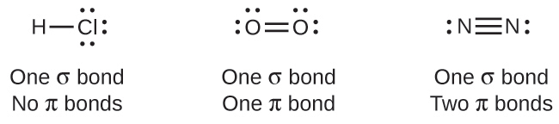
As seen in Table 8.1, an average carbon-carbon single bond is 347 kJ/mol, while in a carbon-carbon double bond, the π bond increases the bond strength by 267 kJ/mol. Adding an additional π bond causes a further increase of 225 kJ/mol. We can see a similar pattern when we compare other σ and π bonds. Thus, each individual π bond is generally weaker than a corresponding σ bond between the same two atoms. In a σ bond, there is a greater degree of orbital overlap than in a π bond.

Example 8.1

Counting σ and π Bonds
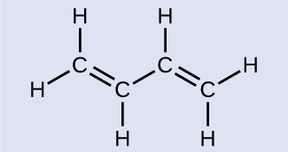
Butadiene, C₄H₆, is used to make synthetic rubber. Identify the number of σ and π bonds contained in this molecule.

Solution
There are six σ C–H bonds and one σ C–C bond, for a total of seven from the single bonds. There are two double bonds that each have a π bond in addition to the σ bond. This gives a total nine σ and two π bonds overall.

Check Your Learning
Identify each illustration as depicting a σ or π bond:
(a) side-by-side overlap of a 4p and a 2p orbital
(b) end-to-end overlap of a 4p and 4p orbital
(c) end-to-end overlap of a 4p and a 2p orbital


Answer:
(a) is a π bond with a node along the axis connecting the nuclei while (b) and (c) are σ bonds that overlap along the axis.

