Exercises

15.1 Precipitation and Dissolution
1.
Complete the changes in concentrations for each of the following reactions:
(a)
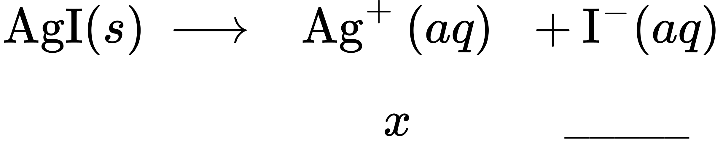
(b)
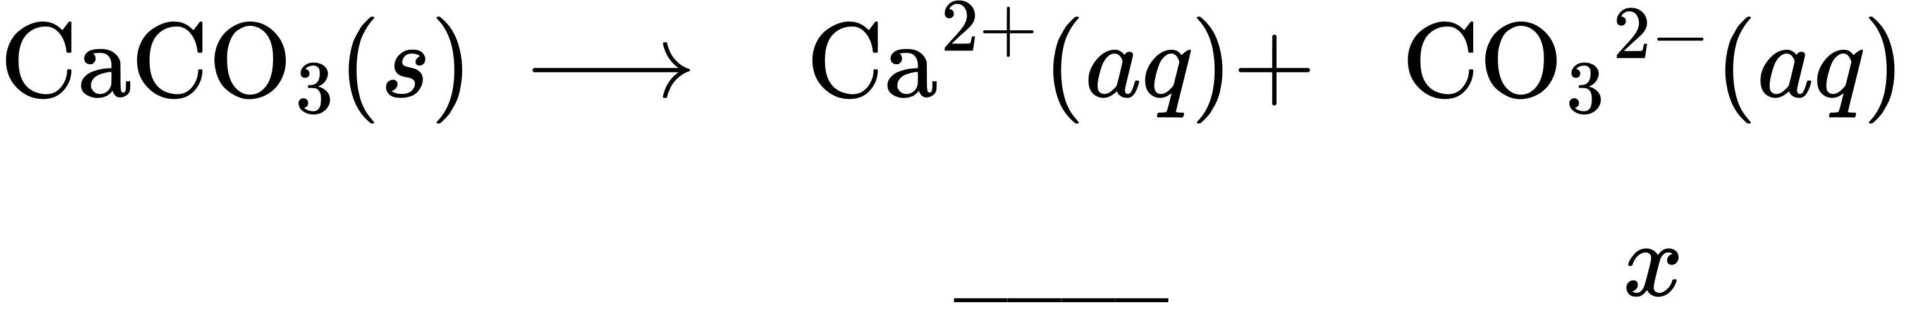
(c)
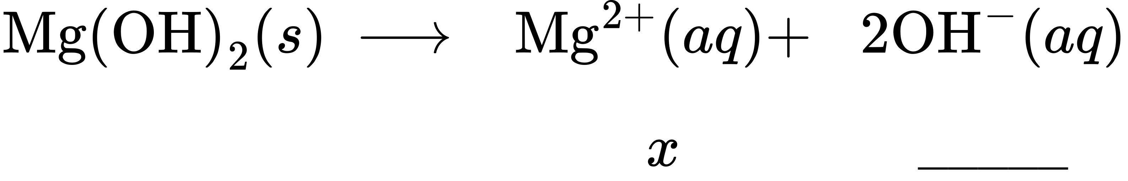
(d)
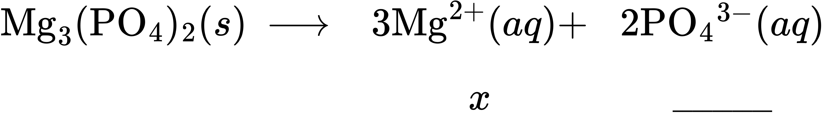
(e)
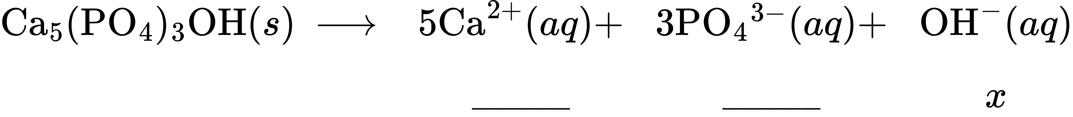
2.
Complete the changes in concentrations for each of the following reactions:
(a)
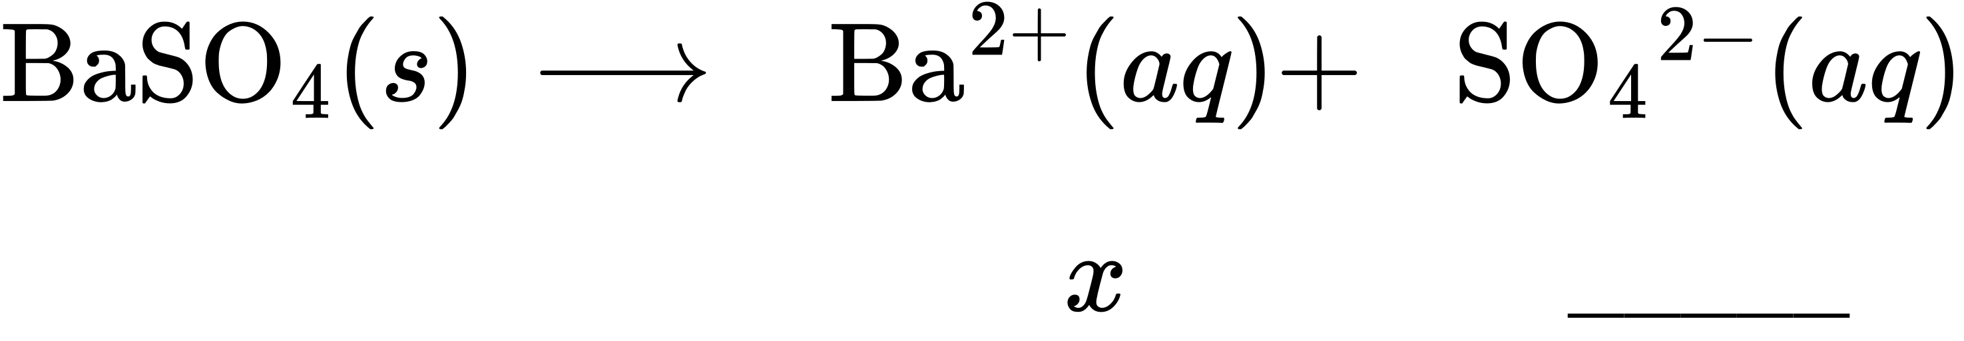
(b
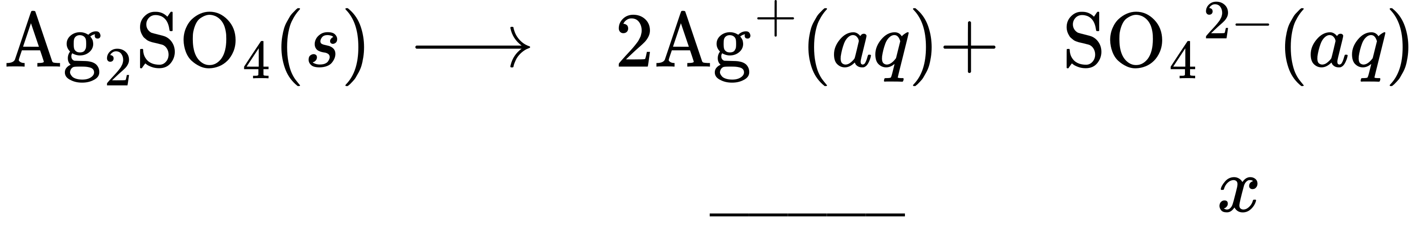
(c)
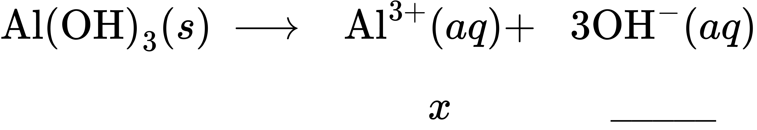
(d)
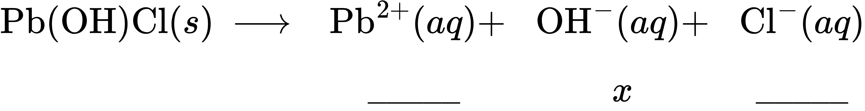
(e)
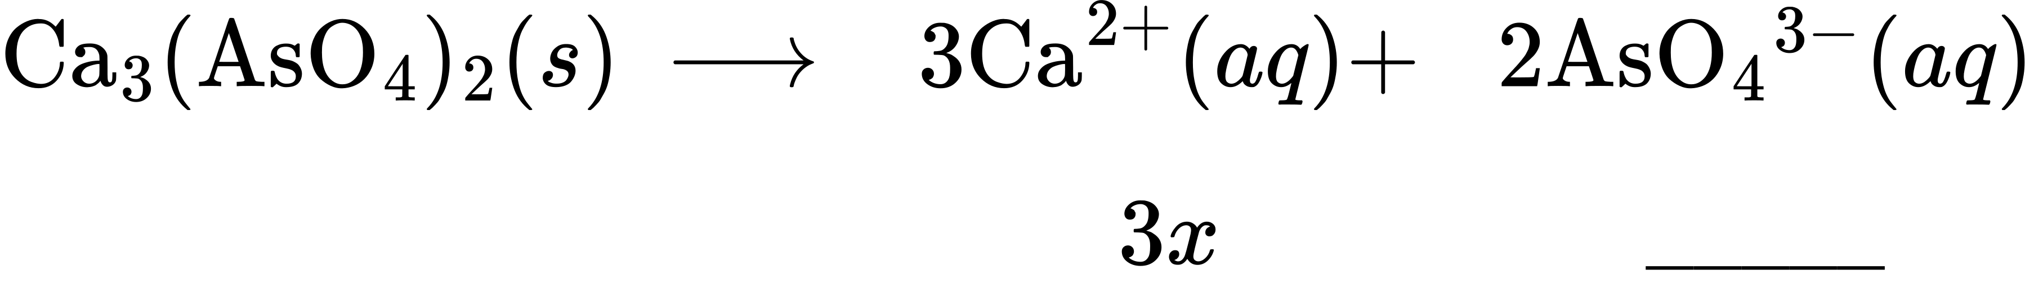
3.
How do the concentrations of Ag⁺ and ${\text{CrO}}_{4}​^{\text{2−}}$ in a saturated solution above 1.0 g of solid Ag₂CrO₄ change when 100 g of solid Ag₂CrO₄ is added to the system? Explain.
4.
How do the concentrations of Pb²⁺ and S^{2–} change when K₂S is added to a saturated solution of PbS?
5.
What additional information do we need to answer the following question: How is the equilibrium of solid silver bromide with a saturated solution of its ions affected when the temperature is raised?
6.
Which of the following slightly soluble compounds has a solubility greater than that calculated from its solubility product because of hydrolysis of the anion present: CoSO₃, CuI, PbCO₃, PbCl₂, Tl₂S, KClO₄?
7.
Which of the following slightly soluble compounds has a solubility greater than that calculated from its solubility product because of hydrolysis of the anion present: AgCl, BaSO₄, CaF₂, Hg₂I₂, MnCO₃, and ZnS?
8.
Write the ionic equation for dissolution and the solubility product (K_{sp}) expression for each of the following slightly soluble ionic compounds:
(a) PbCl₂
(b) Ag₂S
(c) Sr₃(PO₄)₂
(d) SrSO₄
9.
Write the ionic equation for the dissolution and the K_{sp} expression for each of the following slightly soluble ionic compounds:
(a) LaF₃
(b) CaCO₃
(c) Ag₂SO₄
(d) Pb(OH)₂
10.
The Handbook of Chemistry and Physics gives solubilities of the following compounds in grams per 100 mL of water. Because these compounds are only slightly soluble, assume that the volume does not change on dissolution and calculate the solubility product for each.
(a) BaSiF₆, 0.026 g/100 mL (contains ${\text{SiF}}_{6}​^{\text{2−}}$ ions)
(b) Ce(IO₃)₄, 1.5 $×$ 10^{–2} g/100 mL
(c) Gd₂(SO₄)₃, 3.98 g/100 mL
(d) (NH₄)₂PtBr₆, 0.59 g/100 mL (contains ${\text{PtBr}}_{6}​^{\text{2−}}$ ions)
11.
The Handbook of Chemistry and Physics gives solubilities of the following compounds in grams per 100 mL of water. Because these compounds are only slightly soluble, assume that the volume does not change on dissolution and calculate the solubility product for each.
(a) BaSeO₄, 0.0118 g/100 mL
(b) Ba(BrO₃)₂·H₂O, 0.30 g/100 mL
(c) NH₄MgAsO₄·6H₂O, 0.038 g/100 mL
(d) La₂(MoO₄)₃, 0.00179 g/100 mL
12.
Use solubility products and predict which of the following salts is the most soluble, in terms of moles per liter, in pure water: CaF₂, Hg₂Cl₂, PbI₂, or Sn(OH)₂.
13.
Assuming that no equilibria other than dissolution are involved, calculate the molar solubility of each of the following from its solubility product:
(a) KHC₄H₄O₆
(b) PbI₂
(c) Ag₄[Fe(CN)₆], a salt containing the ${\text{Fe(CN)}}_{6}​^{\text{4–}}$ ion
(d) Hg₂I₂
14.
Assuming that no equilibria other than dissolution are involved, calculate the molar solubility of each of the following from its solubility product:
(a) Ag₂SO₄
(b) PbBr₂
(c) AgI
(d) CaC₂O₄·H₂O
15.
Assuming that no equilibria other than dissolution are involved, calculate the concentration of all solute species in each of the following solutions of salts in contact with a solution containing a common ion. Show that changes in the initial concentrations of the common ions can be neglected.
(a) AgCl(s) in 0.025 M NaCl
(b) CaF₂(s) in 0.00133 M KF
(c) Ag₂SO₄(s) in 0.500 L of a solution containing 19.50 g of K₂SO₄
(d) Zn(OH)₂(s) in a solution buffered at a pH of 11.45
16.
Assuming that no equilibria other than dissolution are involved, calculate the concentration of all solute species in each of the following solutions of salts in contact with a solution containing a common ion. Show that changes in the initial concentrations of the common ions can be neglected.
(a) TlCl(s) in 1.250 M HCl
(b) PbI₂(s) in 0.0355 M CaI₂
(c) Ag₂CrO₄(s) in 0.225 L of a solution containing 0.856 g of K₂CrO₄
(d) Cd(OH)₂(s) in a solution buffered at a pH of 10.995
17.
Assuming that no equilibria other than dissolution are involved, calculate the concentration of all solute species in each of the following solutions of salts in contact with a solution containing a common ion. State whether or not it is appropriate to neglect the changes in the initial concentrations of the common ions.
(a) TlCl(s) in 0.025 M TlNO₃
(b) BaF₂(s) in 0.313 M KF
(c) MgC₂O₄ in 2.250 L of a solution containing 8.156 g of Mg(NO₃)₂
(d) Ca(OH)₂(s) in an unbuffered solution initially with a pH of 12.700
18.
Explain why the changes in concentrations of the common ions in Exercise 15.17 can be neglected.
19.
Explain why the changes in concentrations of the common ions in Exercise 15.18 cannot be neglected.
20.
Calculate the solubility of aluminum hydroxide, Al(OH)₃, in a solution buffered at pH 11.00.
21.
Refer to Appendix J for solubility products for calcium salts. Determine which of the calcium salts listed is most soluble in moles per liter and which is most soluble in grams per liter.
22.
Most barium compounds are very poisonous; however, barium sulfate is often administered internally as an aid in the X-ray examination of the lower intestinal tract (Figure 15.4). This use of BaSO₄ is possible because of its low solubility. Calculate the molar solubility of BaSO₄ and the mass of barium present in 1.00 L of water saturated with BaSO₄.
23.
Public Health Service standards for drinking water set a maximum of 250 mg/L (2.60 $×$ 10^{–3} M) of ${\text{SO}}_{4}​^{\text{2−}}$ because of its cathartic action (it is a laxative). Does natural water that is saturated with CaSO₄ (“gyp” water) as a result or passing through soil containing gypsum, CaSO₄·2H₂O, meet these standards? What is the concentration of ${\text{SO}}_{4}​^{\text{2−}}$ in such water?
24.
Perform the following calculations:
(a) Calculate [Ag⁺] in a saturated aqueous solution of AgBr.
(b) What will [Ag⁺] be when enough KBr has been added to make [Br–] = 0.050 M?
(c) What will [Br–] be when enough AgNO₃ has been added to make [Ag⁺] = 0.020 M?
25.
The solubility product of CaSO₄·2H₂O is 2.4 $×$ 10^{–5}. What mass of this salt will dissolve in 1.0 L of 0.010 M ${\text{SO}}_{4}​^{\text{2−}}?$
26.
Assuming that no equilibria other than dissolution are involved, calculate the concentrations of ions in a saturated solution of each of the following (see Appendix J for solubility products).
(a) TlCl
(b) BaF₂
(c) Ag₂CrO₄
(d) CaC₂O₄·H₂O
(e) the mineral anglesite, PbSO₄
27.
Assuming that no equilibria other than dissolution are involved, calculate the concentrations of ions in a saturated solution of each of the following (see Appendix J for solubility products):
(a) AgI
(b) Ag₂SO₄
(c) Mn(OH)₂
(d) Sr(OH)₂·8H₂O
(e) the mineral brucite, Mg(OH)₂
28.
The following concentrations are found in mixtures of ions in equilibrium with slightly soluble solids. From the concentrations given, calculate K_{sp} for each of the slightly soluble solids indicated:
(a) AgBr: [Ag⁺] = 5.7 $×$ 10^{–7} M, [Br–] = 5.7 $×$ 10^{–7} M
(b) CaCO₃: [Ca²⁺] = 5.3 $×$ 10^{–3} M, $[{\text{CO}}_{3}​^{\text{2−}}]$ = 9.0 $×$ 10^{–7} M
(c) PbF₂: [Pb²⁺] = 2.1 $×$ 10^{–3} M, [F–] = 4.2 $×$ 10^{–3} M
(d) Ag₂CrO₄: [Ag⁺] = 5.3 $×$ 10^{–5} M, 3.2 $×$ 10^{–3} M
(e) InF₃: [In³⁺] = 2.3 $×$ 10^{–3} M, [F–] = 7.0 $×$ 10^{–3} M
29.
The following concentrations are found in mixtures of ions in equilibrium with slightly soluble solids. From the concentrations given, calculate K_{sp} for each of the slightly soluble solids indicated:
(a) TlCl: [Tl⁺] = 1.21 $×$ 10^{–2} M, [Cl–] = 1.2 $×$ 10^{–2} M
(b) Ce(IO₃)₄: [Ce⁴⁺] = 1.8 $×$ 10^{–4} M, $[{\text{IO}}_{3}​^{\text{−}}]$ = 2.6 $×$ 10^{–13} M
(c) Gd₂(SO₄)₃: [Gd³⁺] = 0.132 M, $[{\text{SO}}_{\text{4}}​^{\text{2−}}]$ = 0.198 M
(d) Ag₂SO₄: [Ag⁺] = 2.40 $×$ 10^{–2} M, $[{\text{SO}}_{\text{4}}​^{\text{2−}}]$ = 2.05 $×$ 10^{–2} M
(e) BaSO₄: [Ba²⁺] = 0.500 M, $[{\text{SO}}_{\text{4}}​^{\text{2−}}]$ = 2.16 $×$ 10⁻¹⁰ M
30.
Which of the following compounds precipitates from a solution that has the concentrations indicated? (See Appendix J for K_{sp} values.)
(a) KClO₄: [K⁺] = 0.01 M, $[{\text{ClO}}_{4}​^{\text{−}}]$ = 0.01 M
(b) K₂PtCl₆: [K⁺] = 0.01 M, $[{\text{PtCl}}_{\text{6}}​^{\text{2−}}]$ = 0.01 M
(c) PbI₂: [Pb²⁺] = 0.003 M, [I–] = 1.3 $×$ 10^{–3} M
(d) Ag₂S: [Ag⁺] = 1 $×$ 10^{–10} M, [S^{2–}] = 1 $×$ 10^{–13} M
31.
Which of the following compounds precipitates from a solution that has the concentrations indicated? (See Appendix J for K_{sp} values.)
(a) CaCO₃: [Ca²⁺] = 0.003 M, $[{\text{CO}}_{\text{3}}​^{\text{2−}}]$ = 0.003 M
(b) Co(OH)₂: [Co²⁺] = 0.01 M, [OH–] = 1 $×$ 10^{–7} M
(c) CaHPO₄: [Ca²⁺] = 0.01 M, $[{\text{HPO}}_{\text{4}}​^{\text{2−}}]$ = 2 $×$ 10^{–6} M
(d) Pb₃(PO₄)₂: [Pb²⁺] = 0.01 M, $[{\text{PO}}_{\text{4}}​^{\text{3−}}]$= 1 $×$ 10^{–13} M
32.
Calculate the concentration of Tl⁺ when TlCl just begins to precipitate from a solution that is 0.0250 M in Cl–.
33.
Calculate the concentration of sulfate ion when BaSO₄ just begins to precipitate from a solution that is 0.0758 M in Ba²⁺.
34.
Calculate the concentration of Sr²⁺ when SrCrO₄ starts to precipitate from a solution that is 0.0025 M in CrO₄^{2–}.
35.
Calculate the concentration of ${\text{PO}}_{4}​^{\text{3−}}$ when Ag₃PO₄ starts to precipitate from a solution that is 0.0125 M in Ag⁺.
36.
Calculate the concentration of F– required to begin precipitation of CaF₂ in a solution that is 0.010 M in Ca²⁺.
37.
Calculate the concentration of Ag⁺ required to begin precipitation of Ag₂CO₃ in a solution that is 2.50 $×$ 10^{–6} M in ${\text{CO}}_{3}​^{\text{2−}}.$
38.
What [Ag⁺] is required to reduce $[{\text{CO}}_{3}​^{\text{2−}}]$ to 8.2 $×$ 10^{–4} M by precipitation of Ag₂CO₃?
39.
What [F–] is required to reduce [Ca²⁺] to 1.0 $×$ 10^{–4} M by precipitation of CaF₂?
40.
A volume of 0.800 L of a 2 $×$ 10^{–4}-M Ba(NO₃)₂ solution is added to 0.200 L of 5 $×$ 10^{–4} M Li₂SO₄. Does BaSO₄ precipitate? Explain your answer.
41.
Perform these calculations for nickel(II) carbonate. (a) With what volume of water must a precipitate containing NiCO₃ be washed to dissolve 0.100 g of this compound? Assume that the wash water becomes saturated with NiCO₃ (K_{sp} = 1.36 $×$ 10^{–7}).
(b) If the NiCO₃ were a contaminant in a sample of CoCO₃ (K_{sp} = 1.0 $×$ 10^{–12}), what mass of CoCO₃ would have been lost? Keep in mind that both NiCO₃ and CoCO₃ dissolve in the same solution.
42.
Iron concentrations greater than 5.4 $×$ 10^{–6} M in water used for laundry purposes can cause staining. What [OH–] is required to reduce [Fe²⁺] to this level by precipitation of Fe(OH)₂?
43.
A solution is 0.010 M in both Cu²⁺ and Cd²⁺. What percentage of Cd²⁺ remains in the solution when 99.9% of the Cu²⁺ has been precipitated as CuS by adding sulfide?
44.
A solution is 0.15 M in both Pb²⁺ and Ag⁺. If Cl– is added to this solution, what is [Ag⁺] when PbCl₂ begins to precipitate?
45.
What reagent might be used to separate the ions in each of the following mixtures, which are 0.1 M with respect to each ion? In some cases it may be necessary to control the pH. (Hint: Consider the K_{sp} values given in Appendix J.)
(a) ${\text{Hg}}_{2}​^{\text{2+}}$ and Cu²⁺
(b) ${\text{SO}}_{4}​^{\text{2−}}$ and Cl–
(c) Hg²⁺ and Co²⁺
(d) Zn²⁺ and Sr²⁺
(e) Ba²⁺ and Mg²⁺
(f) ${\text{CO}}_{3}​^{\text{2−}}$ and OH–
46.
A solution contains 1.0 $×$ 10^{–5} mol of KBr and 0.10 mol of KCl per liter. AgNO₃ is gradually added to this solution. Which forms first, solid AgBr or solid AgCl?
47.
A solution contains 1.0 $×$ 10^{–2} mol of KI and 0.10 mol of KCl per liter. AgNO₃ is gradually added to this solution. Which forms first, solid AgI or solid AgCl?
48.
The calcium ions in human blood serum are necessary for coagulation (Figure 15.5). Potassium oxalate, K₂C₂O₄, is used as an anticoagulant when a blood sample is drawn for laboratory tests because it removes the calcium as a precipitate of CaC₂O₄·H₂O. It is necessary to remove all but 1.0% of the Ca²⁺ in serum in order to prevent coagulation. If normal blood serum with a buffered pH of 7.40 contains 9.5 mg of Ca²⁺ per 100 mL of serum, what mass of K₂C₂O₄ is required to prevent the coagulation of a 10 mL blood sample that is 55% serum by volume? (All volumes are accurate to two significant figures. Note that the volume of serum in a 10-mL blood sample is 5.5 mL. Assume that the K_{sp} value for CaC₂O₄ in serum is the same as in water.)
49.
About 50% of urinary calculi (kidney stones) consist of calcium phosphate, Ca₃(PO₄)₂. The normal mid range calcium content excreted in the urine is 0.10 g of Ca²⁺ per day. The normal mid range amount of urine passed may be taken as 1.4 L per day. What is the maximum concentration of phosphate ion that urine can contain before a calculus begins to form?
50.
The pH of normal urine is 6.30, and the total phosphate concentration $({[\text{PO}}_{4}​^{\text{3−}}]$ + $[{\text{HPO}}_{4}​^{\text{2−}}]$ + $[{\text{H}}_{2}{\text{PO}}_{4}​^{\text{−}}]$ + [H₃PO₄]) is 0.020 M. What is the minimum concentration of Ca²⁺ necessary to induce kidney stone formation? (See Exercise 15.49 for additional information.)
51.
Magnesium metal (a component of alloys used in aircraft and a reducing agent used in the production of uranium, titanium, and other active metals) is isolated from sea water by the following sequence of reactions:
${\text{Mg}}^{\text{2+}}\left(aq\right)+{\text{Ca(OH)}}_{2}\left(aq\right) → {\text{Mg(OH)}}_{2}\left(s\right)+{\text{Ca}}^{\text{2+}}\left(aq\right)$
${\text{Mg(OH)}}_{2}\left(s\right)+\text{2HCl(}aq) → {\text{MgCl}}_{2}\left(s\right)+{\text{2H}}_{2}\text{O}\left(l\right)$
${\text{MgCl}}_{2}\left(l\right)\overset{ \text{electrolysis} }{→}\text{Mg}\left(s\right)+{\text{Cl}}_{2}\left(g\right)$
Sea water has a density of 1.026 g/cm³ and contains 1272 parts per million of magnesium as Mg²⁺(aq) by mass. What mass, in kilograms, of Ca(OH)₂ is required to precipitate 99.9% of the magnesium in 1.00 $×$ 10³ L of sea water?
52.
Hydrogen sulfide is bubbled into a solution that is 0.10 M in both Pb²⁺ and Fe²⁺ and 0.30 M in HCl. After the solution has come to equilibrium it is saturated with H₂S ([H₂S] = 0.10 M). What concentrations of Pb²⁺ and Fe²⁺ remain in the solution? For a saturated solution of H₂S we can use the equilibrium:
${\text{H}}_{2}\text{S}\left(aq\right)+{\text{2H}}_{2}\text{O}\left(l\right)⇌{\text{2H}}_{3}{\text{O}}^{\text{+}}\left(aq\right)+{\text{S}}^{\text{2−}}\left(aq\right) K=1.0 × {10}^{−26}$
(Hint: The $[{\text{H}}_{3}{\text{O}}^{\text{+}}]$ changes as metal sulfides precipitate.)
53.
Perform the following calculations involving concentrations of iodate ions:
(a) The iodate ion concentration of a saturated solution of La(IO₃)₃ was found to be 3.1 $×$ 10^{–3} mol/L. Find the K_{sp}.
(b) Find the concentration of iodate ions in a saturated solution of Cu(IO₃)₂ (K_{sp} = 7.4 $×$ 10^{–8}).
54.
Calculate the molar solubility of AgBr in 0.035 M NaBr (K_{sp} = 5 $×$ 10^{–13}).
55.
How many grams of Pb(OH)₂ will dissolve in 500 mL of a 0.050-M PbCl₂ solution (K_{sp} = 1.2 $×$ 10^{–15})?
56.
Use the simulation from the earlier Link to Learning to complete the following exercise. Using 0.01 g CaF₂, give the K_{sp} values found in a 0.2-M solution of each of the salts. Discuss why the values change as you change soluble salts.
57.
How many grams of Milk of Magnesia, Mg(OH)₂ (s) (58.3 g/mol), would be soluble in 200 mL of water. K_{sp} = 7.1 $×$ 10^{–12}. Include the ionic reaction and the expression for K_{sp} in your answer. (K_{w} = 1 $×$ 10^{–14} = [H₃O⁺][OH–])
58.
Two hypothetical salts, LM₂ and LQ, have the same molar solubility in H₂O. If K_{sp} for LM₂ is 3.20 $×$ 10^{–5}, what is the K_{sp} value for LQ?
59.
The carbonate ion concentration is gradually increased in a solution containing equal concentrations of the divalent cations of magnesium, calcium, strontium, barium, and manganese. Which of the following carbonates will precipitate first? Which will precipitate last? Explain.
(a) ${\text{MgCO}}_{3}•3{\text{H}}_{2}\text{O} K_{\text{sp}}=1 × {10}^{−5}$
(b) ${\text{CaCO}}_{3} K_{\text{sp}}=8.7 × {10}^{−9}$
(c) ${\text{SrCO}}_{3} K_{\text{sp}}=7 × {10}^{−10}$
(d) ${\text{BaCO}}_{3} K_{\text{sp}}=1.6 × {10}^{−9}$
(e) ${\text{MnCO}}_{3} K_{\text{sp}}=8.8 × {10}^{−11}$
60.
How many grams of Zn(CN)₂(s) (117.44 g/mol) would be soluble in 100 mL of H₂O? Include the balanced reaction and the expression for K_{sp} in your answer. The K_{sp} value for Zn(CN)₂(s) is 3.0 $×$ 10^{–16}.

15.2 Lewis Acids and Bases
61.
Even though Ca(OH)₂ is an inexpensive base, its limited solubility restricts its use. What is the pH of a saturated solution of Ca(OH)₂?
62.
Under what circumstances, if any, does a sample of solid AgCl completely dissolve in pure water?
63.
Explain why the addition of NH₃ or HNO₃ to a saturated solution of Ag₂CO₃ in contact with solid Ag₂CO₃ increases the solubility of the solid.
64.
Calculate the cadmium ion concentration, [Cd²⁺], in a solution prepared by mixing 0.100 L of 0.0100 M Cd(NO₃)₂ with 0.150 L of 0.100 NH₃(aq).
65.
Explain why addition of NH₃ or HNO₃ to a saturated solution of Cu(OH)₂ in contact with solid Cu(OH)₂ increases the solubility of the solid.
66.
Sometimes equilibria for complex ions are described in terms of dissociation constants, K_{d}. For the complex ion ${\text{AlF}}_{6}​^{\text{3−}}$ the dissociation reaction is:
${\text{AlF}}_{6}​^{\text{3−}}⇌{\text{Al}}^{\text{3+}}+6{\text{F}}^{\text{−}}$ and $K_{\text{d}}=\frac{[{\text{Al}}^{\text{3+}}]{[{\text{F}}^{\text{−}}]}^{6}}{[{\text{AlF}}_{6}​^{\text{3−}}]}=2 × {10}^{−24}$
Calculate the value of the formation constant, K_{f}, for ${\text{AlF}}_{\text{6}}​^{\text{3−}}.$
67.
Using the value of the formation constant for the complex ion $\text{Co}{\left({\text{NH}}_{3}\right)}_{6}​^{\text{2+}},$ calculate the dissociation constant.
68.
Using the dissociation constant, K_{d} = 3.3 $×$ 10^{–19}, calculate the equilibrium concentrations of Cd²⁺ and CN– in a 0.250-M solution of $\text{Cd}{\left(\text{CN}\right)}_{4}​^{\text{2−}}.$
69.
Using the dissociation constant, K_{d} = 3.4 $×$ 10^{–15}, calculate the equilibrium concentrations of Zn²⁺ and OH– in a 0.0465-M solution of $\text{Zn}{\left(\text{OH}\right)}_{4}​^{\text{2−}}.$
70.
Using the dissociation constant, K_{d} = 2.2 $×$ 10^{–34}, calculate the equilibrium concentrations of Co³⁺ and NH₃ in a 0.500-M solution of $\text{Co}{\left({\text{NH}}_{3}\right)}_{6}​^{\text{3+}}.$
71.
Using the dissociation constant, K_{d} = 1 $×$ 10^{–44}, calculate the equilibrium concentrations of Fe³⁺ and CN– in a 0.333 M solution of $\text{Fe}{\left(\text{CN}\right)}_{6}​^{\text{3−}}.$
72.
Calculate the mass of potassium cyanide ion that must be added to 100 mL of solution to dissolve 2.0 $×$ 10^{–2} mol of silver cyanide, AgCN.
73.
Calculate the minimum concentration of ammonia needed in 1.0 L of solution to dissolve 3.0 $×$ 10^{–3} mol of silver bromide.
74.
A roll of 35-mm black and white photographic film contains about 0.27 g of unexposed AgBr before developing. What mass of Na₂S₂O₃·5H₂O (sodium thiosulfate pentahydrate or hypo) in 1.0 L of developer is required to dissolve the AgBr as $\text{Ag}{\left({\text{S}}_{2}{\text{O}}_{3}\right)}_{2}​^{\text{3−}}$ (K_{f} = 4.7 $×$ 10¹³)?
75.
We have seen an introductory definition of an acid: An acid is a compound that reacts with water and increases the amount of hydronium ion present. In the chapter on acids and bases, we saw two more definitions of acids: a compound that donates a proton (a hydrogen ion, H⁺) to another compound is called a Brønsted-Lowry acid, and a Lewis acid is any species that can accept a pair of electrons. Explain why the introductory definition is a macroscopic definition, while the Brønsted-Lowry definition and the Lewis definition are microscopic definitions.
76.
Write the Lewis structures of the reactants and product of each of the following equations, and identify the Lewis acid and the Lewis base in each:
(a) ${\text{CO}}_{2}+{\text{OH}}^{\text{−}} → {\text{HCO}}_{3}​^{\text{−}}$
(b) $\text{B}{\left(\text{OH}\right)}_{3}+{\text{OH}}^{\text{−}} → \text{B}{\left(\text{OH}\right)}_{4}​^{\text{−}}$
(c) ${\text{I}}^{\text{−}}+{\text{I}}_{2} → {\text{I}}_{3}​^{\text{−}}$
(d) ${\text{AlCl}}_{3}+{\text{Cl}}^{\text{−}} → {\text{AlCl}}_{4}​^{\text{−}}$ (use Al-Cl single bonds)
(e) ${\text{O}}^{\text{2−}}+{\text{SO}}_{3} → {\text{SO}}_{4}​^{\text{2−}}$
77.
Write the Lewis structures of the reactants and product of each of the following equations, and identify the Lewis acid and the Lewis base in each:
(a) ${\text{CS}}_{2}+{\text{SH}}^{\text{−}} → {\text{HCS}}_{3}​^{\text{−}}$
(b) ${\text{BF}}_{3}+{\text{F}}^{\text{−}} → {\text{BF}}_{4}​^{\text{−}}$
(c) ${\text{I}}^{\text{−}}+{\text{SnI}}_{2} → {\text{SnI}}_{3}​^{\text{−}}$
(d) $\text{Al}{\left(\text{OH}\right)}_{3}+{\text{OH}}^{\text{−}} → \text{Al}{\left(\text{OH}\right)}_{4}​^{\text{−}}$
(e) ${\text{F}}^{\text{−}}+{\text{SO}}_{3} → {\text{SFO}}_{3}​^{\text{−}}$
78.
Using Lewis structures, write balanced equations for the following reactions:
(a) $\text{HCl}\left(g\right)+{\text{PH}}_{3}\left(g\right) →$
(b) ${\text{H}}_{3}{\text{O}}^{+}+{\text{CH}}_{3}​^{\text{−}} →$
(c) $\text{CaO}+{\text{SO}}_{3} →$
(d) ${\text{NH}}_{4}​^{+}+{\text{C}}_{2}{\text{H}}_{5}{\text{O}}^{\text{−}} →$
79.
Calculate $[{\text{HgCl}}_{4}​^{\text{2−}}]$ in a solution prepared by adding 0.0200 mol of NaCl to 0.250 L of a 0.100-M HgCl₂ solution.
80.
In a titration of cyanide ion, 28.72 mL of 0.0100 M AgNO₃ is added before precipitation begins. [The reaction of Ag⁺ with CN– goes to completion, producing the $\text{Ag}{\left(\text{CN}\right)}_{2}​^{\text{−}}$ complex.] Precipitation of solid AgCN takes place when excess Ag⁺ is added to the solution, above the amount needed to complete the formation of $\text{Ag}{\left(\text{CN}\right)}_{2}​^{\text{−}}.$ How many grams of NaCN were in the original sample?
81.
What are the concentrations of Ag⁺, CN–, and $\text{Ag}{\left(\text{CN}\right)}_{2}​^{\text{−}}$ in a saturated solution of AgCN?
82.
In dilute aqueous solution HF acts as a weak acid. However, pure liquid HF (boiling point = 19.5 °C) is a strong acid. In liquid HF, HNO₃ acts like a base and accepts protons. The acidity of liquid HF can be increased by adding one of several inorganic fluorides that are Lewis acids and accept F– ion (for example, BF₃ or SbF₅). Write balanced chemical equations for the reaction of pure HNO₃ with pure HF and of pure HF with BF₃.
83.
The simplest amino acid is glycine, H₂NCH₂CO₂H. The common feature of amino acids is that they contain the functional groups: an amine group, –NH₂, and a carboxylic acid group, –CO₂H. An amino acid can function as either an acid or a base. For glycine, the acid strength of the carboxyl group is about the same as that of acetic acid, CH₃CO₂H, and the base strength of the amino group is slightly greater than that of ammonia, NH₃.
(a) Write the Lewis structures of the ions that form when glycine is dissolved in 1 M HCl and in 1 M KOH.
(b) Write the Lewis structure of glycine when this amino acid is dissolved in water. (Hint: Consider the relative base strengths of the –NH₂ and $−{\text{CO}}_{2}​^{\text{−}}$ groups.)
84.
Boric acid, H₃BO₃, is not a Brønsted-Lowry acid but a Lewis acid. (Hint: See the equation in Exercise 15.76)
(a) Write an equation for its reaction with water.
(b) Predict the shape of the anion thus formed.
(c) What is the hybridization on the boron, and is it consistent with the shape you have predicted?

15.3 Coupled Equilibria
85.
A saturated solution of a slightly soluble electrolyte in contact with some of the solid electrolyte is said to be a system in equilibrium. Explain. Why is such a system called a heterogeneous equilibrium?
86.
Calculate the equilibrium concentration of Ni²⁺ in a 1.0-M solution [Ni(NH₃)₆](NO₃)₂.
87.
Calculate the equilibrium concentration of Zn²⁺ in a 0.30-M solution of $\text{Zn}{\left(\text{CN}\right)}_{4}​^{\text{2−}}.$
88.
Calculate the equilibrium concentration of Cu²⁺ in a solution initially with 0.050 M Cu²⁺ and 1.00 M NH₃.
89.
Calculate the equilibrium concentration of Zn²⁺ in a solution initially with 0.150 M Zn²⁺ and 2.50 M CN–.
90.
Calculate the Fe³⁺ equilibrium concentration when 0.0888 mole of K₃[Fe(CN)₆] is added to a solution with 0.00010 M CN–.
91.
Calculate the Co²⁺ equilibrium concentration when 0.010 mole of [Co(NH₃)₆](NO₃)₂ is added to a solution with 0.25 M NH₃. Assume the volume is 1.00 L.
92.
Calculate the molar solubility of Sn(OH)₂ in a buffer solution containing equal concentrations of NH₃ and ${\text{NH}}_{4}​^{+}.$
93.
Calculate the molar solubility of Al(OH)₃ in a buffer solution with 0.100 M NH₃ and 0.400 M ${\text{NH}}_{4}​^{+}.$
94.
What is the molar solubility of CaF₂ in a 0.100-M solution of HF? K_{a} for HF = 6.4 $×$ 10^{–4}.
95.
What is the molar solubility of BaSO₄ in a 0.250-M solution of NaHSO₄? K_{a} for ${\text{HSO}}_{4}​^{\text{−}}$ = 1.2 $×$ 10^{–2}.
96.
What is the molar solubility of Tl(OH)₃ in a 0.10-M solution of NH₃?
97.
What is the molar solubility of Pb(OH)₂ in a 0.138-M solution of CH₃NH₂?
98.
A solution of 0.075 M CoBr₂ is saturated with H₂S ([H₂S] = 0.10 M). What is the minimum pH at which CoS begins to precipitate?
$\text{CoS}\left(s\right)⇌{\text{Co}}^{\text{2+}}\left(aq\right)+{\text{S}}^{\text{2−}}\left(aq\right) K_{\text{sp}}=2.3 × {10}^{\text{27}}$
${\text{H}}_{2}\text{S}\left(aq\right)+2{\text{H}}_{2}\text{O}\left(l\right)⇌2{\text{H}}_{3}{\text{O}}^{\text{+}}\left(aq\right)+{\text{S}}^{\text{2−}}\left(aq\right) K=8.9 × {10}^{\text{−27}}$
99.
A 0.125-M solution of Mn(NO₃)₂ is saturated with H₂S ([H₂S] = 0.10 M). At what pH does MnS begin to precipitate?
$\text{MnS}\left(s\right)⇌{\text{Mn}}^{\text{2+}}\left(aq\right)+{\text{S}}^{\text{2−}}\left(aq\right) K_{\text{sp}}=2.3 × {10}^{\text{−13}}$
${\text{H}}_{2}\text{S}\left(aq\right)+2{\text{H}}_{2}\text{O}\left(l\right)⇌2{\text{H}}_{3}{\text{O}}^{\text{+}}\left(aq\right)+{\text{S}}^{\text{2−}}\left(aq\right) K=1.0 × {10}^{\text{−26}}$
100.
Both AgCl and AgI dissolve in NH₃.
(a) What mass of AgI dissolves in 1.0 L of 1.0 M NH₃?
(b) What mass of AgCl dissolves in 1.0 L of 1.0 M NH₃?
101.
The following question is taken from a Chemistry Advanced Placement Examination and is used with the permission of the Educational Testing Service.
Solve the following problem:
${\text{MgF}}_{2}\left(s\right)⇌{\text{Mg}}^{\text{2+}}\left(aq\right)+2{\text{F}}^{\text{−}}\left(aq\right)$
In a saturated solution of MgF₂ at 18 °C, the concentration of Mg²⁺ is 1.21 $×$ 10^{–3} M. The equilibrium is represented by the preceding equation.
(a) Write the expression for the solubility-product constant, K_{sp}, and calculate its value at 18 °C.
(b) Calculate the equilibrium concentration of Mg²⁺ in 1.000 L of saturated MgF₂ solution at 18 °C to which 0.100 mol of solid KF has been added. The KF dissolves completely. Assume the volume change is negligible.
(c) Predict whether a precipitate of MgF₂ will form when 100.0 mL of a 3.00 $×$ 10^{–3}-M solution of Mg(NO₃)₂ is mixed with 200.0 mL of a 2.00 $×$ 10^{–3}-M solution of NaF at 18 °C. Show the calculations to support your prediction.
(d) At 27 °C the concentration of Mg²⁺ in a saturated solution of MgF₂ is 1.17 $×$ 10^{–3} M. Is the dissolving of MgF₂ in water an endothermic or an exothermic process? Give an explanation to support your conclusion.
102.
Which of the following compounds, when dissolved in a 0.01-M solution of HClO₄, has a solubility greater than in pure water: CuCl, CaCO₃, MnS, PbBr₂, CaF₂? Explain your answer.
103.
Which of the following compounds, when dissolved in a 0.01-M solution of HClO₄, has a solubility greater than in pure water: AgBr, BaF₂, Ca₃(PO₄)₂, ZnS, PbI₂? Explain your answer.
104.
What is the effect on the amount of solid Mg(OH)₂ that dissolves and the concentrations of Mg²⁺ and OH– when each of the following are added to a mixture of solid Mg(OH)₂ and water at equilibrium?
(a) MgCl₂
(b) KOH
(c) HClO₄
(d) NaNO₃
(e) Mg(OH)₂
105.
What is the effect on the amount of CaHPO₄ that dissolves and the concentrations of Ca²⁺ and ${\text{HPO}}_{4}​^{\text{2−}}$ when each of the following are added to a mixture of solid CaHPO₄ and water at equilibrium?
(a) CaCl₂
(b) HCl
(c) KClO₄
(d) NaOH
(e) CaHPO₄
106.
Identify all chemical species present in an aqueous solution of Ca₃(PO₄)₂ and list these species in decreasing order of their concentrations. (Hint: Remember that the ${\text{PO}}_{4}​^{\text{3−}}$ ion is a weak base.)

