Chapter 15
1.
(a)
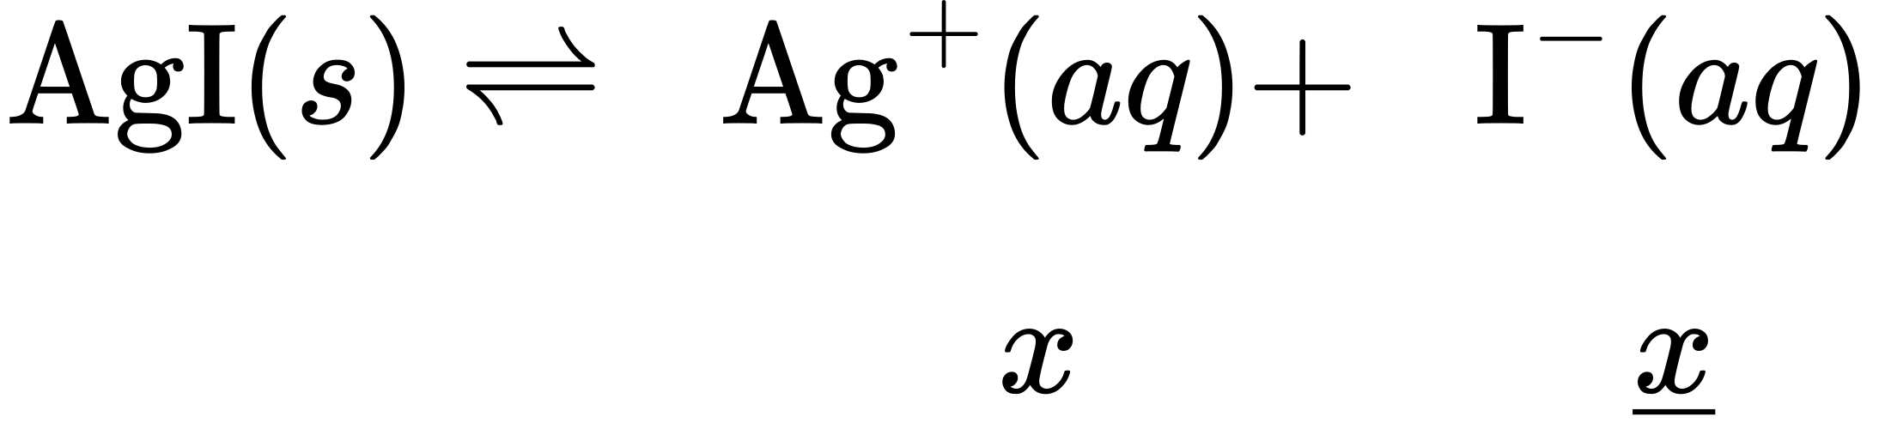
(b)
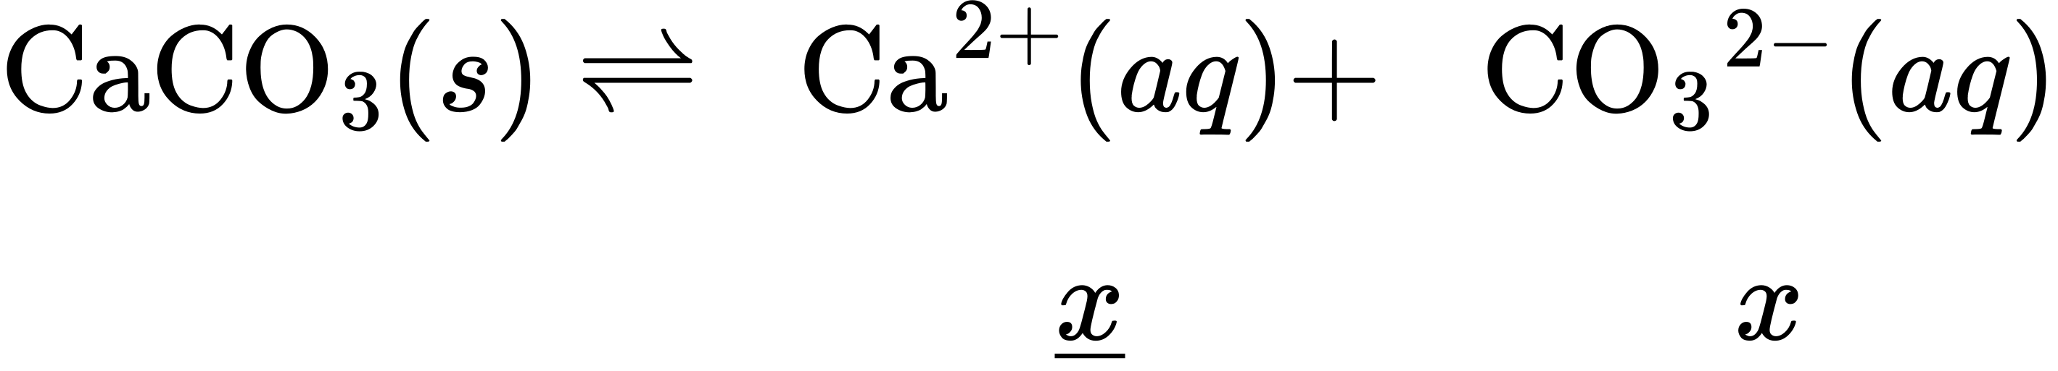
(c)
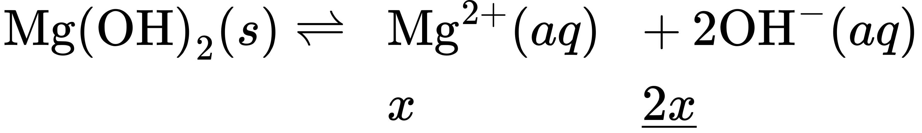
(d)
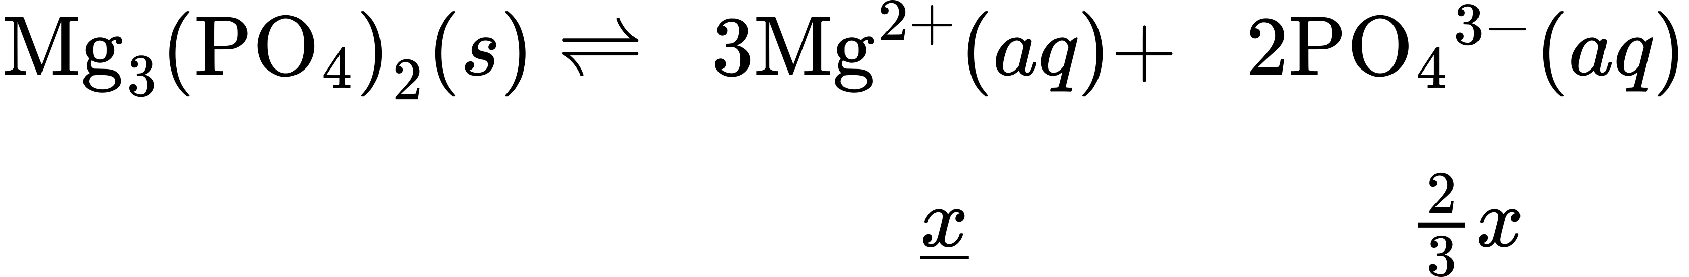
(e)
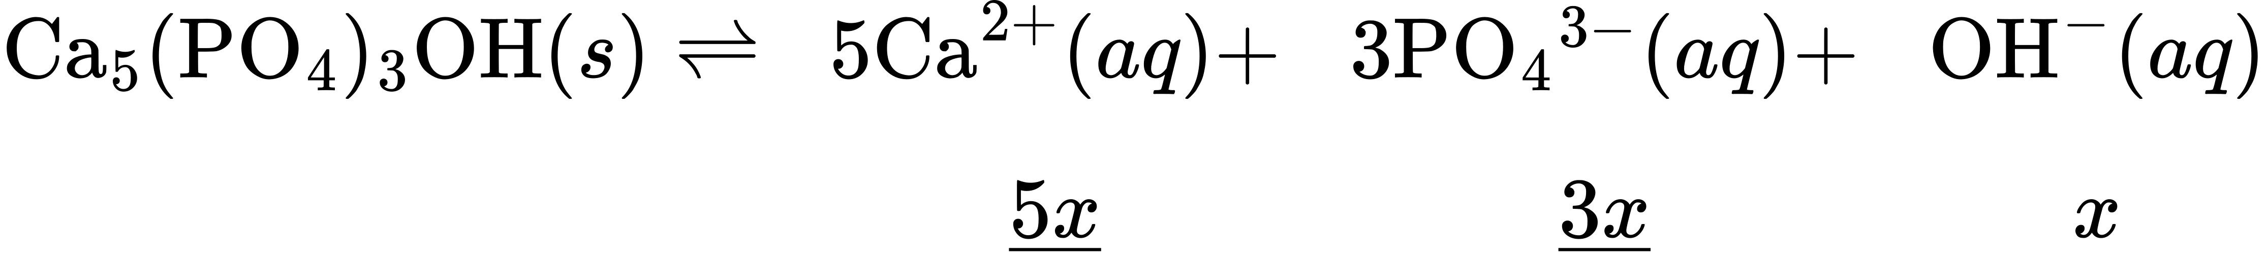
3.
There is no change. A solid has an activity of 1 whether there is a little or a lot.
5.
The solubility of silver bromide at the new temperature must be known. Normally the solubility increases and some of the solid silver bromide will dissolve.
7.
CaF₂, MnCO₃, and ZnS
9.
(a) ${\text{LaF}}_{3}\left(s\right)⇌{\text{La}}^{\text{3+}}\left(aq\right)+{\text{3F}}^{\text{−}}\left(aq\right) K_{\text{sp}}=[{\text{La}}^{\text{3+}}]{[\text{F}}^{\text{−}}]^{3};$
(b) ${\text{CaCO}}_{3}\left(s\right)⇌{\text{Ca}}^{\text{2+}}\left(aq\right)+{\text{CO}}_{3}​^{\text{2−}}\left(aq\right) K_{\text{sp}}=[{\text{Ca}}^{\text{2+}}][{\text{CO}}_{3}​^{\text{2−}}];$
(c) ${\text{Ag}}_{2}{\text{SO}}_{4}\left(s\right)⇌{\text{2Ag}}^{\text{+}}\left(aq\right)+{\text{SO}}_{4}​^{\text{2−}}\left(aq\right) K_{\text{sp}}={[{\text{Ag}}^{\text{+}}]}^{2}[{\text{SO}}_{4}​^{\text{2−}}];$
(d) ${\text{Pb(OH)}}_{2}\left(s\right)⇌{\text{Pb}}^{\text{2+}}\left(aq\right)+{\text{2OH}}^{\text{−}}\left(aq\right) K_{\text{sp}}=[{\text{Pb}}^{\text{2+}}]{[{\text{OH}}^{\text{−}}]}^{2}$
11.
(a)1.77 $×$ 10^{–7}; (b) 1.6 $×$ 10^{–6}; (c) 2.2 $×$ 10^{–9}; (d) 7.91 $×$ 10^{–22}
13.
(a) 2 $×$ 10^{–2} M; (b) 1.5 $×$ 10^{–3} M; (c) 2.27 $×$ 10^{–9} M; (d) 2.2 $×$ 10^{–10} M
15.
(a) 6.4 $×$ 10⁻⁹ M = [Ag⁺], [Cl⁻] = 0.025 M. Check: $\frac{6.4 × {10}^{−9} M}{0.025 M} × \text{100\%}=\text{2.6} × {10}^{−5}\%,$an insignificant change;
(b) 2.2 $×$ 10⁻⁵ M = [Ca²⁺], [F⁻] = 0.0013 M. Check: $\frac{\text{2.26} × {10}^{−5} M}{0.00133 M} × \text{100\%}=\text{1.70\%}.$ This value is less than 5% and can be ignored.
(c) 0.2238 M = $[{\text{SO}}_{4}​^{2\text{−}}];$ [Ag⁺] = 7.4 $×$ 10^{–3} M. Check: $\frac{3.7 × {10}^{−3}}{0.2238} × 100\%=\text{1.64} × {10}^{−2};$ the condition is satisfied.
(d) [OH–] = 2.8 $×$ 10^{–3} M; 5.7 $×$ 10⁻¹² M = [Zn²⁺]. Check: $\frac{5.7 × {10}^{−12}}{2.8 × {10}^{−3}} × \text{100\%}=\text{2.0} × {10}^{−7}\%;$ x is less than 5% of [OH–] and is, therefore, negligible.
17.
(a) The change in initial concentration of common ion may not be neglected (must solve quadratic equation)
[Ti⁺] =0.031 M
[Cl–] = 0.0056 M (b) The change in initial concentration of common ion may be neglected.
[Ba²⁺] = 2.4 $×$ 10^{–4} M
[F–] = 0.313 M;
(c) The change in initial concentration of common ion may be neglected.
[Mg²⁺] = 0.0244 M
$[{\text{C}}_{2}{\text{O}}_{4}​^{\text{2−}}]=2.9 × {10}^{\text{−5}} M$
(d) The change in initial concentration of common ion may be neglected.
[Ca²⁺] = 5.18 $×$ 10^{–4} M
[C₂)₄^{2–}] = 0.051 M
19.
The changes in concentration are greater than 5% and thus exceed the maximum value for disregarding the change.
21.
CaSO₄∙2H₂O is the most soluble Ca salt in mol/L, and it is also the most soluble Ca salt in g/L.
23.
7.8 $×$ 10^{–3} M = $[{\text{SO}}_{4}​^{\text{2−}}]$ = [Ca²⁺]; Since this concentration is higher than 2.60 $×$ 10^{–3} M, “gyp” water does not meet the standards.
25.
Mass (CaSO₄·2H₂O) = 0.72 g/L
27.
(a) [Ag⁺] = [I–] = 1.3 $×$ 10^{–5} M; (b) [Ag⁺] = 2.88 $×$ 10^{–2} M, $[{\text{SO}}_{4}​^{\text{2−}}]$= 1.44 $×$ 10^{–2} M; (c) [Mn²⁺] = 3.7 $×$ 10^{–5} M, [OH–] = 7.4 $×$ 10^{–5} M; (d) [Sr²⁺] = 4.3 $×$ 10^{–2} M, [OH–] = 8.6 $×$ 10^{–2} M; (e) [Mg²⁺] = 1.3 $×$ 10^{–4} M, [OH–] = 2.6 $×$ 10^{–4} M.
29.
(a) 1.45 $×$ 10^{–4}; (b) 8.2 $×$ 10^{–55}; (c) 1.35 $×$ 10^{–4}; (d) 1.18 $×$ 10^{–5}; (e) 1.08 $×$ 10^{–10}
31.
(a) CaCO₃ does precipitate. (b) The compound does not precipitate. (c) The compound does not precipitate. (d) The compound precipitates.
33.
1.42 $×$ 10⁻⁹ M
35.
9.2 $×$ 10⁻¹³ M
37.
[Ag⁺] = 1.8 $×$ 10^{–3} M
39.
6.3 $×$ 10^{–4}
41.
(a) 2.25 L; (b) 7.2 $×$ 10^{–7} g
43.
100% of it is dissolved
45.
(a) ${\text{Hg}}_{2}​^{\text{2+}}$ and Cu²⁺: Add ${\text{SO}}_{4}​^{\text{2−}}.$ (b) ${\text{SO}}_{4}​^{\text{2−}}$ and Cl–: Add Ba²⁺. (c) Hg²⁺ and Co²⁺: Add S^{2–}. (d) Zn²⁺ and Sr²⁺: Add OH– until [OH–] = 0.050 M. (e) Ba²⁺ and Mg²⁺: Add ${\text{SO}}_{4}​^{\text{2−}}.$ (f) ${\text{CO}}_{3}​^{\text{2−}}$ and OH–: Add Ba²⁺.
47.
AgI will precipitate first.
49.
1.5 $×$ 10⁻¹² M
51.
3.99 kg
53.
(a) 3.1 $×$ 10^{–11}; (b) [Cu²⁺] = 2.6 $×$ 10^{–3}; $[{\text{IO}}_{3}​^{\text{−}}]$ = 5.3 $×$ 10^{–3}
55.
1.8 $×$ 10^{–5} g Pb(OH)₂
57.
${\text{Mg(OH)}}_{2}\left(s\right)⇌{\text{Mg}}^{\text{2+}}+{\text{2OH}}^{\text{−}} K_{\text{sp}}=[{\text{Mg}}^{\text{2+}}]{[{\text{OH}}^{\text{−}}]}^{2}$
1.23 $×$ 10⁻³ g Mg(OH)₂
59.
MnCO₃ will form first since it has the smallest K_{sp} value among these homologous compounds and is therefore the least soluble. MgCO₃•3H₂O will be the last to precipitate since it has the largest K_sp value and is the most soluble. K_{sp} value.
62.
when the amount of solid is so small that a saturated solution is not produced
64.
8.2 $×$ 10^{–5} M
66.
5 $×$ 10²³
68.
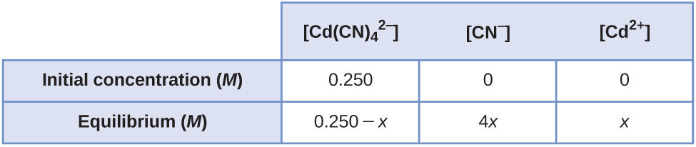
[Cd²⁺] = 5.0 $×$ 10^{–5} M; [CN–] = 2.0 $×$ 10^{–4} M
70.
[Co³⁺] = 3.0 $×$ 10^{–6} M; [NH₃] = 1.8 $×$ 10^{–5} M
72.
1.3 g
74.
0.79 g
76.
(a)
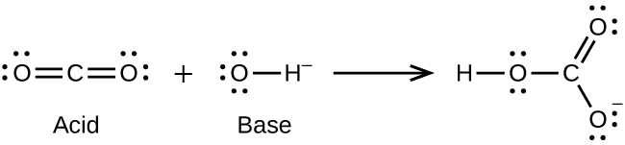
(b)
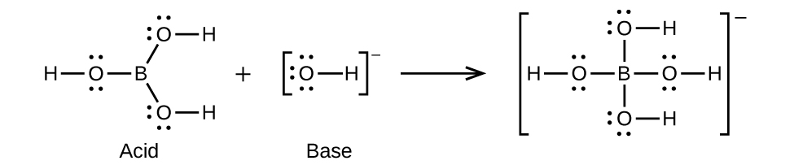
(c)
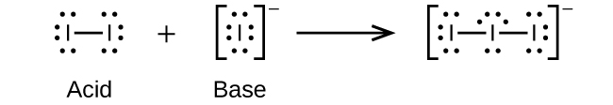
(d)
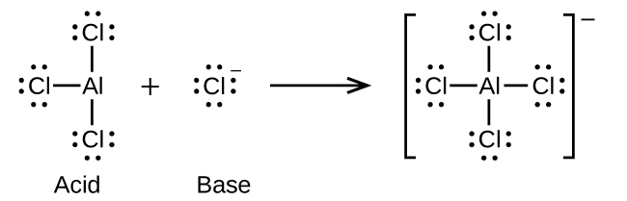
(e)
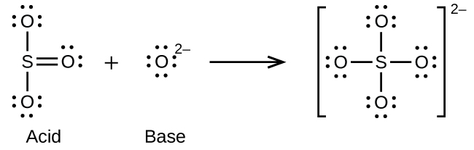
78.
(a)
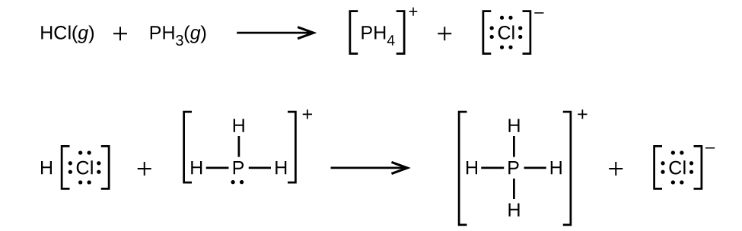
(b) ${\text{H}}_{3}{\text{O}}^{+}+{\text{CH}}_{3}​^{\text{−}} → {\text{CH}}_{4}+{\text{H}}_{2}\text{O}$
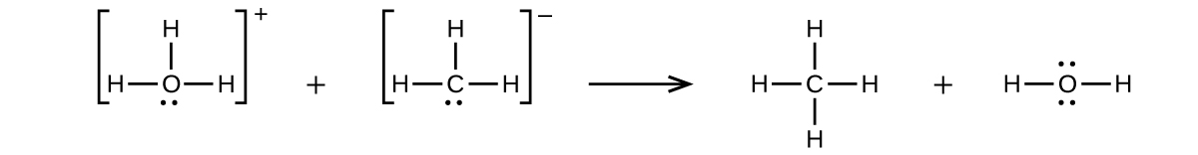
(c) $\text{CaO}+{\text{SO}}_{3} → \text{CaSO}4$
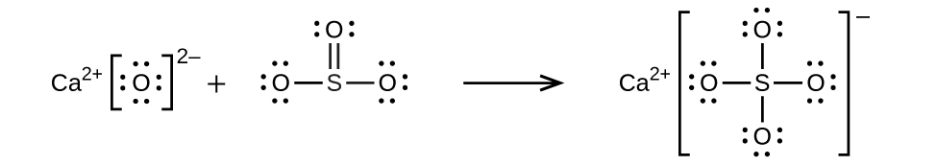
(d) ${\text{NH}}_{4}​^{+}+{\text{C}}_{2}{\text{H}}_{5}{\text{O}}^{\text{−}} → {\text{C}}_{2}{\text{H}}_{5}\text{OH}+{\text{NH}}_{3}$
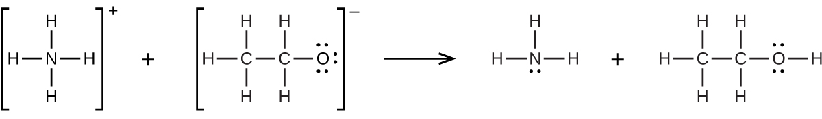
80.
0.0281 g
82.
${\text{HNO}}_{3}\left(l\right)+\text{HF}\left(l\right) → {\text{H}}_{2}{\text{NO}}_{3}​^{+}+{\text{F}}^{\text{−}};$ $\text{HF}\left(l\right)+{\text{BF}}_{3}\left(g\right) → {\text{H}}^{+}+{\text{BF}}_{4}$
84.
(a) ${\text{H}}_{3}{\text{BO}}_{3}+{\text{H}}_{2}\text{O} → {\text{H}}_{4}{\text{BO}}_{4}​^{\text{−}}+{\text{H}}^{+};$ (b) The electronic and molecular shapes are the same—both tetrahedral. (c) The tetrahedral structure is consistent with sp³ hybridization.
86.
0.014 M
88.
7.2 $×$ 10^{–15} M
90.
4.4 $×$ 10⁻²² M
93.
[OH⁻] = 4.5 $×$ 10⁻⁶; [Al³⁺] = 2 $×$ 10^{–16} (molar solubility)
95.
${\text{K}}_{sp}=[{\text{Ba}}^{2+}][{\text{SO}}_{4}​^{\text{2−}}]=[{\text{Ba}}^{2+}]\left(0.049\right)=1.08×{10}^{–10}[{\text{Ba}}^{2+}]=2.2×{10}^{–9}$; (molar solubility)
97.
[OH–] = 7.6 $×$ 10⁻³ M; [Pb²⁺] = 2.1 $×$ 10^{–11} (molar solubility)
99.
7.66
101.
(a) K_{sp} = [Mg²⁺][F–]² = (1.21 $×$ 10^{–3})(2 $×$ 1.21 $×$ 10^{–3})² = 7.09 $×$ 10^{–9}
(b) 7.09 $×$ 10^{–7} M
(c) Determine the concentration of Mg²⁺ and F– that will be present in the final volume. Compare the value of the ion product [Mg²⁺][F–]² with K_{sp}. If this value is larger than K_{sp}, precipitation will occur.
0.1000 L $×$ 3.00 $×$ 10^{–3} M Mg(NO₃)₂ = 0.3000 L $×$ M Mg(NO₃)₂
M Mg(NO₃)₂ = 1.00 $×$ 10^{–3} M
0.2000 L $×$ 2.00 $×$ 10^{–3} M NaF = 0.3000 L $×$ M NaF
M NaF = 1.33 $×$ 10^{–3} M
ion product = (1.00 $×$ 10^{–3})(1.33 $×$ 10^{–3})² = 1.77 $×$ 10^{–9} This value is smaller than K_{sp}, so no precipitation will occur.
(d) MgF₂ is less soluble at 27 °C than at 18 °C. Because added heat acts like an added reagent, when it appears on the product side, the Le Châtelier’s principle states that the equilibrium will shift to the reactants’ side to counter the stress. Consequently, less reagent will dissolve. This situation is found in our case. Therefore, the reaction is exothermic.
103.
BaF₂, Ca₃(PO₄)₂, ZnS; each is a salt of a weak acid, and the $[{\text{H}}_{3}{\text{O}}^{+}]$ from perchloric acid reduces the equilibrium concentration of the anion, thereby increasing the concentration of the cations
105.
Effect on amount of solid CaHPO₄, [Ca²⁺], [OH–]: (a) increase, increase, decrease; (b) decrease, increase, decrease; (c) no effect, no effect, no effect; (d) decrease, increase, decrease; (e) increase, no effect, no effect

