10.3 Phase Transitions

Learning Objectives
By the end of this section, you will be able to:
- Define phase transitions and phase transition temperatures
- Explain the relation between phase transition temperatures and intermolecular attractive forces
- Describe the processes represented by typical heating and cooling curves, and compute heat flows and enthalpy changes accompanying these processes
We witness and utilize changes of physical state, or phase transitions, in a great number of ways. As one example of global significance, consider the evaporation, condensation, freezing, and melting of water. These changes of state are essential aspects of our earth’s water cycle as well as many other natural phenomena and technological processes of central importance to our lives. In this module, the essential aspects of phase transitions are explored.

Vaporization and Condensation
When a liquid vaporizes in a closed container, gas molecules cannot escape. As these gas phase molecules move randomly about, they will occasionally collide with the surface of the condensed phase, and in some cases, these collisions will result in the molecules re-entering the condensed phase. The change from the gas phase to the liquid is called condensation. When the rate of condensation becomes equal to the rate of vaporization, neither the amount of the liquid nor the amount of the vapor in the container changes. The vapor in the container is then said to be in equilibrium with the liquid. Keep in mind that this is not a static situation, as molecules are continually exchanged between the condensed and gaseous phases. Such is an example of a dynamic equilibrium, the status of a system in which reciprocal processes (for example, vaporization and condensation) occur at equal rates. The pressure exerted by the vapor in equilibrium with a liquid in a closed container at a given temperature is called the liquid’s vapor pressure (or equilibrium vapor pressure). The area of the surface of the liquid in contact with a vapor and the size of the vessel have no effect on the vapor pressure, although they do affect the time required for the equilibrium to be reached. We can measure the vapor pressure of a liquid by placing a sample in a closed container, like that illustrated in Figure 10.22, and using a manometer to measure the increase in pressure that is due to the vapor in equilibrium with the condensed phase.
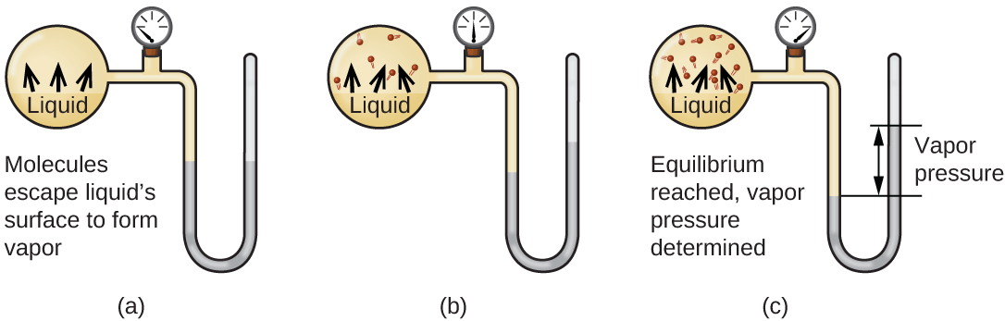
Figure 10.22 In a closed container, dynamic equilibrium is reached when (a) the rate of molecules escaping from the liquid to become the gas (b) increases and eventually (c) equals the rate of gas molecules entering the liquid. When this equilibrium is reached, the vapor pressure of the gas is constant, although the vaporization and condensation processes continue.
The chemical identities of the molecules in a liquid determine the types (and strengths) of intermolecular attractions possible; consequently, different substances will exhibit different equilibrium vapor pressures. Relatively strong intermolecular attractive forces will serve to impede vaporization as well as favoring “recapture” of gas-phase molecules when they collide with the liquid surface, resulting in a relatively low vapor pressure. Weak intermolecular attractions present less of a barrier to vaporization, and a reduced likelihood of gas recapture, yielding relatively high vapor pressures. The following example illustrates this dependence of vapor pressure on intermolecular attractive forces.

Example 10.5

Explaining Vapor Pressure in Terms of IMFs
Given the shown structural formulas for these four compounds, explain their relative vapor pressures in terms of types and extents of IMFs: 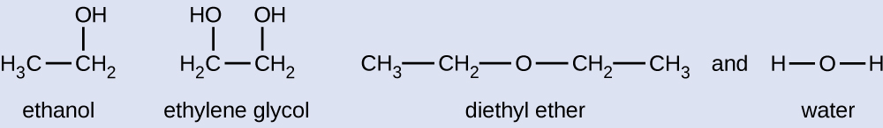

Solution
Diethyl ether has a very small dipole and most of its intermolecular attractions are London forces. Although this molecule is the largest of the four under consideration, its IMFs are the weakest and, as a result, its molecules most readily escape from the liquid. It also has the highest vapor pressure. Due to its smaller size, ethanol exhibits weaker dispersion forces than diethyl ether. However, ethanol is capable of hydrogen bonding and, therefore, exhibits stronger overall IMFs, which means that fewer molecules escape from the liquid at any given temperature, and so ethanol has a lower vapor pressure than diethyl ether. Water is much smaller than either of the previous substances and exhibits weaker dispersion forces, but its extensive hydrogen bonding provides stronger intermolecular attractions, fewer molecules escaping the liquid, and a lower vapor pressure than for either diethyl ether or ethanol. Ethylene glycol has two −OH groups, so, like water, it exhibits extensive hydrogen bonding. It is much larger than water and thus experiences larger London forces. Its overall IMFs are the largest of these four substances, which means its vaporization rate will be the slowest and, consequently, its vapor pressure the lowest.

Check Your Learning
At 20 °C, the vapor pressures of several alcohols are given in this table. Explain these vapor pressures in terms of types and extents of IMFs for these alcohols:
Compound | methanol CH₃OH | ethanol C₂H₅OH | propanol C₃H₇OH | butanol C₄H₉OH
Vapor Pressure at 20 °C | 11.9 kPa | 5.95 kPa | 2.67 kPa | 0.56 kPa

Answer:
All these compounds exhibit hydrogen bonding; these strong IMFs are difficult for the molecules to overcome, so the vapor pressures are relatively low. As the size of molecule increases from methanol to butanol, dispersion forces increase, which means that the vapor pressures decrease as observed:
P_{methanol} > P_{ethanol} > P_{propanol} > P_{butanol}.
As temperature increases, the vapor pressure of a liquid also increases due to the increased average KE of its molecules. Recall that at any given temperature, the molecules of a substance experience a range of kinetic energies, with a certain fraction of molecules having a sufficient energy to overcome IMF and escape the liquid (vaporize). At a higher temperature, a greater fraction of molecules have enough energy to escape from the liquid, as shown in Figure 10.23. The escape of more molecules per unit of time and the greater average speed of the molecules that escape both contribute to the higher vapor pressure.
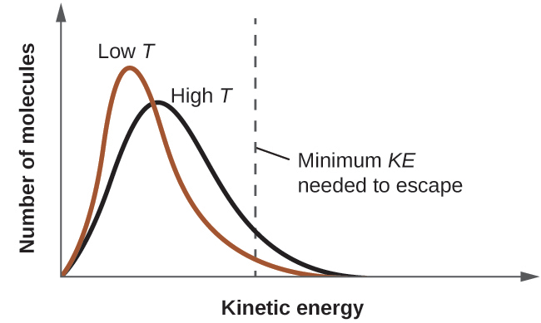
Figure 10.23 Temperature affects the distribution of kinetic energies for the molecules in a liquid. At the higher temperature, more molecules have the necessary kinetic energy, KE, to escape from the liquid into the gas phase.

Boiling Points
When the vapor pressure increases enough to equal the external atmospheric pressure, the liquid reaches its boiling point. The boiling point of a liquid is the temperature at which its equilibrium vapor pressure is equal to the pressure exerted on the liquid by its gaseous surroundings. For liquids in open containers, this pressure is due to the earth’s atmosphere. The normal boiling point of a liquid is defined as its boiling point when surrounding pressure is equal to 1 atm (101.3 kPa). Figure 10.24 shows the variation in vapor pressure with temperature for several different substances. Considering the definition of boiling point, these curves may be seen as depicting the dependence of a liquid’s boiling point on surrounding pressure.
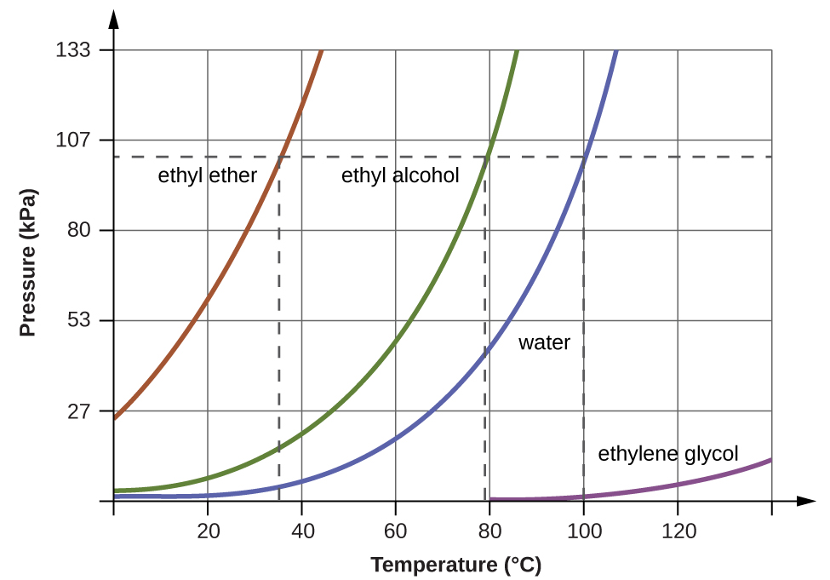
Figure 10.24 The boiling points of liquids are the temperatures at which their equilibrium vapor pressures equal the pressure of the surrounding atmosphere. Normal boiling points are those corresponding to a pressure of 1 atm (101.3 kPa.)

Example 10.6

A Boiling Point at Reduced Pressure
A typical atmospheric pressure in Leadville, Colorado (elevation 10,200 feet) is 68 kPa. Use the graph in Figure 10.24 to determine the boiling point of water at this elevation.

Solution
The graph of the vapor pressure of water versus temperature in Figure 10.24 indicates that the vapor pressure of water is 68 kPa at about 90 °C. Thus, at about 90 °C, the vapor pressure of water will equal the atmospheric pressure in Leadville, and water will boil.

Check Your Learning
The boiling point of ethyl ether was measured to be 10 °C at a base camp on the slopes of Mount Everest. Use Figure 10.24 to determine the approximate atmospheric pressure at the camp.

Answer:
Approximately 40 kPa (0.4 atm)
The quantitative relation between a substance’s vapor pressure and its temperature is described by the Clausius-Clapeyron equation:
$P=Ae^{−\text{Δ}H_{\text{vap}}\text{/}RT}$
where ΔH_{vap} is the enthalpy of vaporization for the liquid, R is the gas constant, and A is a constant whose value depends on the chemical identity of the substance. Temperature T must be in Kelvin in this equation. This equation is often rearranged into logarithmic form to yield the linear equation:
$\text{ln} P=−\frac{\text{Δ}H_{\text{vap}}}{RT} +\text{ln} A$
This linear equation may be expressed in a two-point format that is convenient for use in various computations, as demonstrated in the example exercises that follow. If at temperature T₁, the vapor pressure is P₁, and at temperature T₂, the vapor pressure is P₂, the corresponding linear equations are:
$\text{ln} P_{1}=−\frac{\text{Δ}H_{\text{vap}}}{RT_{1}} +\text{ln} A \text{and} \text{ln} P_{2}=−\frac{\text{Δ}H_{\text{vap}}}{RT_{2}} +\text{ln} A$
Since the constant, A, is the same, these two equations may be rearranged to isolate ln A and then set them equal to one another:
$\text{ln} P_{1}+ \frac{\text{Δ}H_{\text{vap}}}{RT_{1}} =\text{ln} P_{2}+ \frac{\text{Δ}H_{\text{vap}}}{RT_{2}}$
which can be combined into:
$\text{ln} \left(\frac{P_{2}}{P_{1}}\right)= \frac{\text{Δ}H_{\text{vap}}}{R} \left(\frac{1}{T_{1}} − \frac{1}{T_{2}}\right)$

Example 10.7

Estimating Enthalpy of Vaporization
Isooctane (2,2,4-trimethylpentane) has an octane rating of 100. It is used as one of the standards for the octane-rating system for gasoline. At 34.0 °C, the vapor pressure of isooctane is 10.0 kPa, and at 98.8 °C, its vapor pressure is 100.0 kPa. Use this information to estimate the enthalpy of vaporization for isooctane.

Solution
The enthalpy of vaporization, ΔH_{vap}, can be determined by using the Clausius-Clapeyron equation:
$\text{ln} \left(\frac{P_{2}}{P_{1}}\right)= \frac{\text{Δ}H_{\text{vap}}}{R} \left(\frac{1}{T_{1}} − \frac{1}{T_{2}}\right)$
Since we have two vapor pressure-temperature values (T₁ = 34.0 °C = 307.2 K, P₁ = 10.0 kPa and T₂ = 98.8 °C = 372.0 K, P₂ = 100 kPa), we can substitute them into this equation and solve for ΔH_{vap}. Rearranging the Clausius-Clapeyron equation and solving for ΔH_{vap} yields:
$\text{Δ}H_{\text{vap}}= \frac{R\text{⋅}\text{ln} \left(\frac{P_{2}}{P_{1}}\right)}{\left(\frac{1}{T_{1}} − \frac{1}{T_{2}}\right)} = \frac{\left(8.3145 \text{J/mol}\text{⋅}\text{K}\right)\text{⋅}\text{ln} \left(\frac{\text{100 kPa}}{\text{10.0 kPa}}\right)}{\left(\frac{1}{307.2 \text{K}} − \frac{1}{372.0 \text{K}}\right)} =\text{33,800 J/mol}=\text{33.8 kJ/mol}$
Note that the pressure can be in any units, so long as they agree for both P values, but the temperature must be in kelvin for the Clausius-Clapeyron equation to be valid.

Check Your Learning
At 20.0 °C, the vapor pressure of ethanol is 5.95 kPa, and at 63.5 °C, its vapor pressure is 53.3 kPa. Use this information to estimate the enthalpy of vaporization for ethanol.

Answer:
41,360 J/mol or 41.4 kJ/mol

Example 10.8

Estimating Temperature (or Vapor Pressure)
For benzene (C₆H₆), the normal boiling point is 80.1 °C and the enthalpy of vaporization is 30.8 kJ/mol. What is the boiling point of benzene in Denver, where atmospheric pressure = 83.4 kPa?

Solution
If the temperature and vapor pressure are known at one point, along with the enthalpy of vaporization, ΔH_{vap,} then the temperature that corresponds to a different vapor pressure (or the vapor pressure that corresponds to a different temperature) can be determined by using the Clausius-Clapeyron equation:
$\text{ln} \left(\frac{P_{2}}{P_{1}}\right)= \frac{\text{Δ}H_{\text{vap}}}{R} \left(\frac{1}{T_{1}} − \frac{1}{T_{2}}\right)$
Since the normal boiling point is the temperature at which the vapor pressure equals atmospheric pressure at sea level, we know one vapor pressure-temperature value (T₁ = 80.1 °C = 353.3 K, P₁ = 101.3 kPa, ΔH_{vap} = 30.8 kJ/mol) and want to find the temperature (T₂) that corresponds to vapor pressure P₂ = 83.4 kPa. We can substitute these values into the Clausius-Clapeyron equation and then solve for T₂. Rearranging the Clausius-Clapeyron equation and solving for T₂ yields:
$T_{2}={\left(\frac{−R\text{⋅}\text{ln} \left(\frac{P_{2}}{P_{1}}\right)}{\text{Δ}H_{\text{vap}}} + \frac{1}{T_{1}}\right)}^{−1}={\left(\frac{−\left(8.3145 \text{J/mol}\text{⋅}\text{K}\right)\text{⋅}\text{ln} \left(\frac{83.4 \text{kPa}}{101.3 \text{kPa}}\right)}{\text{30,800 J/mol}} + \frac{1}{353.3 \text{K}}\right)}^{−1}=\text{346.9 K or} {73.8}^{∘}\text{C}$

Check Your Learning
For acetone (CH₃)₂CO, the normal boiling point is 56.5 °C and the enthalpy of vaporization is 31.3 kJ/mol. What is the vapor pressure of acetone at 25.0 °C?

Answer:
30.1 kPa

Enthalpy of Vaporization
Vaporization is an endothermic process. The cooling effect can be evident when you leave a swimming pool or a shower. When the water on your skin evaporates, it removes heat from your skin and causes you to feel cold. The energy change associated with the vaporization process is the enthalpy of vaporization, ΔH_{vap}. For example, the vaporization of water at standard temperature is represented by:
${\text{H}}_{2}\text{O(}l) → {\text{H}}_{2}\text{O(}g) \text{Δ}H_{\text{vap}}=\text{44.01 kJ/mol}$
As described in the chapter on thermochemistry, the reverse of an endothermic process is exothermic. And so, the condensation of a gas releases heat:
${\text{H}}_{2}\text{O}\left(g\right) → {\text{H}}_{2}\text{O(}l) \text{Δ}H_{\text{con}}=\text{−Δ}H_{\text{vap}}=−44.01 \text{kJ/mol}$

Example 10.9

Using Enthalpy of Vaporization
One way our body is cooled is by evaporation of the water in sweat (Figure 10.25). In very hot climates, we can lose as much as 1.5 L of sweat per day. Although sweat is not pure water, we can get an approximate value of the amount of heat removed by evaporation by assuming that it is. How much heat is required to evaporate 1.5 L of water (1.5 kg) at T = 37 °C (normal body temperature); ΔH_{vap} = 43.46 kJ/mol at 37 °C.

Figure 10.25 Evaporation of sweat helps cool the body. (credit: “Kullez”/Flickr)

Solution
We start with the known volume of sweat (approximated as just water) and use the given information to convert to the amount of heat needed:
$1.5 \text{L} × \frac{1000 \text{g}}{1\text{L}} × \frac{1 \text{mol}}{18 \text{g}} × \frac{43.46 \text{kJ}}{1 \text{mol}} =3.6 × {10}^{3} \text{kJ}$
Thus, 3600 kJ of heat are removed by the evaporation of 1.5 L of water.

Check Your Learning
How much heat is required to evaporate 100.0 g of liquid ammonia, NH₃, at its boiling point if its enthalpy of vaporization is 4.8 kJ/mol?

Answer:
28 kJ

Melting and Freezing
When we heat a crystalline solid, we increase the average energy of its atoms, molecules, or ions and the solid gets hotter. At some point, the added energy becomes large enough to partially overcome the forces holding the molecules or ions of the solid in their fixed positions, and the solid begins the process of transitioning to the liquid state, or melting. At this point, the temperature of the solid stops rising, despite the continual input of heat, and it remains constant until all of the solid is melted. Only after all of the solid has melted will continued heating increase the temperature of the liquid (Figure 10.26).
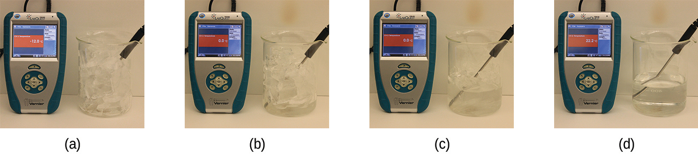
Figure 10.26 (a) This beaker of ice has a temperature of −12.0 °C. (b) After 10 minutes the ice has absorbed enough heat from the air to warm to 0 °C. A small amount has melted. (c) Thirty minutes later, the ice has absorbed more heat, but its temperature is still 0 °C. The ice melts without changing its temperature. (d) Only after all the ice has melted does the heat absorbed cause the temperature to increase to 22.2 °C. (credit: modification of work by Mark Ott)
If we stop heating during melting and place the mixture of solid and liquid in a perfectly insulated container so no heat can enter or escape, the solid and liquid phases remain in equilibrium. This is almost the situation with a mixture of ice and water in a very good thermos bottle; almost no heat gets in or out, and the mixture of solid ice and liquid water remains for hours. In a mixture of solid and liquid at equilibrium, the reciprocal processes of melting and freezing occur at equal rates, and the quantities of solid and liquid therefore remain constant. The temperature at which the solid and liquid phases of a given substance are in equilibrium is called the melting point of the solid or the freezing point of the liquid. Use of one term or the other is normally dictated by the direction of the phase transition being considered, for example, solid to liquid (melting) or liquid to solid (freezing).
The enthalpy of fusion and the melting point of a crystalline solid depend on the strength of the attractive forces between the units present in the crystal. Molecules with weak attractive forces form crystals with low melting points. Crystals consisting of particles with stronger attractive forces melt at higher temperatures.
The amount of heat required to change one mole of a substance from the solid state to the liquid state is the enthalpy of fusion, ΔH_{fus} of the substance. The enthalpy of fusion of ice is 6.0 kJ/mol at 0 °C. Fusion (melting) is an endothermic process:
${\text{H}}_{2}\text{O}\left(s\right) → {\text{H}}_{2}\text{O(}l) \text{Δ}H_{\text{fus}}=\text{6.01 kJ/mol}$
The reciprocal process, freezing, is an exothermic process whose enthalpy change is −6.0 kJ/mol at 0 °C:
${\text{H}}_{2}\text{O}\left(l\right) → {\text{H}}_{2}\text{O(}s) \text{Δ}H_{\text{frz}}=\text{−Δ}H_{\text{fus}}=−6.01 \text{kJ/mol}$

Sublimation and Deposition
Some solids can transition directly into the gaseous state, bypassing the liquid state, via a process known as sublimation. At room temperature and standard pressure, a piece of dry ice (solid CO₂) sublimes, appearing to gradually disappear without ever forming any liquid. Snow and ice sublime at temperatures below the melting point of water, a slow process that may be accelerated by winds and the reduced atmospheric pressures at high altitudes. When solid iodine is warmed, the solid sublimes and a vivid purple vapor forms (Figure 10.27). The reverse of sublimation is called deposition, a process in which gaseous substances condense directly into the solid state, bypassing the liquid state. The formation of frost is an example of deposition.
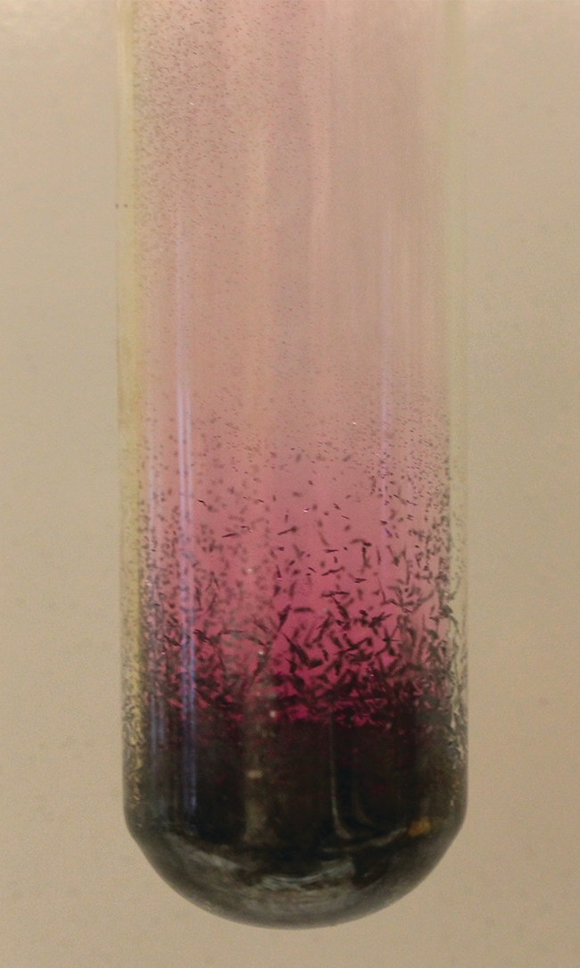
Figure 10.27 Sublimation of solid iodine in the bottom of the tube produces a purple gas that subsequently deposits as solid iodine on the colder part of the tube above. (credit: modification of work by Mark Ott)
Like vaporization, the process of sublimation requires an input of energy to overcome intermolecular attractions. The enthalpy of sublimation, ΔH_{sub}, is the energy required to convert one mole of a substance from the solid to the gaseous state. For example, the sublimation of carbon dioxide is represented by:
${\text{CO}}_{2}\left(s\right) → {\text{CO}}_{2}\left(g\right) \text{Δ}H_{\text{sub}}=\text{26.1 kJ/mol}$
Likewise, the enthalpy change for the reverse process of deposition is equal in magnitude but opposite in sign to that for sublimation:
${\text{CO}}_{2}\left(g\right) → {\text{CO}}_{2}\left(s\right) \text{Δ}H_{\text{dep}}=\text{−Δ}H_{\text{sub}}=−26.1 \text{kJ/mol}$
Consider the extent to which intermolecular attractions must be overcome to achieve a given phase transition. Converting a solid into a liquid requires that these attractions be only partially overcome; transition to the gaseous state requires that they be completely overcome. As a result, the enthalpy of fusion for a substance is less than its enthalpy of vaporization. This same logic can be used to derive an approximate relation between the enthalpies of all phase changes for a given substance. Though not an entirely accurate description, sublimation may be conveniently modeled as a sequential two-step process of melting followed by vaporization in order to apply Hess’s Law. Viewed in this manner, the enthalpy of sublimation for a substance may be estimated as the sum of its enthalpies of fusion and vaporization, as illustrated in Figure 10.28. For example:
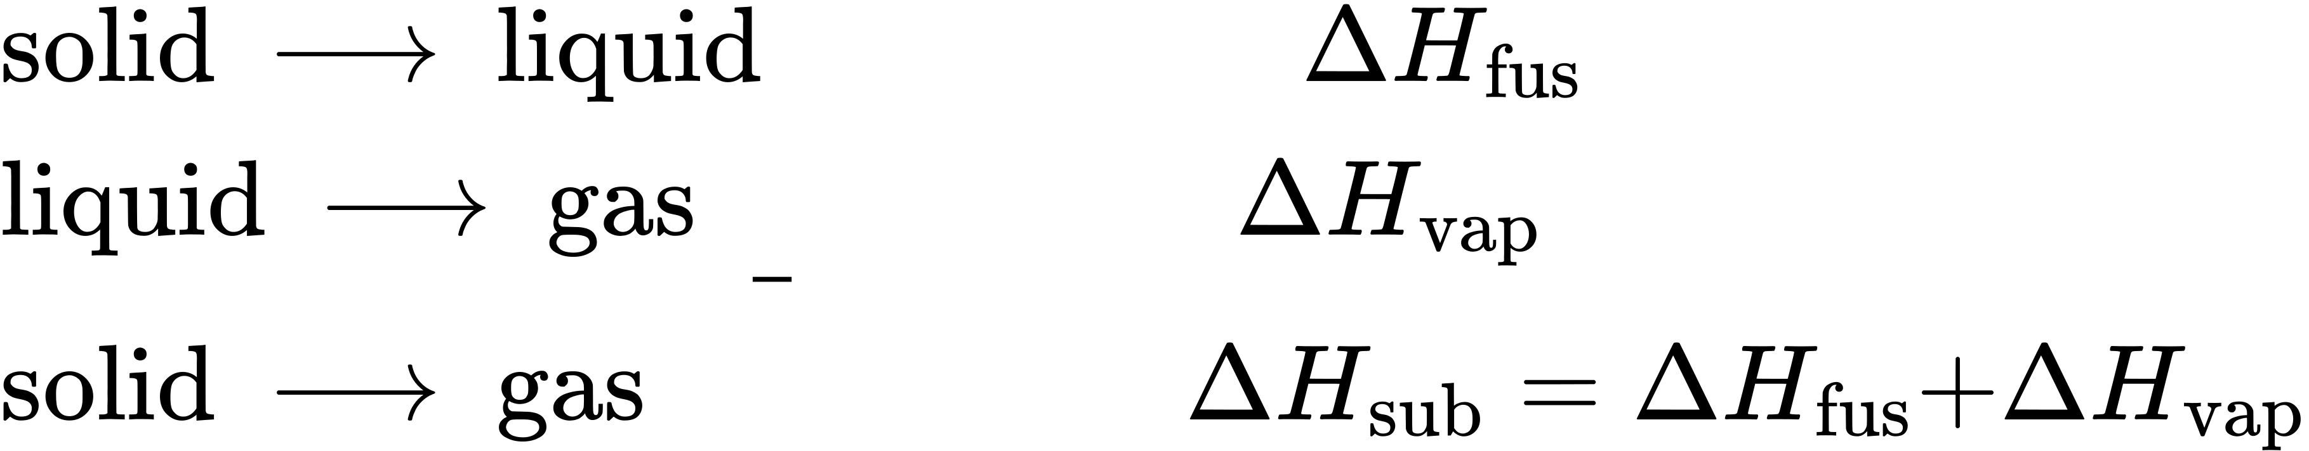
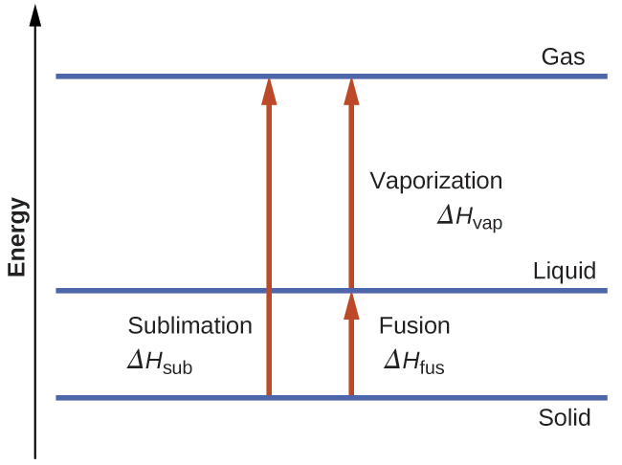
Figure 10.28 For a given substance, the sum of its enthalpy of fusion and enthalpy of vaporization is approximately equal to its enthalpy of sublimation.

Heating and Cooling Curves
In the chapter on thermochemistry, the relation between the amount of heat absorbed or released by a substance, q, and its accompanying temperature change, ΔT, was introduced:
$q=mc\text{Δ}T$
where m is the mass of the substance and c is its specific heat. The relation applies to matter being heated or cooled, but not undergoing a change in state. When a substance being heated or cooled reaches a temperature corresponding to one of its phase transitions, further gain or loss of heat is a result of diminishing or enhancing intermolecular attractions, instead of increasing or decreasing molecular kinetic energies. While a substance is undergoing a change in state, its temperature remains constant. Figure 10.29 shows a typical heating curve.
Consider the example of heating a pot of water to boiling. A stove burner will supply heat at a roughly constant rate; initially, this heat serves to increase the water’s temperature. When the water reaches its boiling point, the temperature remains constant despite the continued input of heat from the stove burner. This same temperature is maintained by the water as long as it is boiling. If the burner setting is increased to provide heat at a greater rate, the water temperature does not rise, but instead the boiling becomes more vigorous (rapid). This behavior is observed for other phase transitions as well: For example, temperature remains constant while the change of state is in progress.
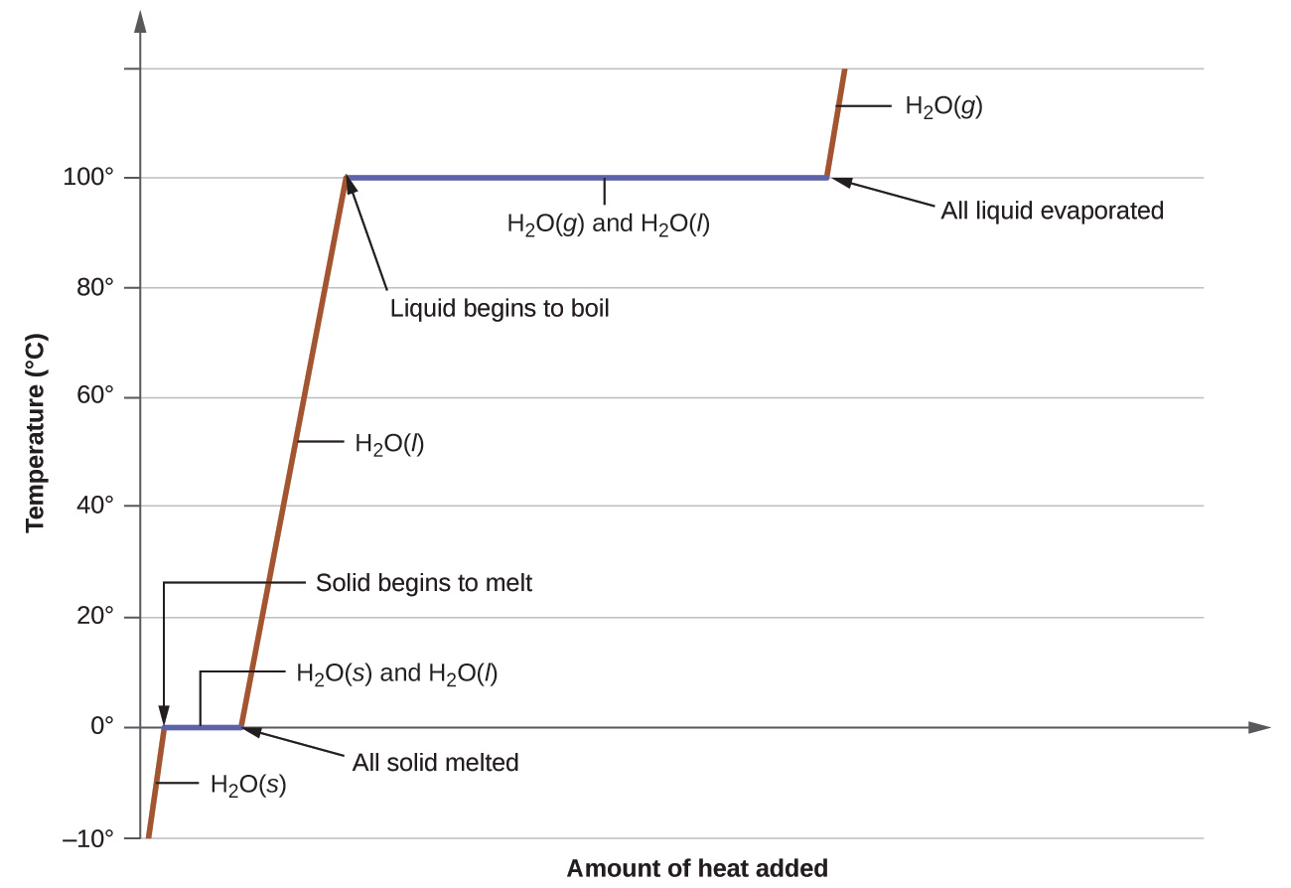
Figure 10.29 A typical heating curve for a substance depicts changes in temperature that result as the substance absorbs increasing amounts of heat. Plateaus in the curve (regions of constant temperature) are exhibited when the substance undergoes phase transitions.

Example 10.10

Total Heat Needed to Change Temperature and Phase for a Substance
How much heat is required to convert 135 g of ice at −15 °C into water vapor at 120 °C?

Solution
The transition described involves the following steps:
- Heat ice from −15 °C to 0 °C
- Melt ice
- Heat water from 0 °C to 100 °C
- Boil water
- Heat steam from 100 °C to 120 °C
The heat needed to change the temperature of a given substance (with no change in phase) is: q = m $×$ c $×$ ΔT (see previous chapter on thermochemistry). The heat needed to induce a given change in phase is given by q = n $×$ ΔH.
Using these equations with the appropriate values for specific heat of ice, water, and steam, and enthalpies of fusion and vaporization, we have:
$q_{\text{total}}={\left(m\text{⋅}c\text{⋅}\text{Δ}T\right)}_{\text{ice}}+n\text{⋅}\text{Δ}H_{\text{fus}}+{\left(m\text{⋅}c\text{⋅}\text{Δ}T\right)}_{\text{water}}+n\text{⋅}\text{Δ}H_{\text{vap}}+{\left(m\text{⋅}c\text{⋅}\text{Δ}T\right)}_{\text{steam}}$
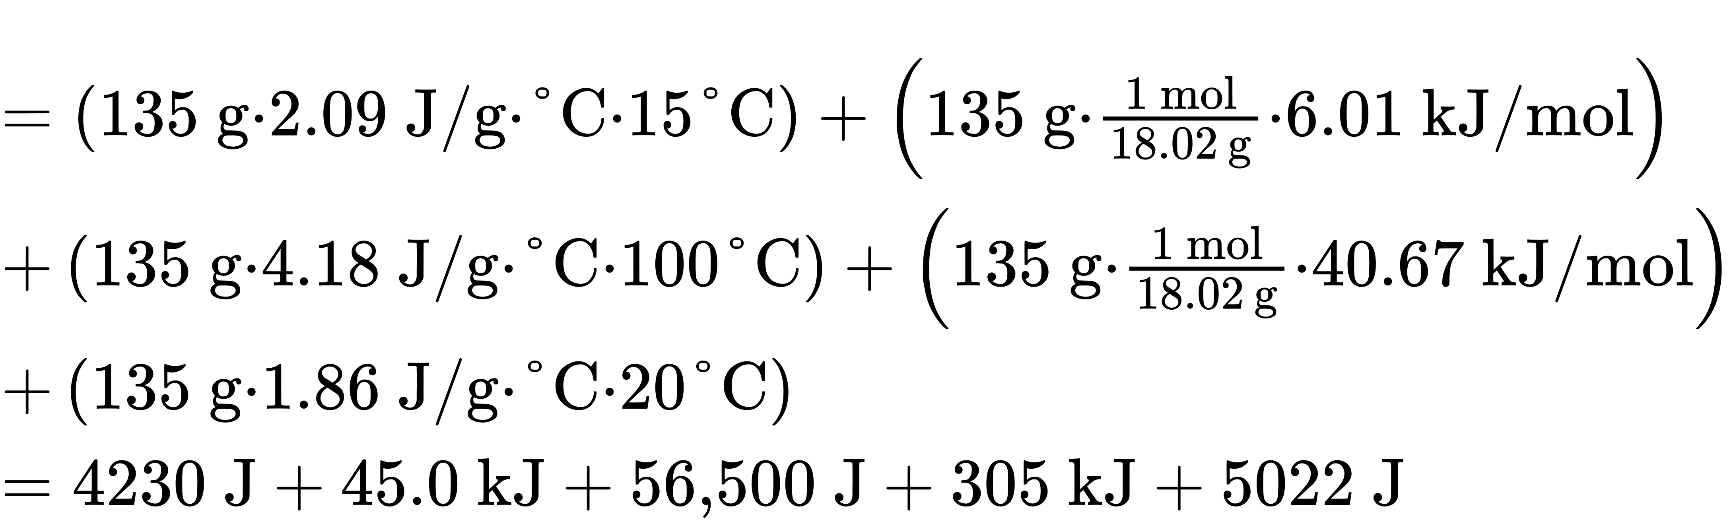
Converting the quantities in J to kJ permits them to be summed, yielding the total heat required:
$=4.23 \text{kJ}+\text{45.0 kJ}+\text{56.5 kJ}+\text{305 kJ}+\text{5.02 kJ}=\text{416 kJ}$
NOTE: The value of ΔH_{vap} at the boiling point of water (40.67 kJ/mol) is used here instead of the value at standard temperature (44.01 kJ/mol).

Check Your Learning
What is the total amount of heat released when 94.0 g water at 80.0 °C cools to form ice at −30.0 °C?

Answer:
68.7 kJ

