17.7 Electrolysis

Learning Objectives
By the end of this section, you will be able to:
- Describe the process of electrolysis
- Compare the operation of electrolytic cells with that of galvanic cells
- Perform stoichiometric calculations for electrolytic processes
Electrochemical cells in which spontaneous redox reactions take place (galvanic cells) have been the topic of discussion so far in this chapter. In these cells, electrical work is done by a redox system on its surroundings as electrons produced by the redox reaction are transferred through an external circuit. This final section of the chapter will address an alternative scenario in which an external circuit does work on a redox system by imposing a voltage sufficient to drive an otherwise nonspontaneous reaction, a process known as electrolysis. A familiar example of electrolysis is recharging a battery, which involves use of an external power source to drive the spontaneous (discharge) cell reaction in the reverse direction, restoring to some extent the composition of the half-cells and the voltage of the battery. Perhaps less familiar is the use of electrolysis in the refinement of metallic ores, the manufacture of commodity chemicals, and the electroplating of metallic coatings on various products (e.g., jewelry, utensils, auto parts). To illustrate the essential concepts of electrolysis, a few specific processes will be considered.

The Electrolysis of Molten Sodium Chloride
Metallic sodium, Na, and chlorine gas, Cl₂, are used in numerous applications, and their industrial production relies on the large-scale electrolysis of molten sodium chloride, NaCl(l). The industrial process typically uses a Downs cell similar to the simplified illustration shown in Figure 17.18. The reactions associated with this process are:
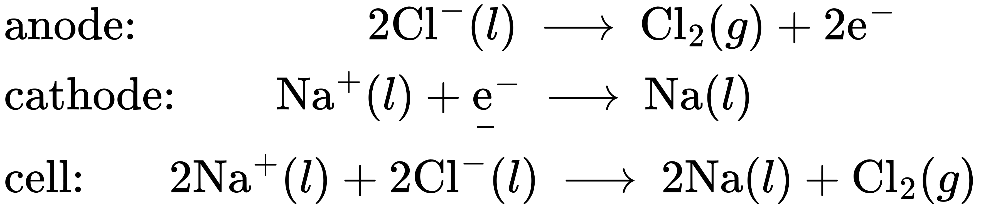
The cell potential for the above process is negative, indicating the reaction as written (decomposition of liquid NaCl) is not spontaneous. To force this reaction, a positive potential of magnitude greater than the negative cell potential must be applied to the cell.
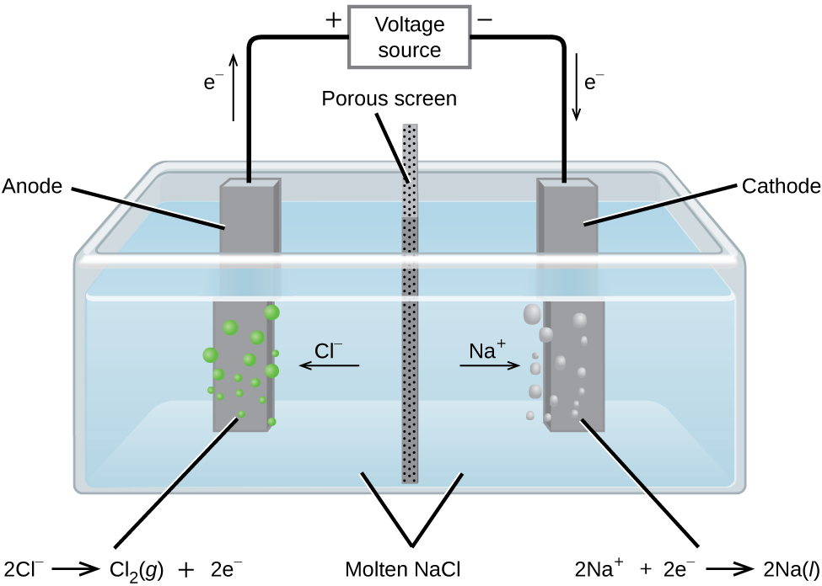
Figure 17.18 Cells of this sort (a cell for the electrolysis of molten sodium chloride) are used in the Downs process for production of sodium and chlorine, and they typically use iron cathodes and carbon anodes.

The Electrolysis of Water
Water may be electrolytically decomposed in a cell similar to the one illustrated in Figure 17.19. To improve electrical conductivity without introducing a different redox species, the hydrogen ion concentration of the water is typically increased by addition of a strong acid. The redox processes associated with this cell are
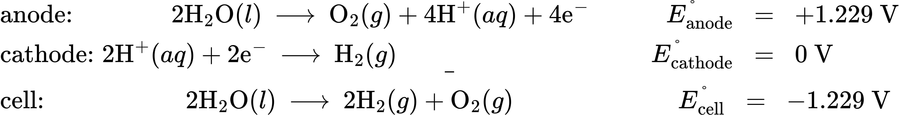
Again, the cell potential as written is negative, indicating a nonspontaneous cell reaction that must be driven by imposing a cell voltage greater than +1.229 V. Keep in mind that standard electrode potentials are used to inform thermodynamic predictions here, though the cell is not operating under standard state conditions. Therefore, at best, calculated cell potentials should be considered ballpark estimates.
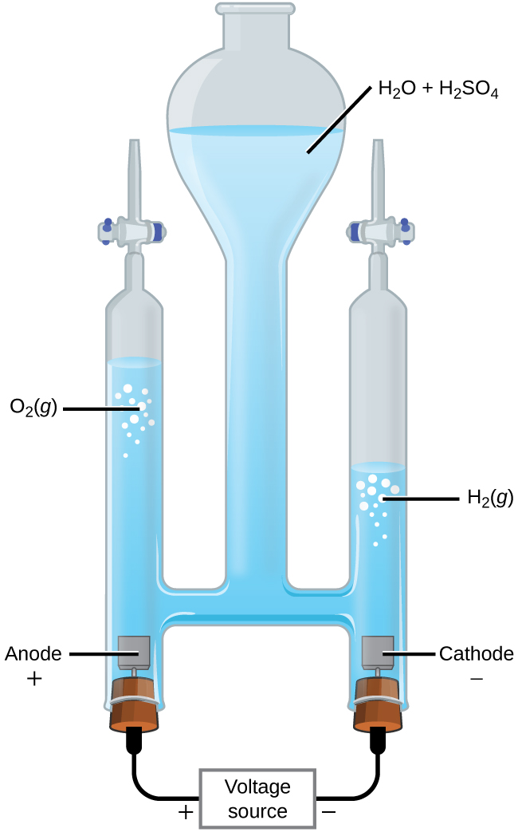
Figure 17.19 The electrolysis of water produces stoichiometric amounts of oxygen gas at the anode and hydrogen at the cathode.

The Electrolysis of Aqueous Sodium Chloride
When aqueous solutions of ionic compounds are electrolyzed, the anode and cathode half-reactions may involve the electrolysis of either water species (H₂O, H⁺, OH⁻) or solute species (the cations and anions of the compound). As an example, the electrolysis of aqueous sodium chloride could involve either of these two anode reactions:
The standard electrode (reduction) potentials of these two half-reactions indicate water may be oxidized at a less negative/more positive potential (–1.229 V) than chloride ion (–1.358 V). Thermodynamics thus predicts that water would be more readily oxidized, though in practice it is observed that both water and chloride ion are oxidized under typical conditions, producing a mixture of oxygen and chlorine gas.
Turning attention to the cathode, the possibilities for reduction are:
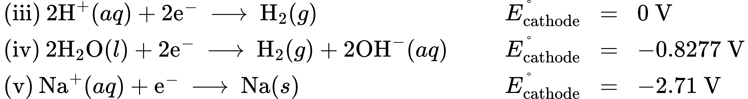
Comparison of these standard half-reaction potentials suggests the reduction of hydrogen ion is thermodynamically favored. However, in a neutral aqueous sodium chloride solution, the concentration of hydrogen ion is far below the standard state value of 1 M (approximately 10⁻⁷ M), and so the observed cathode reaction is actually reduction of water. The net cell reaction in this case is then
$\text{cell: 2}{\text{H}}_{2}\text{O}\left(l\right)+2{\text{Cl}}^{\text{−}}\left(aq\right) → {\text{H}}_{2}\left(g\right)+{\text{Cl}}_{2}\left(g\right)+2{\text{OH}}^{\text{−}}\left(aq\right) E_{\text{cell}}^{​^{∘}}=−2.186 V$
This electrolysis reaction is part of the chlor-alkali process used by industry to produce chlorine and sodium hydroxide (lye).

Chemistry in Everyday Life

Electroplating
An important use for electrolytic cells is in electroplating. Electroplating results in a thin coating of one metal on top of a conducting surface. Reasons for electroplating include making the object more corrosion resistant, strengthening the surface, producing a more attractive finish, or for purifying metal. The metals commonly used in electroplating include cadmium, chromium, copper, gold, nickel, silver, and tin. Common consumer products include silver-plated or gold-plated tableware, chrome-plated automobile parts, and jewelry. The silver plating of eating utensils is used here to illustrate the process. (Figure 17.20).
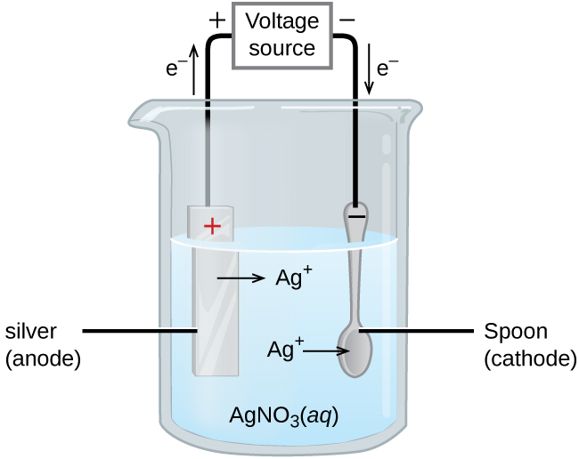
Figure 17.20 This schematic shows an electrolytic cell for silver plating eating utensils.
In the figure, the anode consists of a silver electrode, shown on the left. The cathode is located on the right and is the spoon, which is made from inexpensive metal. Both electrodes are immersed in a solution of silver nitrate. Applying a sufficient potential results in the oxidation of the silver anode
$\text{anode: Ag}\left(s\right) → {\text{Ag}}^{\text{+}}\left(aq\right)+{\text{e}}^{\text{−}}$
and reduction of silver ion at the (spoon) cathode:
${\text{cathode: Ag}}^{\text{+}}\left(aq\right)+{\text{e}}^{\text{−}} → \text{Ag}\left(s\right)$
The net result is the transfer of silver metal from the anode to the cathode. Several experimental factors must be carefully controlled to obtain high-quality silver coatings, including the exact composition of the electrolyte solution, the cell voltage applied, and the rate of the electrolysis reaction (electrical current).

Quantitative Aspects of Electrolysis
Electrical current is defined as the rate of flow for any charged species. Most relevant to this discussion is the flow of electrons. Current is measured in a composite unit called an ampere, defined as one coulomb per second (A = 1 C/s). The charge transferred, Q, by passage of a constant current, I, over a specified time interval, t, is then given by the simple mathematical product
$Q=It$
When electrons are transferred during a redox process, the stoichiometry of the reaction may be used to derive the total amount of (electronic) charge involved. For example, the generic reduction process
${\text{M}}^{\text{n}\text{+}}\left(aq\right)+{\text{ne}}^{\text{−}} → \text{M}\left(s\right)$
involves the transfer of n mole of electrons. The charge transferred is, therefore,
$Q=nF$
where F is Faraday’s constant, the charge in coulombs for one mole of electrons. If the reaction takes place in an electrochemical cell, the current flow is conveniently measured, and it may be used to assist in stoichiometric calculations related to the cell reaction.

Example 17.9

Converting Current to Moles of Electrons
In one process used for electroplating silver, a current of 10.23 A was passed through an electrolytic cell for exactly 1 hour. How many moles of electrons passed through the cell? What mass of silver was deposited at the cathode from the silver nitrate solution?

Solution
Faraday’s constant can be used to convert the charge (Q) into moles of electrons (n). The charge is the current (I) multiplied by the time
$n= \frac{Q}{F} = \frac{\frac{\text{10.23 C}}{\text{s}} × \text{1 hr} × \frac{\text{60 min}}{\text{hr}} × \frac{\text{60 s}}{\text{min}}}{9{\text{6,485 C/mol e}}^{\text{−}}} = \frac{\text{36,830 C}}{\text{96,485 C/mol} {\text{e}}^{\text{−}}} =0.381{\text{7 mol e}}^{\text{−}}$
From the problem, the solution contains AgNO₃, so the reaction at the cathode involves 1 mole of electrons for each mole of silver
${\text{cathode: Ag}}^{\text{+}}\left(aq\right)+{\text{e}}^{\text{−}} → \text{Ag}\left(s\right)$
The atomic mass of silver is 107.9 g/mol, so
$\text{mass Ag}={\text{0.3817 mol e}}^{\text{−}} × \frac{\text{1 mol Ag}}{{\text{1 mol e}}^{\text{−}}} × \frac{\text{107.9 g Ag}}{\text{1 mol Ag}} =4\text{1.19 g Ag}$

Check Your Learning
Aluminum metal can be made from aluminum(III) ions by electrolysis. What is the half-reaction at the cathode? What mass of aluminum metal would be recovered if a current of 25.0 A passed through the solution for 15.0 minutes?

Answer:
${\text{Al}}^{3+}\left(aq\right)+3 {\text{e}}^{\text{−}} → \text{Al}\left(s\right);$ 0.0777 mol Al = 2.10 g Al.

Example 17.10

Time Required for Deposition
In one application, a 0.010-mm layer of chromium must be deposited on a part with a total surface area of 3.3 m² from a solution of containing chromium(III) ions. How long would it take to deposit the layer of chromium if the current was 33.46 A? The density of chromium (metal) is 7.19 g/cm³.

Solution
First, compute the volume of chromium that must be produced (equal to the product of surface area and thickness):
$\text{volume}= \left(\text{0.010 mm} × \frac{\text{1 cm}}{\text{10 mm}}\right) × \left(3.3{ \text{m}}^{2} × \left(\frac{10,000{ \text{cm}}^{2}}{1{ \text{m}}^{2}}\right)\right) ={\text{33 cm}}^{3}$
Use the computed volume and the provided density to calculate the molar amount of chromium required:
$\text{mass}=\text{volume} × \text{density}=33 {\text{cm}}^{3} × \frac{\text{7.19 g}}{{\text{cm}}^{3}} =\text{237 g Cr}$
$\text{mol Cr}=\text{237 g Cr} × \frac{\text{1 mol Cr}}{\text{52.00 g Cr}} =\text{4.56 mol Cr}$
The stoichiometry of the chromium(III) reduction process requires three moles of electrons for each mole of chromium(0) produced, and so the total charge required is:
$Q=\text{4.56 mol Cr} × \frac{3{ \text{mol e}}^{\text{−}}}{\text{1 mol Cr}} × \frac{\text{96485 C}}{{\text{mol e}}^{\text{−}}} =1.32 × {10}^{6} \text{C}$
Finally, if this charge is passed at a rate of 33.46 C/s, the required time is:
$t= \frac{Q}{I} = \frac{1.32 × {10}^{6} \text{C}}{\text{33.46 C/s}} =3.95 × {10}^{4} \text{s}=\text{11.0 hr}$

Check Your Learning
What mass of zinc is required to galvanize the top of a 3.00 m $×$ 5.50 m sheet of iron to a thickness of 0.100 mm of zinc? If the zinc comes from a solution of Zn(NO₃)₂ and the current is 25.5 A, how long will it take to galvanize the top of the iron? The density of zinc is 7.140 g/cm³.

Answer:
11.8 kg Zn requires 382 hours.

