6.3 Development of Quantum Theory

Learning Objectives
By the end of this section, you will be able to:
- Extend the concept of wave–particle duality that was observed in electromagnetic radiation to matter as well
- Understand the general idea of the quantum mechanical description of electrons in an atom, and that it uses the notion of three-dimensional wave functions, or orbitals, that define the distribution of probability to find an electron in a particular part of space
- List and describe traits of the four quantum numbers that form the basis for completely specifying the state of an electron in an atom
Bohr’s model explained the experimental data for the hydrogen atom and was widely accepted, but it also raised many questions. Why did electrons orbit at only fixed distances defined by a single quantum number n = 1, 2, 3, and so on, but never in between? Why did the model work so well describing hydrogen and one-electron ions, but could not correctly predict the emission spectrum for helium or any larger atoms? To answer these questions, scientists needed to completely revise the way they thought about matter.

Behavior in the Microscopic World
We know how matter behaves in the macroscopic world—objects that are large enough to be seen by the naked eye follow the rules of classical physics. A billiard ball moving on a table will behave like a particle: It will continue in a straight line unless it collides with another ball or the table cushion, or is acted on by some other force (such as friction). The ball has a well-defined position and velocity (or a well-defined momentum, p = mv, defined by mass m and velocity v) at any given moment. In other words, the ball is moving in a classical trajectory. This is the typical behavior of a classical object.
When waves interact with each other, they show interference patterns that are not displayed by macroscopic particles such as the billiard ball. For example, interacting waves on the surface of water can produce interference patterns similar to those shown on Figure 6.16. This is a case of wave behavior on the macroscopic scale, and it is clear that particles and waves are very different phenomena in the macroscopic realm.

Figure 6.16 An interference pattern on the water surface is formed by interacting waves. The waves are caused by reflection of water from the rocks. (credit: modification of work by Sukanto Debnath)
As technological improvements allowed scientists to probe the microscopic world in greater detail, it became increasingly clear by the 1920s that very small pieces of matter follow a different set of rules from those we observe for large objects. The unquestionable separation of waves and particles was no longer the case for the microscopic world.
One of the first people to pay attention to the special behavior of the microscopic world was Louis de Broglie. He asked the question: If electromagnetic radiation can have particle-like character, can electrons and other submicroscopic particles exhibit wavelike character? In his 1925 doctoral dissertation, de Broglie extended the wave–particle duality of light that Einstein used to resolve the photoelectric-effect paradox to material particles. He predicted that a particle with mass m and velocity v (that is, with linear momentum p) should also exhibit the behavior of a wave with a wavelength value λ, given by this expression in which h is the familiar Planck’s constant:
$λ= \frac{h}{mv} = \frac{h}{p}$
This is called the de Broglie wavelength. Unlike the other values of λ discussed in this chapter, the de Broglie wavelength is a characteristic of particles and other bodies, not electromagnetic radiation (note that this equation involves velocity [v, m/s], not frequency [ν, Hz]. Although these two symbols appear nearly identical, they mean very different things). Where Bohr had postulated the electron as being a particle orbiting the nucleus in quantized orbits, de Broglie argued that Bohr’s assumption of quantization can be explained if the electron is considered not as a particle, but rather as a circular standing wave such that only an integer number of wavelengths could fit exactly within the orbit (Figure 6.17).
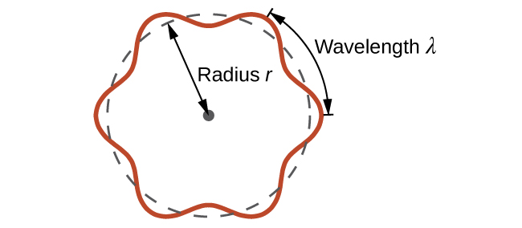
Figure 6.17 If an electron is viewed as a wave circling around the nucleus, an integer number of wavelengths must fit into the orbit for this standing wave behavior to be possible.
For a circular orbit of radius r, the circumference is 2πr, and so de Broglie’s condition is:
$2πr=nλ, n=1, 2, 3, …$
Shortly after de Broglie proposed the wave nature of matter, two scientists at Bell Laboratories, C. J. Davisson and L. H. Germer, demonstrated experimentally that electrons can exhibit wavelike behavior by showing an interference pattern for electrons travelling through a regular atomic pattern in a crystal. The regularly spaced atomic layers served as slits, as used in other interference experiments. Since the spacing between the layers serving as slits needs to be similar in size to the wavelength of the tested wave for an interference pattern to form, Davisson and Germer used a crystalline nickel target for their “slits,” since the spacing of the atoms within the lattice was approximately the same as the de Broglie wavelengths of the electrons that they used. Figure 6.18 shows an interference pattern. It is strikingly similar to the interference patterns for light shown in Electromagnetic Energy for light passing through two closely spaced, narrow slits. The wave–particle duality of matter can be seen in Figure 6.18 by observing what happens if electron collisions are recorded over a long period of time. Initially, when only a few electrons have been recorded, they show clear particle-like behavior, having arrived in small localized packets that appear to be random. As more and more electrons arrived and were recorded, a clear interference pattern that is the hallmark of wavelike behavior emerged. Thus, it appears that while electrons are small localized particles, their motion does not follow the equations of motion implied by classical mechanics, but instead it is governed by some type of a wave equation. Thus the wave–particle duality first observed with photons is actually a fundamental behavior intrinsic to all quantum particles.
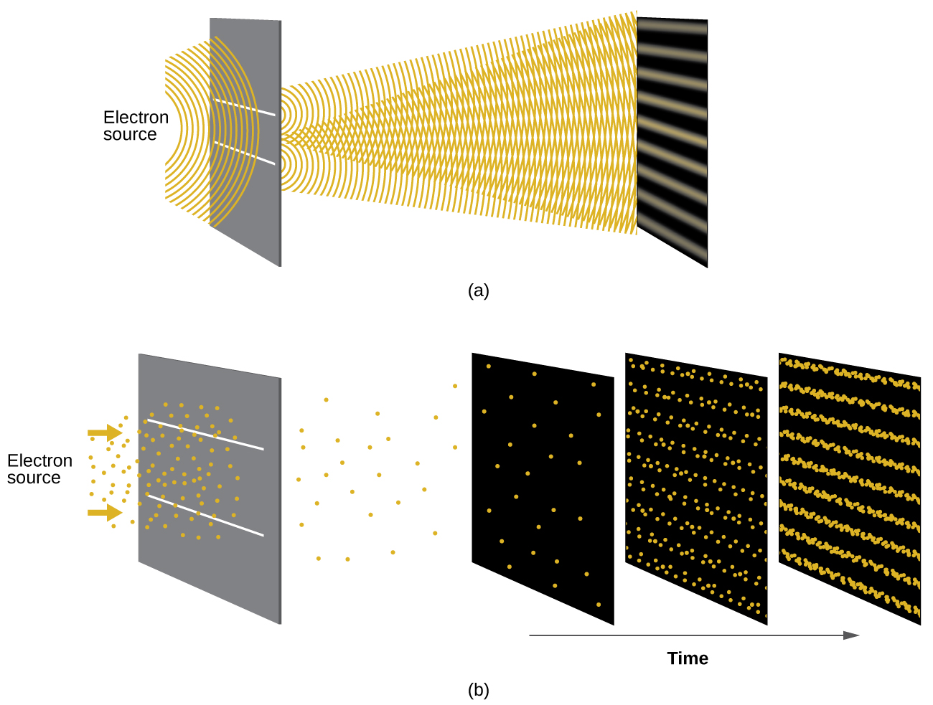
Figure 6.18 (a) The interference pattern for electrons passing through very closely spaced slits demonstrates that quantum particles such as electrons can exhibit wavelike behavior. (b) The experimental results illustrated here demonstrate the wave–particle duality in electrons.

Link to Learning
View the Dr. Quantum – Double Slit Experiment cartoon for an easy-to-understand description of wave–particle duality and the associated experiments.

Example 6.6

Calculating the Wavelength of a Particle
If an electron travels at a velocity of 1.000 $×$ 10⁷ m s^{–1} and has a mass of 9.109 $×$ 10^{–28} g, what is its wavelength?

Solution
We can use de Broglie’s equation to solve this problem, but we first must do a unit conversion of Planck’s constant. You learned earlier that 1 J = 1 kg m²/s². Thus, we can write h = 6.626 $×$ 10^{–34} J s as 6.626 $×$ 10^{–34} kg m²/s.
$λ= \frac{h}{mv}$
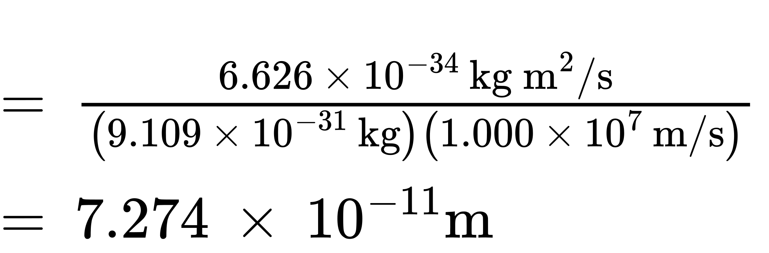
This is a small value, but it is significantly larger than the size of an electron in the classical (particle) view. This size is the same order of magnitude as the size of an atom. This means that electron wavelike behavior is going to be noticeable in an atom.

Check Your Learning
Calculate the wavelength of a softball with a mass of 100 g traveling at a velocity of 35 m s^{–1}, assuming that it can be modeled as a single particle.

Answer:
1.9 $×$ 10^{–34} m.
We never think of a thrown softball having a wavelength, since this wavelength is so small it is impossible for our senses or any known instrument to detect.
Werner Heisenberg considered the limits of how accurately we can measure properties of an electron or other microscopic particles. He determined that there is a fundamental limit to how accurately one can measure both a particle’s position and its momentum simultaneously. The more accurately we measure the momentum of a particle, the less accurately we can determine its position at that time, and vice versa. This is summed up in what we now call the Heisenberg uncertainty principle: It is fundamentally impossible to determine simultaneously and exactly both the momentum and the position of a particle. For a particle of mass m moving with velocity v_{x} in the x direction (or equivalently with momentum p_{x}), the product of the uncertainty in the position, Δx, and the uncertainty in the momentum, Δp_{x} , must be greater than or equal to $\frac{ℏ}{2}$ (where $ℏ = \frac{h}{2π},$ the value of Planck’s constant divided by 2π).
$\text{Δ}x × \text{Δ}p_{x}=\left(\text{Δ}x\right)\left(m\text{Δ}v\right)≥ \frac{ℏ}{2}$
This equation allows us to calculate the limit to how precisely we can know both the simultaneous position of an object and its momentum. For example, if we improve our measurement of an electron’s position so that the uncertainty in the position (Δx) has a value of, say, 1 pm (10^{–12} m, about 1% of the diameter of a hydrogen atom), then our determination of its momentum must have an uncertainty with a value of at least
$\left[\text{Δ}p=m\text{Δ}v= \frac{ħ}{\left(2\text{Δ}x\right)} \right]= \frac{\left(1.055 × {10}^{−34}{ \text{kg m}}^{\text{2}}\text{/s}\right)}{\left(2 × 1 × {10}^{−12} \text{m}\right)} = 5 × {10}^{−23} \text{kg m/s}.$
The value of ħ is not large, so the uncertainty in the position or momentum of a macroscopic object like a baseball is too insignificant to observe. However, the mass of a microscopic object such as an electron is small enough that the uncertainty can be large and significant.
It should be noted that Heisenberg’s uncertainty principle is not just limited to uncertainties in position and momentum, but it also links other dynamical variables. For example, when an atom absorbs a photon and makes a transition from one energy state to another, the uncertainty in the energy and the uncertainty in the time required for the transition are similarly related, as ΔE Δt ≥ $\frac{ℏ}{2}.$
Heisenberg’s principle imposes ultimate limits on what is knowable in science. The uncertainty principle can be shown to be a consequence of wave–particle duality, which lies at the heart of what distinguishes modern quantum theory from classical mechanics.

Link to Learning
Read this article that describes a recent macroscopic demonstration of the uncertainty principle applied to microscopic objects.

The Quantum–Mechanical Model of an Atom
Shortly after de Broglie published his ideas that the electron in a hydrogen atom could be better thought of as being a circular standing wave instead of a particle moving in quantized circular orbits, Erwin Schrödinger extended de Broglie’s work by deriving what is today known as the Schrödinger equation. When Schrödinger applied his equation to hydrogen-like atoms, he was able to reproduce Bohr’s expression for the energy and, thus, the Rydberg formula governing hydrogen spectra. Schrödinger described electrons as three-dimensional stationary waves, or wavefunctions, represented by the Greek letter psi, ψ. A few years later, Max Born proposed an interpretation of the wavefunction ψ that is still accepted today: Electrons are still particles, and so the waves represented by ψ are not physical waves but, instead, are complex probability amplitudes. The square of the magnitude of a wavefunction ${\text{∣}ψ\text{∣}}^{2}$ describes the probability of the quantum particle being present near a certain location in space. This means that wavefunctions can be used to determine the distribution of the electron’s density with respect to the nucleus in an atom. In the most general form, the Schrödinger equation can be written as:
$\hat{H}ψ=Eψ$
$\hat{H}$ is the Hamiltonian operator, a set of mathematical operations representing the total energy of the quantum particle (such as an electron in an atom), ψ is the wavefunction of this particle that can be used to find the special distribution of the probability of finding the particle, and $E$ is the actual value of the total energy of the particle.
Schrödinger’s work, as well as that of Heisenberg and many other scientists following in their footsteps, is generally referred to as quantum mechanics.

Link to Learning
You may also have heard of Schrödinger because of his famous thought experiment. This story explains the concepts of superposition and entanglement as related to a cat in a box with poison.

Understanding Quantum Theory of Electrons in Atoms
The goal of this section is to understand the electron orbitals (location of electrons in atoms), their different energies, and other properties. The use of quantum theory provides the best understanding to these topics. This knowledge is a precursor to chemical bonding.
As was described previously, electrons in atoms can exist only on discrete energy levels but not between them. It is said that the energy of an electron in an atom is quantized, that is, it can be equal only to certain specific values and can jump from one energy level to another but not transition smoothly or stay between these levels.
The energy levels are labeled with an n value, where n = 1, 2, 3, …. Generally speaking, the energy of an electron in an atom is greater for greater values of n. This number, n, is referred to as the principal quantum number. The principal quantum number defines the location of the energy level. It is essentially the same concept as the n in the Bohr atom description. Another name for the principal quantum number is the shell number. The shells of an atom can be thought of concentric circles radiating out from the nucleus. The electrons that belong to a specific shell are most likely to be found within the corresponding circular area. The further we proceed from the nucleus, the higher the shell number, and so the higher the energy level (Figure 6.19). The positively charged protons in the nucleus stabilize the electronic orbitals by electrostatic attraction between the positive charges of the protons and the negative charges of the electrons. So the further away the electron is from the nucleus, the greater the energy it has.
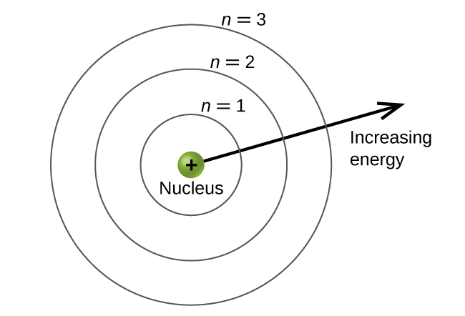
Figure 6.19 Different shells are numbered by principal quantum numbers.
This quantum mechanical model for where electrons reside in an atom can be used to look at electronic transitions, the events when an electron moves from one energy level to another. If the transition is to a higher energy level, energy is absorbed, and the energy change has a positive value. To obtain the amount of energy necessary for the transition to a higher energy level, a photon is absorbed by the atom. A transition to a lower energy level involves a release of energy, and the energy change is negative. This process is accompanied by emission of a photon by the atom. The following equation summarizes these relationships and is based on the hydrogen atom:
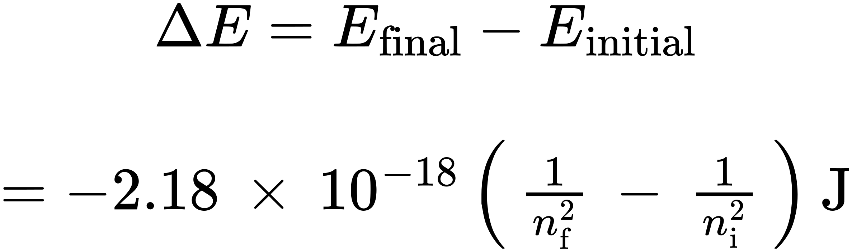
The values n_{f} and n_{i} are the final and initial energy states of the electron. Example 6.5 in the previous section of the chapter demonstrates calculations of such energy changes.
The principal quantum number is one of three quantum numbers used to characterize an orbital. An atomic orbital is a general region in an atom within which an electron is most probable to reside. The quantum mechanical model specifies the probability of finding an electron in the three-dimensional space around the nucleus and is based on solutions of the Schrödinger equation. In addition, the principal quantum number defines the energy of an electron in a hydrogen or hydrogen-like atom or an ion (an atom or an ion with only one electron) and the general region in which discrete energy levels of electrons in a multi-electron atoms and ions are located.
Another quantum number is l, the secondary (angular momentum) quantum number. It is an integer that may take the values, l = 0, 1, 2, …, n – 1. This means that an orbital with n = 1 can have only one value of l, l = 0, whereas n = 2 permits l = 0 and l = 1, and so on. Whereas the principal quantum number, n, defines the general size and energy of the orbital, the secondary quantum number l specifies the shape of the orbital. Orbitals with the same value of l define a subshell.
Orbitals with l = 0 are called s orbitals and they make up the s subshells. The value l = 1 corresponds to the p orbitals. For a given n, p orbitals constitute a p subshell (e.g., 3p if n = 3). The orbitals with l = 2 are called the d orbitals, followed by the f-, g-, and h-orbitals for l = 3, 4, and 5.
There are certain distances from the nucleus at which the probability density of finding an electron located at a particular orbital is zero. In other words, the value of the wavefunction ψ is zero at this distance for this orbital. Such a value of radius r is called a radial node. The number of radial nodes in an orbital is n – l – 1.
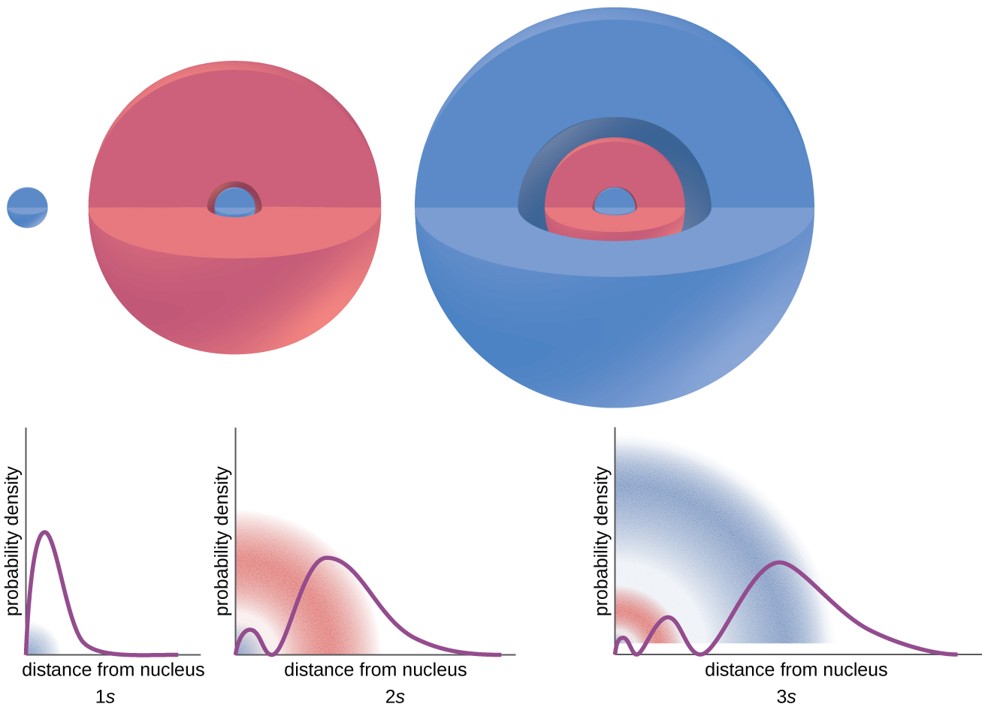
Figure 6.20 The graphs show the probability (y axis) of finding an electron for the 1s, 2s, 3s orbitals as a function of distance from the nucleus.
Consider the examples in Figure 6.20. The orbitals depicted are of the s type, thus l = 0 for all of them. It can be seen from the graphs of the probability densities that there are 1 – 0 – 1 = 0 places where the density is zero (nodes) for 1s (n = 1), 2 – 0 – 1 = 1 node for 2s, and 3 – 0 – 1 = 2 nodes for the 3s orbitals.
The s subshell electron density distribution is spherical and the p subshell has a dumbbell shape. The d and f orbitals are more complex. These shapes represent the three-dimensional regions within which the electron is likely to be found.
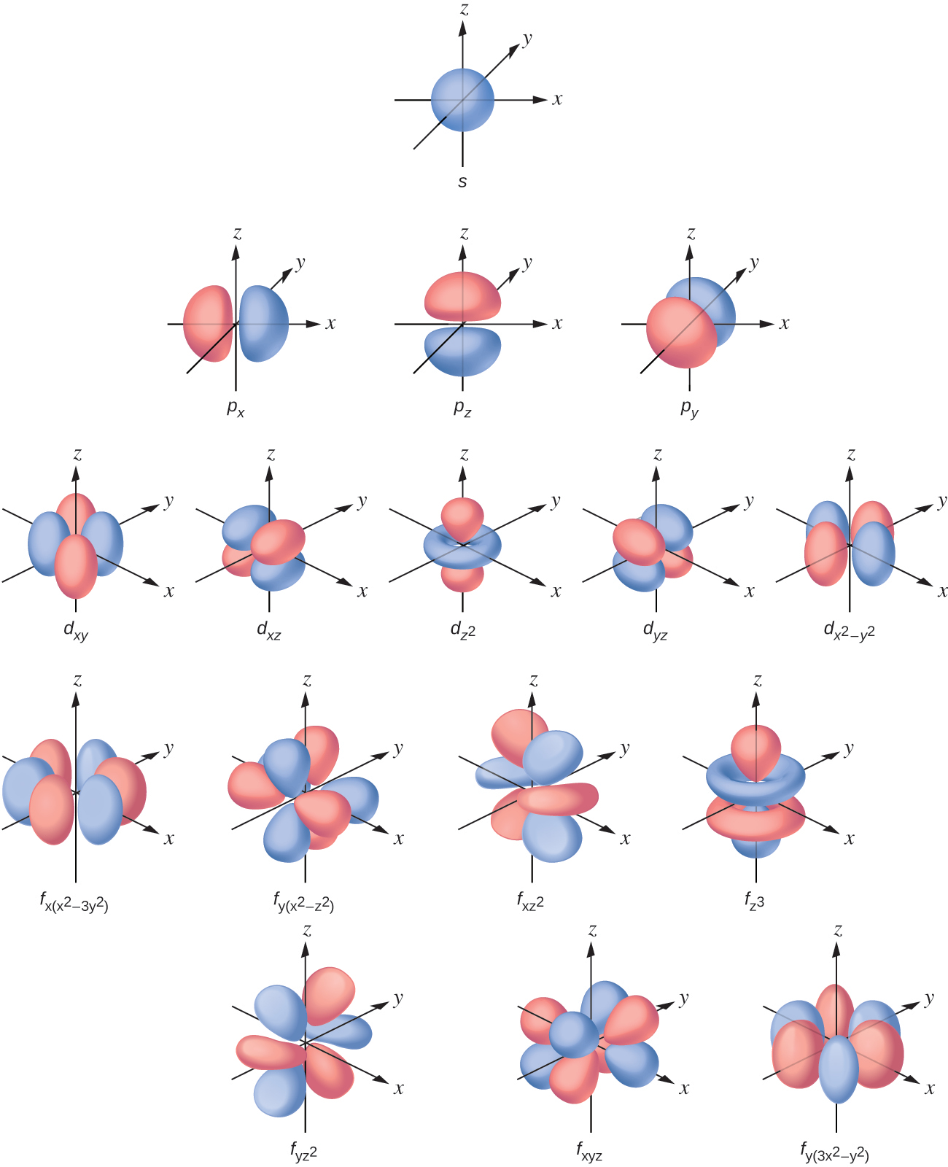
Figure 6.21 Shapes of s, p, d, and f orbitals.
The magnetic quantum number, m_{l}, specifies the relative spatial orientation of a particular orbital. Generally speaking, m_{l} can be equal to –l, –(l – 1), …, 0, …, (l – 1), l. The total number of possible orbitals with the same value of l (that is, in the same subshell) is 2l + 1. Thus, there is one s-orbital in an s subshell (l = 0), there are three p-orbitals in a p subshell (l = 1), five d-orbitals in a d subshell (l = 2), seven f-orbitals in an f subshell (l = 3), and so forth. The principal quantum number defines the general value of the electronic energy. The angular momentum quantum number determines the shape of the orbital. And the magnetic quantum number specifies orientation of the orbital in space, as can be seen in Figure 6.21.
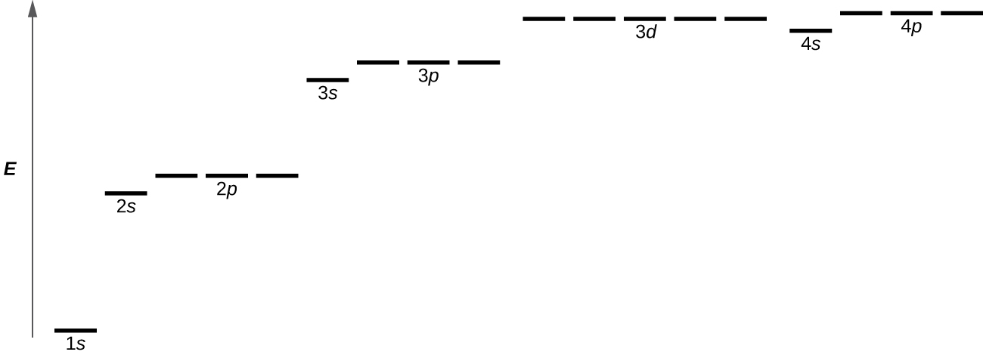
Figure 6.22 The chart shows the energies of electron orbitals in a multi-electron atom.
Figure 6.22 illustrates the energy levels for various orbitals. The number before the orbital name (such as 2s, 3p, and so forth) stands for the principal quantum number, n. The letter in the orbital name defines the subshell with a specific angular momentum quantum number l = 0 for s orbitals, 1 for p orbitals, 2 for d orbitals. Finally, there are more than one possible orbitals for l ≥ 1, each corresponding to a specific value of m_{l}. In the case of a hydrogen atom or a one-electron ion (such as He⁺, Li²⁺, and so on), energies of all the orbitals with the same n are the same. This is called a degeneracy, and the energy levels for the same principal quantum number, n, are called degenerate orbitals. However, in atoms with more than one electron, this degeneracy is eliminated by the electron–electron interactions, and orbitals that belong to different subshells have different energies, as shown on Figure 6.22. Orbitals within the same subshell are still degenerate and have the same energy.
While the three quantum numbers discussed in the previous paragraphs work well for describing electron orbitals, some experiments showed that they were not sufficient to explain all observed results. It was demonstrated in the 1920s that when hydrogen-line spectra are examined at extremely high resolution, some lines are actually not single peaks but, rather, pairs of closely spaced lines. This is the so-called fine structure of the spectrum, and it implies that there are additional small differences in energies of electrons even when they are located in the same orbital. These observations led Samuel Goudsmit and George Uhlenbeck to propose that electrons have a fourth quantum number. They called this the spin quantum number, or m_{s}.
The other three quantum numbers, n, l, and m_{l}, are properties of specific atomic orbitals that also define in what part of the space an electron is most likely to be located. Orbitals are a result of solving the Schrödinger equation for electrons in atoms. The electron spin is a different kind of property. It is a completely quantum phenomenon with no analogues in the classical realm. In addition, it cannot be derived from solving the Schrödinger equation and is not related to the normal spatial coordinates (such as the Cartesian x, y, and z). Electron spin describes an intrinsic electron "rotation" or "spinning." Each electron acts as a tiny magnet or a tiny rotating object with an angular momentum, or as a loop with an electric current, even though this rotation or current cannot be observed in terms of spatial coordinates.
The magnitude of the overall electron spin can only have one value, and an electron can only “spin” in one of two quantized states. One is termed the α state, with the z component of the spin being in the positive direction of the z axis. This corresponds to the spin quantum number $m_{s}= \frac{1}{2}.$ The other is called the β state, with the z component of the spin being negative and $m_{s}=−\frac{1}{2}.$ Any electron, regardless of the atomic orbital it is located in, can only have one of those two values of the spin quantum number. The energies of electrons having $m_{s}=−\frac{1}{2}$ and $m_{s}= \frac{1}{2}$ are different if an external magnetic field is applied.
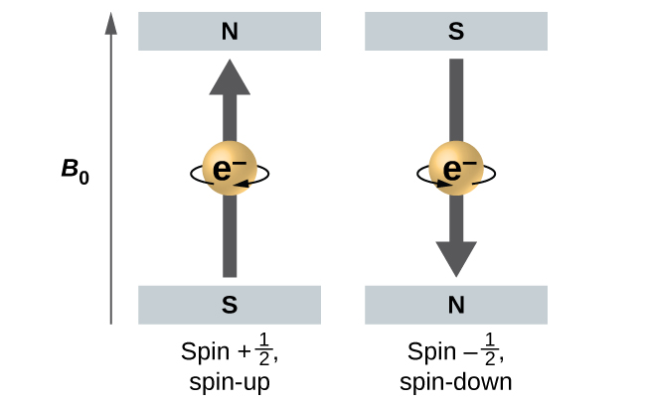
Figure 6.23 Electrons with spin values $±\frac{1}{2}$ in an external magnetic field.
Figure 6.23 illustrates this phenomenon. An electron acts like a tiny magnet. Its moment is directed up (in the positive direction of the z axis) for the $\frac{1}{2}$ spin quantum number and down (in the negative z direction) for the spin quantum number of $− \frac{1}{2}.$ A magnet has a lower energy if its magnetic moment is aligned with the external magnetic field (the left electron on Figure 6.23) and a higher energy for the magnetic moment being opposite to the applied field. This is why an electron with $m_{s}= \frac{1}{2}$ has a slightly lower energy in an external field in the positive z direction, and an electron with $m_{s}=−\frac{1}{2}$ has a slightly higher energy in the same field. This is true even for an electron occupying the same orbital in an atom. A spectral line corresponding to a transition for electrons from the same orbital but with different spin quantum numbers has two possible values of energy; thus, the line in the spectrum will show a fine structure splitting.

The Pauli Exclusion Principle
An electron in an atom is completely described by four quantum numbers: n, l, m_{l}, and m_{s}. The first three quantum numbers define the orbital and the fourth quantum number describes the intrinsic electron property called spin. An Austrian physicist Wolfgang Pauli formulated a general principle that gives the last piece of information that we need to understand the general behavior of electrons in atoms. The Pauli exclusion principle can be formulated as follows: No two electrons in the same atom can have exactly the same set of all the four quantum numbers. What this means is that two electrons can share the same orbital (the same set of the quantum numbers n, l, and m_{l}) only if their spin quantum numbers m_{s} have different values. Since the spin quantum number can only have two values $\left(± \frac{1}{2} \right),$ no more than two electrons can occupy the same orbital (and if two electrons are located in the same orbital, they must have opposite spins). Therefore, any atomic orbital can be populated by only zero, one, or two electrons.
The properties and meaning of the quantum numbers of electrons in atoms are briefly summarized in Table 6.1.
Quantum Numbers, Their Properties, and Significance
Name | Symbol | Allowed values | Physical meaning
principal quantum number | n | 1, 2, 3, 4, …. | shell, the general region for the value of energy for an electron on the orbital
angular momentum or azimuthal quantum number | l | 0 ≤ l ≤ n – 1 | subshell, the shape of the orbital
magnetic quantum number | m_{l} | – l ≤ m_{l} ≤ l | orientation of the orbital
spin quantum number | m_{s} | $\frac{1}{2} , −\frac{1}{2}$ | direction of the intrinsic quantum “spinning” of the electron
Table 6.1

Example 6.7

Working with Shells and Subshells
Indicate the number of subshells, the number of orbitals in each subshell, and the values of l and m_{l} for the orbitals in the n = 4 shell of an atom.

Solution
For n = 4, l can have values of 0, 1, 2, and 3. Thus, s, p, d, and f subshells are found in the n = 4 shell of an atom. For l = 0 (the s subshell), m_{l} can only be 0. Thus, there is only one 4s orbital. For l = 1 (p-type orbitals), m can have values of –1, 0, +1, so we find three 4p orbitals. For l = 2 (d-type orbitals), m_{l} can have values of –2, –1, 0, +1, +2, so we have five 4d orbitals. When l = 3 (f-type orbitals), m_{l} can have values of –3, –2, –1, 0, +1, +2, +3, and we can have seven 4f orbitals. Thus, we find a total of 16 orbitals in the n = 4 shell of an atom.

Check Your Learning
Identify the subshell in which electrons with the following quantum numbers are found: (a) n = 3, l = 1; (b) n = 5, l = 3; (c) n = 2, l = 0.

Answer:
(a) 3p (b) 5f (c) 2s

Example 6.8

Maximum Number of Electrons
Calculate the maximum number of electrons that can occupy a shell with (a) n = 2, (b) n = 5, and (c) n as a variable. Note you are only looking at the orbitals with the specified n value, not those at lower energies.

Solution
(a) When n = 2, there are four orbitals (a single 2s orbital, and three orbitals labeled 2p). These four orbitals can contain eight electrons.
(b) When n = 5, there are five subshells of orbitals that we need to sum:
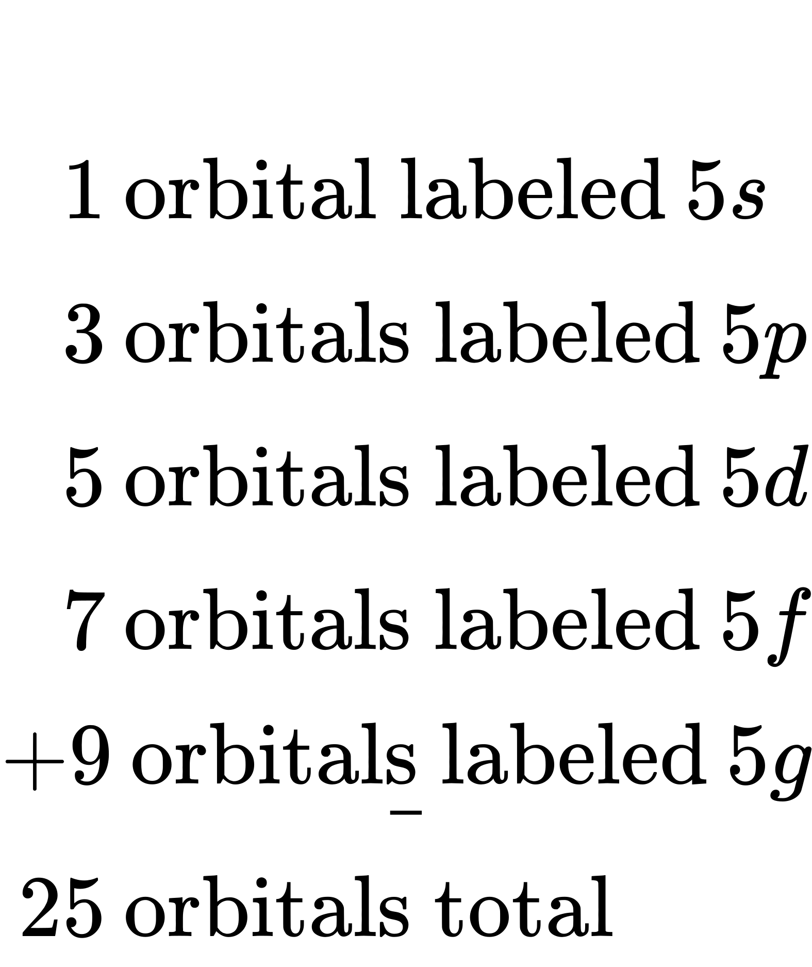
Again, each orbital holds two electrons, so 50 electrons can fit in this shell.
(c) The number of orbitals in any shell n will equal n². There can be up to two electrons in each orbital, so the maximum number of electrons will be 2 $×$ n².

Check Your Learning
If a shell contains a maximum of 32 electrons, what is the principal quantum number, n?

Answer:
n = 4

Example 6.9

Working with Quantum Numbers
Complete the following table for atomic orbitals:
Orbital | n | l | m_{l} degeneracy | Radial nodes (no.)
4f
 | 4 | 1
 | 7 |  | 7 | 3
5d

Solution
The table can be completed using the following rules:
- The orbital designation is nl, where l = 0, 1, 2, 3, 4, 5, … is mapped to the letter sequence s, p, d, f, g, h, …,
- The m_{l} degeneracy is the number of orbitals within an l subshell, and so is 2l + 1 (there is one s orbital, three p orbitals, five d orbitals, seven f orbitals, and so forth).
- The number of radial nodes is equal to n – l – 1.
Orbital | n | l | m_{l} degeneracy | Radial nodes (no.)
4f | 4 | 3 | 7 | 0
4p | 4 | 1 | 3 | 2
7f | 7 | 3 | 7 | 3
5d | 5 | 2 | 5 | 2

Check Your Learning
How many orbitals have l = 2 and n = 3?

Answer:
The five degenerate 3d orbitals

