Chapter 20
1.
There are several sets of answers; one is:
(a) C₅H₁₂
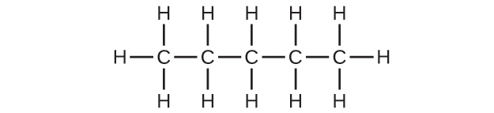
(b) C₅H₁₀
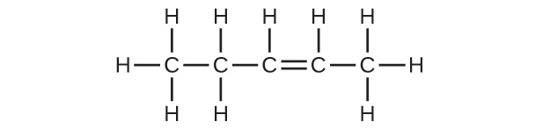
(c) C₅H₈
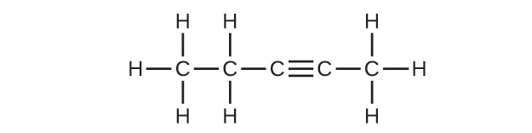
3.
Both reactions result in bromine being incorporated into the structure of the product. The difference is the way in which that incorporation takes place. In the saturated hydrocarbon, an existing C–H bond is broken, and a bond between the C and the Br can then be formed. In the unsaturated hydrocarbon, the only bond broken in the hydrocarbon is the π bond whose electrons can be used to form a bond to one of the bromine atoms in Br₂ (the electrons from the Br–Br bond form the other C–Br bond on the other carbon that was part of the π bond in the starting unsaturated hydrocarbon).
5.
Unbranched alkanes have free rotation about the C–C bonds, yielding all orientations of the substituents about these bonds equivalent, interchangeable by rotation. In the unbranched alkenes, the inability to rotate about the $\text{C}=\text{C}$ bond results in fixed (unchanging) substituent orientations, thus permitting different isomers. Since these concepts pertain to phenomena at the molecular level, this explanation involves the microscopic domain.
7.
They are the same compound because each is a saturated hydrocarbon containing an unbranched chain of six carbon atoms.
9.
(a) C₆H₁₄
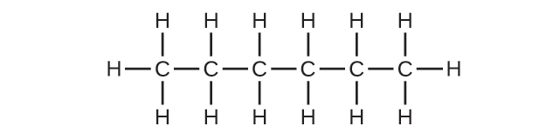
(b) C₆H₁₄
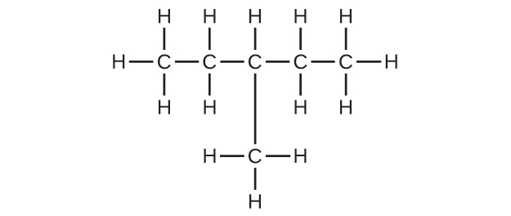
(c) C₆H₁₂
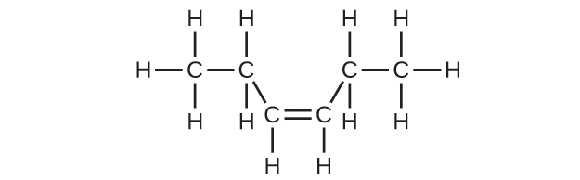
(d) C₆H₁₂
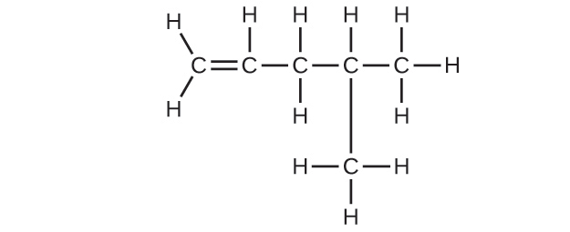
(e) C₆H₁₀
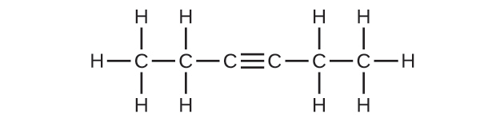
(f) C₆H₁₀
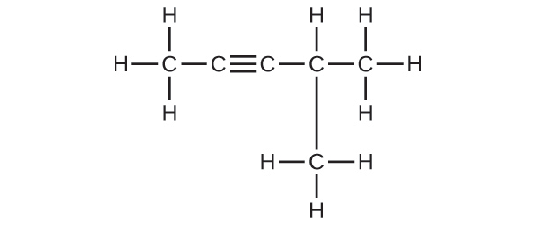
11.
(a) 2,2-dibromobutane; (b) 2-chloro-2-methylpropane; (c) 2-methylbutane; (d) 1-butyne; (e) 4-fluoro-4-methyl-1-octyne; (f) trans-1-chloropropene; (g) 4-methyl-1-pentene
13.
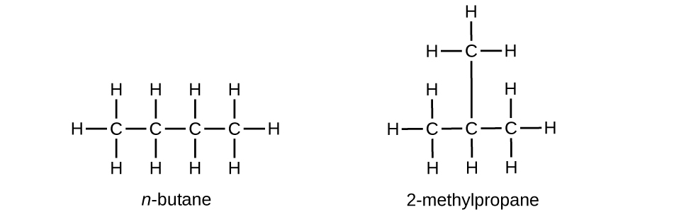
15.
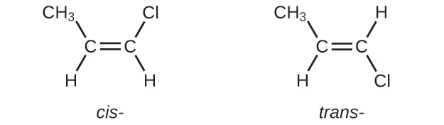
17.
(a) 2,2,4-trimethylpentane; (b) 2,2,3-trimethylpentane, 2,3,4-trimethylpentane, and 2,3,3-trimethylpentane:
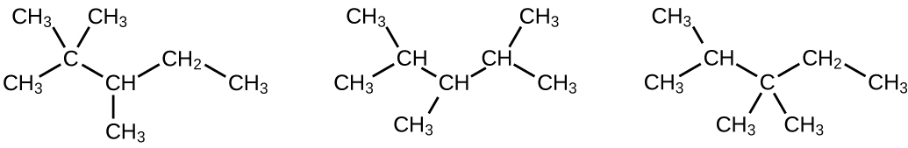
19.
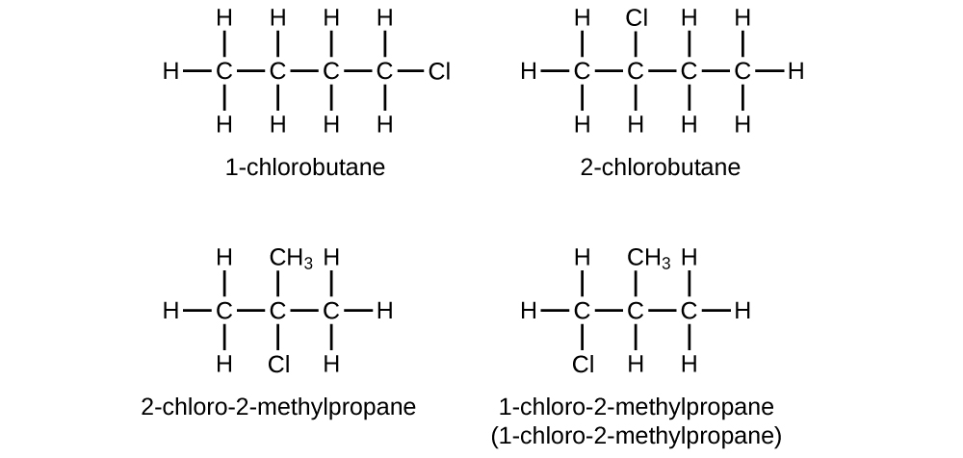
21.
In the following, the carbon backbone and the appropriate number of hydrogen atoms are shown in condensed form:
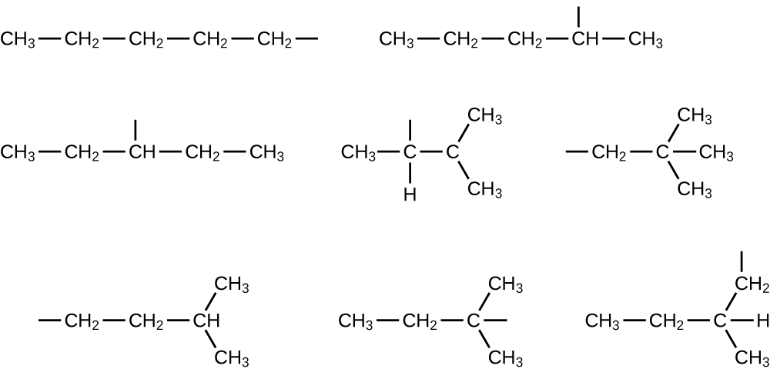
23.
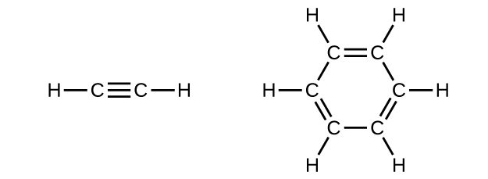
In acetylene, the bonding uses sp hybrids on carbon atoms and s orbitals on hydrogen atoms. In benzene, the carbon atoms are sp² hybridized.
25.
(a) $\text{CH}≡{\text{CCH}}_{2}{\text{CH}}_{3}+2{\text{I}}_{2} → {\text{CHI}}_{2}{\text{CI}}_{2}{\text{CH}}_{2}{\text{CH}}_{3}$
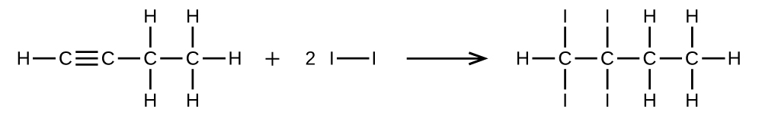
(b) ${\text{CH}}_{3}{\text{CH}}_{2}{\text{CH}}_{2}{\text{CH}}_{2}{\text{CH}}_{3}+8{\text{O}}_{2} → 5{\text{CO}}_{2}+{\text{6H}}_{2}\text{O}$
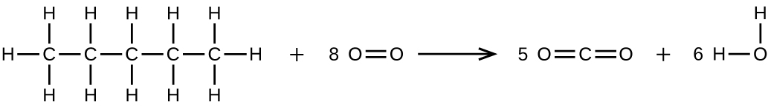
27.
74.5 g
29.
9.328 $×$ 10² kg
31.
(a) ethyl alcohol, ethanol: CH₃CH₂OH; (b) methyl alcohol, methanol: CH₃OH; (c) ethylene glycol, ethanediol: HOCH₂CH₂OH; (d) isopropyl alcohol, 2-propanol: CH₃CH(OH)CH₃; (e) glycerine, l,2,3-trihydroxypropane: HOCH₂CH(OH)CH₂OH
33.
(a) 1-ethoxybutane, butyl ethyl ether; (b) 1-ethoxypropane, ethyl propyl ether; (c) 1-methoxypropane, methyl propyl ether
35.
HOCH₂CH₂OH, two alcohol groups; CH₃OCH₂OH, ether and alcohol groups
37.
(a)
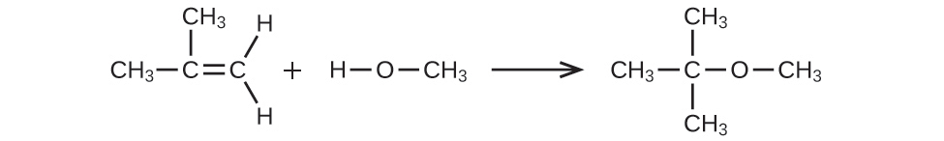
(b) 4.593 $×$ 10² L
39.
(a) ${\text{CH}}_{3}\text{CH}={\text{CHCH}}_{3}+{\text{H}}_{2}\text{O} → {\text{CH}}_{3}{\text{CH}}_{2}{\text{CH(OH)CH}}_{3}$
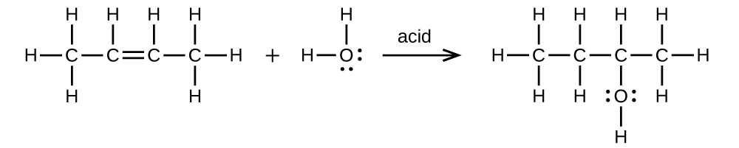
(b) ${\text{CH}}_{3}{\text{CH}}_{2}\text{OH} → {\text{CH}}_{2}={\text{CH}}_{2}+{\text{H}}_{2}\text{O}$
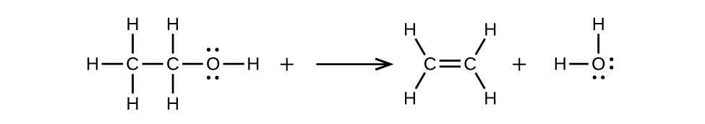
41.
(a)

(b)

(c)

43.
A ketone contains a group bonded to two additional carbon atoms; thus, a minimum of three carbon atoms are needed.
45.
Since they are both carboxylic acids, they each contain the –COOH functional group and its characteristics. The difference is the hydrocarbon chain in a saturated fatty acid contains no double or triple bonds, whereas the hydrocarbon chain in an unsaturated fatty acid contains one or more multiple bonds.
47.
(a) CH₃CH(OH)CH₃: all carbons are tetrahedral; (b) ${\text{CH}}_{3}\text{C}\text{O}{\text{CH}}_{3}\text{:}$ the end carbons are tetrahedral and the central carbon is trigonal planar; (c) CH₃OCH₃: all are tetrahedral; (d) CH₃COOH: the methyl carbon is tetrahedral and the acid carbon is trigonal planar; (e) CH₃CH₂CH₂CH(CH₃)CHCH₂: all are tetrahedral except the right-most two carbons, which are trigonal planar
49.
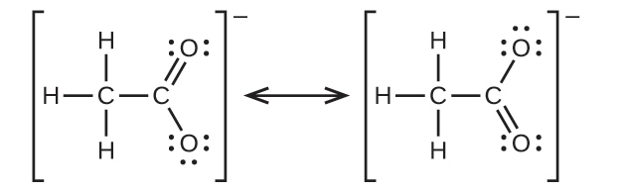
51.
(a) ${\text{CH}}_{3}{\text{CH}}_{2}{\text{CH}}_{2}{\text{CH}}_{2}{\text{OH}+\text{CH}}_{3}\text{C}\left(\text{O}\right)\text{OH} → {\text{CH}}_{3}\text{C}\left(\text{O}\right){\text{OCH}}_{2}{\text{CH}}_{2}{\text{CH}}_{2}{\text{CH}}_{3}+{\text{H}}_{2}\text{O:}$
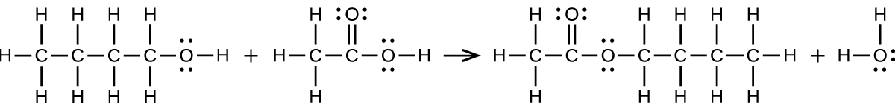
(b) $2{\text{CH}}_{3}{\text{CH}}_{2}\text{COOH}+{\text{CaCO}}_{3} → {\left({\text{CH}}_{3}{\text{CH}}_{2}\text{COO}\right)}_{2}\text{Ca}+{\text{CO}}_{2}+{\text{H}}_{2}\text{O:}$
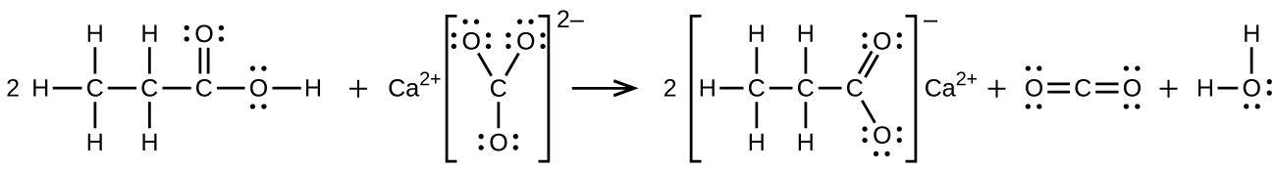
53.
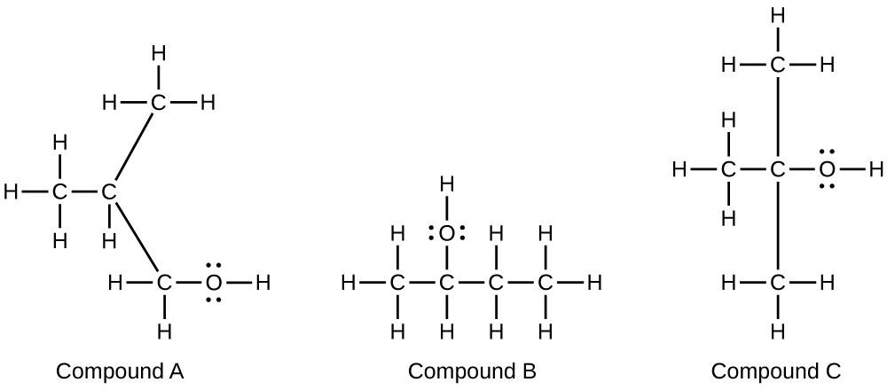
55.
Trimethyl amine: trigonal pyramidal, sp³; trimethyl ammonium ion: tetrahedral, sp³
57.
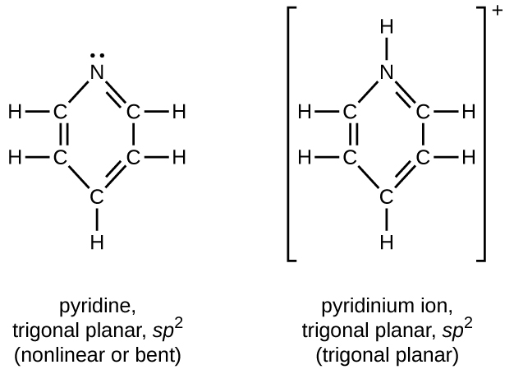
59.
${\text{CH}}_{3}{\text{NH}}_{2}+{\text{H}}_{3}{\text{O}}^{+} → {\text{CH}}_{3}{\text{NH}}_{3}​^{+}+{\text{H}}_{2}\text{O}$
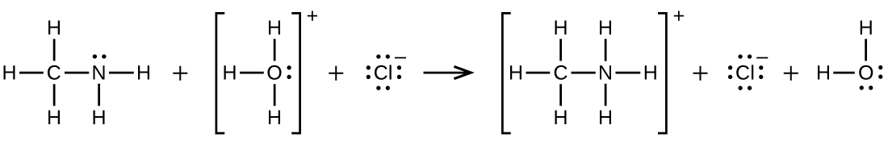
61.
CH₃CH = CHCH₃(sp²) + Cl $→$ CH₃CH(Cl)H(Cl)CH₃(sp³); 2C₆H₆(sp²) + 15O₂ $→$ 12CO₂(sp) + 6H₂O
63.
The carbon in CO₃²⁻, initially at sp², changes hybridization to sp in CO₂.

