9.4 Effusion and Diffusion of Gases

Learning Objectives
By the end of this section, you will be able to:
- Define and explain effusion and diffusion
- State Graham’s law and use it to compute relevant gas properties
If you have ever been in a room when a piping hot pizza was delivered, you have been made aware of the fact that gaseous molecules can quickly spread throughout a room, as evidenced by the pleasant aroma that soon reaches your nose. Although gaseous molecules travel at tremendous speeds (hundreds of meters per second), they collide with other gaseous molecules and travel in many different directions before reaching the desired target. At room temperature, a gaseous molecule will experience billions of collisions per second. The mean free path is the average distance a molecule travels between collisions. The mean free path increases with decreasing pressure; in general, the mean free path for a gaseous molecule will be hundreds of times the diameter of the molecule
In general, we know that when a sample of gas is introduced to one part of a closed container, its molecules very quickly disperse throughout the container; this process by which molecules disperse in space in response to differences in concentration is called diffusion (shown in Figure 9.27). The gaseous atoms or molecules are, of course, unaware of any concentration gradient, they simply move randomly—regions of higher concentration have more particles than regions of lower concentrations, and so a net movement of species from high to low concentration areas takes place. In a closed environment, diffusion will ultimately result in equal concentrations of gas throughout, as depicted in Figure 9.27. The gaseous atoms and molecules continue to move, but since their concentrations are the same in both bulbs, the rates of transfer between the bulbs are equal (no net transfer of molecules occurs).
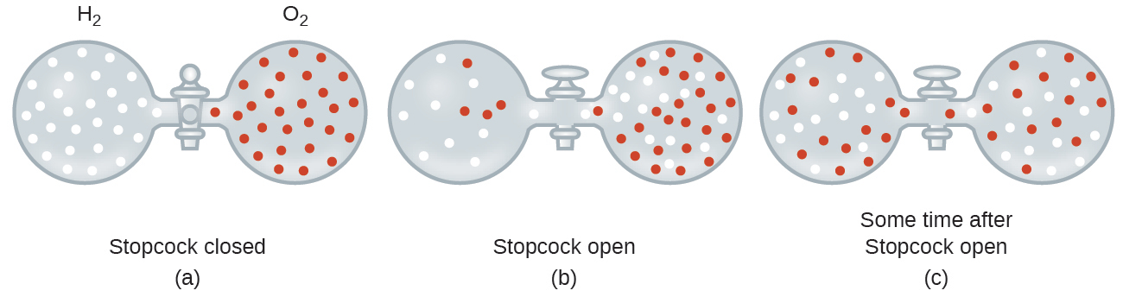
Figure 9.27 (a) Two gases, H₂ and O₂, are initially separated. (b) When the stopcock is opened, they mix together. The lighter gas, H₂, passes through the opening faster than O₂, so just after the stopcock is opened, more H₂ molecules move to the O₂ side than O₂ molecules move to the H₂ side. (c) After a short time, both the slower-moving O₂ molecules and the faster-moving H₂ molecules have distributed themselves evenly on both sides of the vessel.
We are often interested in the rate of diffusion, the amount of gas passing through some area per unit time:
$\text{rate of diffusion}= \frac{\text{amount of gas passing through an area}}{\text{unit of time}}$
The diffusion rate depends on several factors: temperature; the mass of the atoms or molecules; the concentration gradient (the increase or decrease in concentration from one point to another); the amount of surface area available for diffusion; and the distance the gas particles must travel. Note also that the time required for diffusion to occur is inversely proportional to the rate of diffusion, as shown in the rate of diffusion equation.
A process involving movement of gaseous species similar to diffusion is effusion, the escape of gas molecules through a tiny hole such as a pinhole in a balloon into a vacuum (Figure 9.28). Although diffusion and effusion rates both depend on the molar mass of the gas involved, their rates are not equal; however, the ratios of their rates are the same.
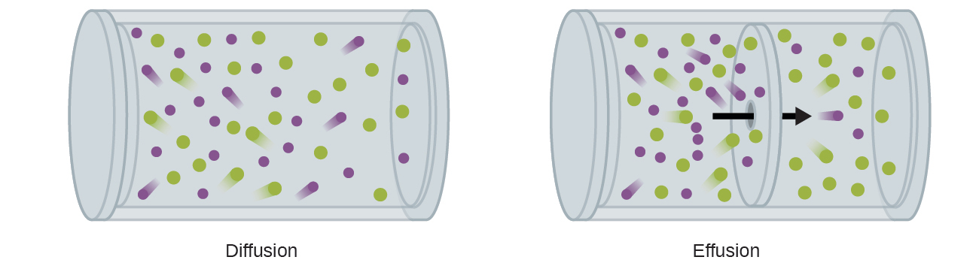
Figure 9.28 Diffusion involves the unrestricted dispersal of molecules throughout space due to their random motion. When this process is restricted to passage of molecules through very small openings in a physical barrier, the process is called effusion.
If a mixture of gases is placed in a container with porous walls, the gases effuse through the small openings in the walls. The lighter gases pass through the small openings more rapidly (at a higher rate) than the heavier ones (Figure 9.29). In 1832, Thomas Graham studied the rates of effusion of different gases and formulated Graham’s law of effusion: The rate of effusion of a gas is inversely proportional to the square root of its molar mass:
$\text{rate of effusion}∝\frac{1}{\sqrt{\text{ℳ}}}$
This means that if two gases A and B are at the same temperature and pressure, the ratio of their effusion rates is inversely proportional to the ratio of the square roots of their molar masses:
$\frac{\text{rate of effusion of A}}{\text{rate of effusion of B}} = \frac{\sqrt{{\text{ℳ}}_{\text{B}}}}{\sqrt{{\text{ℳ}}_{\text{A}}}}$
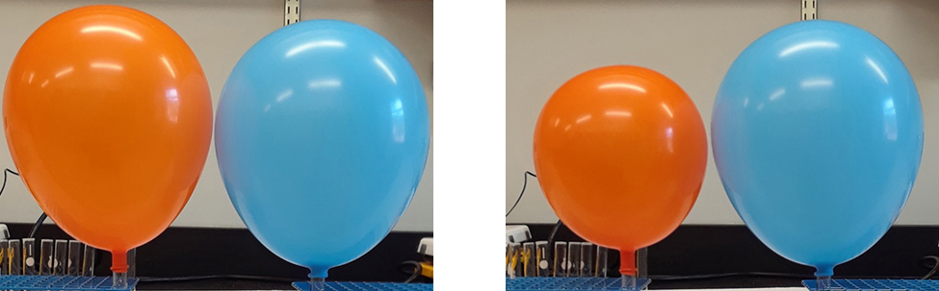
Figure 9.29 The left photograph shows two balloons inflated with different gases, helium (orange) and argon (blue).The right-side photograph shows the balloons approximately 12 hours after being filled, at which time the helium balloon has become noticeably more deflated than the argon balloon, due to the greater effusion rate of the lighter helium gas. (credit: modification of work by Paul Flowers)

Example 9.20

Applying Graham’s Law to Rates of Effusion
Calculate the ratio of the rate of effusion of hydrogen to the rate of effusion of oxygen.

Solution
From Graham’s law, we have:
$\frac{\text{rate of effusion of hydrogen}}{\text{rate of effusion of oxygen}} = \frac{\sqrt{32 {\text{g mol}}^{\text{−1}}}}{\sqrt{2 {\text{g mol}}^{\text{−1}}}} = \frac{\sqrt{16}}{\sqrt{1}} = \frac{4}{1}$
Hydrogen effuses four times as rapidly as oxygen.

Check Your Learning
At a particular pressure and temperature, nitrogen gas effuses at the rate of 79 mL/s. Under the same conditions, at what rate will sulfur dioxide effuse?

Answer:
52 mL/s

Example 9.21

Effusion Time Calculations
It takes 243 s for 4.46 $×$ 10⁻⁵ mol Xe to effuse through a tiny hole. Under the same conditions, how long will it take 4.46 $×$ 10⁻⁵ mol Ne to effuse?

Solution
It is important to resist the temptation to use the times directly, and to remember how rate relates to time as well as how it relates to mass. Recall the definition of rate of effusion:
$\text{rate of effusion}= \frac{\text{amount of gas transferred}}{\text{time}}$
and combine it with Graham’s law:
$\frac{\text{rate of effusion of gas Xe}}{\text{rate of effusion of gas Ne}} = \frac{\sqrt{{\text{ℳ}}_{\text{Ne}}}}{\sqrt{{\text{ℳ}}_{\text{Xe}}}}$
To get:
$\frac{\frac{\text{amount of Xe transferred}}{\text{time for Xe}}}{\frac{\text{amount of Ne transferred}}{\text{time for Ne}}} = \frac{\sqrt{{\text{ℳ}}_{\text{Ne}}}}{\sqrt{{\text{ℳ}}_{\text{Xe}}}}$
Noting that amount of A = amount of B, and solving for time for Ne:
$\frac{\frac{\text{amount of Xe}}{\text{time for Xe}}}{\frac{\text{amount of Ne}}{\text{time for Ne}}} = \frac{\text{time for Ne}}{\text{time for Xe}} = \frac{\sqrt{{\text{ℳ}}_{\text{Ne}}}}{\sqrt{{\text{ℳ}}_{\text{Xe}}}} = \frac{\sqrt{{\text{ℳ}}_{\text{Ne}}}}{\sqrt{{\text{ℳ}}_{\text{Xe}}}}$
and substitute values:
$\frac{\text{time for Ne}}{243 \text{s}} =\sqrt{\frac{20.2 \text{g mol}}{131.3 \text{g mol}}} =0.392$
Finally, solve for the desired quantity:
$\text{time for Ne}=0.392 × 243 \text{s}=95.3 \text{s}$
Note that this answer is reasonable: Since Ne is lighter than Xe, the effusion rate for Ne will be larger than that for Xe, which means the time of effusion for Ne will be smaller than that for Xe.

Check Your Learning
A party balloon filled with helium deflates to $\frac{2}{3}$ of its original volume in 8.0 hours. How long will it take an identical balloon filled with the same number of moles of air (ℳ = 28.2 g/mol) to deflate to $\frac{1}{2}$ of its original volume?

Answer:
32 h

Example 9.22

Determining Molar Mass Using Graham’s Law
An unknown gas effuses 1.66 times more rapidly than CO₂. What is the molar mass of the unknown gas? Can you make a reasonable guess as to its identity?

Solution
From Graham’s law, we have:
$\frac{\text{rate of effusion of Unknown}}{{\text{rate of effusion of CO}}_{2}} = \frac{\sqrt{{\text{ℳ}}_{{\text{CO}}_{2}}}}{\sqrt{{\text{ℳ}}_{Unknown}}}$
Plug in known data:
$\frac{1.66}{1} = \frac{\sqrt{44.0 \text{g/mol}}}{\sqrt{{\text{ℳ}}_{Unknown}}}$
Solve:
${\text{ℳ}}_{Unknown}= \frac{44.0 \text{g/mol}}{{\left(1.66\right)}^{2}} =16.0 \text{g/mol}$
The gas could well be CH₄, the only gas with this molar mass.

Check Your Learning
Hydrogen gas effuses through a porous container 8.97-times faster than an unknown gas. Estimate the molar mass of the unknown gas.

Answer:
162 g/mol

How Sciences Interconnect

Use of Diffusion for Nuclear Energy Applications: Uranium Enrichment
Gaseous diffusion has been used to produce enriched uranium for use in nuclear power plants and weapons. Naturally occurring uranium contains only 0.72% of ²³⁵U, the kind of uranium that is “fissile,” that is, capable of sustaining a nuclear fission chain reaction. Nuclear reactors require fuel that is 2–5% ²³⁵U, and nuclear bombs need even higher concentrations. One way to enrich uranium to the desired levels is to take advantage of Graham’s law. In a gaseous diffusion enrichment plant, uranium hexafluoride (UF₆, the only uranium compound that is volatile enough to work) is slowly pumped through large cylindrical vessels called diffusers, which contain porous barriers with microscopic openings. The process is one of diffusion because the other side of the barrier is not evacuated. The ²³⁵UF₆ molecules have a higher average speed and diffuse through the barrier a little faster than the heavier ²³⁸UF₆ molecules. The gas that has passed through the barrier is slightly enriched in ²³⁵UF₆ and the residual gas is slightly depleted. The small difference in molecular weights between ²³⁵UF₆ and ²³⁸UF₆ only about 0.4% enrichment, is achieved in one diffuser (Figure 9.30). But by connecting many diffusers in a sequence of stages (called a cascade), the desired level of enrichment can be attained.
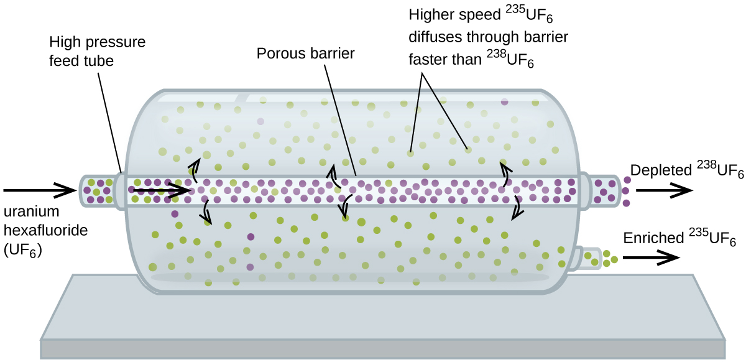
Figure 9.30 In a diffuser, gaseous UF₆ is pumped through a porous barrier, which partially separates ²³⁵UF₆ from ²³⁸UF₆ The UF₆ must pass through many large diffuser units to achieve sufficient enrichment in ²³⁵U.
The large scale separation of gaseous ²³⁵UF₆ from ²³⁸UF₆ was first done during the World War II, at the atomic energy installation in Oak Ridge, Tennessee, as part of the Manhattan Project (the development of the first atomic bomb). Although the theory is simple, this required surmounting many daunting technical challenges to make it work in practice. The barrier must have tiny, uniform holes (about 10^{–6} cm in diameter) and be porous enough to produce high flow rates. All materials (the barrier, tubing, surface coatings, lubricants, and gaskets) need to be able to contain, but not react with, the highly reactive and corrosive UF₆.
Because gaseous diffusion plants require very large amounts of energy (to compress the gas to the high pressures required and drive it through the diffuser cascade, to remove the heat produced during compression, and so on), it is now being replaced by gas centrifuge technology, which requires far less energy. A current hot political issue is how to deny this technology to Iran, to prevent it from producing enough enriched uranium for them to use to make nuclear weapons.

