9.5 The Kinetic-Molecular Theory

Learning Objectives
- State the postulates of the kinetic-molecular theory
- Use this theory’s postulates to explain the gas laws
The gas laws that we have seen to this point, as well as the ideal gas equation, are empirical, that is, they have been derived from experimental observations. The mathematical forms of these laws closely describe the macroscopic behavior of most gases at pressures less than about 1 or 2 atm. Although the gas laws describe relationships that have been verified by many experiments, they do not tell us why gases follow these relationships.
The kinetic molecular theory (KMT) is a simple microscopic model that effectively explains the gas laws described in previous modules of this chapter. This theory is based on the following five postulates described here. (Note: The term “molecule” will be used to refer to the individual chemical species that compose the gas, although some gases are composed of atomic species, for example, the noble gases.)
- Gases are composed of molecules that are in continuous motion, travelling in straight lines and changing direction only when they collide with other molecules or with the walls of a container.
- The molecules composing the gas are negligibly small compared to the distances between them.
- The pressure exerted by a gas in a container results from collisions between the gas molecules and the container walls.
- Gas molecules exert no attractive or repulsive forces on each other or the container walls; therefore, their collisions are elastic (do not involve a loss of energy).
- The average kinetic energy of the gas molecules is proportional to the kelvin temperature of the gas.
The test of the KMT and its postulates is its ability to explain and describe the behavior of a gas. The various gas laws can be derived from the assumptions of the KMT, which have led chemists to believe that the assumptions of the theory accurately represent the properties of gas molecules. We will first look at the individual gas laws (Boyle’s, Charles’s, Amontons’s, Avogadro’s, and Dalton’s laws) conceptually to see how the KMT explains them. Then, we will more carefully consider the relationships between molecular masses, speeds, and kinetic energies with temperature, and explain Graham’s law.

The Kinetic-Molecular Theory Explains the Behavior of Gases, Part I
Recalling that gas pressure is exerted by rapidly moving gas molecules and depends directly on the number of molecules hitting a unit area of the wall per unit of time, we see that the KMT conceptually explains the behavior of a gas as follows:
- Amontons’s law. If the temperature is increased, the average speed and kinetic energy of the gas molecules increase. If the volume is held constant, the increased speed of the gas molecules results in more frequent and more forceful collisions with the walls of the container, therefore increasing the pressure (Figure 9.31).
- Charles’s law. If the temperature of a gas is increased, a constant pressure may be maintained only if the volume occupied by the gas increases. This will result in greater average distances traveled by the molecules to reach the container walls, as well as increased wall surface area. These conditions will decrease the both the frequency of molecule-wall collisions and the number of collisions per unit area, the combined effects of which balance the effect of increased collision forces due to the greater kinetic energy at the higher temperature.
- Boyle’s law. If the gas volume of a given amount of gas at a given temperature is decreased (that is, if the gas is compressed), the molecules will be exposed to a decreased container wall area. Collisions with the container wall will therefore occur more frequently and the pressure exerted by the gas will increase (Figure 9.31).
- Avogadro’s law. At constant pressure and temperature, the frequency and force of molecule-wall collisions are constant. Under such conditions, increasing the number of gaseous molecules will require a proportional increase in the container volume in order to yield a decrease in the number of collisions per unit area to compensate for the increased frequency of collisions (Figure 9.31).
- Dalton’s Law. Because of the large distances between them, the molecules of one gas in a mixture bombard the container walls with the same frequency whether other gases are present or not, and the total pressure of a gas mixture equals the sum of the (partial) pressures of the individual gases.
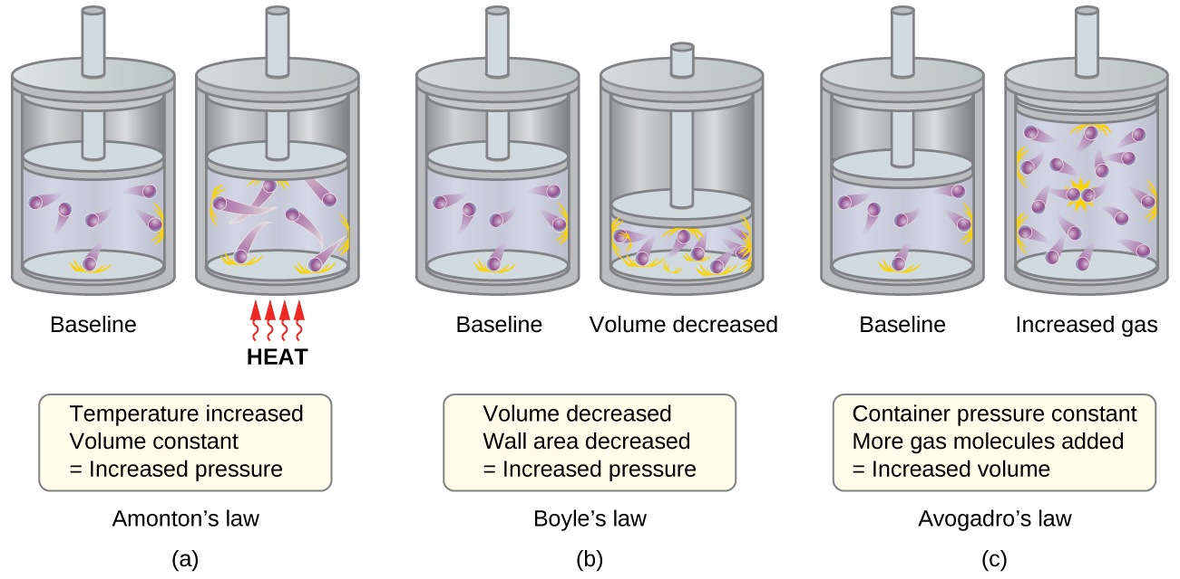
Figure 9.31 (a) When gas temperature increases, gas pressure increases due to increased force and frequency of molecular collisions. (b) When volume decreases, gas pressure increases due to increased frequency of molecular collisions. (c) When the amount of gas increases at a constant pressure, volume increases to yield a constant number of collisions per unit wall area per unit time.

molecular speeds and Kinetic Energy
The previous discussion showed that the KMT qualitatively explains the behaviors described by the various gas laws. The postulates of this theory may be applied in a more quantitative fashion to derive these individual laws. To do this, we must first look at speeds and kinetic energies of gas molecules, and the temperature of a gas sample.
In a gas sample, individual molecules have widely varying speeds; however, because of the vast number of molecules and collisions involved, the molecular speed distribution and average speed are constant. This molecular speed distribution is known as a Maxwell-Boltzmann distribution, and it depicts the relative numbers of molecules in a bulk sample of gas that possesses a given speed (Figure 9.32).
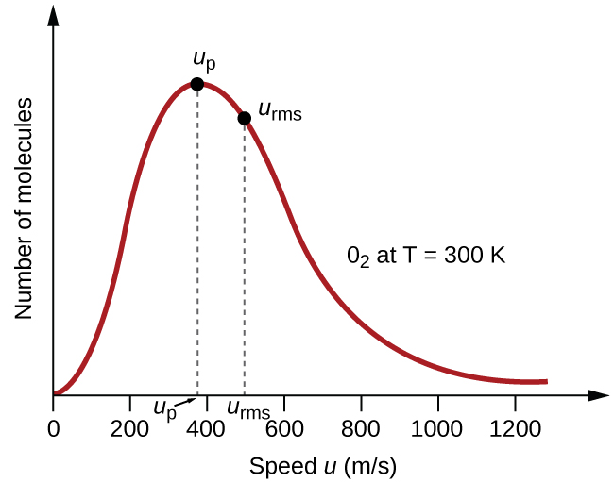
Figure 9.32 The molecular speed distribution for oxygen gas at 300 K is shown here. Very few molecules move at either very low or very high speeds. The number of molecules with intermediate speeds increases rapidly up to a maximum, which is the most probable speed, then drops off rapidly. Note that the most probable speed, ν_{p}, is a little less than 400 m/s, while the root mean square speed, u_{rms}, is closer to 500 m/s.
The kinetic energy (KE) of a particle of mass (m) and speed (u) is given by:
$\text{KE}= \frac{1}{2} mu^{2}$
Expressing mass in kilograms and speed in meters per second will yield energy values in units of joules (J = kg m² s^{–2}). To deal with a large number of gas molecules, we use averages for both speed and kinetic energy. In the KMT, the root mean square speed of a particle, u_{rms}, is defined as the square root of the average of the squares of the speeds with n = the number of particles:
$u_{\text{r}\text{m}\text{s}}=\sqrt{\overset{¯}{u^{2}}}=\sqrt{\frac{u_{1}^{2}+u_{2}^{2}+u_{3}^{2}+u_{4}^{2}+…}{n}}$
The average kinetic energy for a mole of particles, KE_{avg}, is then equal to:
${\text{KE}}_{\text{avg}}= \frac{1}{2}{Mu}_{\text{rms}}^{2}$
where M is the molar mass expressed in units of kg/mol. The KE_{avg} of a mole of gas molecules is also directly proportional to the temperature of the gas and may be described by the equation:
${\text{KE}}_{\text{avg}}= \frac{3}{2} RT$
where R is the gas constant and T is the kelvin temperature. When used in this equation, the appropriate form of the gas constant is 8.314 J/mol⋅K (8.314 kg m²s^{–2}mol^{–1}K^{–1}). These two separate equations for KE_{avg} may be combined and rearranged to yield a relation between molecular speed and temperature:
$\frac{1}{2}{Mu}_{\text{rms}}^{2}= \frac{3}{2} RT$
$u_{\text{rms}}=\sqrt{\frac{3RT}{M}}$

Example 9.23

Calculation of u_{rms}
Calculate the root-mean-square speed for a nitrogen molecule at 30 °C.

Solution
Convert the temperature into Kelvin:
$30 \text{°C}+273=\text{303 K}$
Determine the molar mass of nitrogen in kilograms:
$\frac{28.0 \text{g}}{\text{1 mol}} × \frac{\text{1 kg}}{1000 \text{g}} =0.028 \text{kg/mol}$
Replace the variables and constants in the root-mean-square speed equation, replacing Joules with the equivalent kg m²s^{–2}:
$u_{\text{rms}}=\sqrt{\frac{3RT}{M}}$
$u_{\text{r}\text{m}\text{s}}= \sqrt{\frac{3\left(8.314 \text{J/mol K}\right)\left(\text{303 K}\right)}{\left(0.028 \text{kg/mol}\right)}} = \sqrt{2.70 × {10}^{5} {\text{m}}^{2}{\text{s}}^{−2}} =519 \text{m/s}$

Check Your Learning
Calculate the root-mean-square speed for a mole of oxygen molecules at –23 °C.

Answer:
441 m/s
If the temperature of a gas increases, its KE_{avg} increases, more molecules have higher speeds and fewer molecules have lower speeds, and the distribution shifts toward higher speeds overall, that is, to the right. If temperature decreases, KE_{avg} decreases, more molecules have lower speeds and fewer molecules have higher speeds, and the distribution shifts toward lower speeds overall, that is, to the left. This behavior is illustrated for nitrogen gas in Figure 9.33.
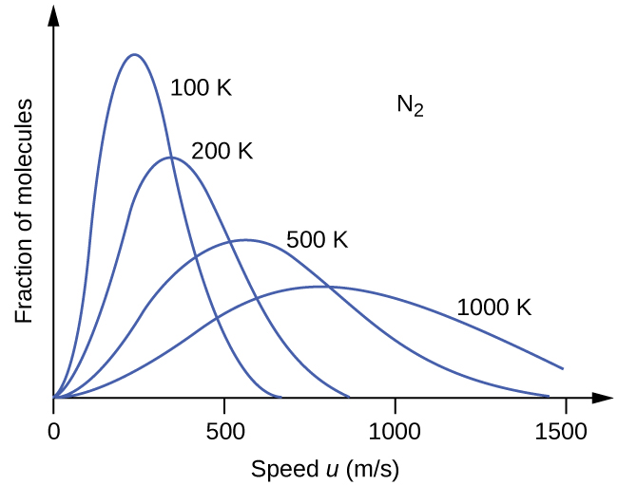
Figure 9.33 The molecular speed distribution for nitrogen gas (N₂) shifts to the right and flattens as the temperature increases; it shifts to the left and heightens as the temperature decreases.
At a given temperature, all gases have the same KE_{avg} for their molecules. Gases composed of lighter molecules have more high-speed particles and a higher u_{rms}, with a speed distribution that peaks at relatively higher speeds. Gases consisting of heavier molecules have more low-speed particles, a lower u_{rms}, and a speed distribution that peaks at relatively lower speeds. This trend is demonstrated by the data for a series of noble gases shown in Figure 9.34.
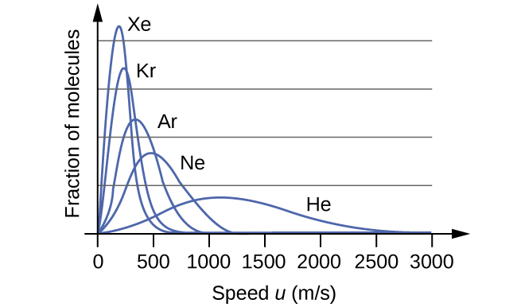
Figure 9.34 molecular speed is directly related to molecular mass. At a given temperature, lighter molecules move faster on average than heavier molecules.

Link to Learning
The gas simulator may be used to examine the effect of temperature on molecular speeds. Examine the simulator’s “energy histograms” (molecular speed distributions) and “species information” (which gives average speed values) for molecules of different masses at various temperatures.

The Kinetic-Molecular Theory Explains the Behavior of Gases, Part II
According to Graham’s law, the molecules of a gas are in rapid motion and the molecules themselves are small. The average distance between the molecules of a gas is large compared to the size of the molecules. As a consequence, gas molecules can move past each other easily and diffuse at relatively fast rates.
The rate of effusion of a gas depends directly on the (average) speed of its molecules:
$\text{effusion rate} ∝ u_{\text{rms}}$
Using this relation, and the equation relating molecular speed to mass, Graham’s law may be easily derived as shown here:
$u_{\text{rms}}=\sqrt{\frac{3RT}{M}}$
$M= \frac{3RT}{u_{\text{r}\text{m}\text{s}}^{2}} = \frac{3RT}{{\overset{¯}{u}}^{2}}$
$\frac{\text{effusion rate A}}{\text{effusion rate B}} = \frac{u_{\text{r}\text{m}\text{s} \text{A}}}{u_{\text{r}\text{m}\text{s} \text{B}}} = \frac{\sqrt{\frac{3RT}{M_{\text{A}}}}}{\sqrt{\frac{3RT}{M_{\text{B}}}}} = \sqrt{\frac{M_{\text{B}}}{M_{\text{A}}}}$
The ratio of the rates of effusion is thus derived to be inversely proportional to the ratio of the square roots of their masses. This is the same relation observed experimentally and expressed as Graham’s law.

