18.2 Occurrence and Preparation of the Representative Metals

Learning Objectives
By the end of this section, you will be able to:
- Identify natural sources of representative metals
- Describe electrolytic and chemical reduction processes used to prepare these elements from natural sources
Because of their reactivity, we do not find most representative metals as free elements in nature. However, compounds that contain ions of most representative metals are abundant. In this section, we will consider the two common techniques used to isolate the metals from these compounds—electrolysis and chemical reduction.
These metals primarily occur in minerals, with lithium found in silicate or phosphate minerals, and sodium and potassium found in salt deposits from evaporation of ancient seas and in silicates. The alkaline earth metals occur as silicates and, with the exception of beryllium, as carbonates and sulfates. Beryllium occurs as the mineral beryl, Be₃Al₂Si₆O₁₈, which, with certain impurities, may be either the gemstone emerald or aquamarine. Magnesium is in seawater and, along with the heavier alkaline earth metals, occurs as silicates, carbonates, and sulfates. Aluminum occurs abundantly in many types of clay and in bauxite, an impure aluminum oxide hydroxide. The principle tin ore is the oxide cassiterite, SnO₂, and the principle lead and thallium ores are the sulfides or the products of weathering of the sulfides. The remaining representative metals occur as impurities in zinc or aluminum ores.

Electrolysis
Ions of metals in of groups 1 and 2, along with aluminum, are very difficult to reduce; therefore, it is necessary to prepare these elements by electrolysis, an important process discussed in the chapter on electrochemistry. Briefly, electrolysis involves using electrical energy to drive unfavorable chemical reactions to completion; it is useful in the isolation of reactive metals in their pure forms. Sodium, aluminum, and magnesium are typical examples.

The Preparation of Sodium
The most important method for the production of sodium is the electrolysis of molten sodium chloride; the set-up is a Downs cell, shown in Figure 18.10. The reaction involved in this process is:
$\text{2NaCl}\left(l\right) \underset{600 \text{°C}}{\overset{ \text{electrolysis} }{→}} \text{2Na}\left(l\right)+{\text{Cl}}_{2}\left(g\right)$
The electrolysis cell contains molten sodium chloride (melting point 801 °C), to which calcium chloride has been added to lower the melting point to 600 °C (a colligative effect). The passage of a direct current through the cell causes the sodium ions to migrate to the negatively charged cathode and pick up electrons, reducing the ions to sodium metal. Chloride ions migrate to the positively charged anode, lose electrons, and undergo oxidation to chlorine gas. The overall cell reaction comes from adding the following reactions:
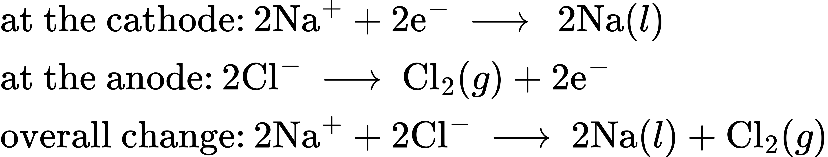
Separation of the molten sodium and chlorine prevents recombination. The liquid sodium, which is less dense than molten sodium chloride, floats to the surface and flows into a collector. The gaseous chlorine goes to storage tanks. Chlorine is also a valuable product.
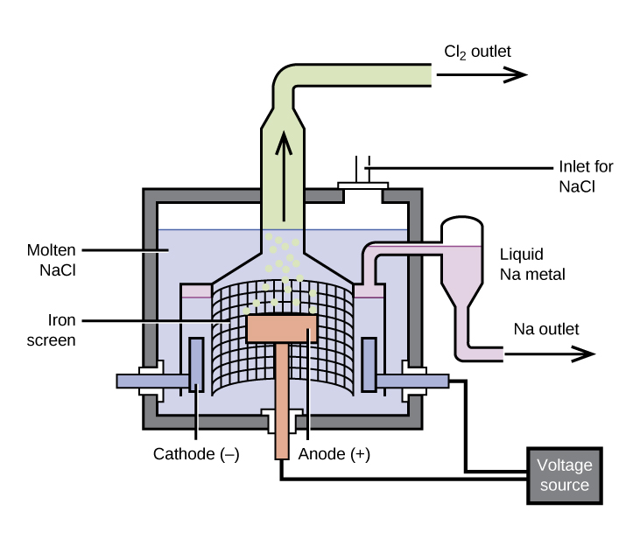
Figure 18.10 Pure sodium metal is isolated by electrolysis of molten sodium chloride using a Downs cell. It is not possible to isolate sodium by electrolysis of aqueous solutions of sodium salts because hydrogen ions are more easily reduced than are sodium ions; as a result, hydrogen gas forms at the cathode instead of the desired sodium metal. The high temperature required to melt NaCl means that liquid sodium metal forms.

The Preparation of Aluminum
The preparation of aluminum utilizes a process invented in 1886 by Charles M. Hall, who began to work on the problem while a student at Oberlin College in Ohio. Paul L. T. Héroult discovered the process independently a month or two later in France. In honor to the two inventors, this electrolysis cell is known as the Hall–Héroult cell. The Hall–Héroult cell is an electrolysis cell for the production of aluminum. Figure 18.11 illustrates the Hall–Héroult cell.
The production of aluminum begins with the purification of bauxite, the most common source of aluminum. The reaction of bauxite, AlO(OH), with hot sodium hydroxide forms soluble sodium aluminate, while clay and other impurities remain undissolved:
$\text{AlO}\left(\text{OH}\right)\left(s\right)+\text{NaOH}\left(aq\right)+{\text{H}}_{2}\text{O}\left(l\right) → \text{Na}[\text{Al}{\left(\text{OH}\right)}_{4}]\left(aq\right)$
After the removal of the impurities by filtration, the addition of acid to the aluminate leads to the reprecipitation of aluminum hydroxide:
$\text{Na}[\text{Al}{\left(\text{OH}\right)}_{4}]\left(aq\right)+{\text{H}}_{3}{\text{O}}^{\text{+}}\left(aq\right) → \text{Al}{\left(\text{OH}\right)}_{3}\left(s\right)+{\text{Na}}^{\text{+}}\left(aq\right)+{\text{2H}}_{2}\text{O}\left(l\right)$
The next step is to remove the precipitated aluminum hydroxide by filtration. Heating the hydroxide produces aluminum oxide, Al₂O₃, which dissolves in a molten mixture of cryolite, Na₃AlF₆, and calcium fluoride, CaF₂. Electrolysis of this solution takes place in a cell like that shown in Figure 18.11. Reduction of aluminum ions to the metal occurs at the cathode, while oxygen, carbon monoxide, and carbon dioxide form at the anode.
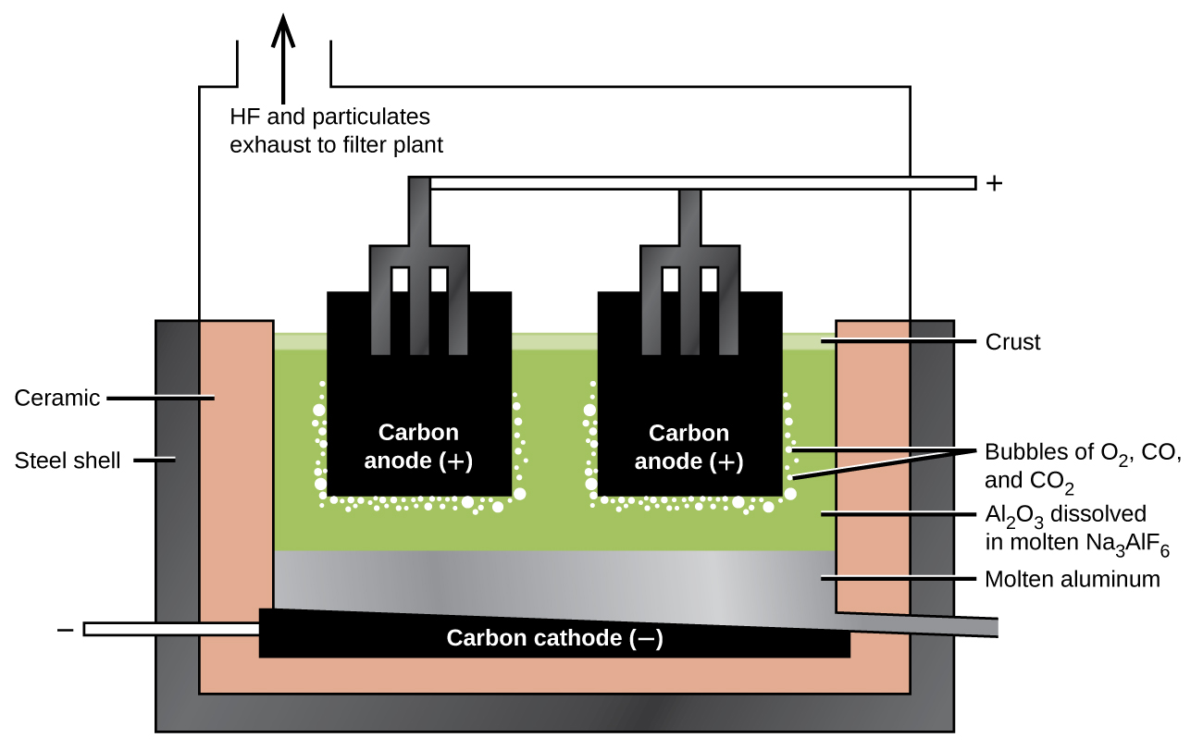
Figure 18.11 An electrolytic cell is used for the production of aluminum. The electrolysis of a solution of cryolite and calcium fluoride results in aluminum metal at the cathode, and oxygen, carbon monoxide, and carbon dioxide at the anode.

The Preparation of Magnesium
Magnesium is the other metal that is isolated in large quantities by electrolysis. Seawater, which contains approximately 0.5% magnesium chloride, serves as the major source of magnesium. Addition of calcium hydroxide to seawater precipitates magnesium hydroxide. The addition of hydrochloric acid to magnesium hydroxide, followed by evaporation of the resultant aqueous solution, leaves pure magnesium chloride. The electrolysis of molten magnesium chloride forms liquid magnesium and chlorine gas:
${\text{MgCl}}_{2}\left(aq\right)+\text{Ca}{\left(\text{OH}\right)}_{2}\left(aq\right) → \text{Mg}{\left(\text{OH}\right)}_{2}\left(s\right)+{\text{CaCl}}_{2}\left(aq\right)$
$\text{Mg}{\left(\text{OH}\right)}_{2}\left(s\right)+\text{2HCl}\left(aq\right) → {\text{MgCl}}_{2}\left(aq\right)+{\text{2H}}_{2}\text{O}\left(l\right)$
${\text{MgCl}}_{2}\left(l\right) → \text{Mg}\left(l\right)+{\text{Cl}}_{2}\left(g\right)$
Some production facilities have moved away from electrolysis completely. In the next section, we will see how the Pidgeon process leads to the chemical reduction of magnesium.

Chemical Reduction
It is possible to isolate many of the representative metals by chemical reduction using other elements as reducing agents. In general, chemical reduction is much less expensive than electrolysis, and for this reason, chemical reduction is the method of choice for the isolation of these elements. For example, it is possible to produce potassium, rubidium, and cesium by chemical reduction, as it is possible to reduce the molten chlorides of these metals with sodium metal. This may be surprising given that these metals are more reactive than sodium; however, the metals formed are more volatile than sodium and can be distilled for collection. The removal of the metal vapor leads to a shift in the equilibrium to produce more metal (see how reactions can be driven in the discussions of Le Châtelier’s principle in the chapter on fundamental equilibrium concepts).
The production of magnesium, zinc, and tin provide additional examples of chemical reduction.

The Preparation of Magnesium
The Pidgeon process involves the reaction of magnesium oxide with elemental silicon at high temperatures to form pure magnesium:
$\text{Si}\left(s\right)+\text{2MgO}\left(s\right) \overset{ \text{Δ} }{→} {\text{SiO}}_{2}\left(s\right)+\text{2Mg}\left(g\right)$
Although this reaction is unfavorable in terms of thermodynamics, the removal of the magnesium vapor produced takes advantage of Le Châtelier’s principle to continue the forward progress of the reaction. Over 75% of the world’s production of magnesium, primarily in China, comes from this process.

The Preparation of Zinc
Zinc ores usually contain zinc sulfide, zinc oxide, or zinc carbonate. After separation of these compounds from the ores, heating in air converts the ore to zinc oxide by one of the following reactions:
$\text{2ZnS}\left(s\right)+{\text{3O}}_{2}\left(g\right) \overset{ \text{Δ} }{→} \text{2ZnO}\left(s\right)+{\text{2SO}}_{2}\left(g\right)$
${\text{ZnCO}}_{3}\left(s\right) \overset{ \text{Δ} }{→} \text{ZnO}\left(s\right)+{\text{CO}}_{2}\left(g\right)$
Carbon, in the form of coal, reduces the zinc oxide to form zinc vapor:
$\text{ZnO}\left(s\right)+\text{C}\left(s\right) → \text{Zn}\left(g\right)+\text{CO}\left(g\right)$
The zinc can be distilled (boiling point 907 °C) and condensed. This zinc contains impurities of cadmium (767 °C), iron (2862 °C), lead (1750 °C), and arsenic (613 °C). Careful redistillation produces pure zinc. Arsenic and cadmium are distilled from the zinc because they have lower boiling points. At higher temperatures, the zinc is distilled from the other impurities, mainly lead and iron.

The Preparation of Tin
The ready reduction of tin(IV) oxide by the hot coals of a campfire accounts for the knowledge of tin in the ancient world. In the modern process, the roasting of tin ores containing SnO₂ removes contaminants such as arsenic and sulfur as volatile oxides. Treatment of the remaining material with hydrochloric acid removes the oxides of other metals. Heating the purified ore with carbon at temperature above 1000 °C produces tin:
${\text{SnO}}_{2}\left(s\right)+\text{2C}\left(s\right) \overset{ \text{Δ} }{→} \text{Sn}\left(s\right)+\text{2CO}\left(g\right)$
The molten tin collects at the bottom of the furnace and is drawn off and cast into blocks.

