Name: Sihle Shaun Ngena

Company: Deviare

**Import the dataset into the Python environment**

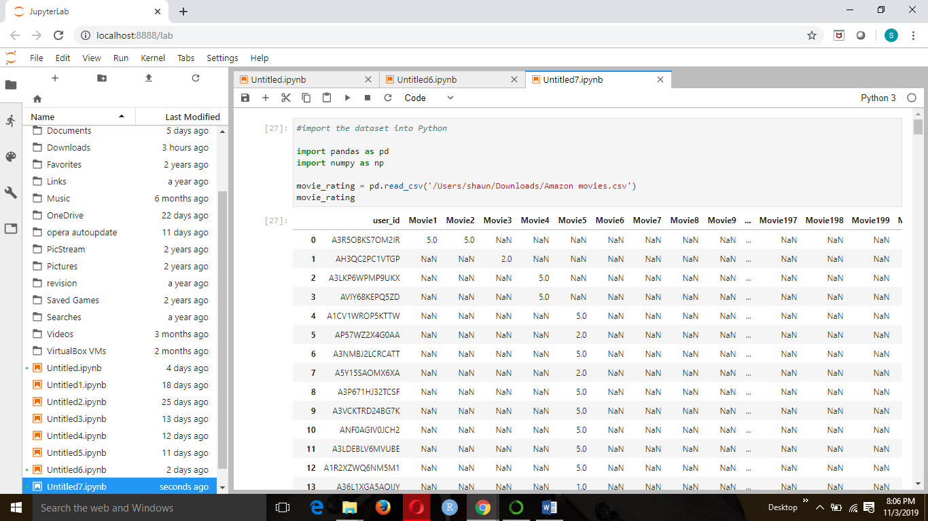

**Replace all missing values with 0**

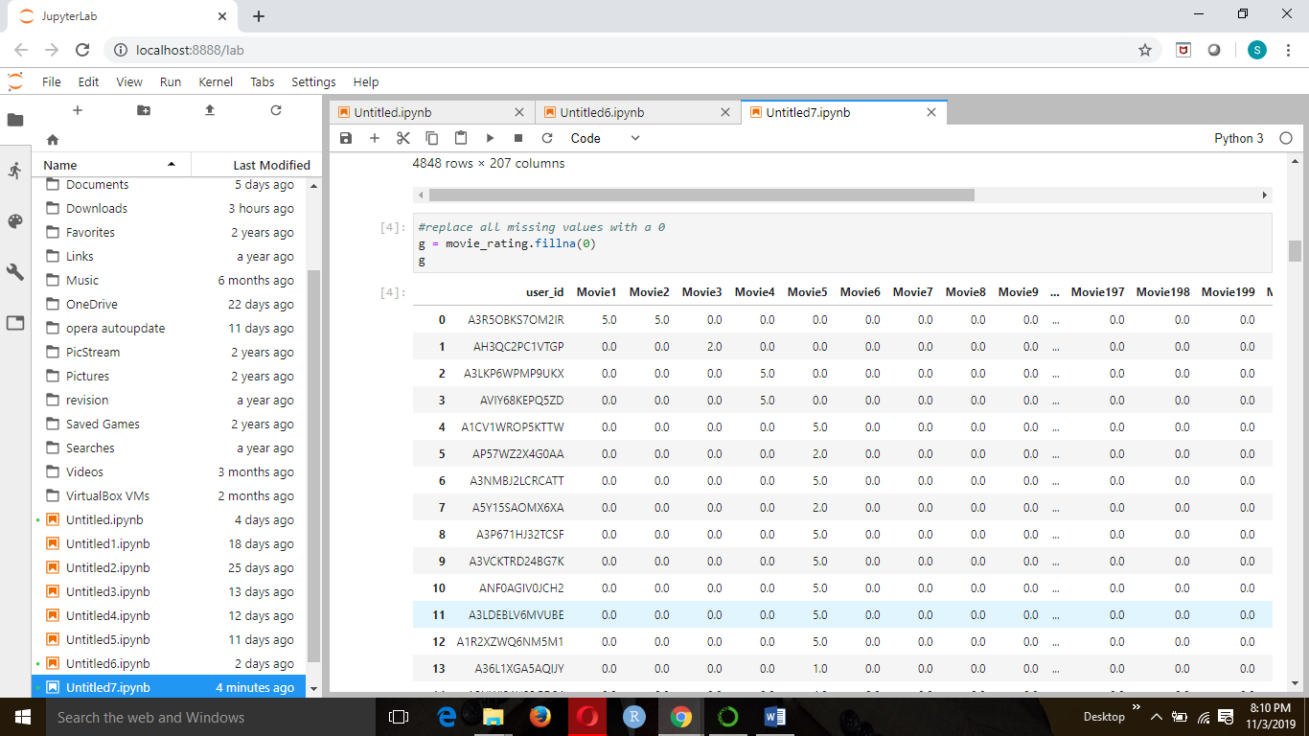

**Question 1**

**Which movies have maximum views/ratings?**

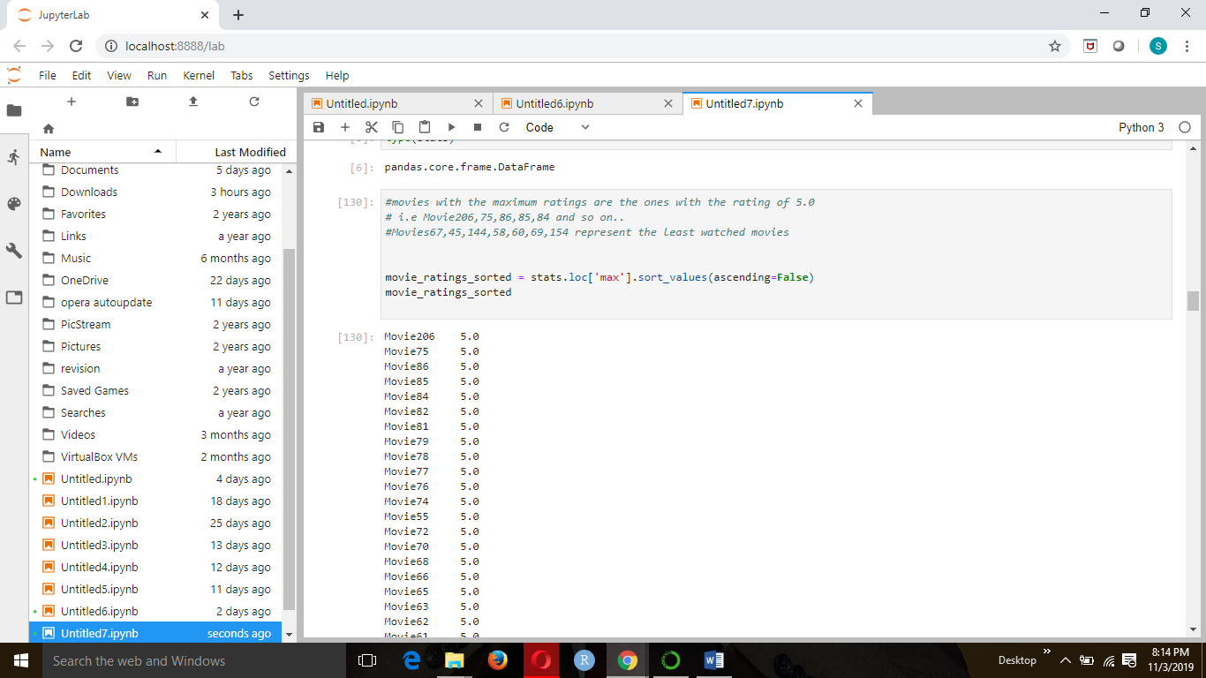

Question 2

**What is the average rating for each movie? Define the top 5 movies with the maximum ratings?**

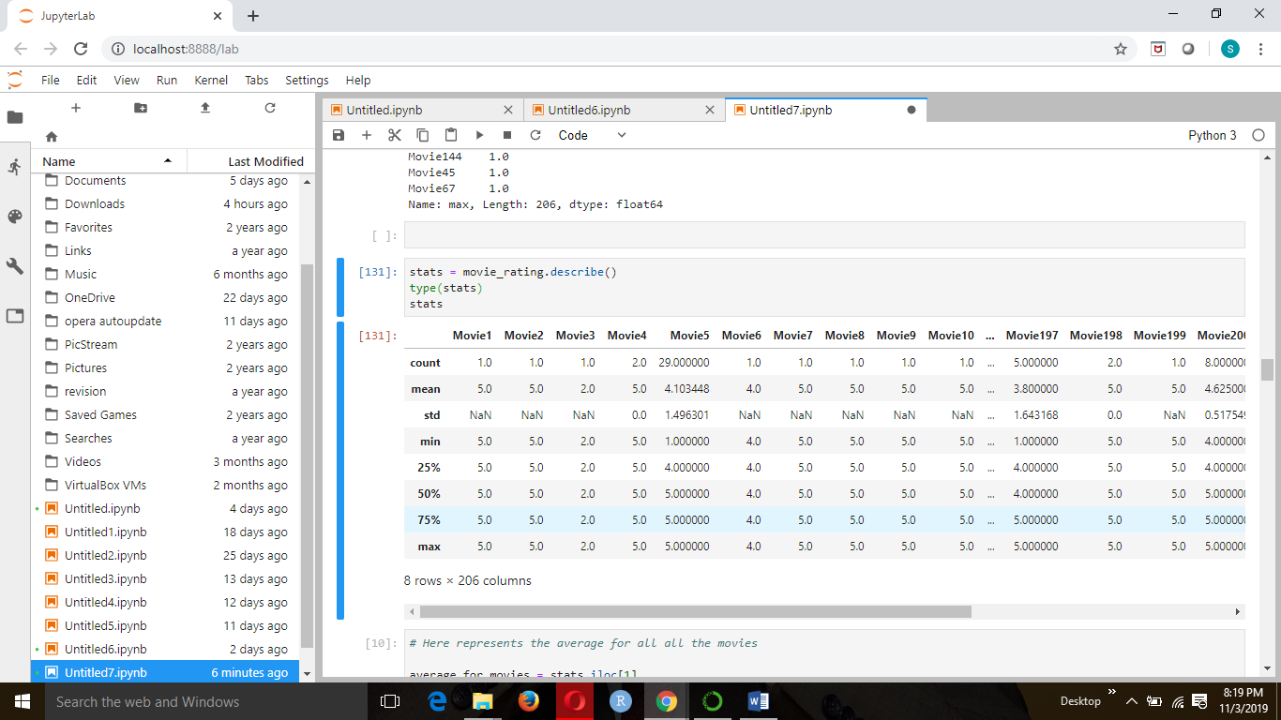

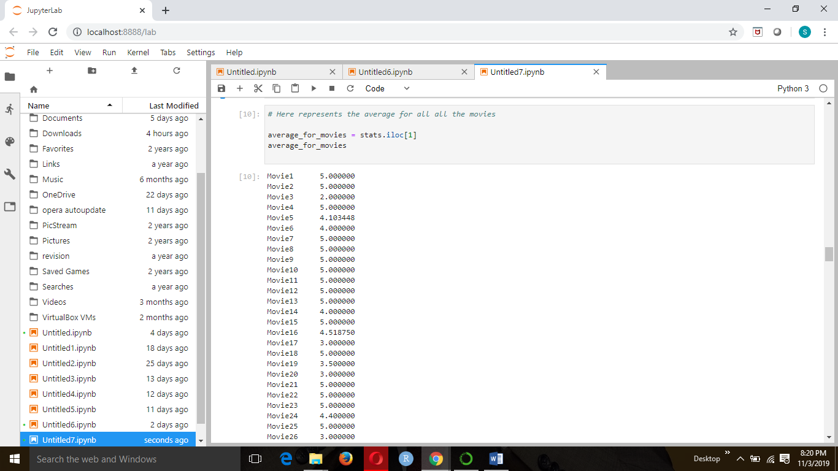

**Define the 5 movies with the max rating**

**movies with the maximum ratings are the ones with the rating of 5.0**

**i.e Movie206,75,86,85,84**

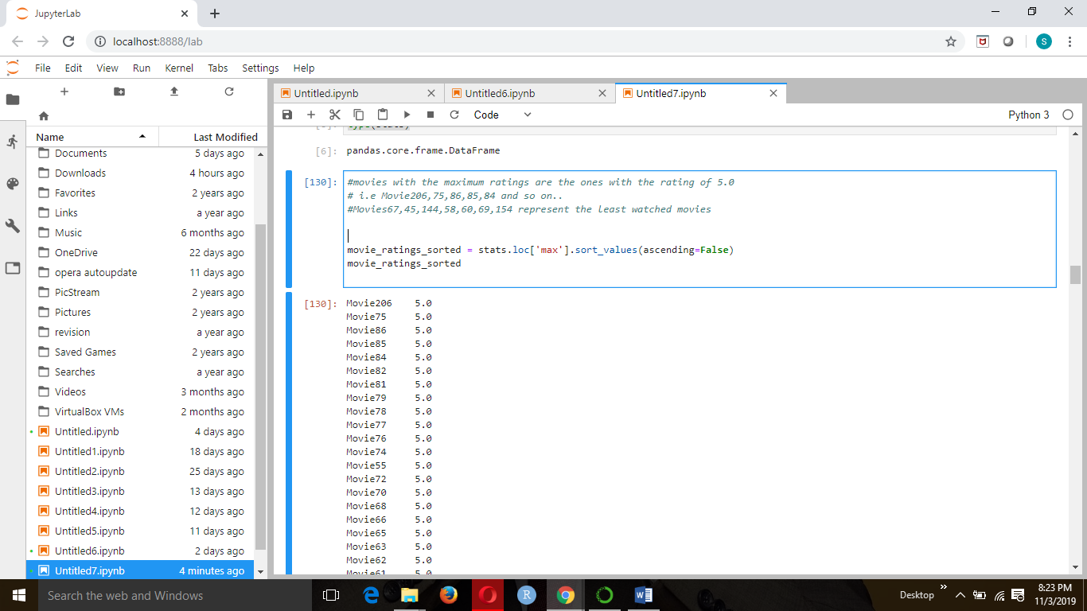

**Question 3**

**Define the top 5 movies with the least audience.**

**Movies67,45,144,58,60,69,154 represent the least watched movies represented at the bottom of the list as 1.0**

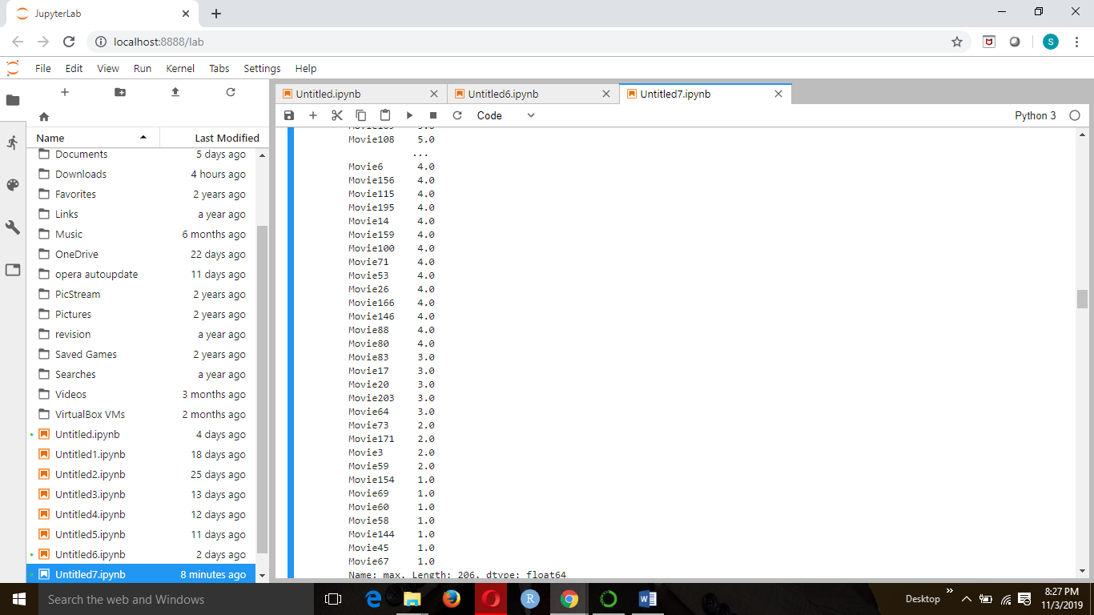

**Question 4**

**- Recommendation Model: Some of the movies hadn’t been watched and therefore, are not rated by the users. Netflix would like to take this as an opportunity and build a machine learning recommendation algorithm which provides the ratings for each of the users.**

* **Divide the data into training and test data**
* **Build a recommendation model on training data**
* **Make predictions on the test data**

