Introduction to my database
Welcome to my database! You can find 6 categories here, they are adult income, car price, iris, letter recognition, twitter and iris two class. I used them in my experiment about how to select algorithm for machine learning. Now Let me introduce these data sets for you.
What first comes is adult income data set. Below is the visualization of the data set in the table format.
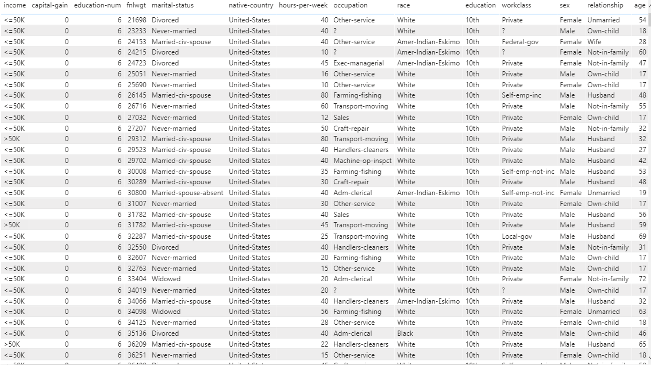
Figure 1
What I need to do with this data set is to determine whether a person makes over 50K a year.
Here we have classes >50k and <=50k and we have following attributes:
age: continuous.
workclass: Private, Self-emp-not-inc, Self-emp-inc, Federal-gov, Local-gov, State-gov, Without-pay, Never-worked.
fnlwgt: continuous.
education: Bachelors, Some-college, 11th, HS-grad, Prof-school, Assoc-acdm, Assoc-voc, 9th, 7th-8th, 12th, Masters, 1st-4th, 10th, Doctorate, 5th-6th, Preschool.
education-num: continuous.
marital-status: Married-civ-spouse, Divorced, Never-married, Separated, Widowed, Married-spouse-absent, Married-AF-spouse.
occupation: Tech-support, Craft-repair, Other-service, Sales, Exec-managerial, Prof-specialty, Handlers-cleaners, Machine-op-inspct, Adm-clerical, Farming-fishing, Transport-moving, Priv-house-serv, Protective-serv, Armed-Forces.
relationship: Wife, Own-child, Husband, Not-in-family, Other-relative, Unmarried.
race: White, Asian-Pac-Islander, Amer-Indian-Eskimo, Other, Black.
sex: Female, Male.
capital-gain: continuous.
capital-loss: continuous.
hours-per-week: continuous.
native-country: United-States, Cambodia, England, Puerto-Rico, Canada, Germany, Outlying-US(Guam-USVI-etc), India, Japan, Greece, South, China, Cuba, Iran, Honduras, Philippines, Italy, Poland, Jamaica, Vietnam, Mexico, Portugal, Ireland, France, Dominican-Republic, Laos, Ecuador, Taiwan, Haiti, Columbia, Hungary, Guatemala, Nicaragua, Scotland, Thailand, Yugoslavia, El-Salvador, Trinadad&Tobago, Peru, Hong, Holand-Netherlands.

Here is the bar chart of adult income.
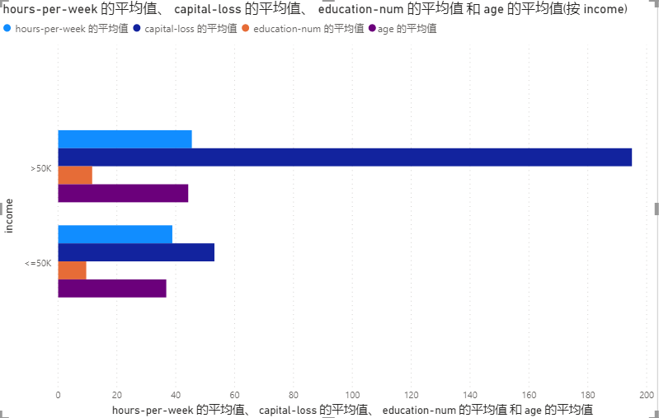
Figure 2.1
I create the chart to compare the numerical difference ( like hours per week instead of the race or workclass )between the high-come and the low-income.From this picture, we can find capital-loss is the most prominent one.

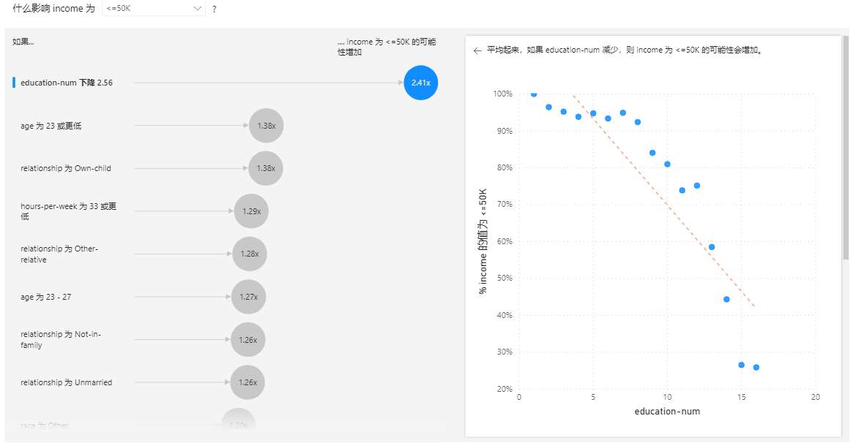
Figure 2.2
Attached is the analysis of the data set. We can see that education-num is the most effective factor which has the weight of 2.41.
Anyway, above is just my introduction and illustration of this data set. If you are interested in it, you can download and try it.

Next data set is Car Price.
This data set consists of 3 types of entities:the specification of an auto in terms of various characteristics, its assigned insurance risk rating, its normalized losses in use as compared to other cars.
price is what we need to predict
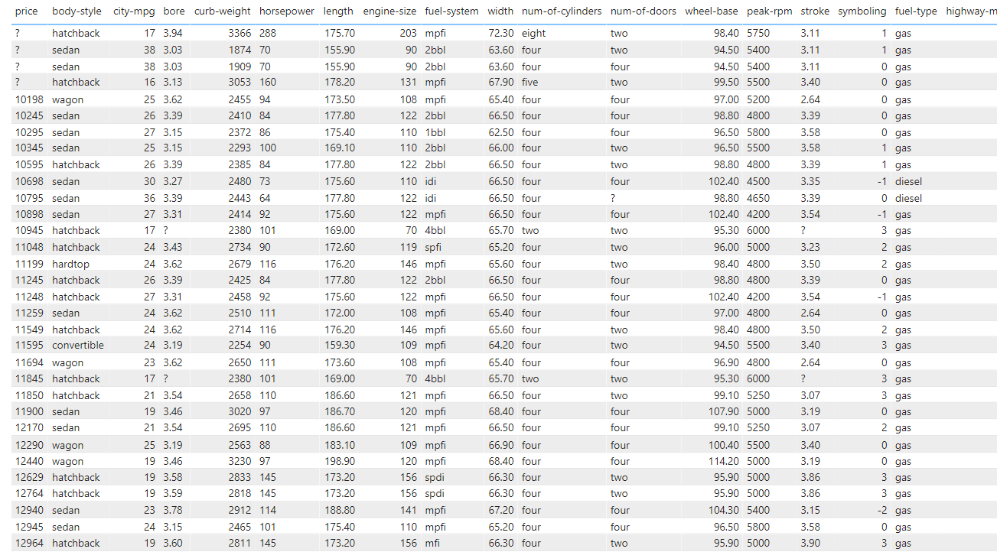
Figure 3.1
It has following attributes:

symboling,normalized-losses,make,fuel-type,aspiration,num-of-doors,body-style,drive-wheels,engine-location,wheel-base,Length,Width,height,Curb-weight,engine-type,num-of-cylinders,engine-size,fuel-system,bore,Stroke,compression-ratio,horsepower,peak-rpm,city-mpg,highway-mpg,price

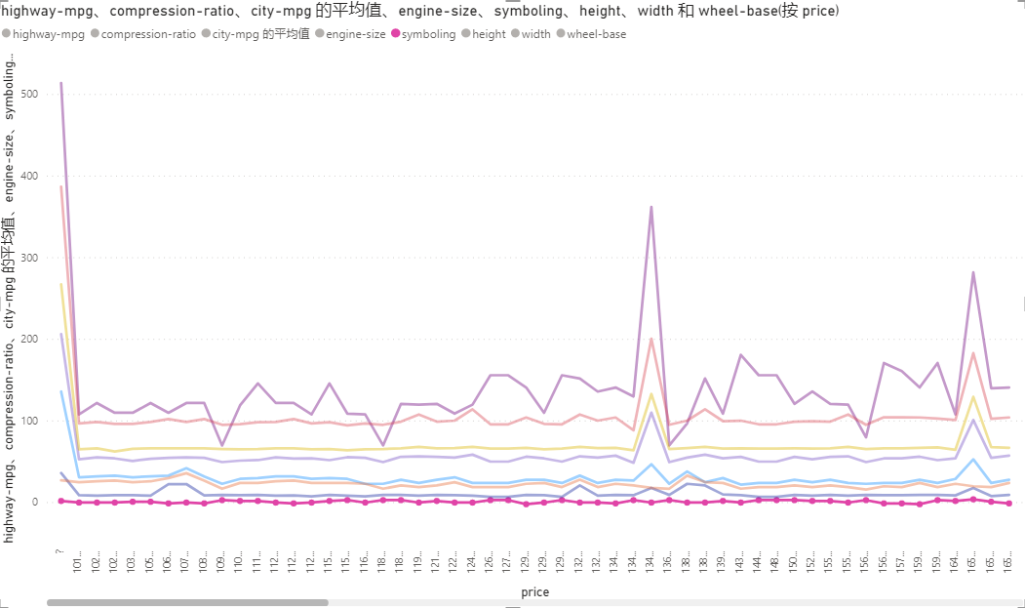
FIgure 3.2

X axis is the increasing price, and y axis are the factors. We can see that compression-ratio, city-mpg and symboling do nothing with the price. They do not change as the price increases.

Other factors change in a lockstep way but fluctuate in different levels. This means these factors may have some similarities or relation between them.

Third one is iris data set.
This dataset has features shown as below:
Id SepalLengthCm SepalWidthCm PetalLengthCm PetalWidthCm Species

It has 3 classes of flowers (3 species). Species is the label / target
id is just like index
SepalLengthCm SepalWidthCm PetalLengthCm PetalWidthCm, these 4 features are the main factors.

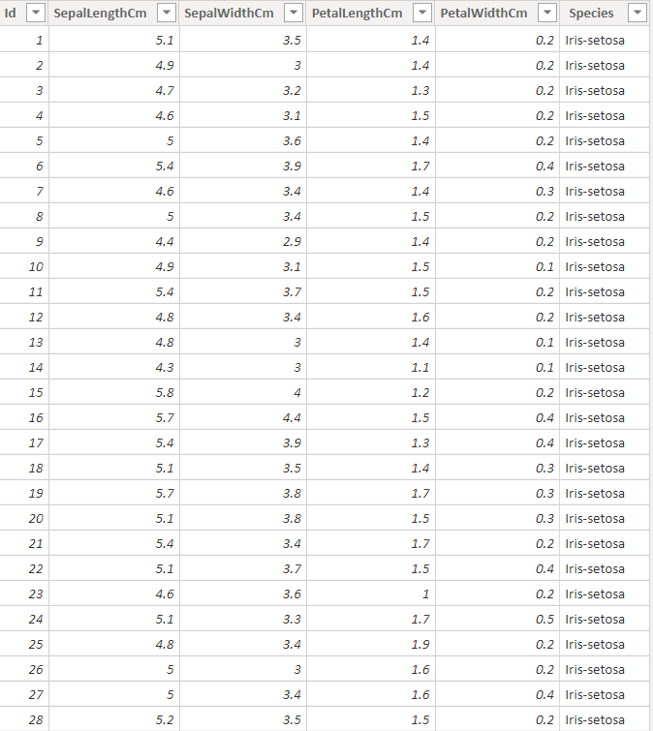
Figure 4.1
Above is table of the iris data set.Then I choose 2 features to see the distribution of 3 kinds of iris flowers. The figure is shown below. We can the data are separated clearly based on the 2 attributes PetalLengthCm and SepalLengthCm.
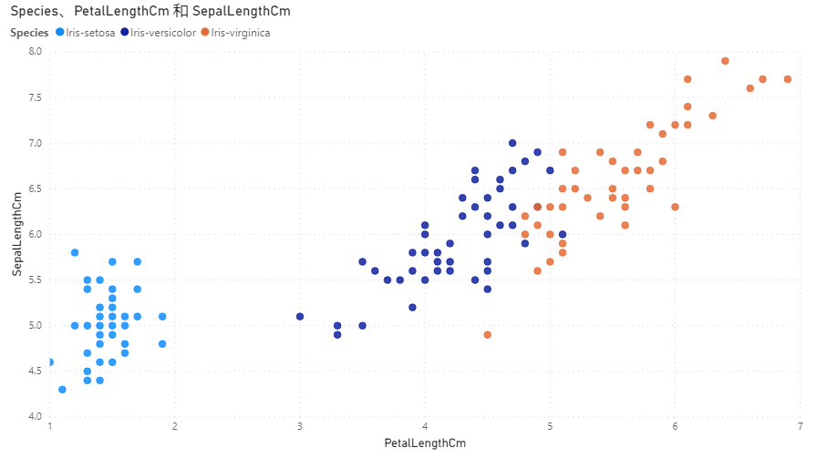
Figure 4.2
Also I create a bar chart, you can see that setosa has the largest sepal width. Versicolor has the smallest sepal width. Also we can see the relation of the tendency of the other 3 factors with the 3 flowers: For the other 3 factors, setosa has the smallest value and virginica has the largest value.
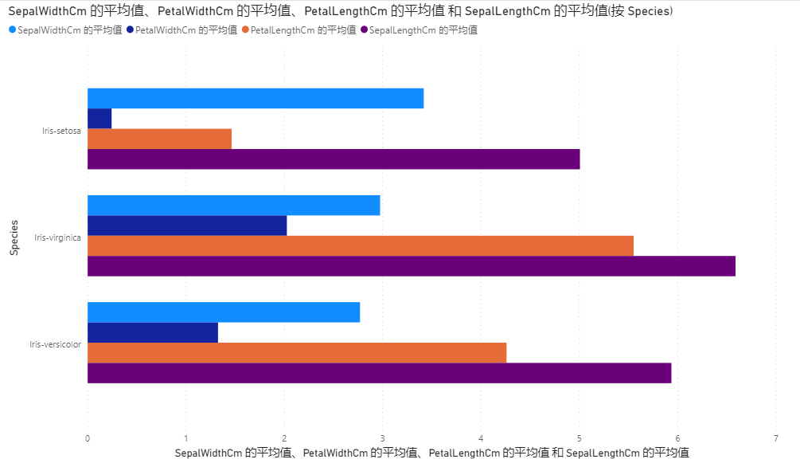
Figure 4.3

Fourth is the Letter Image Recognition Data
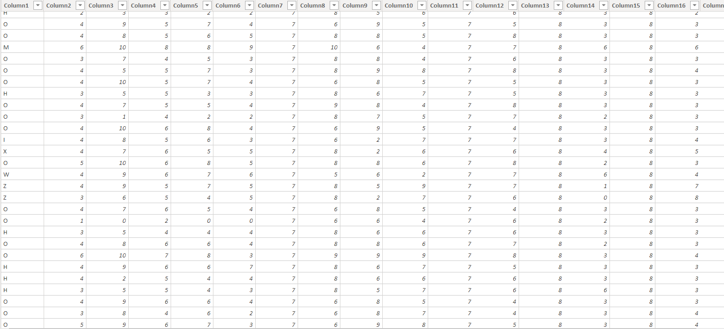
Figure 5.1
Attribute Information:
1. letter capital letter (26 values from A to Z)
2. x-box horizontal position of box (integer)
3. y-box vertical position of box (integer)
4. width width of box (integer)
5. high height of box (integer)
6. onpix total # on pixels (integer)
7. x-bar mean x of on pixels in box (integer)
8. y-bar mean y of on pixels in box (integer)
9. x2bar mean x variance (integer)
10. y2bar mean y variance (integer)
11. xybar mean x y correlation (integer)
12. x2ybr mean of x * x * y (integer)
13. xy2br mean of x * y * y (integer)
14. x-ege mean edge count left to right (integer)
15. xegvy correlation of x-ege with y (integer)
16. y-ege mean edge count bottom to top (integer)
17. yegvx correlation of y-ege with x (integer)

26 Labels/ 26 Classes: from A to Z

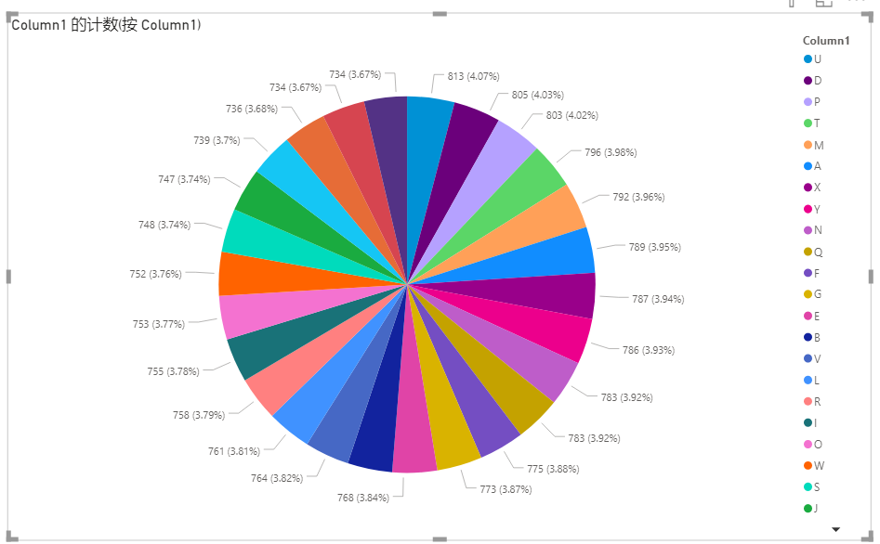
Figure 5.2
From the distribution diagram, It can be seen that the distribution of these data of the alpha are even and balanced.

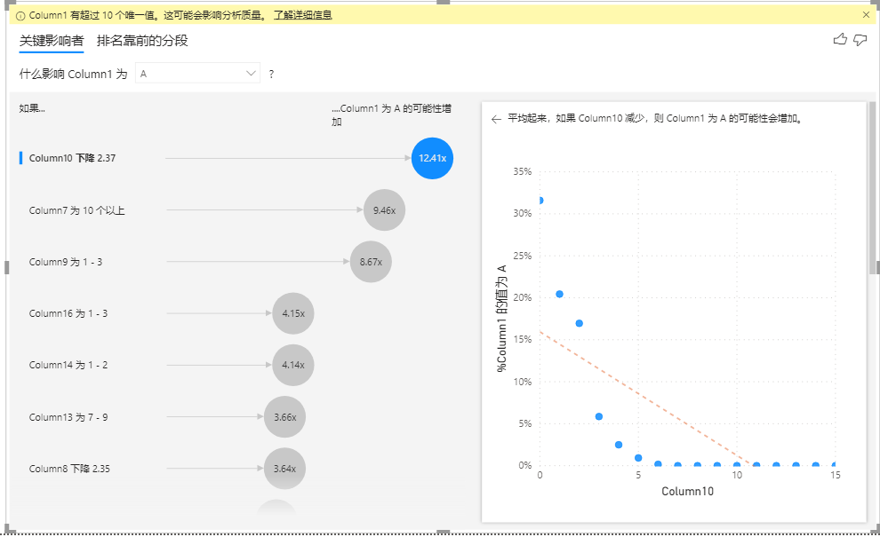
Figure 5.3
We can see from the figure that col 10 which is y2bar mean y variance is the most effective and dominant factor.

Last is comment on twitter data set.
The dataset contains three distinct categories: “hate speech,” “offensive,” “neither,”
which labeled as 0,1,2.

the source is importantly reliable provided by the researchers, they have used the Twitter API
that they searched for tweets containing terms from the lexicon, and extracted the time-line
for each user, resulting in a set of 85.4 million tweets.they took a random sample from
this and asked CrowdFlower(CF) workers to label each tweet as one of three
categories: hate speech, offensive, and neither.

The dataset has following attribute:
index count hate_speech offensive_lang neither class tweet

Below is the table of the data.
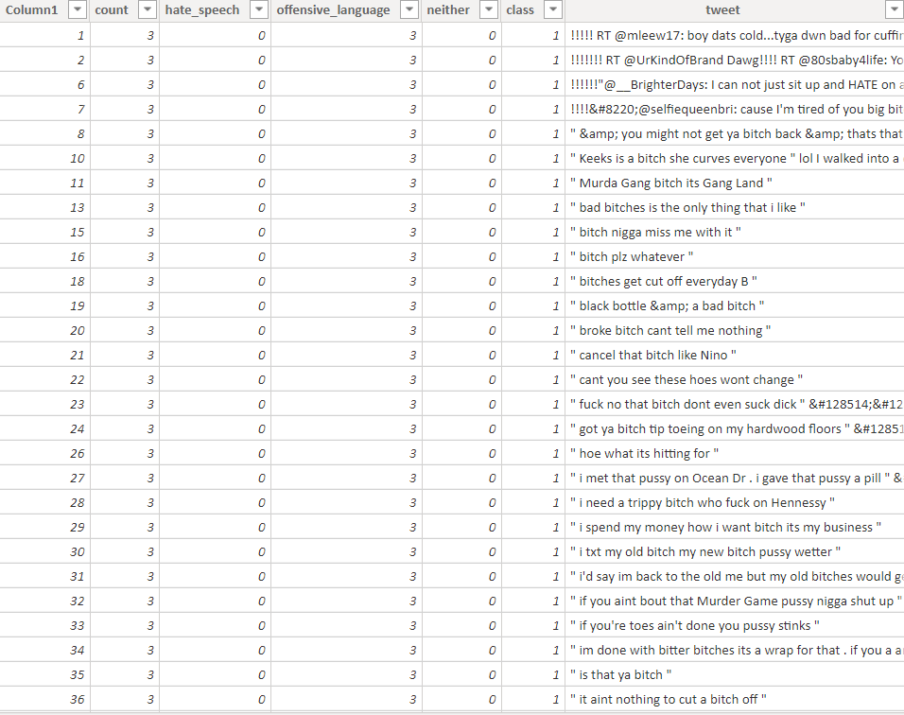
Figure 6.1
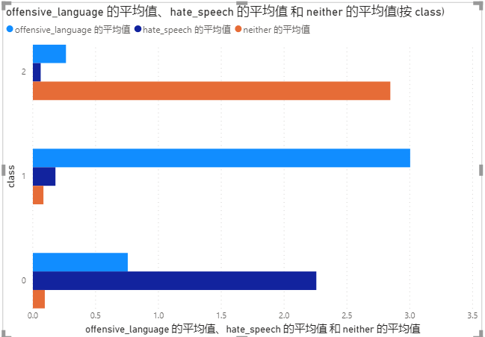
Figure 6.2
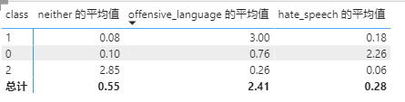
Figure 6.3
The 2 pictures above show the relation between the average value and classes. But in my experiment, I actually tried twice using the numerical data or not using it. For the one using numerical inputs, I just combine the numerical inputs and the encoded integer got from the tweet text after feature hashing, this trial has the accuracy of 99.9% ! For the one just considering the twitter text, I just analyze the encoded integer and input them into a classification model, the accuracy for this trial is over 80% .

