Simon Chen
N10013388
sc4900
Homework 5

1)

Pseudo Code:
1) Give menu to the user
2) Take in input of user
3) Perform intended input of user, quit if he chooses
4) Create appropriate functor
5) Run perform_if with the functor, print functor
6)Repeat

Preconditions: The user gives a valid input, if not prompt for a valid input
Postconditions: Check if perform_if returns 0, if it does tell the user's input was not found

O(n)

2)
(a)
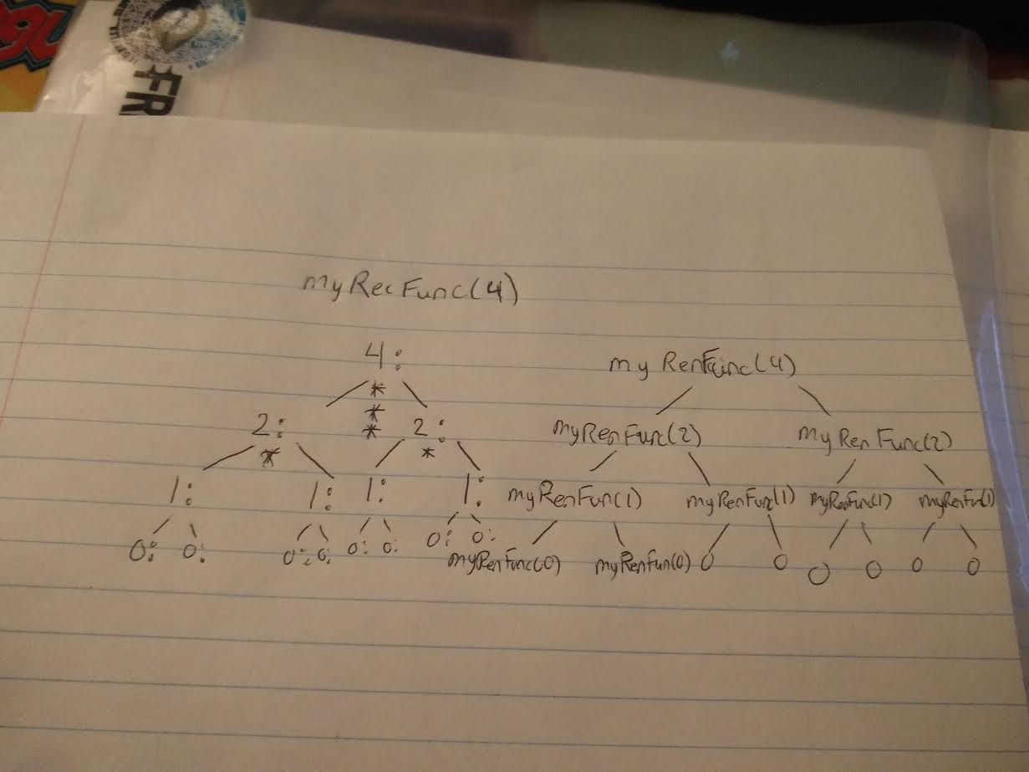
(b)
4: 2: 1: 0: 0:
1: 0: 0:
*
2: 1: 0: 0:
1: 0: 0:
*
***
(c) nlog(n)

3)
(a)
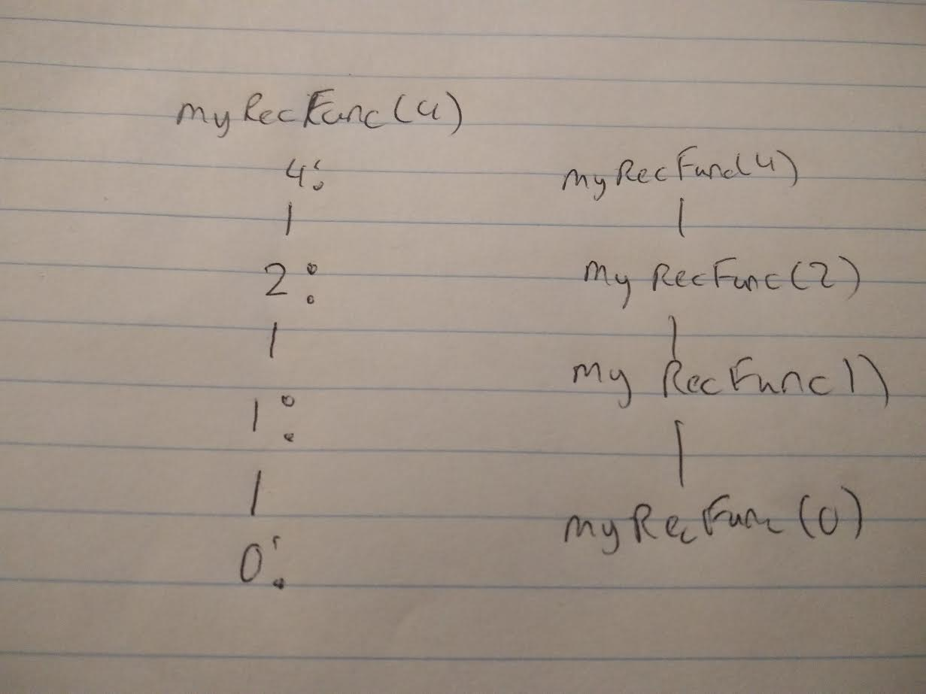
(b)
4: 2: 1: 0: 0
(c) log(n)

4) 17

Work:
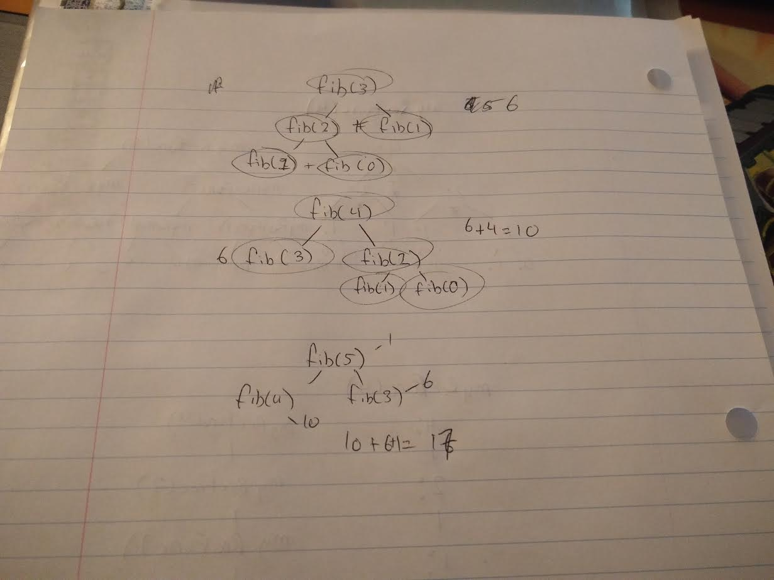

5)
0,8,9,-11,2,0,3
-11,8,9,2,0,3
-11,2,8,9,0,3
-11,0,2,8,9,3
-11,0,2,3,8,9

6)
8,-11,9,2,0,3
8,-11,9,2,0,3
-11,0,2,3,8,9

7)
0-11,8,3,2,0,9,
-11,0,2,9,8,3,
-11,0,2,3,8,9,

8)
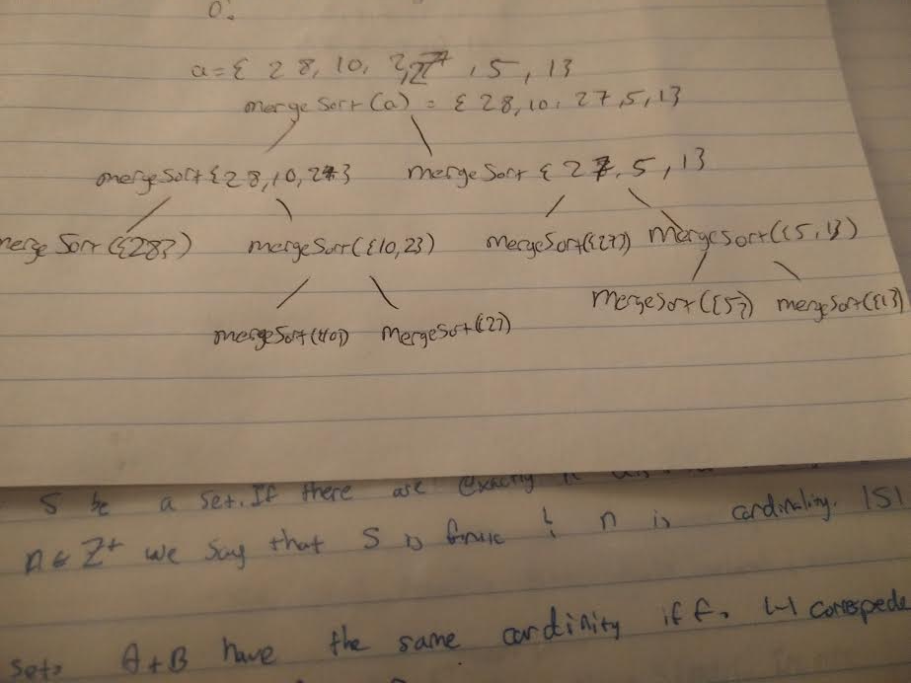

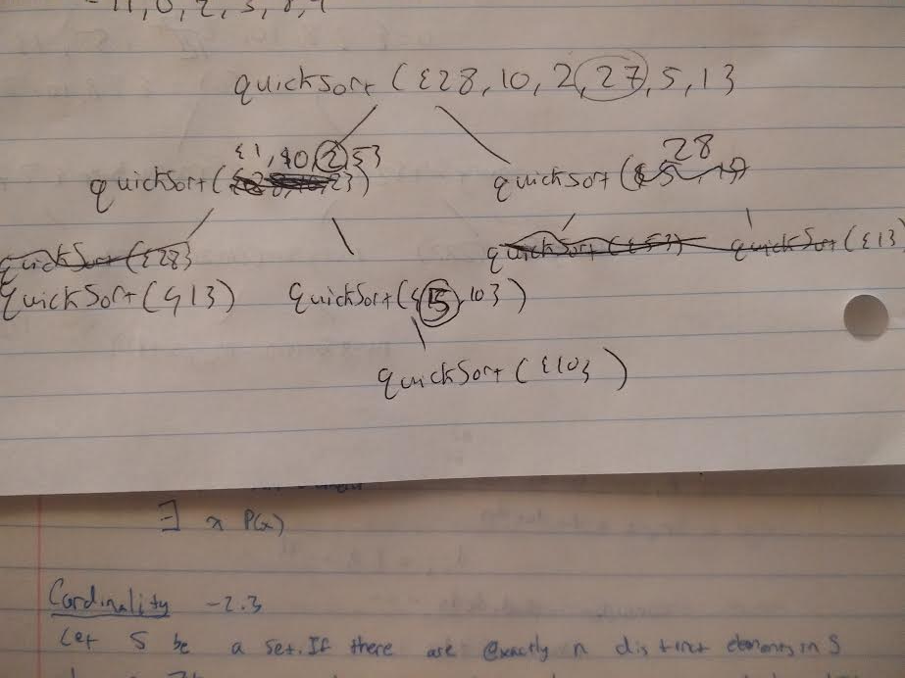

9)
insertion sort: O(n)
merge sort: O(nlog(n))
quick sort: O(nlog(n))

10)
log(n)
11)
The I = k+1 check is done, because when it is the k+1 item it is the nth item from the end of the list, which means that item is the item we're looking for in the sorted order.

