Simon Chen
N10013388
sc4900
Homework 6

1)
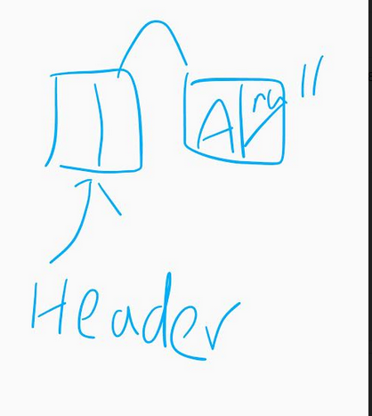

2)
(a) No
(b) No

3)
(a) Yes
(b) No
(c)Yes
(d)Np

4)
(a)Valid
(b)Invalid, because list iterators are bidirectional and not random, so you can't add/subtract indexes
(c)Valid

5)No, if the object is in the node right after the header node, it won't check the object and it won't get deleted. Also once it gets the the object before the nullptr, it'll try to access the prev->next->data which is the nullptr's data which could crash the program or return a nonsenscial value depending on the compiler.

