Indian Fresher Job Market Analysis 2025
A Data Analytics Project Report | Python · Pandas · Plotly · Streamlit
Dataset: Indian_Fresher_Salary_Skills_2025.csv | 500 Job Listings | 2023–2025 Graduates
Key Performance Indicators
Total Jobs | Avg Salary (LPA) | Companies | Offer Rate | Remote Jobs % | Top Role | Top Skill
500 | Rs 6.87 LPA | 8 | 50.8 % | 47.0 % | Data Scientist | SQL

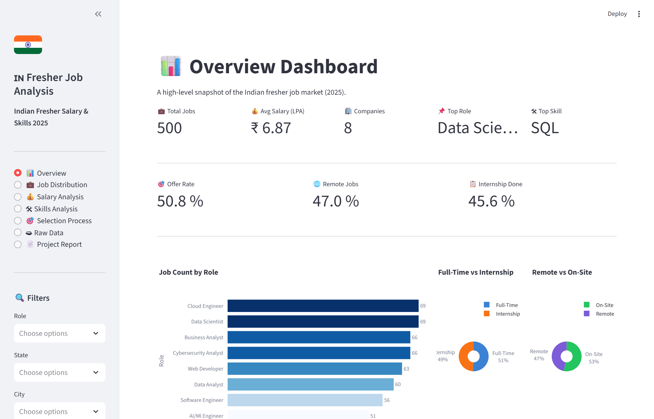
Figure 1: Overview Dashboard — KPI metrics, salary distribution, top role and skill charts

1. Project Objective
This project performs an end-to-end data analytics study of the Indian fresher job market using a structured dataset of 500 job listings. The core objectives are:
- Help fresh graduates understand salary expectations, in-demand skills, and hiring patterns across roles, cities, and company types.
- Assist employers and recruiters in benchmarking compensation and identifying skill gaps in the fresher talent pool.
- Provide career counsellors with evidence-based guidance on degrees, skills, and locations to recommend to job-seeking graduates.
- Build a fully interactive Streamlit dashboard with real-time filters for role, city, skill, work type, and more.

2. Dataset Description
The dataset Indian_Fresher_Salary_Skills_2025.csv contains 500 rows and 21 columns covering fresher job listings posted in India for 2023–2025 graduation cohorts.
Property | Value
File Name | Indian_Fresher_Salary_Skills_2025.csv
Total Records | 500 job listings
Total Columns | 21
Graduation Cohorts | 2023, 2024, 2025
Unique Roles | 8
Unique Companies | 8 (Infosys, Deloitte, Wipro, Capgemini, Cognizant, Accenture, TCS, Startup)
Cities | Noida, Mumbai, Chennai, Delhi, Hyderabad, Kolkata, Bangalore, Pune
States | UP, Telangana, Tamil Nadu, Karnataka, Delhi, West Bengal, Maharashtra
Skills Tracked | SQL, AWS, Java, Power BI, Machine Learning, Excel, Python, Linux
Salary Range (LPA) | Rs 3.03 to Rs 11.94 (Avg: Rs 6.87)

All 21 columns: job_id, role, company, company_type, city, state, degree, graduation_year, skills, primary_skill, experience_required, internship_experience, remote, work_type, salary_lpa, stipend_if_intern, selection_rounds, aptitude_test, coding_test, interview_count, offer_made.

3. Tech Stack
Tool / Library | Version | Purpose in This Project
Python | 3.10+ | Core programming language for all modules
Pandas | 2.0+ | Data loading, cleaning, transformation, groupby aggregations, cross-tabs
NumPy | 1.26+ | Numerical operations and dtype handling (used by Pandas internally)
Plotly Express | 5.20+ | Interactive bar, pie, box, histogram, heatmap charts in the dashboard
Streamlit | 1.35+ | Multi-page interactive web dashboard with real-time sidebar filters

4. Data Cleaning
The raw CSV was processed through a 7-step cleaning pipeline in modules/data_loader.py before any analysis was performed. Results: 0 duplicates, 0 missing values found.
Step | Action | Result
1 – Whitespace Stripping | Strip leading/trailing spaces from all string columns | Clean text, no padding artefacts
2 – Case Standardisation | Title-case all categoricals; fix acronyms (SQL, AWS, Power BI, MNC) | Consistent display names
3 – Binary Flag Decoding | Map 0/1 integers to Remote/On-Site, Yes/No, Offer Made/No Offer | Human-readable filter labels
4 – Skills List Expansion | Parse comma-separated skills into a Python list (skills_list column) | Enables per-skill frequency & salary analysis
5 – Duplicate Removal | Check for duplicate rows | 0 duplicates found
6 – Missing Value Check | Verify all 21 columns for null values | 0 missing values found
7 – Dtype Enforcement | Cast numeric columns to float64/int64 | Prevents type errors in aggregations

5. Analysis Performed

5.1 Job Distribution Analysis
Method: value_counts() on each categorical column to compute frequency and percentage share. Cross-tabulations (groupby on two columns) for role × work type and role × remote. A city × role heatmap is built from a pivot table fed into Plotly's px.imshow.
Role | Count | % Share
Data Scientist | 69 | 13.8%
Cloud Engineer | 69 | 13.8%
Cybersecurity Analyst | 66 | 13.2%
Business Analyst | 66 | 13.2%
Web Developer | 63 | 12.6%
Data Analyst | 60 | 12.0%
Software Engineer | 56 | 11.2%
Ai/Ml Engineer | 51 | 10.2%

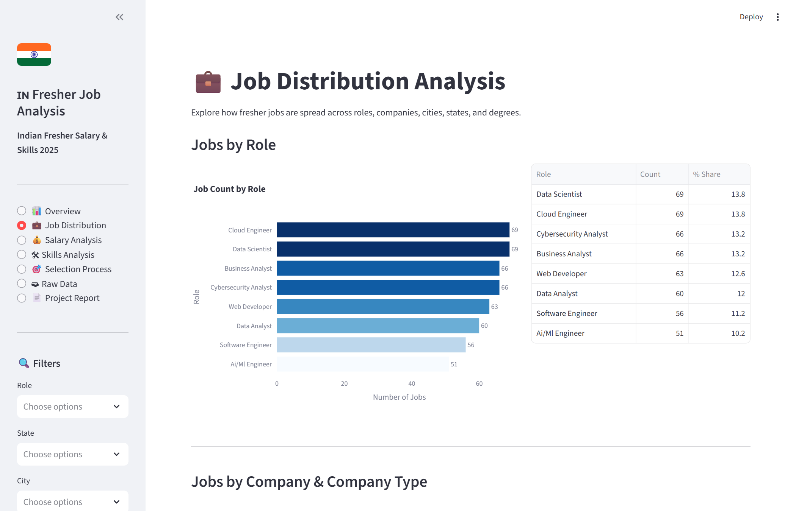
Figure 2: Job Distribution Page — jobs by role, company, city, state, degree, work type and city-role heatmap

5.2 Salary Analysis
Method: groupby(column)[salary_lpa].agg([mean, median, min, max, count]) applied across role, company, city, state, degree, experience level, internship status, work type, and primary skill. Box plots show spread; histogram shows distribution shape.
Role | Avg (LPA) | Median | Min | Max | Jobs
Ai/Ml Engineer | 9.18 | 9.45 | 6.03 | 11.82 | 51
Data Scientist | 8.89 | 9.07 | 6.04 | 11.94 | 69
Cloud Engineer | 7.42 | 7.51 | 5.23 | 9.95 | 69
Cybersecurity Analyst | 7.20 | 7.02 | 5.06 | 9.93 | 66
Data Analyst | 5.69 | 5.70 | 3.05 | 7.87 | 60
Business Analyst | 5.58 | 5.66 | 3.03 | 7.93 | 66
Software Engineer | 5.54 | 5.84 | 3.08 | 7.88 | 56
Web Developer | 5.52 | 5.61 | 3.05 | 7.96 | 63

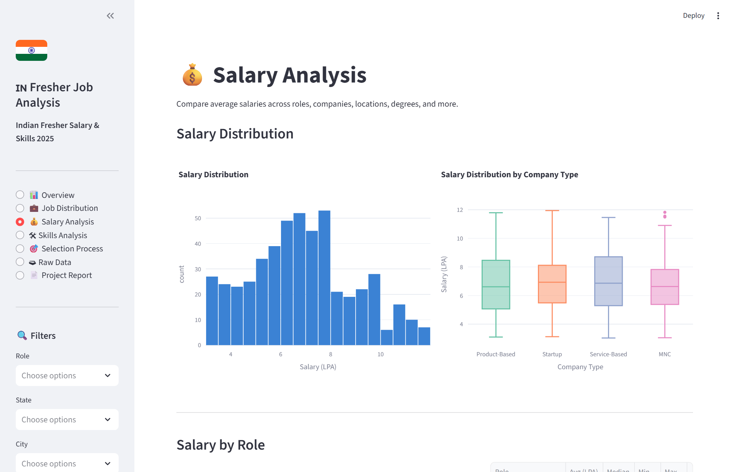
Figure 3: Salary Analysis Page — salary by role, company, location, degree, internship and skill

5.3 Skills Analysis
Method: The skills_list column is exploded into a long-form DataFrame (one row per job-skill pair) using _explode_skills(). Row counts give true frequency. A groupby(role) on the exploded frame returns the top 3 skills per role. Joining back to salary_lpa gives average salary per skill.
Skill | Frequency | % of Jobs
SQL | 197 | 39.4%
AWS | 196 | 39.2%
Java | 195 | 39.0%
Power BI | 187 | 37.4%
Machine Learning | 184 | 36.8%
Excel | 182 | 36.4%
Python | 180 | 36.0%
Linux | 179 | 35.8%

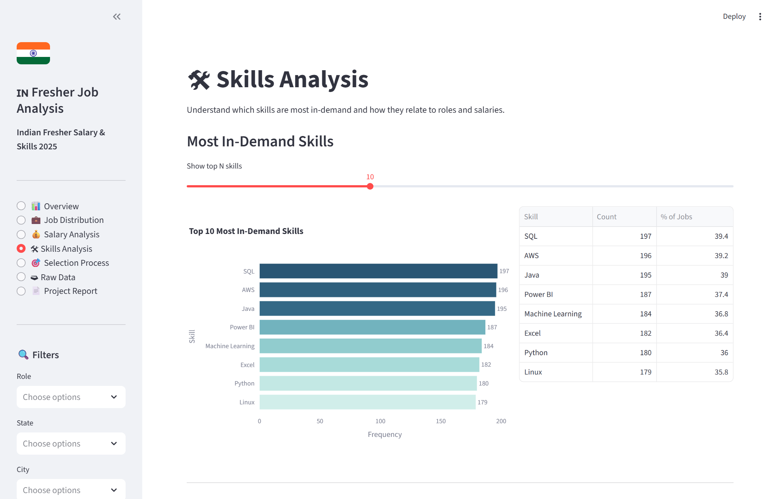
Figure 4: Skills Analysis Page — skill frequency, top skills per role, salary by skill

5.4 Selection Process & Offer Analysis
Method: groupby(selection_rounds)[offer_made].mean() for offer rate per round count. Cross-tab of aptitude_done x coding_done gives offer rate for every test combination. Selection funnel: Total Applicants → Aptitude Test → Coding Test → Interview → Offer.
Funnel Stage | Count
Total Applicants | 500
Aptitude Test | 244
Coding Test | 253
Interview | 500
Offer | 254

Selection Rounds | Total | Offers Made | Offer Rate (%)
2.0 | 116.0 | 57.0 | 49.1%
3.0 | 128.0 | 68.0 | 53.1%
4.0 | 113.0 | 64.0 | 56.6%
5.0 | 143.0 | 65.0 | 45.5%

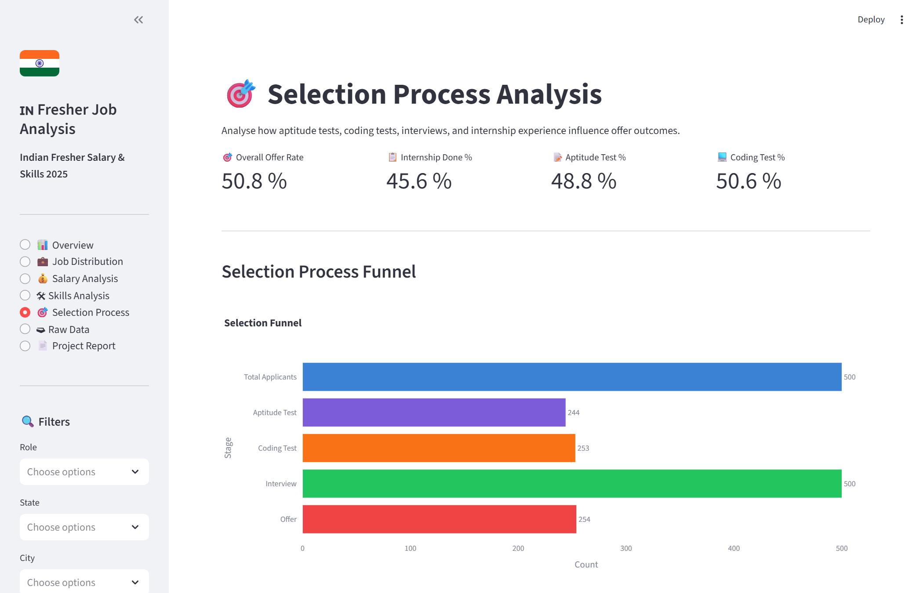
Figure 5: Selection Process Page — offer funnel, offer rate by rounds, test combinations, internship impact

6. Key Findings

6.1 Job Market
- 500 total job listings across 8 companies, 8 cities, and 7 states.
- Infosys and Deloitte posted the most jobs (71 each); Startup category follows with 70.
- Noida leads with 74 listings (14.8%), followed by Mumbai (69) and Chennai (67).
- Data Scientist and Cloud Engineer are the most common roles (69 each, 13.8%).
- 47% of all listings offer remote work; 54% are on-site.
- Startup (27%) and MNC (25.4%) company types dominate the listings.

6.2 Salary
- Average salary: Rs 6.87 LPA. Range: Rs 3.03 to Rs 11.94 LPA.
- AI/ML Engineer is highest paid at Rs 9.18 LPA; Data Scientist at Rs 8.89 LPA.
- Web Developer (Rs 5.52 LPA) and Software Engineer (Rs 5.54 LPA) are lowest paid.
- Kolkata (Rs 7.23 LPA) and Delhi (Rs 7.10 LPA) offer the highest city-level averages.
- Capgemini pays the most on average (Rs 7.18 LPA); Wipro the least (Rs 6.60 LPA).
- B.Com graduates earn Rs 7.35 LPA average — highest among all degree types.
City | Avg Salary (LPA)
Kolkata | Rs 7.23
Delhi | Rs 7.10
Hyderabad | Rs 6.98
Noida | Rs 6.85
Mumbai | Rs 6.82
Bangalore | Rs 6.76
Pune | Rs 6.71
Chennai | Rs 6.52

6.3 Skills
- SQL is the most demanded skill (197 listings, 39.4%), followed by AWS (196) and Java (195).
- All 8 tracked skills appear in 35-40% of listings — multi-skill profiles are the norm.
- AWS-primary roles offer the highest average salary (Rs 7.16 LPA).
- Every skill spans all 8 roles — no skill is exclusive to a single profession.
Primary Skill | Avg Salary (LPA)
AWS | Rs 7.16
Python | Rs 7.00
Excel | Rs 6.99
SQL | Rs 6.92
Linux | Rs 6.89
Power BI | Rs 6.71
Java | Rs 6.69
Machine Learning | Rs 6.64

6.4 Selection Process
- Overall offer rate: 50.8% (254 offers out of 500 listings).
- Aptitude test only: 54.3% offer rate — the highest of all test combinations.
- Coding test only: 46.3% offer rate — the lowest combination.
- 4-round selection processes yield the highest offer rate (56.6%).
- 5-round processes yield the lowest offer rate (45.5%) — more rounds reduces offer uptake.
- Freshers without internship experience had slightly higher offer rate (52.9% vs 48.2%).
Aptitude Test | Coding Test | Total | Offers | Offer Rate (%)
No | No | 120 | 61 | 50.8%
No | Yes | 136 | 63 | 46.3%
Yes | No | 127 | 69 | 54.3%
Yes | Yes | 117 | 61 | 52.1%

7. Business Insights
For Freshers:
- Prioritise SQL, Python, AWS, and Power BI — these appear in the widest range of roles.
- Target AI/ML Engineer or Data Scientist roles for maximum salary — they pay Rs 2-3 LPA more than Web Developer or Software Engineer roles.
- Noida, Delhi, and Mumbai have the most listings. Nearly half of all jobs are available remotely.
- Prepare specifically for aptitude tests — they correlate with the highest offer rates among all test combinations.
- Any degree can get you hired — BCA and B.Com holders are well-represented alongside B.Tech/M.Tech graduates.
For Employers:
- The Rs 6-8 LPA band is the competitive sweet spot for attracting quality fresher candidates.
- 3-4 selection rounds optimises offer conversion rate. Adding a 5th round reduces offer uptake by ~11 percentage points.
- Including an aptitude test in the pipeline correlates with better offer outcomes vs. coding-test-only pipelines.
- Remote flexibility (offered in 47% of listings) is now a baseline expectation for freshers, not a differentiator.

8. Dashboard UI Summary
The Streamlit dashboard (app.py) delivers 7 pages with interactive Plotly charts. All charts and KPIs respond in real time to sidebar filter changes.
Page | What It Shows
Overview | 8 KPI metrics, salary histogram, top role bar chart, top skills bar chart
Job Distribution | Jobs by role, company, city, state, degree, work type; city-role heatmap
Salary Analysis | Salary by role, company, location, degree, internship, skill, graduation year
Skills Analysis | Skill frequency, top skills per role, salary by skill, primary skill distribution
Selection Process | Offer funnel, offer rate by rounds, test combinations, internship impact
Raw Data | Browse and download the cleaned dataset as CSV; descriptive statistics
Project Report | Full written report rendered in-app with download as Markdown button

Sidebar filters: Role, State, City, Work Type, Remote/On-Site, Degree, Experience Level, Internship Done, and Skill.
Screenshots of all 7 dashboard pages:
Overview Page — KPIs, salary histogram, top roles and skills
Job Distribution Page — role, company, city, state charts and heatmap
Salary Analysis Page — salary by role, company, location, skill
Skills Analysis Page — demand frequency, top skills, salary by skill
Selection Process Page — offer funnel, round analysis, test combinations
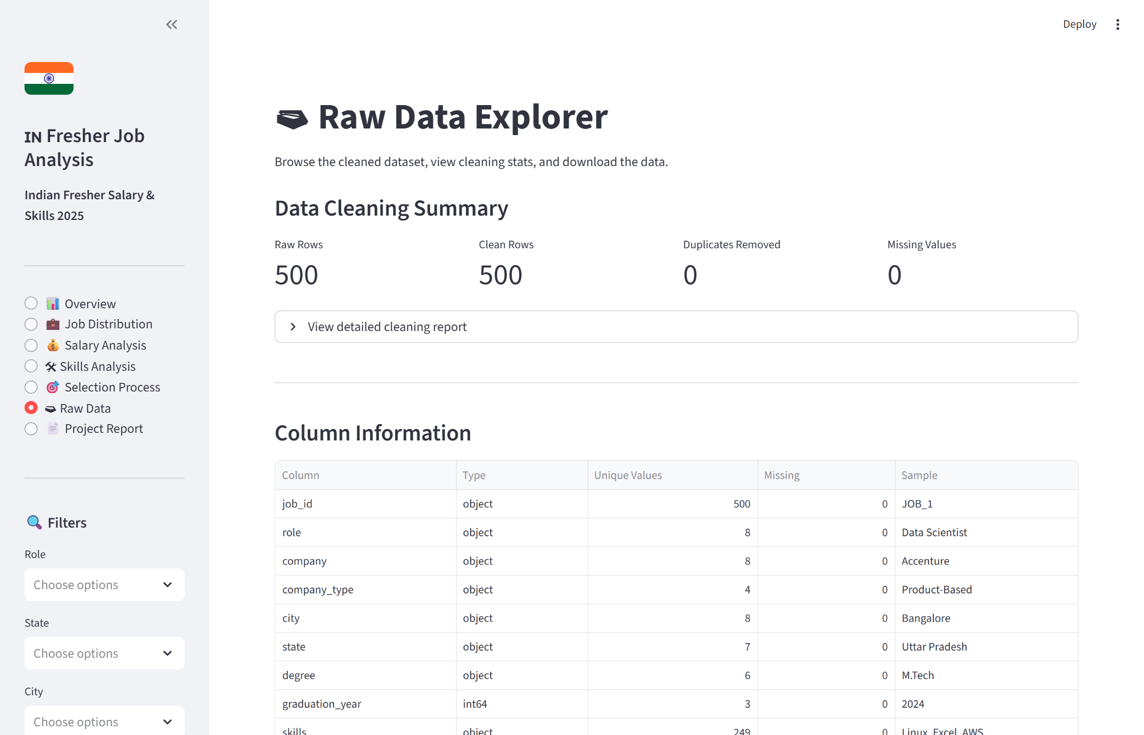
Raw Data Explorer Page — filterable table with CSV download
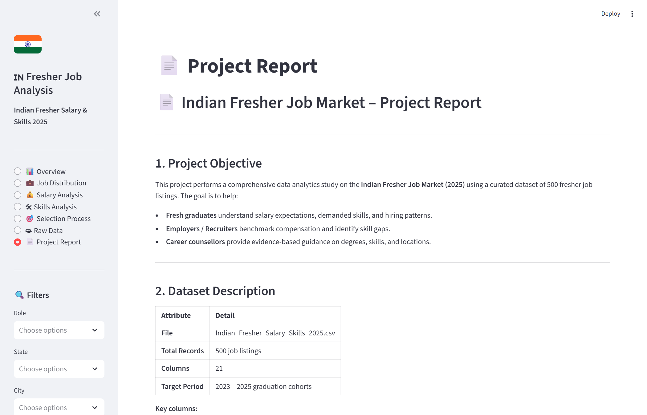
Project Report Page — full written report rendered in-app

9. Limitations
# | Limitation
1 | Curated dataset — may not reflect all real-world hiring noise (salary negotiation, etc.)
2 | No timestamps on postings — time-series / trend analysis is not possible
3 | Only 8 companies — findings may not generalise to all Indian employers
4 | Each job lists only 3 skills — actual job descriptions may require many more
5 | No gender / demographic data — pay-equity analysis cannot be performed
6 | Only 8 cities and 7 states — tier-2 and tier-3 city dynamics not captured

10. Future Improvements
- Scrape live data from Naukri, LinkedIn, or Internshala to enrich and validate findings.
- Add time-series trend analysis once multi-year timestamped data is available.
- Expand geography to tier-2 and tier-3 cities (Coimbatore, Jaipur, Ahmedabad, etc.).
- Apply NLP on job description text to extract richer skill taxonomies beyond 8 skills.
- Compare fresher salary data with experienced hire benchmarks to quantify the experience premium.
- Add export-to-PDF from the Streamlit dashboard for sharing filtered reports.

Indian Fresher Job Market Analysis 2025 | Built with Python, Pandas, Plotly & Streamlit

