***COSTCO***

**LIST OF REQUIREMENTS: -**

1. Access customer account: Enable both customers and staff members to access a user-friendly interface where they can effortlessly view and efficiently handle customer account information, encompassing diverse facets such as membership status, previous transactions, and important personal data for a personalized and streamlined experience.
2. Update membership details: Customers can easily access their accounts through both online platforms and physical stores, granting them the convenience to make changes such as upgrading their memberships, renewing subscriptions, or modifying personal information swiftly and efficiently.
3. Search inventory: Enable both customers and employees to conveniently access up-to-date information on inventory availability for a wide range of products at different locations, ensuring seamless management and informed decision-making for all stakeholders involved.
4. Place bulk orders: Customers have the convenient option to easily place bulk orders through the user-friendly interface of our website or the handy mobile app, ensuring a seamless shopping experience across different platforms.
5. Cancel sales order: The system should include user-friendly options that allow customers and staff members to easily cancel orders that are still pending processing or have not been shipped yet.
6. Edit customer order: Customers are welcome to request adjustments to their orders, such as altering the quantity of items or swapping out products, as long as these changes are made prior to the designated deadline set for order modifications.
7. Process returns and refunds: Enable efficient handling of returns and processing of refunds both online and at physical locations.
8. Schedule deliveries and pickups: Customers are provided with the flexibility to choose between scheduling the delivery of their purchased goods or opting for in-store pickups, allowing them to select the option that best suits their preferences and convenience.
9. Track customer loyalty and rewards: As the overseer of a sophisticated system, your responsibilities include diligently tracking customer purchases, applying accrued loyalty points, and rewarding loyal patrons with the appropriate perks and benefits.

**RESEARCH PAPER DOCUMENT GATHERING: -**

* I used a number of requirements collecting approaches to identify the most relevant needs for a system created for Costco:
* Interviews with Stakeholders: Conducting interviews with Costco’s management, employees, and select customers to understand their needs and pain points. This direct communication helps pinpoint specific functionalities required in the system.
* Observation: Visiting various Costco locations to observe operations, customer interactions, and employee tasks to identify system needs that support these activities efficiently.
* Market Analysis: Analyzing competitors and similar retail operations to identify industry standards and innovative practices that could be beneficial to incorporate
* Document Analysis: Reviewing existing documents and reports from Costco, like operational manuals, training materials, and IT system documentation to understand the current state of their system and identify areas for improvement.
* Surveys and Questionnaires: Deploying surveys to a broader customer base will allow us to collect valuable insights on user satisfaction, understand usability issues that may arise, and identify desired features that will enhance the functionality of the new system.
* Workshops: Facilitating workshops with different department heads to brainstorm and prioritize the needs that the new system should meet.

**The Reason I choose these sources and techniques: -**

The selection of these specific techniques was carefully done by evaluating their track record of delivering precise, actionable feedback from both real users and stakeholders actively involved in the process. This approach emphasizes the significance of interviews and observational studies which play a crucial role in grasping the day-to-day operational hurdles faced. Additionally, delving into document analysis establishes a solid groundwork rooted in current methodologies, thereby promoting consistency and enhancement within the organizational framework. Through a comprehensive examination of market dynamics, the competitive positioning of Costco is thoroughly explored to guarantee that any future enhancements or upgrades are not only aligned with internal requirements but also strategically aligned with external market conditions, challenges, and opportunities on the horizon. This strategic outlook ensures that Costco's operational efficiency and strategic decision-making processes are not only internally robust but also outwardly competitive in the ever-evolving market landscape.

Data Flow Diagrams: Draw the Context Diagram, Level 0 Diagram, and Level 1 DFD diagrams that depict at least 2 processes identified in the Level 0 Diagram. Use Visio to draw these diagrams.

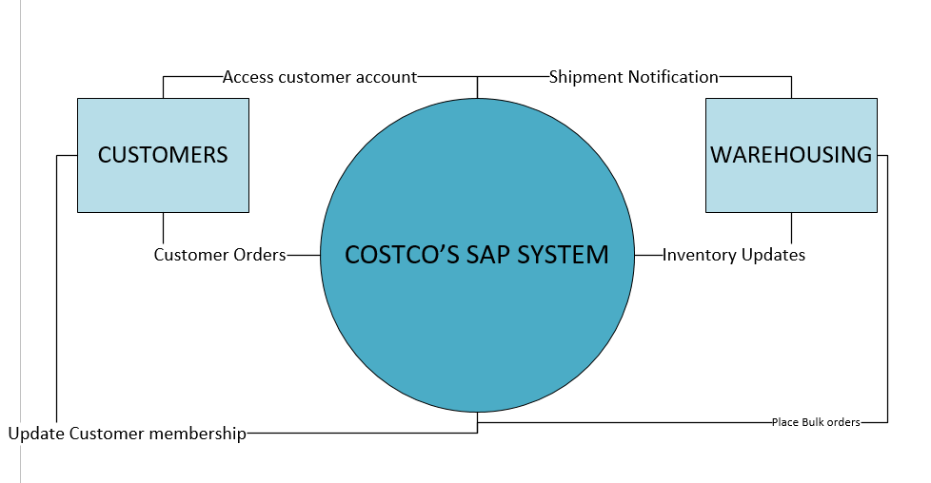

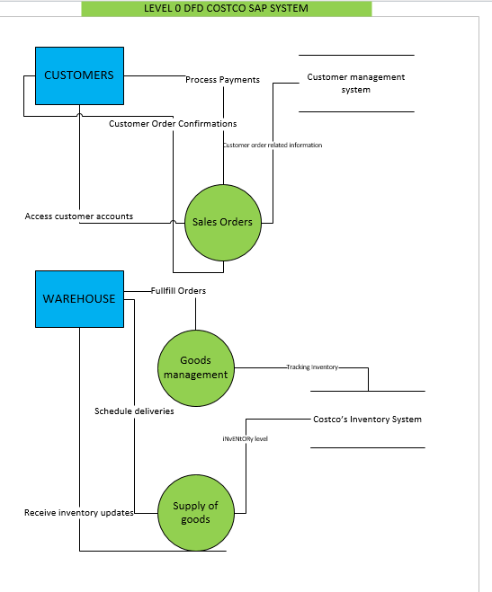

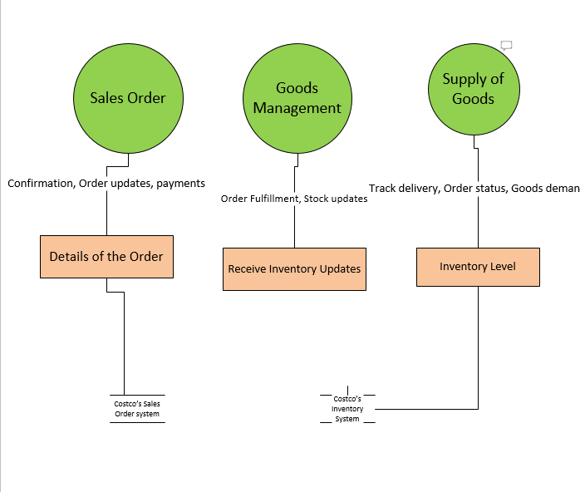

USE CASE DIAGRAM: -

