Lab 5: Inheritance

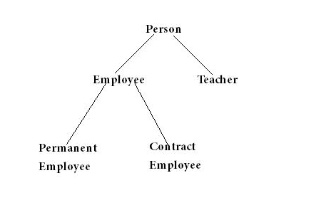

public class Person {  
  
    String name;  
    int age;  
  
    public Person(String n, int a) {  
        name = n;  
        age = a;  
    }  
  
    public void printDetails() {  
        System.out.println("Name: " + name);  
        System.out.println("Age: " + age);  
    }  
}

Student : name , age, major, and gpa

Teacher:name, age, faculty

Employee:name, age, employeeId,

PermanentEmployee:name, age, employeeId, salary

ContractEmployee: name, age, employeeId, payment

Write test program to

1 create object and call every methods

2 create an ArrayList to keep every object that created in 1.