
Tribhuvan University
Institute of Science and Technology
Amrit Campus

Lab Report on
Neural Network (CSC-372)

Submitted to:
Department of Computer Science & Information Technology Amrit Campus, Thamel, Kathmandu
Tribhuvan University

In partial fulfillment of the requirement for the Bachelor’s Degree in Computer Science & Information Technology

Submitted by:
Type Your Name Here
Roll No.: Type Your Roll No / Type Your Batch

Submitted To
Mr. Akkal Bahadur Bist
Department of Computer Science & Information Technology Amrit Campus, Thamel, Kathmandu

August, 2025

Tribhuvan University
Institute of Science and Technology
Amrit Campus
Department of Computer Science and Information Technology

Student’s Declaration

I hereby declare that I am the only author of this lab work and the information contained in this lab report is entirely original and that no sources other than those listed below were consulted in its creation.

.................................................
Type Your Name Here
Roll No. Type Your Roll No. / Type Your Batch Date: Type Date Here

Tribhuvan University
Institute of Science and Technology
Amrit Campus
Department of Computer Science and Information Technology

Lab Work Approval

This is to certify that I have reviewed the lab work submitted by the student mentioned above and approve it as satisfactory. The lab work meets the required academic standards of the course B. Sc. CSIT VI Semester Neural Network (CSC-372).

..........................................
Mr. Akkal Bahadur Bist Department of CSIT Amrit Campus, TU Date: .........

Table of Contents

Lab-1: Write a python program to create a neuron and predict its output using the threshold activation function. 1
Lab-2: Write a python program to train an AND Gate Using Percep-
tron Learning Algorithm. 2
Lab-3: Write a python program to train perceptron using given train-
ing set and predict class for the input (6,82) and (5.3,52). 3
Lab-4: Write a python program to implement Min-Max Scalar. 4
Lab-5: Write a python program to implement Standard Scalar. 5
Lab-6: Implement Backpropagation algorithm to train an ANN of configuration 2x2x1 to achieve XOR function. 6
Lab-7: Implement Backpropagation algorithm to train an ANN of configuration 3x2x1x1 to achieve majority function with 3-bit data.
Output of the network must be 1 where there are two or more 1’s in
the data. 7
Lab-8: Write a Python program to solve the XOR problem using Radial Basis Function (RBF) function taking (0,0) and (1,1) as centers. 8
Lab-9: Implement the K-Means algorithm without using libraries for the given dataset: D=(1,1),(2,1),(4,3),(5,4). Where, k=2. Select two points as initial centroids, assign points to the nearest centroid using Euclidean distance, update centroids as the mean of assigned points,
repeat until convergence, and print the final clusters with centroids. 9
Lab-10: Write a Python program to implement a 2×2 SOM to clus- ter the points (0.1,0.8),(0.5,0.4),(0.3,0.7),(0.9,0.2) and show weight
updates for 5 iterations. 10
Lab-11: Write a Python program to implement Learning Vector Quan- tization (LVQ) for the dataset (1,1) → 0,(2,1) → 0,(4,3) → 1,(5,4) →
1, update prototypes for 5 iterations, and classify the dataset. 11
Lab-12: Write a Python program to implement an RNN with three hidden nodes to predict the letter ’L’ in the word ’ASCOL’ given the letters ’A’, ’S’, ’C’, and ’O’. Assume Tanh activation for the hid- den layer and softmax activation for the output layer, and show the
forward propagation step-by-step. 12
Example: Self Organizing Map (SOM) 13

Lab-1: Write a python program to create a neuron and predict its output using the threshold activation function.
This lab work is assignemd from [1]

Lab-2: Write a python program to train an AND Gate Using Perceptron Learning Algorithm.
Start from here....

Lab-3: Write a python program to train perceptron using given training set and predict class for the input (6,82) and (5.3,52).

Height (x₁) | Weight (x₂) | Class (t)
5.9 | 75 | Male
5.8 | 86 | Male
5.2 | 50 | Female
5.4 | 55 | Female
6.1 | 85 | Male
5.5 | 62 | Female
Start from here....

Lab-4: Write a python program to implement Min-Max Scalar.
Start from here.... if you need to insert image code here ...

Figure 1: This is the logo

Lab-5: Write a python program to implement Standard Scalar.
Start from here....

Lab-6: Implement Backpropagation algorithm to train an ANN of configuration 2x2x1 to achieve XOR function.
Start from Here ...

Lab-7: Implement Backpropagation algorithm to train an ANN of configuration 3x2x1x1 to achieve majority func- tion with 3-bit data. Output of the network must be 1 where there are two or more 1’s in the data.
Start from Here ...

Lab-8: Write a Python program to solve the XOR problem using Radial Basis Function (RBF) function taking (0,0) and (1,1) as centers.
Start from Here ...

Lab-9: Implement the K-Means algorithm without using libraries for the given dataset: D=(1,1),(2,1),(4,3),(5,4). Where, k=2. Select two points as initial centroids, assign points to the nearest centroid using Euclidean distance, update centroids as the mean of assigned points, repeat until convergence, and print the final clusters with cen- troids.
Start from Here ...

Lab-10: Write a Python program to implement a 2×2 SOM to cluster the points (0.1,0.8),(0.5,0.4),(0.3,0.7),(0.9,0.2) and show weight updates for 5 iterations.

Lab-11: Write a Python program to implement Learning Vector Quantization (LVQ) for the dataset (1,1) → 0,(2,1)
→ 0,(4,3) → 1,(5,4) → 1, update prototypes for 5 itera- tions, and classify the dataset.

Lab-12: Write a Python program to implement an RNN with three hidden nodes to predict the letter ’L’ in the word ’ASCOL’ given the letters ’A’, ’S’, ’C’, and ’O’. As- sume Tanh activation for the hidden layer and softmax activation for the output layer, and show the forward prop- agation step-by-step.

Example: Self Organizing Map (SOM)
Consider the following 2-D SOM and 3-D inputs. Show the working of SOM for the inputs
(0.25, 0.15, 0.55)

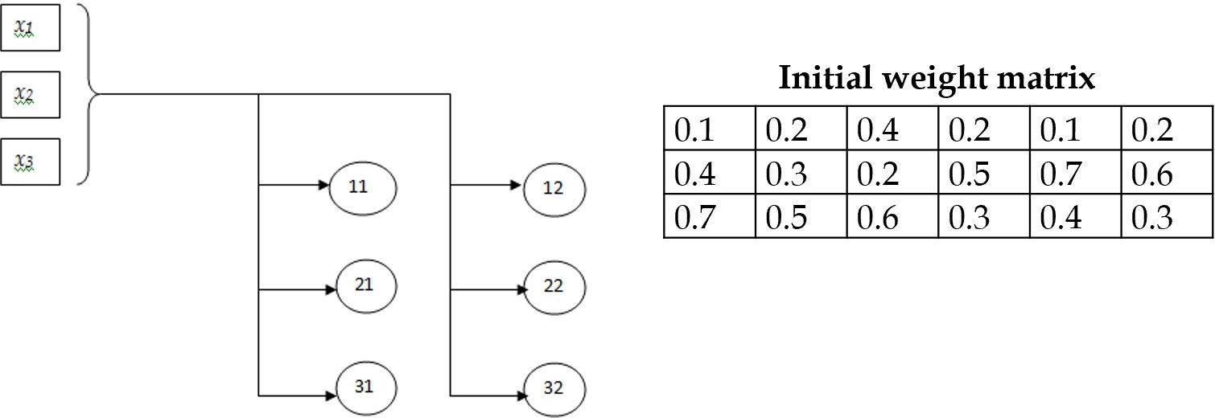

Figure 2: 2-D SOM with initial weight matrix

Solve this question using the Self-Organizing Map method.
Calculate:

and update weights. Assume The weight update formula is:
d₁ = d(x, w₁) α = 1, σ = 1

w_{j}(n + 1) = w_{j}(n) + αh_{ji}(x − w_{j}(n))
with
(
)

hji
(x⃗) = exp
d2
− 2σ2
ji

Self-Organizing Map Example
Consider a 2 × 3 SOM grid with the input
x = (0.25, 0.15, 0.55).
The initial weight matrix (columns correspond to neurons 11, 12, 21, 22, 31, 32):

0.1


W = 0.4
0.7
0.1 0.2
0.7 0.6 .


0.2 | 0.4 | 0.2
0.3 | 0.2 | 0.5
0.5 | 0.6 | 0.3

0.4 0.3

- Distance Calculation
The Euclidean distance for each node is:
d_{j} = x − w_{j} .
For the first neuron:
d₁₁ = √(0.25 − 0.10)2 + (0.15 − 0.40)2 + (0.55 − 0.70)2 = 0.3279.
Similarly,
d₁₁ = 0.3279, d₁₂ = 0.1658, d₂₁ = 0.1658,
d₂₂ = 0.4330, d₃₁ = 0.5895, d₃₂ = 0.5172.
The smallest distance is d₁₂ = d₂₁ = 0.1658. Assume tie-breaking chooses BMU = (1,2) = 12.

- Neighborhood Function
The neighborhood function:

hji
= exp(

d2
ji
)
− 2σ2

, σ = 1.

Grid distances from BMU (12):

Node | 11 | 12 | 21 | 22 | 31 | 32
Grid distance | 1 | 0 | √2 | 1 | √5 | 2
hji | 0.6065 | 1.0000 | 0.3679 | 0.6065 | 0.0821 | 0.1353

- Weight Update
The update rule:

Thus,

w^{(new)} = w_{j} + αh_{ji}(x − w_{j}), α = 1.

0.1910
j
W ^{(new)} = 0.2484
0.1123 0.2068
0.6549 0.5391 .
0.2500 | 0.3448 | 0.2303
0.1500 | 0.1816 | 0.2877

0.6090 0.5500 0.5816 0.4516 0.4123 0.3338
The BMU (12) exactly matches the input (h = 1), and all other nodes are shifted toward
x proportional to h_{ji}.

References
- Haykin, S.S. (2009). Neural Networks and Learning Machines. Pearson. ISBN 9780131293762.
- Vaswani, Ashish et al. (2017). Attention is all you need. Advances in Neural Infor- mation Processing Systems, 30.

