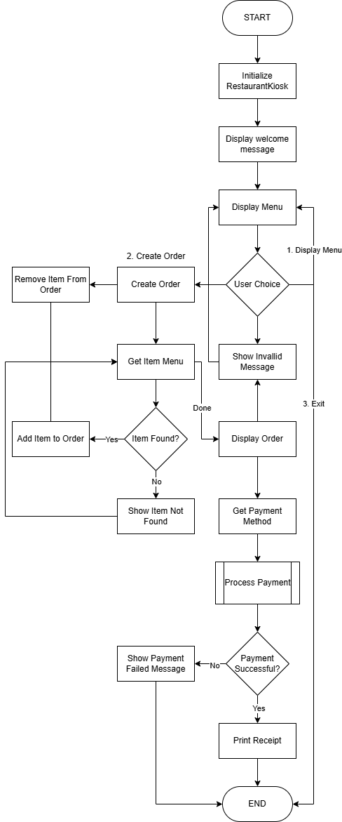

Restaurant Kiosk System Flowchart Explanation
Initialization and Welcome
The program starts by initializing the restaurant kiosk, which likely involves setting up the necessary data structures, connecting to any required databases or services, and preparing the system for user interaction. After the initialization, the system displays a welcome message to the user, setting the stage for the main functionality.

Menu Display
Following the welcome message, the system displays the menu of available items to the user. This is the entry point for the user to interact with the kiosk and begin the order creation process.

User Choices
The user is presented with three main options:
- Display Menu: The user can choose to display the menu again, which may be useful if they need to review the available items.
- Create Order: The user can select this option to start building their order.
- Exit: The user can choose to exit the program, terminating the session.

If the user selects an invalid option, the system displays an error message and redirects the user back to the menu display.

Order Creation
When the user selects the "Create Order" option, the system enters the order creation process. This involves the following steps:
- Get Item Menu: The user is prompted to enter the name of the menu item they would like to add to their order.
- Item Found?: The system checks if the entered item name matches an existing menu item. If the item is found, it is added to the order. If the item is not found, an error message is displayed.
- Display Order: Once the user is done adding items, the current order is displayed to the user.

During the order creation process, the user also has the option to "Remove Item From Order" if they need to make changes to their order.

Payment Processing
After the order is complete, the system prompts the user to select a payment method. The payment is then processed, and the system checks if the payment was successful.
- Process Payment: The payment is processed using the selected method.
- Payment Successful?: The system checks the status of the payment. If the payment is successful, the receipt is printed, and the program ends. If the payment is unsuccessful, an error message is displayed, and the program ends.

Error Handling
Throughout the flowchart, there are several steps dedicated to handling errors and invalid user input. For example, the "Show Invalid Message" step is triggered when the user selects an invalid option, and the "Show Item Not Found" step is displayed when the user enters a menu item that doesn't exist.

These error handling steps ensure that the system provides clear feedback to the user and guides them back to the appropriate part of the process, maintaining a smooth and user-friendly experience.
High level representation version
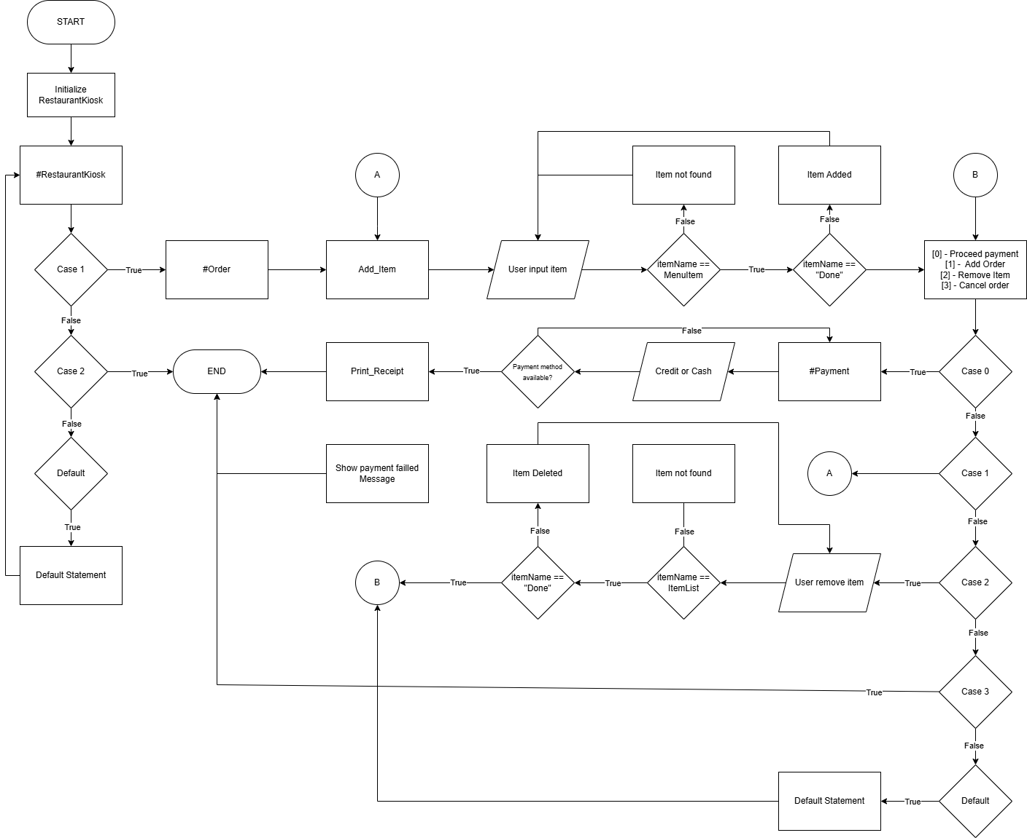
NOTE: This flowchart is same as the first one

