Before / After Comparison
HW3 · LinkShelf · Issue #3: Add Bookmark
Repository: https://github.com/Sijia711/linkshelf-p2

Method
I cloned the same Next.js starter project into two folders and opened a fresh Antigravity conversation for each. I used the same model and the same prompt. Both folders contained the PRD and mockup images. The only planned difference was that Experiment A did not have AGENTS.md, while Experiment B did. Both implementations used local state; neither connected to the database. No experimental changes were committed or pushed.

Results
Check | Without rules (A) | With rules (B)
Feature | Add Bookmark worked; extra search, tags, and delete UI | Add Bookmark worked; related dashboard UI
Test framework | Node.js test runner | Vitest + React Testing Library
Passing tests | 18 reported | 33 reported
Coverage | Not reported | 83.9% statements; 85.8% lines reported
Test scope | Validation, helper functions, flow-level logic | Validation, component interactions, homepage integration
Lint / build | Both reported passing | Both reported passing
Workflow guidance | No commit / PR guidance in report | Suggested issue-linked commit and PR text

What changed
Without rules, the AI still produced a usable feature and referenced the mockups on its own. With rules, it followed the requested Vitest approach, reported coverage, and provided issue-based commit/PR guidance. The test count increased from 18 to 33, although counts alone do not prove higher quality. Both versions implemented more related UI than the minimal prompt needed.

Limitation and refinement
These are results reported by the two Antigravity runs, not an independent audit. The different test frameworks also make a direct test-count comparison imperfect. To keep future AI changes smaller, I added a Scope Control section to AGENTS.md: implement only the current Issue, avoid unrelated features, and avoid unnecessary dependencies or UI components.

Experiment Evidence
Screenshots from the two original Antigravity runs. The local folders were kept separate, and neither experiment was pushed to the main repository.
A — Without Rules | B — With Rules
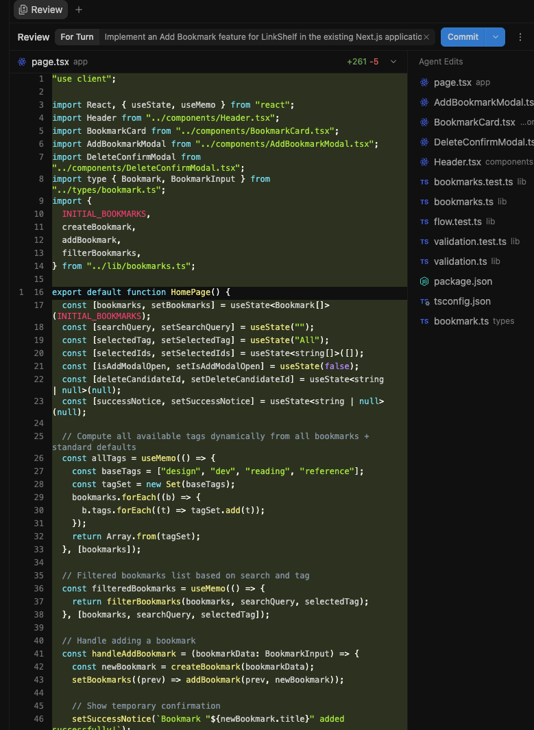 | 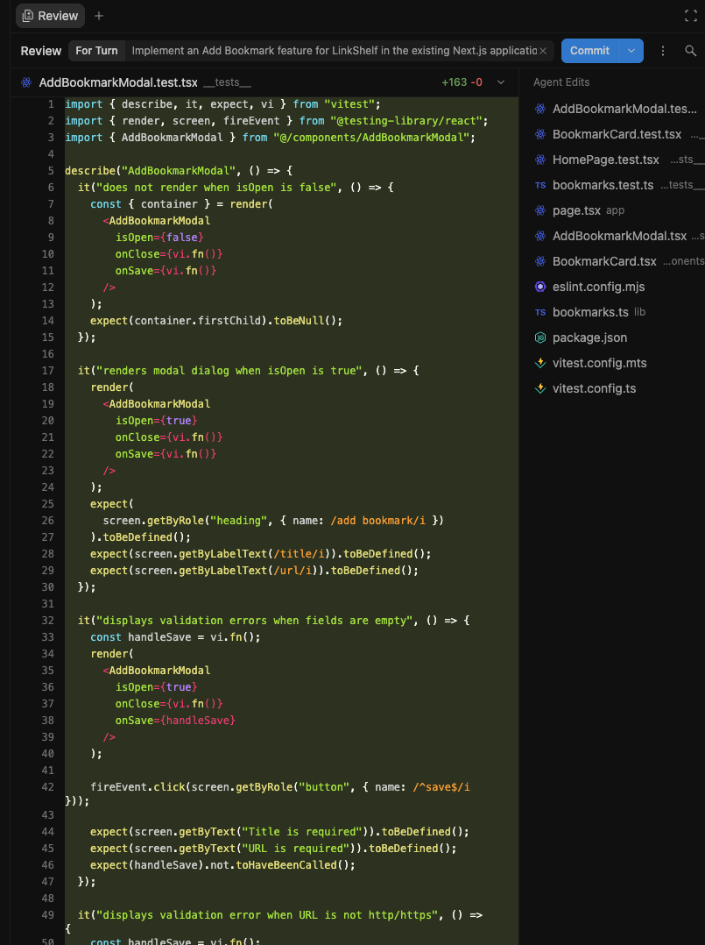
Source folders: ~/Documents/linkshelf-no-rules and ~/Documents/linkshelf-with-rules.

