Cyclistic Bike-Share Analysis: Converting Casual Riders to Members

Analyst: Oluwasijibomi Oderinde
Date: 17/04/2026
Tools Used: SQL (DB Browser for SQLite), R (tidyverse, ggplot2

1. Business Task
The Director of Marketing at Cyclistic, a bike-share company in Chicago, believes that maximizing annual memberships is key to future growth. The goal of this analysis is to understand how annual members and casual riders use Cyclistic bikes differently. The insights will inform a marketing strategy aimed at converting casual riders into profitable annual members.
Primary Stakeholders:
- Lily Moreno (Director of Marketing)
- Cyclistic Executive Team (detail-oriented approvers)

2. Data Sources
Source: Lyft Bikes and Scooters, LLC ("Divvy"), operating as Cyclistic in this fictional case study. Data provided by Motivate International Inc. under a [public data license](https://ride.divvybikes.com/data-license-agreement).
Time Period: April 2025 – March 2026 (12 months)
Format: 12 CSV files, totalling approximately 3.7 million rows before cleaning.
Reliability: First-party operational data collected automatically via bike docking stations and mobile apps. Personally identifiable information (names, credit card numbers) is excluded to protect rider privacy.

3. Data Processing & Cleaning
Data processing was performed using SQL (DB Browser for SQLite) to handle the large volume of records efficiently.

Key steps included:
- Combining 12 monthly CSV files into a single table using `.import` commands.
- Calculating new features: `ride_length_mins`, `day_of_week`, `start_hour`, `month_num`.
- Applying data quality filters:
  - Removed rides shorter than 1 minute (likely false starts or maintenance)
  - Removed rides longer than 24 hours (likely lost or stolen bikes)
  - Excluded records with missing station names or invalid timestamps
Resulting clean dataset: `cyclistic_clean_12months.csv` (3,705,236 rows)
Link to SQL cleaning script in repository
https://github.com/Sijibomi0909/Cyclistic-bike-share-analysis

4. Analysis & Key Findings
All visualizations were created using R (ggplot2). An interactive version of this dashboard was also prototyped in Tableau Public.
4.1 Overall Ridership

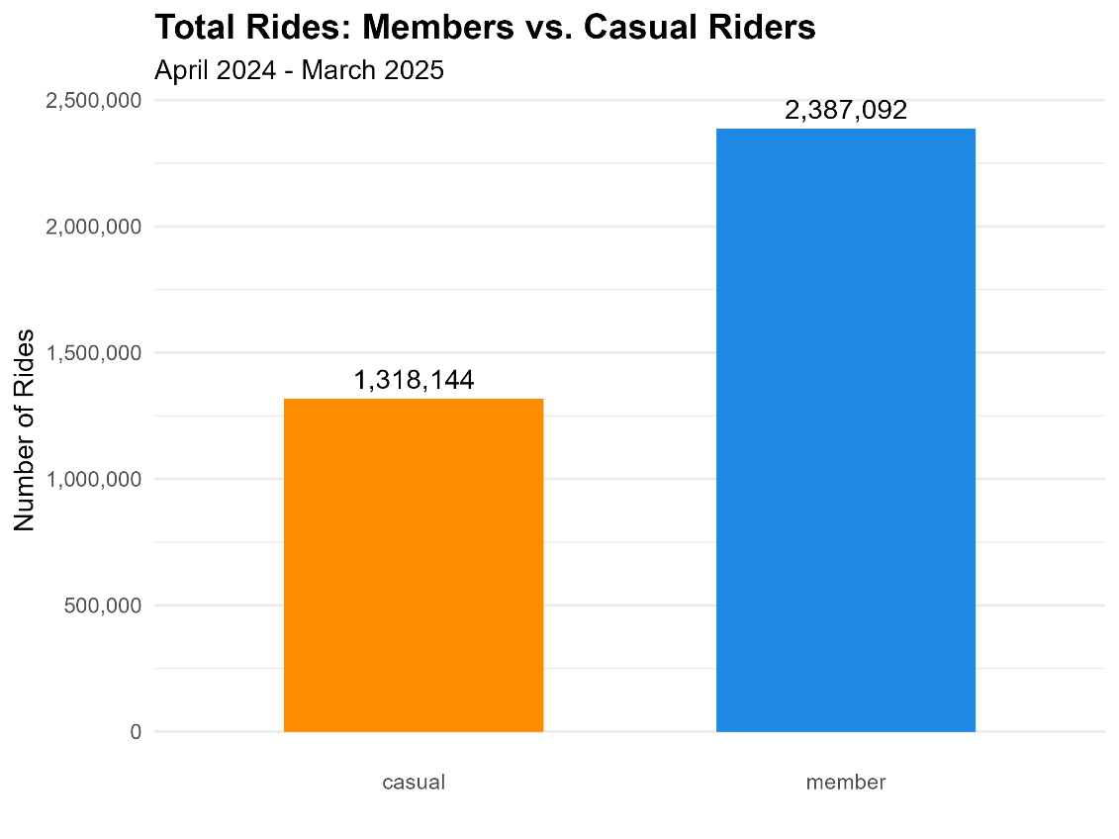
Finding: Annual members account for approximately 64% of total rides, while casual riders make up 36%. This demonstrates a substantial base of casual riders available for conversion.
4.2 Average Ride Duration

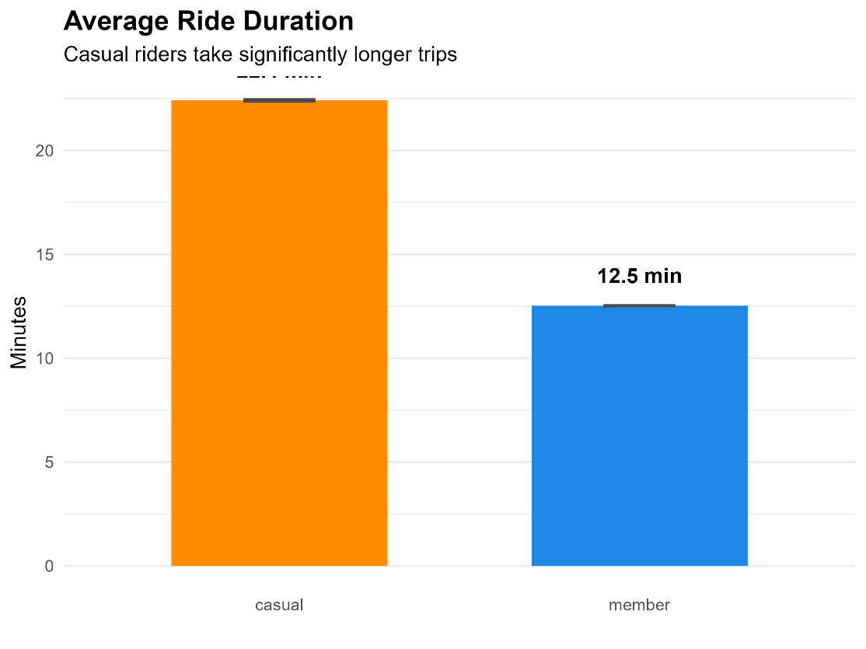
Finding: Casual riders take significantly longer trips than members.
Casual Average: ~22.5 minutes
Member Average: ~12.1 minutes
Statistical Significance: A two-sample t-test confirms the difference is statistically significant (p < 0.001).
Interpretation: Casual riders are primarily leisure users or tourists, while members use bikes for quick, utilitarian trips (e.g., commuting).

4.3 Ride Frequency by Hour and Day (Heatmap)
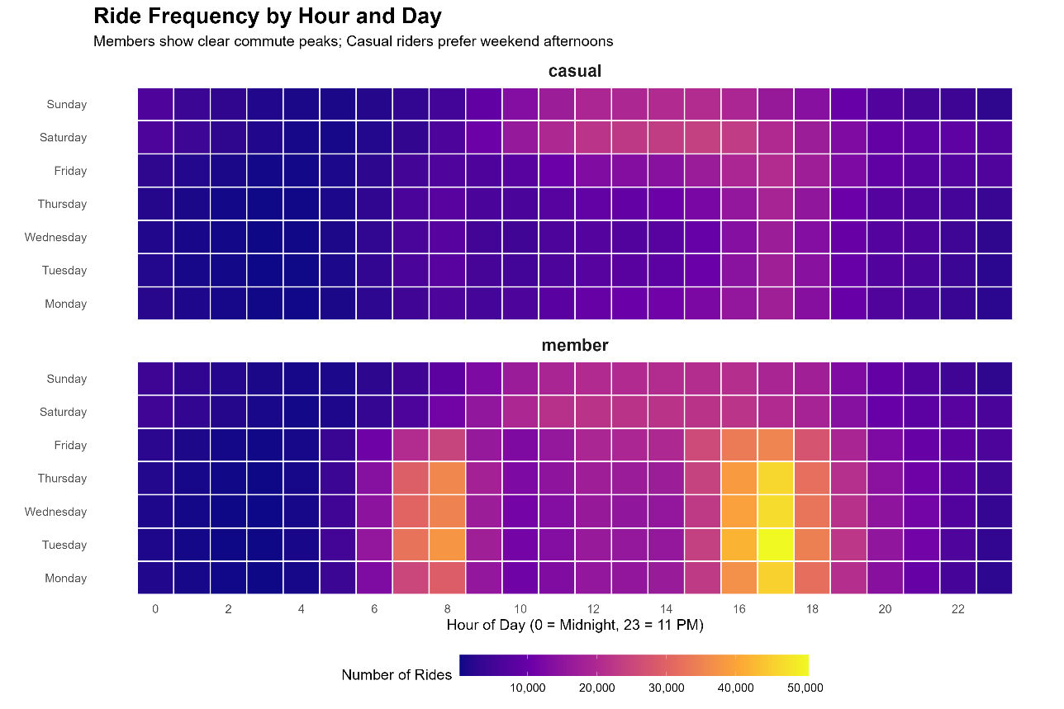
Finding (Members): Strong peaks during weekday commute hours (7-9 AM and 4-6 PM). Minimal weekend usage.
Finding (Casual): Peak usage on Saturday and Sunday afternoons (12-4 PM). Weekday usage is spread throughout the day with no clear commute pattern.

4.4 Bike Type Preference
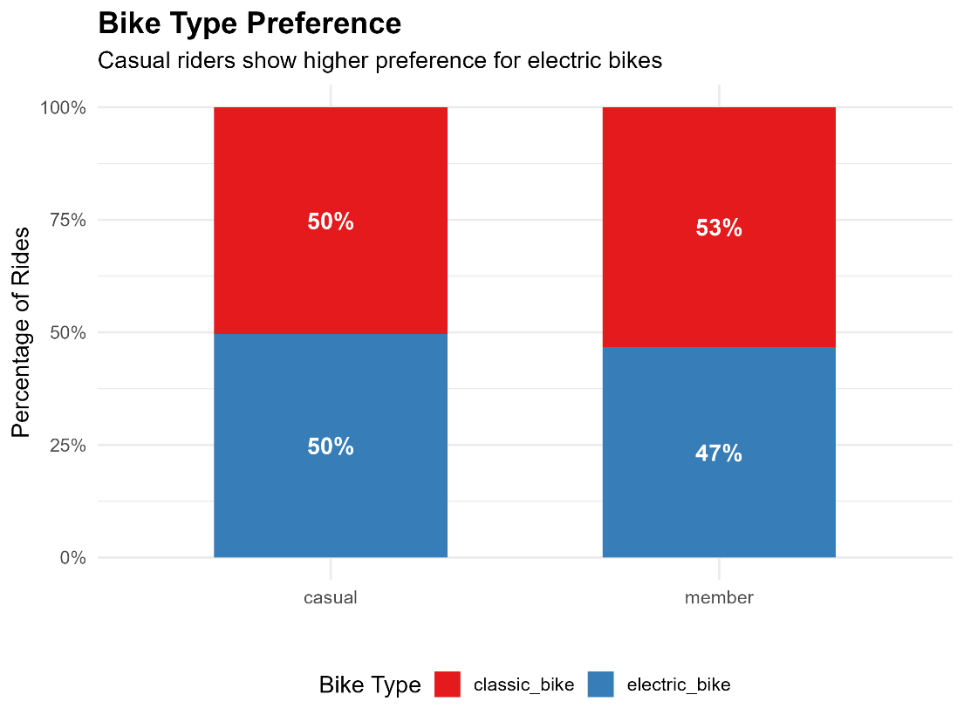
Finding: Casual riders show a stronger preference for electric bikes (36% of their rides) compared to members (22%).
Interpretation: Electric bikes may serve as a "gateway" option for casual users seeking convenience or novelty.

5. Combined Dashboard

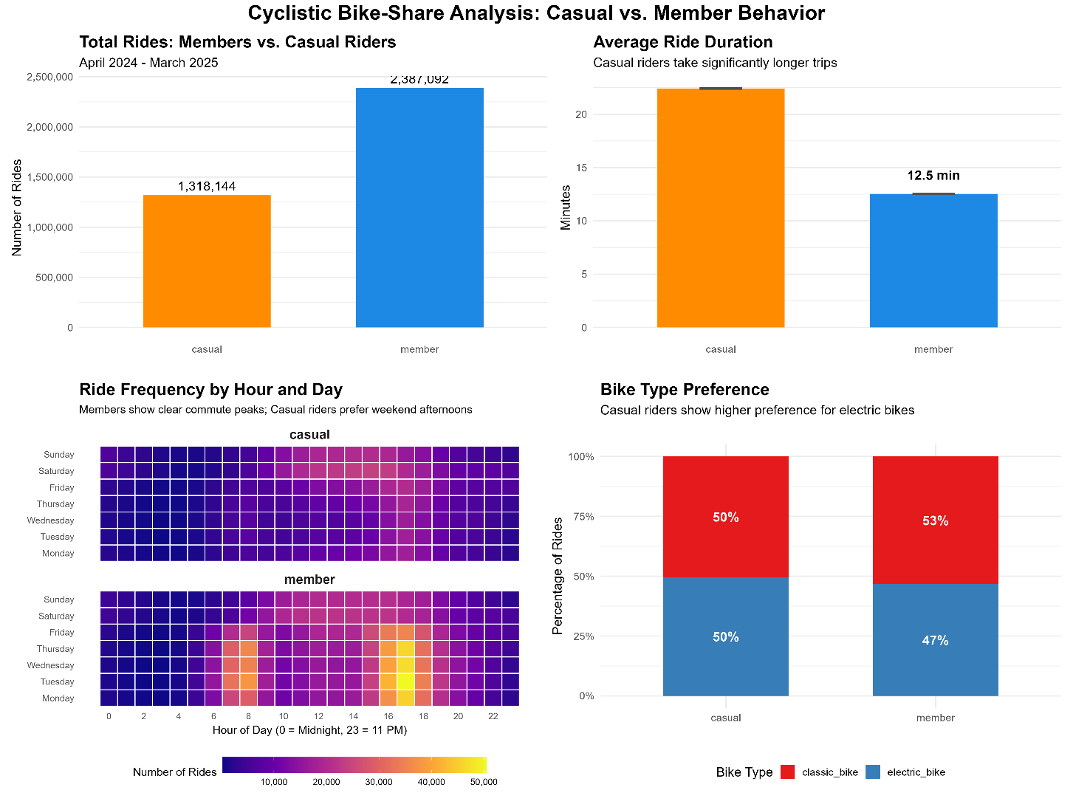

6. Recommendations
Based on the analysis, I propose the following three data-driven marketing strategies:
1: Launch a "Weekend Warrior" Summer Flex Pass
Insight: Casual riders ride 2-3x longer and are most active on weekend afternoons and during summer months.
Action: Introduce a limited-time membership tier: "Summer Flex Pass" . For a one-time fee ($X), riders get unlimited weekend rides from June through September. Advertise this exclusively to existing casual riders via push notifications on Saturday mornings (when they are most engaged) and targeted social media ads featuring leisure imagery.
Expected Impact: Lowers the barrier to trying a "membership-like" experience, priming casuals for full annual conversion.
2: Incentivize Electric Bike Users with Targeted In-App Prompts
Insight: Casual riders are 64% more likely to choose an electric bike than members.
Action: Implement a dynamic in-app message that triggers when a casual rider unlocks an electric bike for the third time in a calendar month. The message should state: "You've ridden e-bikes 3 times this month. With an Annual Membership, you'd save $Y on these rides. Upgrade now and your next e-bike ride is free."
Expected Impact: Connects a rider's specific behavior (e-bike preference) directly to membership savings, making the value proposition tangible.
3: Target the "Commuter Fence-Sitter" with Geofenced Email Offers
Insight: A small but valuable segment of casual riders uses bikes during weekday morning hours (7-9 AM), suggesting they are commuting but haven't committed to a membership.
Action: Use geofencing and trip data to identify casual riders who start a trip near a residential area and end near a business district on a weekday morning at least twice in one week. Send these riders a personalized email with the subject line: "Turn Your Commute into Savings." Offer a 15% discount on their first year of annual membership.
Expected Impact: Converts high-frequency, high-value casual users who are already demonstrating member-like behavior.

7. Next Steps & Additional Data Opportunities

- A/B Testing: Pilot the "Summer Flex Pass" in one geographic zone to measure conversion lift before citywide rollout.
- Survey Data: Conduct a short in-app survey targeting casual riders who take long weekend trips to understand *why* they haven't purchased a membership (e.g., cost, frequency of use, lack of awareness).
- Weather Integration: Overlay historical weather data to determine if casual ridership is more sensitive to temperature/precipitation than member ridership, enabling more precise seasonal marketing timing.
8. Portfolio Links & Resources
GitHub Repository: [https://github.com/Sijibomi0909/Cyclistic-bike-share-analysis]

This case study was completed as part of the Google Data Analytics Professional Certificate Capstone Project.

