Group 19

Author: Xie Yuchen

Software Requirements

Elevator

Table of Contents

System Objective 2

Domain Analysis 2

Use Cases 4

System Architecture & Software Requirements 4

R1: Floor Panel 5

R2: In Elevator Panel 5

R3: Coordinate System 5

## System Objective

In this project, we aim to develop a elevator system that provide fast experience for passengers to travel among three floors. With the coordinated elevator mobilization system plus the button and the display panel, the waiting time of passengers should be minimized and the experience of the customer will be significant.

## Domain Analysis

The participant of activities in the elevator system can be categorized into Elevator and Passenger. The relationship between elevator and passenger is also proposed in the class diagram:

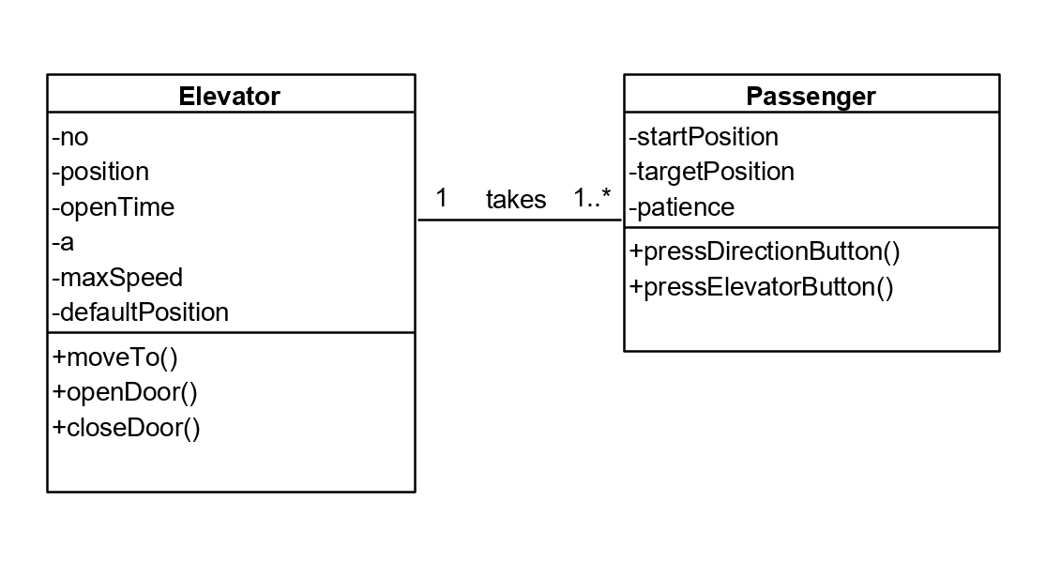

Here is the activity diagram of a passenger taking an elevator:

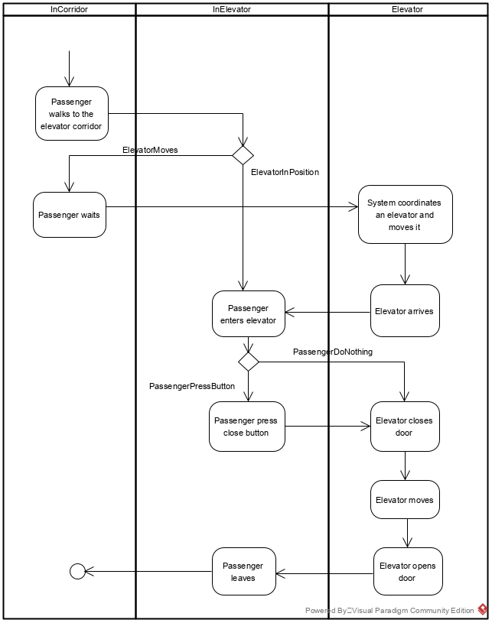

## Use Cases

From the activity diagram above, we can conclude the use cases of both passengers and the coordinate system:

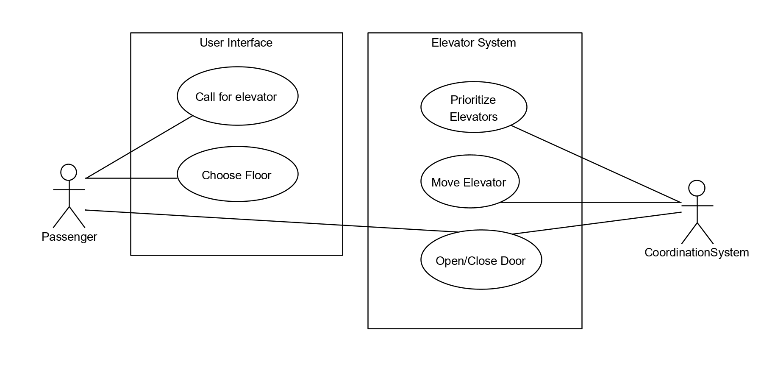

## System Architecture & Software Requirements

The system should include two parts: User Interface and Coordinate System. The UI part consists of both corridor UI and in-elevator UI so that the passenger can be informed of the movement of the elevator whatever status he is in. Requirements for each part is also listed below:

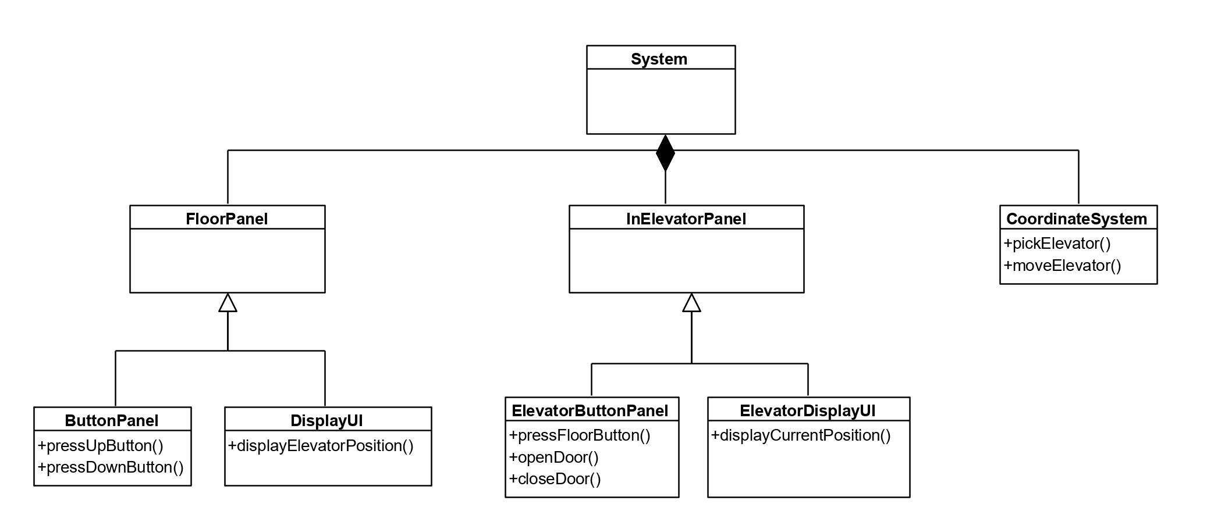

### R1: Floor Panel

* R1.1: The panel should be able to display the current position of a specific elevator and its moving direction.
* R1.2: The passenger should be able to press the up/down button.
  + R1.2.1 If no elevator is on this floor, pressing the button should cause the system to coordinate an elevator to move to this floor
  + R1.2.2 If at least one elevator is on the floor, pressing the button should open an elevator.
  + R1.2.3 If the elevator is open on the floor, pressing the button should keep the door open.
* R1.3: The button should light up when pressed, and should go out when the elevator arrives.

### R2: In Elevator Panel

* R2.1 The panel should be able to display the current position of the elevator and its moving direction.
* R2.2 The passenger should be able to press the floor button
  + R2.2.1 The passenger should be able to cancel floor selection by two rapid press.
  + R2.2.2 The button should light up when pressed
  + R2.2.3 The button should go out if the elevator arrives at the specific floor or if being cancelled by the passenger.
* R2.3 The passenger should be able to control the elevator door by pressing open/close door button.

### R3: Coordinate System

* R3.1 The coordinate system should be able to select a ‘better’ elevator when a passenger pressed the button
  + R3.1.1 If both elevator is not in use, coordinate the elevator that is closer to the target floor.
  + R3.1.2 If one elevator is in motion:
    - Coordinate the moving elevator if the target floor is covered in its original path.
    - Coordinate the static elevator to get to the target floor otherwise.
  + R3.1.3 If both elevator are in motion:
    - Coordinate an elevator(with less person) if its original path covers the floor.
    - Otherwise, wait until an elevator finishes its path and coordinate it to the target floor.
* R3.2 The coordinate system should coordinate the elevators to a specific default floor if the elevator maintains motionless for **5**\* minutes.