Group 19

Author: Cong Xinzhou

Software Requirements

Painkiller Injection System

Table of Contents

System Objective 2

Domain Analysis 2

System Architecture 3

Use Cases 4

Software Requirements 4

R1: Patient Button 4

R2: Physician UI 4

R3: Injection System 4

## System Objective

In this project, we are developing a software that can help the physician to provide the painkiller for the patients more safely. Besides providing an interface for the physician who set the dose, the system can also calculate the injection amount and avoid more painkiller than the safety limit injected into the patient.

## Domain Analysis

There are three main participants in the pain killer injection system: the patient, the physician and the injection system. The physician set the dose for the patient, and the injection system make sure that the injection will not exceed any limits. Their attributes and relationships are shown below:

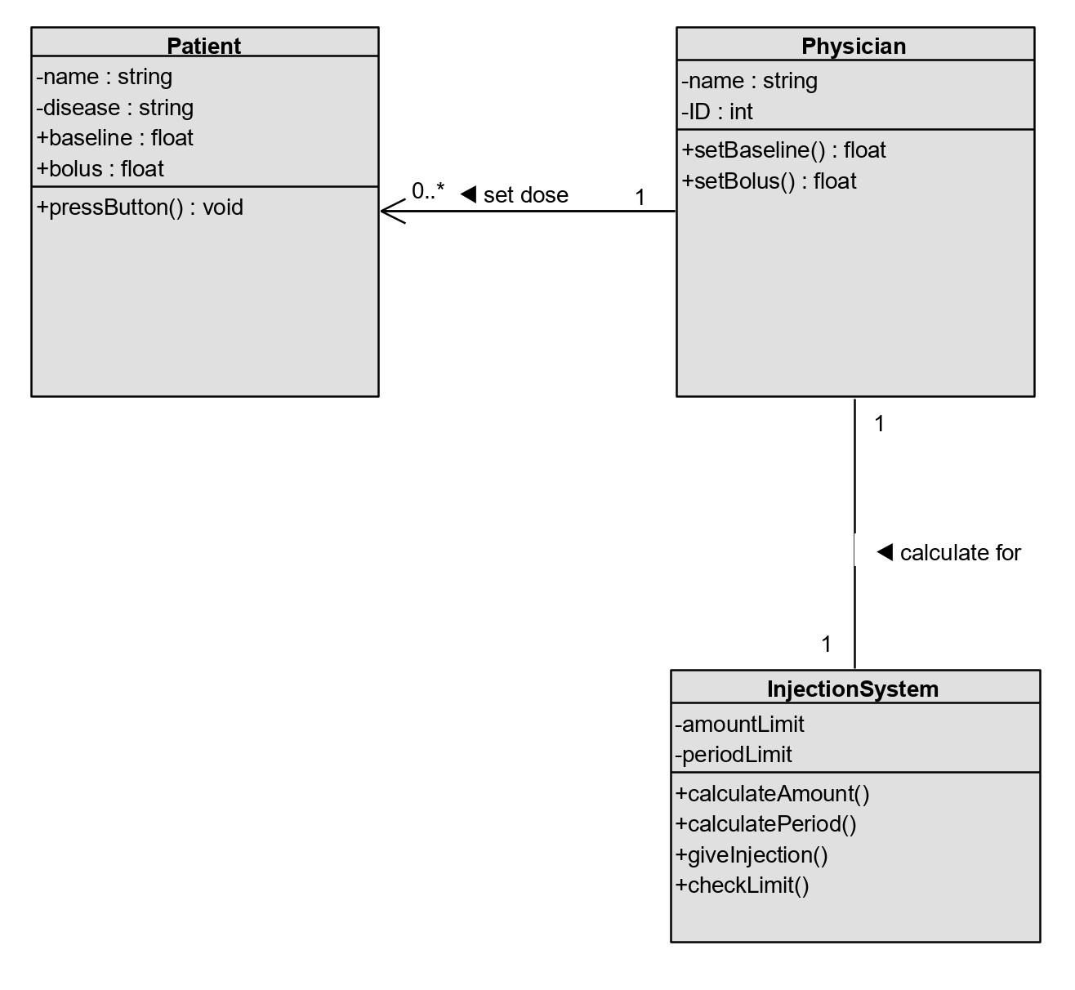

The sequence of events of this injection system is a for loop that is working all the time. Every time the systems gives a baseline injection or the patient tries to give himself a bolus, the system has to check if the injection will exceed any limits:

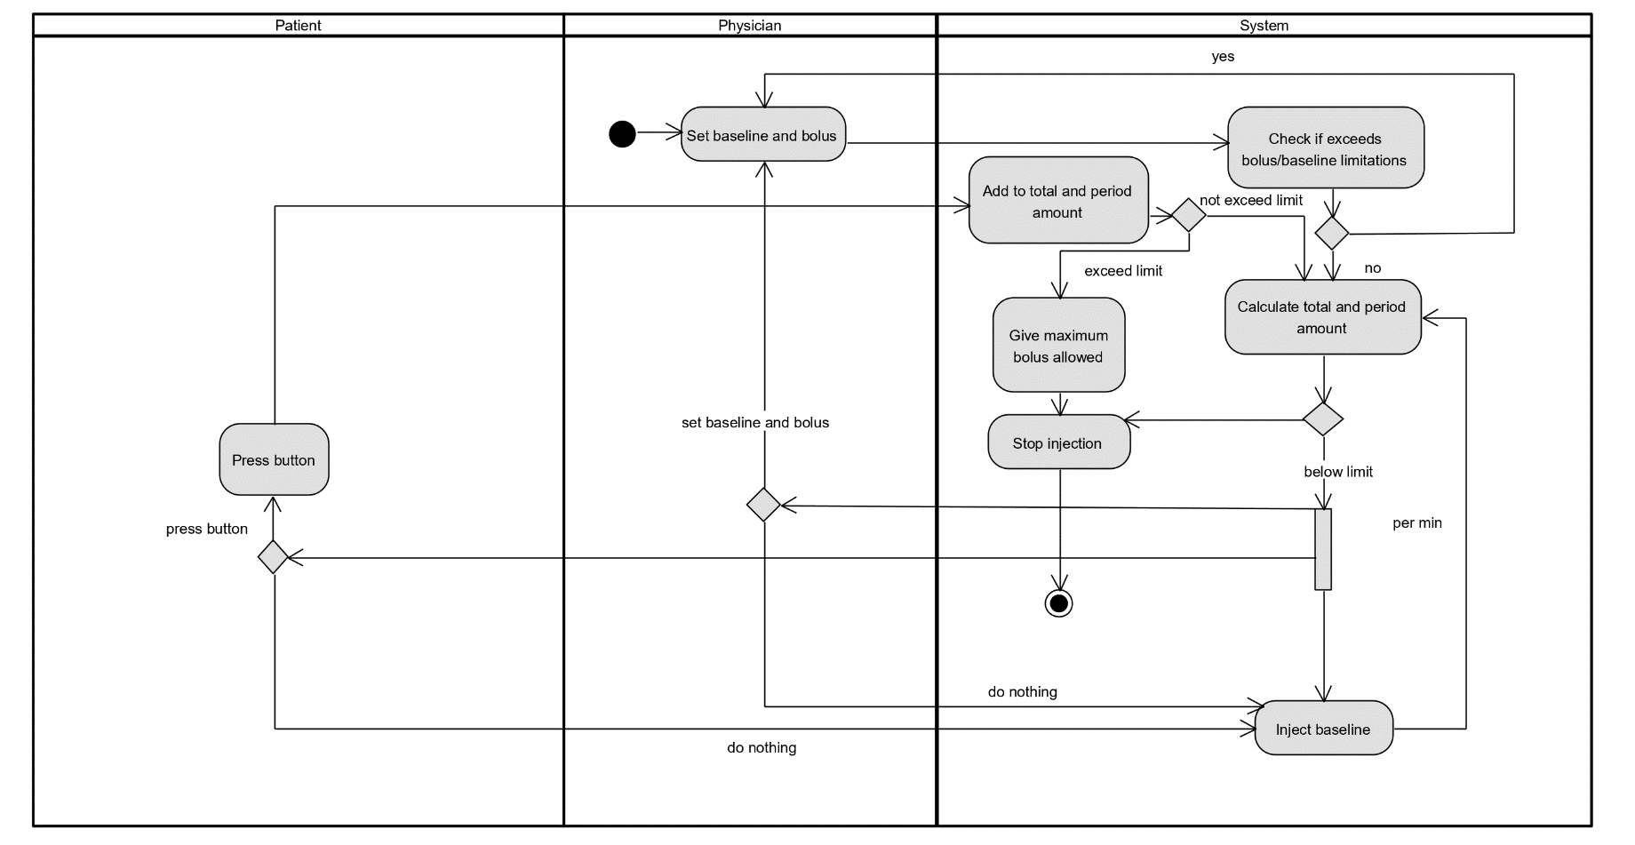

## System Architecture

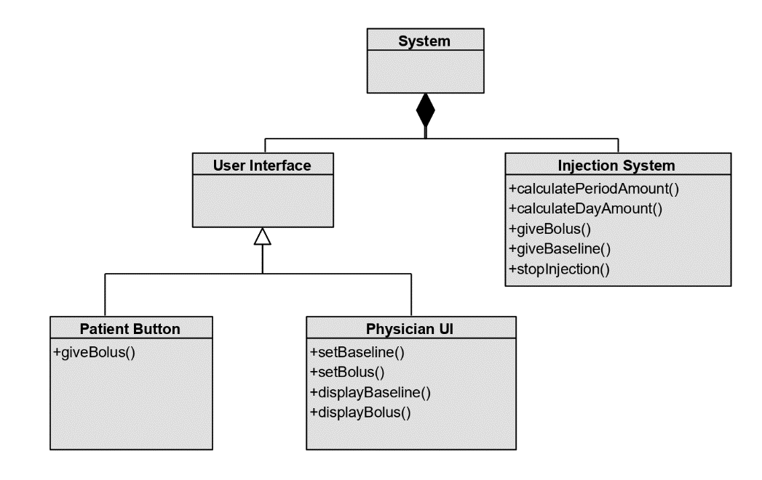The system consists of two parts: the user interface and the injection system. The injection system is responsible for giving injections and stopping injections when meeting any limits. The user interface includes patient button and physician UI. The patient button can only give the patient bolus (successful or not), and shows no feedback. The physician UI helps the physician set baseline and bolus for the injection system and also displays them.

## Use Cases

As expressed above, the use case of the injection system should be like:

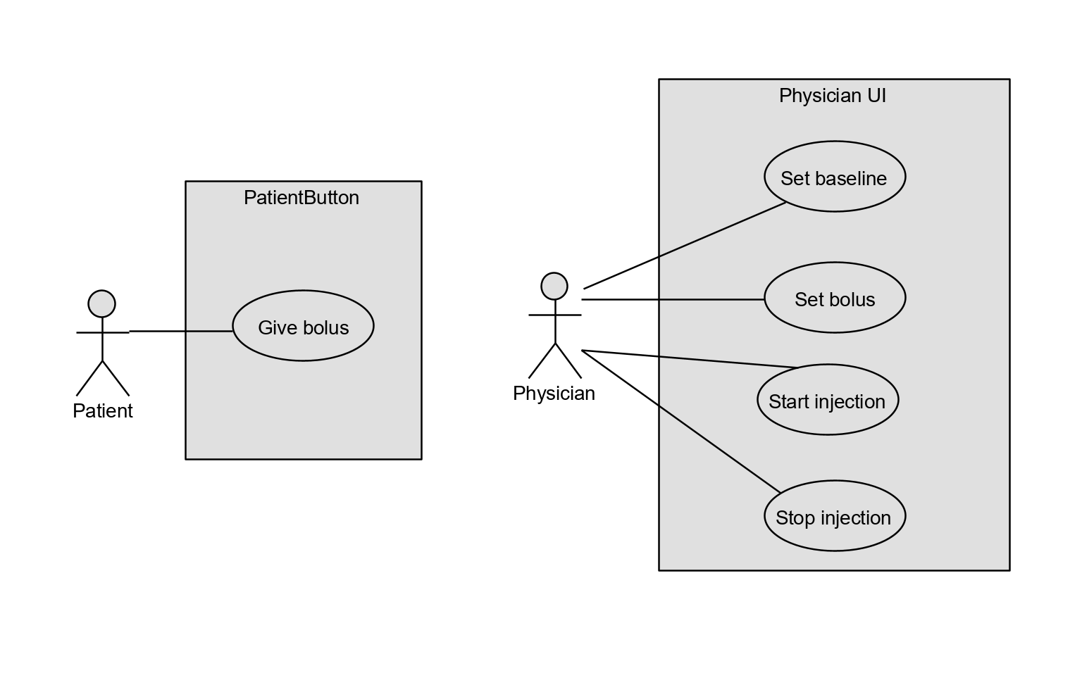

## Software Requirements

### R1: Patient Button

* R1.1: The button being pressed should give the patient a bolus if not exceeding the limit.
* R1.2: If exceeding the limit, the patient will not get any feedback.

### R2: Physician UI

* R2.1: The physician should set time and speed for the baseline injection
* R2.2: The physician only set amount for the bolus injection.
* R2.3: If the injection system reports any error, the physician gets it.

### R3: Injection System

* R3.1: The injection system gives baseline injection to the patient according to the settings given by the physician
  + R3.1.1: If the baseline injection exceeds any limits, the injection system stops the injection automatically.
* R3.2: The injection system gives bolus injection to the patient if the button is pressed
  + R3.2.1: If the bolus exceeds limits, the injection system will give a maximum bolus allowed and stop all the injection.
* R3.3: The injection system calculates the period limit by tracking every injection given in the past hour.
* R3.4: The injection system should report error to the physician if:
  + R3.4.1: The settings of baseline/bolus exceed the limit.
  + R3.4.2: The total amount of baseline exceeds the period/day limit.