Step 1： Copy a grid to the scene and create a maze information for it:

Go into Maps/, right click and create a new MazeInformation.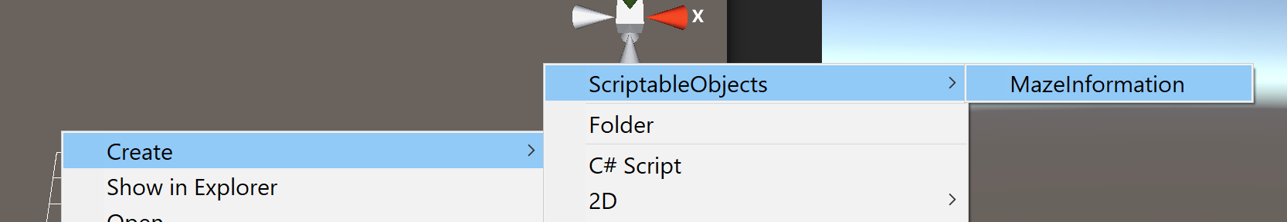

Create one Information file for each maze you make!! I made a new one “TutorialMaze” for now.

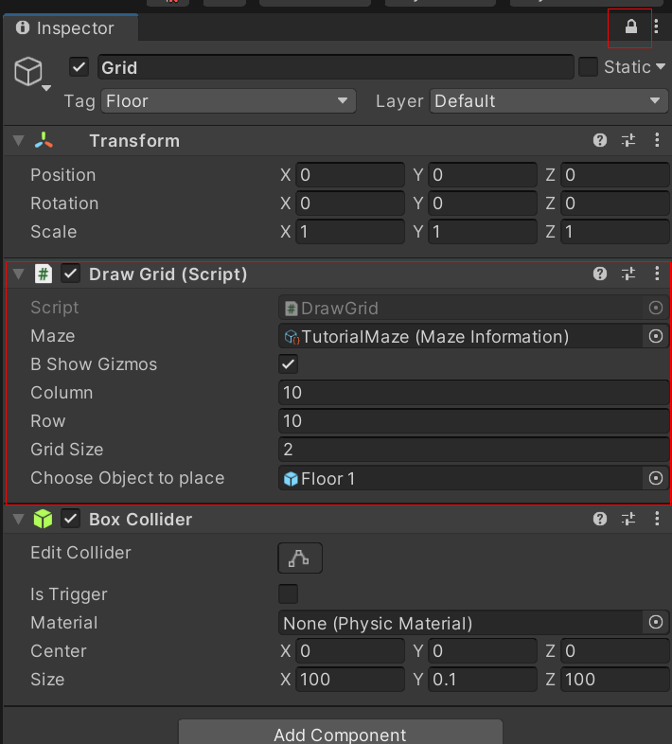Step 2: Inspector:

Click on the lock so that you can make modifications to the maze all the time.

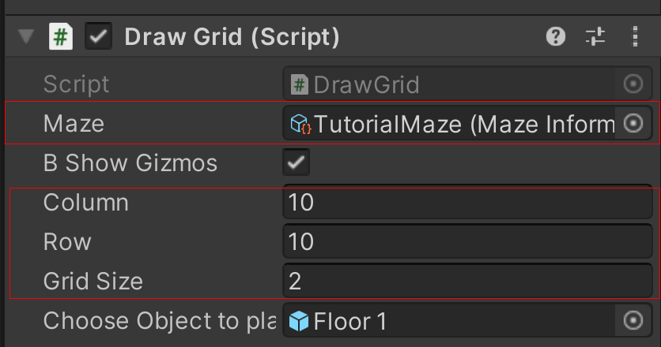Drag the information file into the inspector. Also, can change column and row parameters of the grid here:

Step 3: Drag the object you want to place into the inspector: (Prefabs should be under Prefabs/ArtAssets for now).

Left click on the grid to place a object, Right click to delete an object

Mouse hover on the object and press left shift to rotate an object.

Try not to use undo function since it’s also writing map information.

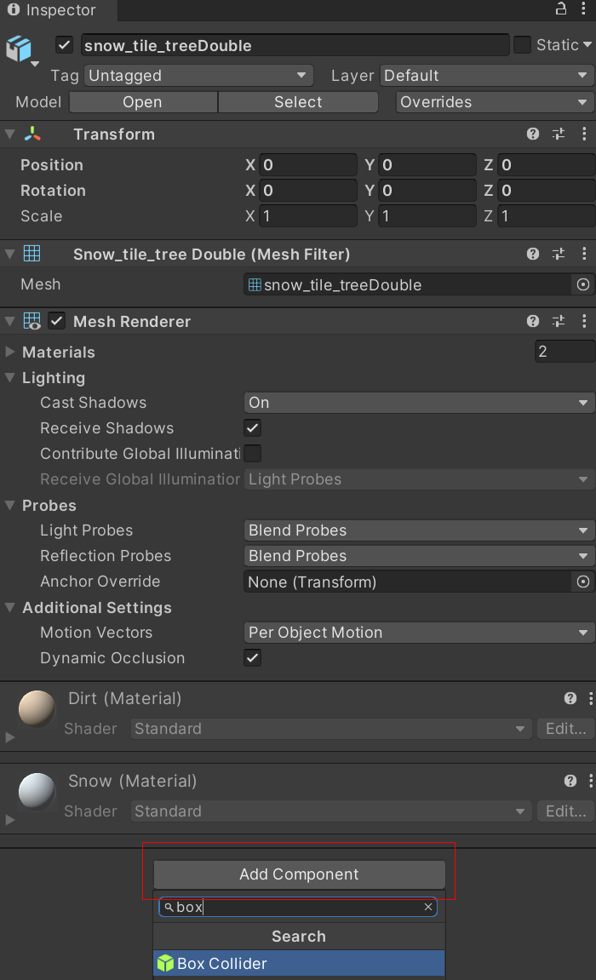There are also some assets I got from the Internet in Assets/PlaceHolderAssets/FBXs. If you want to use them, drag them to the scene, in the Inspector(might have to unlock the previous Grid first), add component -> Box collider.

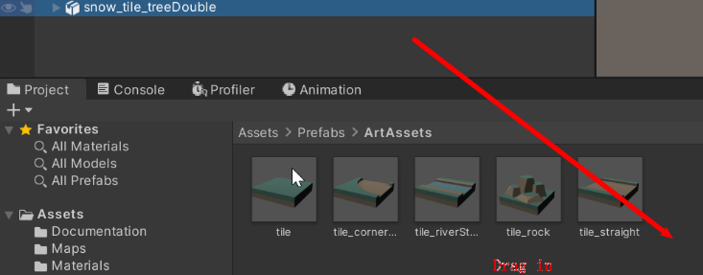Then drag it back to the prefab folder and save it as original prefab. It should be the same as other prefabs I made. You can delete it from the scene then.

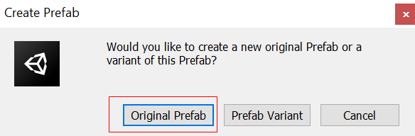

If you want to make it an obstacle, add component -> obstacle, and set the parameters.