#CityGenerator User Guide

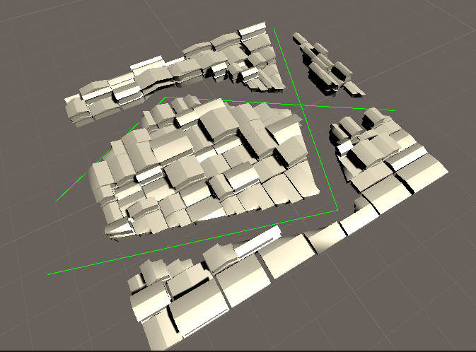

1. In Assets/Hdas, drag city_ancient_chinese_gen.hda into scene. (you won’t see any geometry at first)
2. Adjust the parameters in inspector (as name suggests)

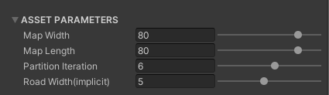

1. In window HoudiniEngine, select new node -> curve to build a road spline

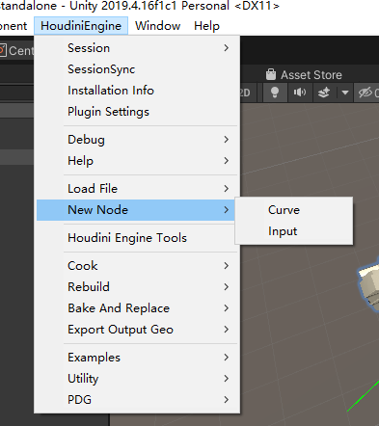

1. in city_ancient_chinese_gen, add slot and choose road spline as input. Then you will see roads effects city generations.

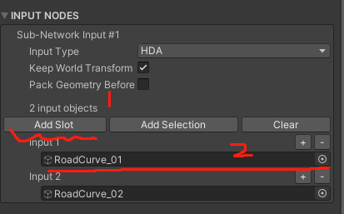

1. You can add more road splines in city generator.

Have fun!