**Necessary Components to Set Up a New Scene:**

-GameManager

-Attach Script *GameManager*

-Attach Script *UIManager*

-UI

-TimeText (Simply a text)

-HP (Just copy the one from the example scene for now)

-DiscCenter (whose position will be the center of all discs)

-Attach Script *PlayerLogic*

-Ground (a plane the Navmesh can walk on. Tick Static then bake it)

**To Set Up:**

***GameManager***:

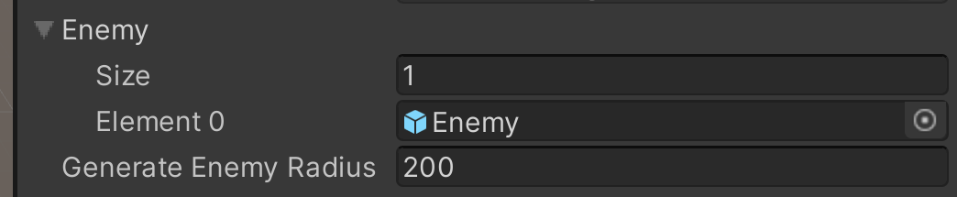

Put 1 in Size and then drag the prefab of the enemy into Element 0;

Generate Enemy Radius: The radius of the circular area that spawns enemy

***UIManager***:

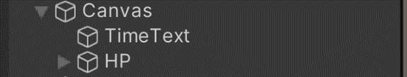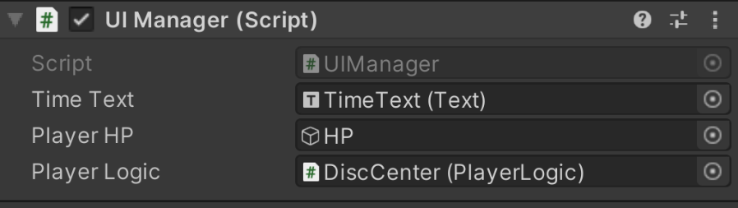

Drag in UI Components

Drag in the Center Component with *PlayerLogic*

**About Disc Center:**

***PlayerLogic:***

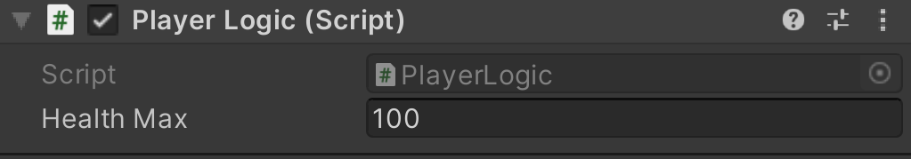

Health Max: The Max Health of the player

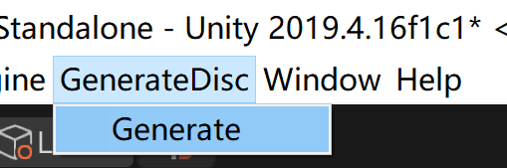Use this to **generate discs:**

1. Go to Generateisc/Generate
2. Select the component you want to use for center:

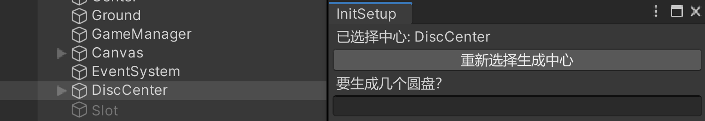

If you want to reselect, select another object and then press the button.

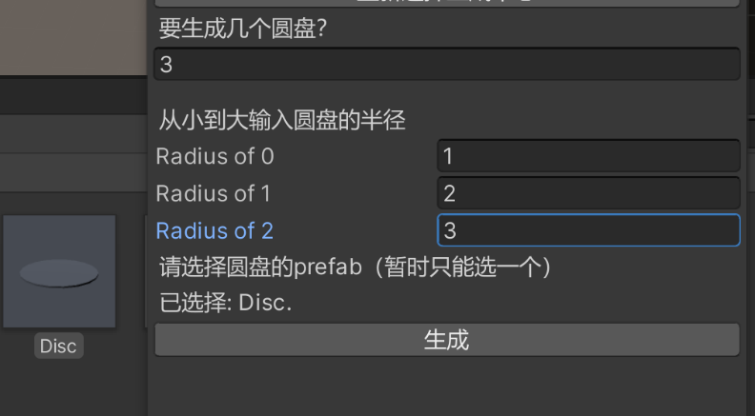

1. Fill in the numbers
2. Select the prefab from the Asset
3. Hit the Generate Button.

**Other Settings:**

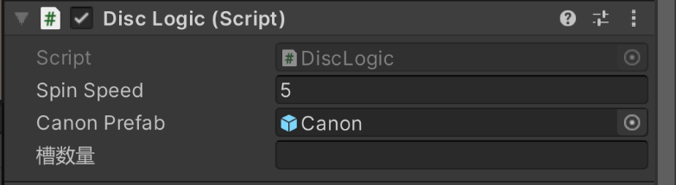***DiscLogic:***

The spinning speed of the disc when being dragged

Drag in the canon prefab

Fill in the number and then hit the generate button. It will automatically change the number of canons on the disc.

***CanonLogic:***

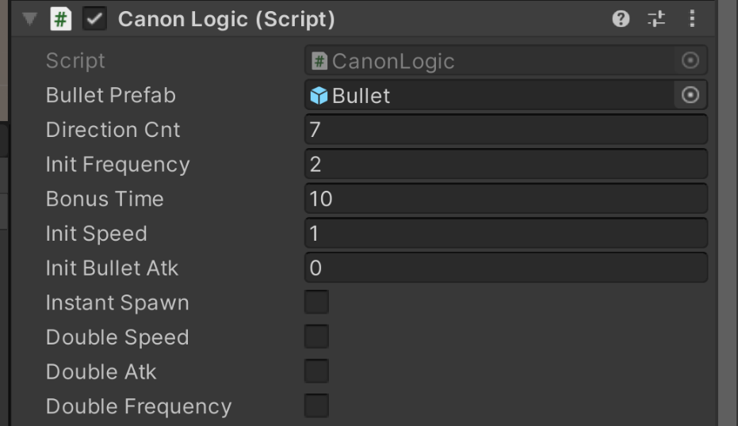

Drag in the bullet prefab

向N个方向发射炮弹

生成炮弹的频率

N秒内攻击频率*2

初始速度

攻击力

被击中的炮台立刻生发射一次炮弹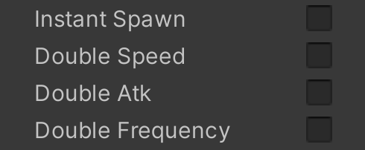

被击中的炮台下一次生成的炮弹初始速度*2

被击中的炮台下一次生成的炮弹攻击力*2

被击中的炮台10秒内攻击频率*2

***EnemyLogic***: (Set in prefab)

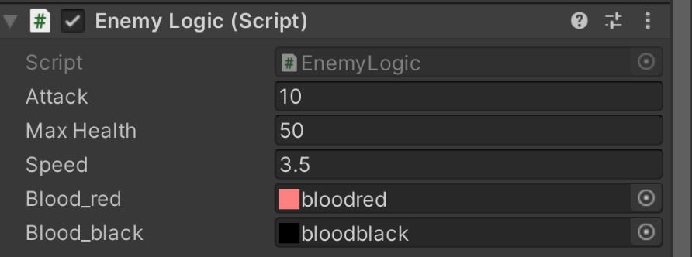

Attack of the enemy

HP of the enemy

Moving speed of the enemy

Blood_red UI

Blood black UI

To set the frequency of spawning enemy, see EnemySpawnFrequencyCalculation() in GameManager.cs(68)

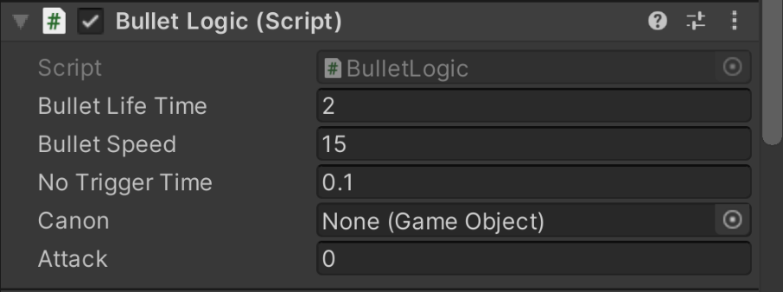***BulletLogic***: (Set in prefab)

After N seconds the bullet disappear

The speed of the bullet

Ignore it

Ignore it

The attack of the bullet