Report

Link to github: <https://github.com/Sikai1996?tab=repositories>

THIS WEBSITES WERE CREATED BY THE STUDENT WHO NAMED SIKAI. THE STUDENT HAVE DONE MOST SKILLS IN HTML AND CSS. AND HE EXTENDED MANY OTHER SKILLS. HE CREATED FOUR

PAGES WITH BACKGROUND IMAGES. AND EACH PAGE HAVE FOUR BUTTONS. IT WILL BE EASIER FOR PEOPLE TO CHOOSE ANY PAGE. THE BUTTONS ARE ALL HAVE BORDERS. IT IS QUITE GOOD.

IN COLLECTION PAGE, THE STUDENT USED 12 PHOTOGRAPHS. HE USED GRID LAYOUT TO SHOW PHOTOGRAPHS. HE HAVE DONE MANY OTHER SKILLS IN CONTACT PAGE. IN HOME PAGE, PEOPLE

CAN ALSO CLICK TWO LITTLE ICONS TO CONNECT TO GUTHUB AND CODEPEN. BUT THE STUDENT NEED TO IMPROVE THE VIEW OF THE PAGES. HE NEED TO MAKE IT MORE BEAUTIFUL AND SKILLFUL.

THE STUDENT CAN USE GOOGLE DESIGN OR OTHER HELPFUL THINGS. SOME CODE ARE FROM W3SCHOOLS.COM AND YOUTUBE.

THE STUDENT HAVE DISCUSSED WITH HIS CLASSMATES ABOUT THIS ASSIGNMENT. THEY

TALKED ABOUT SOME SKILLS SUCH AS GRID, BUTTONS AND FOOTER. IT IS HELPFUL. IT MADE BOTH OF THEM MORE SKILLFUL. THE STUDENT ALSO SEARCHED SOME INFORMATION FROM

GOOGLE.

SOMETIMES WHEN THE STUDENT WANTED TO SHOW MORE SKILLS, IT ALWAYS HAD SOME PROBLEMS.

AND HE COULD NOT FIND THEM WASIER.

THIS ASSIGNMENT HAVE TAKEN THE STUDENT ABOUT A WEEK. HE FINISHED MOST PAGES

QUICKLY. BUT THERE ARE SOME SMALL PROBLEMS TOOK HIM MUCH TIME. SO HE SPENT MUCH TIME TO FIX THE PROBLEM. THE STUDENT ALSO WANT TO STUDY MORE SKILLS IN THE FUTURE.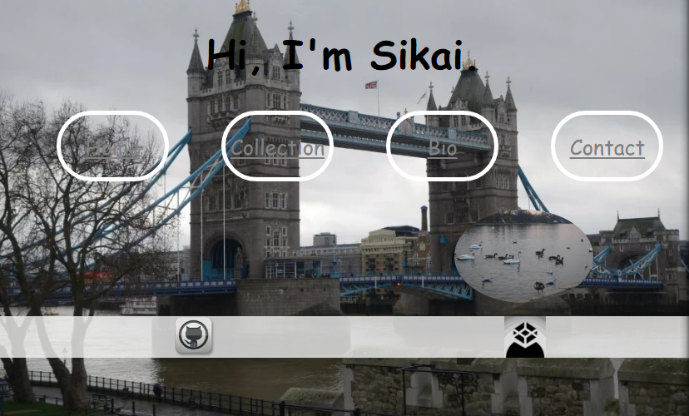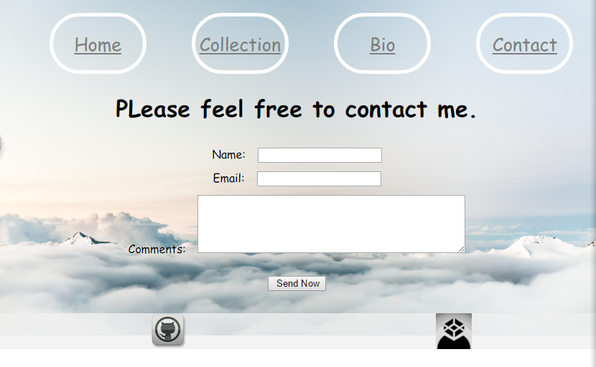

Old code:

Index.html

----------------------------------------------------------------------------

<!DOCTYPE html>

<!--Sikai He -->

<!--16429428 -->

<html>

<head>

<meta charset="utf-8">

<title>Personal Information</title>

<link rel="stylesheet" href="css/style.css" type="text/css"/>

</head>

<body>

<main class="container">

<nav class="information">

<h1>I am Sikai He</h1>

<p>

<a href="cv.html">CV</a>

</p>

<p>

<a href="bio.html">Biography</a>

</p>

<p>

<a href="contact.html">Contact</a>

</p>

</nav>

<img src="image/happy.jpg"

alt="photograph"

width="300"

height="300"

class="pic"/>

</main>

</body>

</html>

**Cv.html**

<!DOCTYPE html>

<!--Sikai He -->

<!--16429428 -->

<html>

<head>

<meta charset="utf-8">

<title>CV</title>

<link rel="stylesheet" href="css/cv.css" type="text/css"/>

</head>

<body>

<main class="container">

<h1>Sikai He</h1>

<h2>

University:

</h2>

<h3>

I am a university student right now. Before I attend to University, I studied

International Founation Programme about 7 months. And I got the scholarship.

In year 1, I have studied Computer Games Development. I study Software

Engineering, Web Development, Games Techniques and so on. Now I study porgramming

language. Such as Java and ActionScript 3.

</h3>

<h2>

Hign School:

</h2>

<h3>

Graduated from FuQing No.1 Hign School.

</h3>

</main>

</body>

</html>

**Contact.html**

<!DOCTYPE html>

<!--Sikai He -->

<!--16429428 -->

<html>

<head>

<meta charset="utf-8">

<title>Contact</title>

<link rel="stylesheet" href="css/contact.css" type="text/css"/>

</head>

<body>

<nav class="container">

<h1>Email address</h1>

<h2> Add me</h2>

</nav>

</body>

</html>

**Bio.html**

<!DOCTYPE html>

<!--Sikai He -->

<!--16429428 -->

<html>

<head>

<meta charset="utf-8">

<title>Biography</title>

<link rel="stylesheet" href="css/bio.css" type="text/css"/>

</head>

<body>

<main class="container">

<h1>

About Me

</h1>

<h2>

I like the computer modules. When I enter the code I feel very cool.

I also like to play computer games. I often play with my friends.

It also gave me interest in the computer. I am a university student now.

I'm learning about computer games. I will learn more programming languages.

If you want to know more about me, just message me.

</h2>

</main>

</body>

</html>

**Css**

style

-----------------------------

body{

background-image: url("../image/picture.jpg");

max-height: 50%;

max-width: 50%;

background-size: cover;

background-position: center;

position: relative;

margin: 0;

top: 0;

flex-direction:column;

justify-content: center;

text-align: center;

align-items: center;

align-self: center;

}

.container{

flex-direction: column;

margin-top:20%;

position:relative;

}

.information{

display:flex;

flex-direction:column;

padding:20px 60px;

margin:0 auto;

color:black;

justify-content:center;

justify-content: space-around;

align-items: center;

align-items: stretch;

align-self: center;

box-shadow: inset 0 0 0 2px;

}

.pic{

display:flex;

position:relative;

justify-content:center;

margin-top:auto;

left:200px;

}

cv

------------------------------

body{

background-image: url("../image/hi.jpg");

max-height: 50%;

max-width: 50%;

background-size: cover;

background-position: center;

position: relative;

margin: 0;

top: 0;

flex-direction:column;

justify-content: center;

text-align: center;

align-items: center;

align-self: center;

}

contact

----------------------------------------

body{

background-image: url("../image/year.jpg");

max-height: 50%;

max-width: 50%;

background-size: cover;

position: relative;

margin: 0;

top: 0;

flex-direction:column;

justify-content: center;

text-align: center;

align-items: center;

align-self: center;

}

.container{

font-family:arial;

display:block;

align-items:center;

color:white;

align-items: stretch;

align-self: center;

justify-content: center;

position:relative;

box-shadow: inset 0 0 0 2px;

}

bio

--------------------------------------------

body{

background-image:url("../image/new.jpg");

max-height: 50%;

max-width: 50%;

background-size: cover;

position: relative;

margin: 0;

top: 0;

flex-direction:column;

justify-content: center;

text-align: center;

align-items: center;

align-self: center;

}

.container{

font-family:arial;

padding:0;

display:block;

align-items:center;

color:black;

align-items: stretch;

align-self: center;

justify-content: center;

position:relative;

margin: 10;

}

**New code**

INDEX.HTML

----------------------------------------------------------------------------------------------

<!DOCTYPE html>

<!-- Sikai He -->

<!-- 16429428 -->

<html>

<head>

<meta charset="utf-8">

<title>Home</title>

<link rel="stylesheet" href="css/index.css" type="text/css"/>

</head>

<body class="home">

<main class= "container">

<h1>Hi, I'm Sikai.</h1>

<ul class="buttons">

<li>

<a href="index.html" class="bon" >Home</a>

</li>

<li>

<a href="collection.html" class="bon">Collection</a>

</li>

<li>

<a href="bio.html" class="bon">Bio</a>

</li>

<li>

<a href="contact.html" class="bon">Contact</a>

</li>

</ul><!-- you can use these buttons to choose pages -->

<img src="pic/me.jpg"

alt="photograph"

class="photo">

</main><!-- a fictitious photo -->

</body>

<footer>

<ul class="footer">

<li>

<a href="https://github.com/Sikai1996?tab=repositories">

<img src="pic/github.png" alt="github" class="pho" /></a>

</li>

<li>

<a href="https://codepen.io/Sikai/">

<img src="pic/codepen.png" alt="codepen" class="pho" /></a>

</li><!-- these websies connect to github and codepen -->

</ul>

</footer>

</html>

COLLECTION PAGE

-------------------------------------------------------------------------------------------------------------------------

<!DOCTYPE html>

<!-- Sikai He -->

<!-- 16429428 -->

<html>

<head>

<meta charset="utf-8">

<title>Collection</title>

<link rel="stylesheet" href="css/index.css" type="text/css"/>

</head>

<body class="back">

<ul class="buttons">

<li>

<a href="index.html" class="bon" >Home</a>

</li>

<li>

<a href="collection.html" class="bon">Collection</a>

</li>

<li>

<a href="bio.html" class="bon">Bio</a>

</li>

<li>

<a href="contact.html" class="bon">Contact</a>

</li>

</ul>

<h1>Pictures</h1>

<ul>

<table>

<tr>

<td><img class="thumbnail-image" src="pic/buck.jpg" /></td>

<td><img class="thumbnail-image" src="pic/bigben.jpg" /></td>

<td><img class="thumbnail-image" src="pic/bridge.jpg" /></td>

<td><img class="thumbnail-image" src="pic/eye.jpg" /></td>

</tr>

<tr>

<td><img class="thumbnail-image" src="pic/view.jpg" /></td>

<td><img class="thumbnail-image" src="pic/che.jpg" /></td>

<td><img class="thumbnail-image" src="pic/tower.jpg" /></td>

<td><img class="thumbnail-image" src="pic/see.jpg" /></td>

</tr>

<tr>

<td><img class="thumbnail-image" src="pic/muse.jpg" /></td>

<td><img class="thumbnail-image" src="pic/sas.jpg" /></td>

<td><img class="thumbnail-image" src="pic/qwe.jpg" /></td>

<td><img class="thumbnail-image" src="pic/zxc.jpg" /></td>

</tr><!-- these images are all photographed by me -->

</table>

</ul>

</body>

<footer>

<ul class="footer">

<li>

<a href="https://github.com/Sikai1996?tab=repositories">

<img src="pic/github.png" alt="github" class="pho" /></a>

</li>

<li>

<a href="https://codepen.io/Sikai/">

<img src="pic/codepen.png" alt="codepen" class="pho" /></a>

</li>

</ul>

</footer>

</html>

BIO PAGE

<!DOCTYPE html>

<!-- Sikai He -->

<!-- 16429428 -->

<html>

<head>

<meta charset="utf-8">

<title>Biography</title>

<link rel="stylesheet" href="css/index.css" type="text/css"/>

</head>

<body class="bio">

<ul class="buttons">

<li>

<a href="index.html" class="bon">Home</a>

</li>

<li>

<a href="collection.html" class="bon" >Collection</a>

</li>

<li>

<a href="bio.html" class="bon">Bio</a>

</li>

<li>

<a href="contact.html" class="bon" >Contact</a>

</li>

</ul>

<nav class="info">

<h1>About The Images</h1>

<h2 >These pictures were taken when I went to London on Christmas Day 2016.

I was playing in London for three days.During this period I went to many famous attractions.

Such as Buckingham Palace, Big Ben, London Eye, British Museum and so on.

I took these pictures in these days.</h2>

</nav><!-- some information about my images -->

</body>

<footer>

<ul class="footer">

<li>

<a href="https://github.com/Sikai1996?tab=repositories">

<img src="pic/github.png" alt="github" class="pho" /></a>

</li>

<li>

<a href="https://codepen.io/Sikai/">

<img src="pic/codepen.png" alt="codepen" class="pho" /></a>

</li>

</ul>

</footer>

</html>

CONTACT PAGE

<!DOCTYPE html>

<!-- Sikai He -->

<!-- 16429428 -->

<html>

<head>

<meta charset="utf-8">

<title>Contact</title>

<link rel="stylesheet" href="css/index.css" type="text/css"/>

</head>

<body class="con">

<ul class="buttons">

<li>

<a href="index.html" class="bon">Home</a>

</li>

<li>

<a href="collection.html" class="bon">Collection</a>

</li>

<li>

<a href="bio.html" class="bon">Bio</a>

</li>

<li>

<a href="contact.html" class="bon">Contact</a>

</li>

</ul>

<h1>PLease feel free to contact me.</h1>

<form class="Form">

<div>

<label form="myname">Name:</label>

<input type="text" name="myname" id="myname" />

</div><!-- write your name here -->

<div>

<label form="email">Email:</label>

<input type="text" name="email" id="email" />

</div><!-- write your email here -->

<div>

<label form="comments">Comments:</label>

<textarea name="comments" id="comments" rows="5" cols="50"></textarea>

</div><!-- and there are some comments -->

<div class="submit">

<input type="submit" value=" Send Now" />

</div>

</form>

</body>

<footer>

<ul class="footer">

<li>

<a href="https://github.com/Sikai1996?tab=repositories">

<img src="pic/github.png" alt="github" class="pho" /></a>

</li>

<li>

<a href="https://codepen.io/Sikai/">

<img src="pic/codepen.png" alt="codepen" class="pho" /></a>

</li>

</ul>

</footer>

</html>

CSS

/*Sikai He*/

/*16429428*/

body{

margin:auto;

text-align: center;

justify-content: center;

font-family: cursive;

}/*this is all pages size */

.home{

background-image: url("../pic/bri.jpg");

max-height: 100%;

max-width: 100%;

background-size: cover;

background-position: center;

overflow: hidden;

position: relative;

margin: 0;

top: 0;

background-repeat:no-repeat;

}/* home page */

.bio{

background-image: url("../pic/tow.jpg");

max-height: 100%;

max-width: 100%;

height: 370px;

background-size: cover;

background-position: center;

position: relative;

overflow: hidden;

margin: 0;

top: 0;

background-repeat:no-repeat;

}/* bio page */

.con{

background-image: url("../pic/clou.jpg");

max-height: 100%;

max-width: 100%;

height: 370px;

background-size: cover;

background-position: center;

overflow: hidden;

position: relative;

margin: 0;

top: 0;

background-repeat:no-repeat;

}/* contact page */

.container{

text-align: center;

justify-content: center;

font-size: 18pt;

position: relative;

}/* the size of the word */

.buttons{

display: flex;

flex-direction: row;

justify-content: center;

justify-content: space-around;

list-style-type: none;

}/* four buttons size */

.bon{

display: flex;

border: 5px solid white;

border-radius: 10em;

display: inline-block;

height: 3em;

line-height: 3em;

text-align: center;

color: gray;

margin-top: 4px;

margin-bottom: 4px;

min-width: 5em;

font-size: 25px;

text-decoration: none

padding: 15px;

-webkit-transition-duration: 0.4s;

transition-duration: 0.4s;

}/* the borders of the buttons and some skills */

.bon:hover {

background-color: gray;

color: white;

}

.back{

background-color: rgba(255, 0, 0, 0.5);

}

.photo{

display: flex;

width: 20%;

height: 20%;

position: relative;

margin-top:30px;

left: 550px;

border-radius: 50%;

}/* home page photo */

.info{

text-align: center;

justify-content: center;

margin-top: auto;

margin-left: 200px;

margin-right:200px;

line-height: 60px;

color: rgba(255, 0, 0, 0.5);

}/* the information of my images */

.submit{

text-align: center;

padding: 15px;

}

label{

float:center;

width: 150px;

text-align: left;

padding-right: 12px;

margin-top: 12px;

}/* contact page. label information*/

input, textarea{

margin-top: 12px;

}

.thumbnail-image{

height: 300px;

width: 300px;

}

.footer{

display: flex;

flex-direction: row;

justify-content: center;

justify-content: space-around;

background-color: rgba(240, 240, 240, 0.8);

list-style-type: none;

}/* about the footer. make it more flex */

.pho{

display: flex;

width:50px;

height:50px;

position: relative;

}

/* All images can be used. Some of them are free. Others are photographed by me.

https://www.w3schools.com/html/html_links.asp */