Lab02

GitHub Integration

1120530224

陳祿恩

組合語言與逆向工程
- Create/Login GitHub.
- Create a new repo, ASM-Lab02.
- Using the AddSub program, write a program that subtracts three integers using only 32-bit registers. Insert a call DumpRegsstatement to display the register values.
- Commit your code to github.

- Listing File.
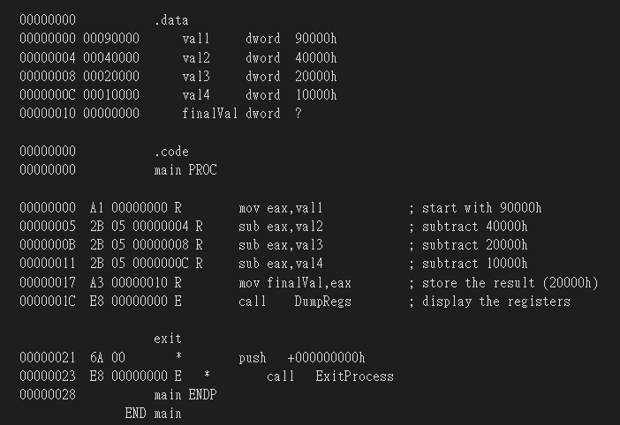
- Your github account
Sikako
- Github URL to the repo
https://github.com/Sikako/ASM-Lab02

