TRUBA INSTITUTE OF ENGINEERING &

INFORMATION TECHNOLOGY,

BHOPAL



**MINOR PROJECT REPORT**

Submitted in partial fulfillment of the requirements for the Degree of

Bachelors of Engineering in Information Technology

Submitted To:



**[RAJEEV GANDHI PRODYOGOKI VISHWAVIDYALAYA, BHOPAL (M.P.)]**

Submitted By:

**Sikander Makrani (0114IT161054), Mohd Alam Khan (0114IT161025)**

**Akanksha Sinha (0114IT161006)**

Under the Guidance of:

**Puneet Himthani (CSE/IT)**

**Kapil Raghuwanshi (CSE/IT)**

TRUBA INSTITUTE OF ENGINEERING &

INFORMATION TECHNOLOGY,

BHOPAL

  
(Session:2018-2019)

DEPARTMENT OF INFORMATION TECHNOLOGY

CERTIFICATE

This is to certify that “**Sikander Makrani, Mohd Alam Khan , Akanksha Sinha”,**Student of **IT-VI Semester**  of “ **Truba Institute of Engineering & Information Technology, Bhopal**” has completed their Project titled “**ZILA VIKAS MANCH**” ,as per the syllabus and has submitted a satisfactory report on this project as a partial fulfilment towards the award of degree of **Bachelor of Engineering** in **Information Technology** under **Rajiv Gandhi Proudyogiki Vishwavidyalaya, Bhopal.**

**PUNEET HIMTHANI PROF. AMIT SAXENA Dr.RAJEEV ARYA**

**KAPIL RAGHUWANSHI Head (CSE/IT) Director**

**(Project Guide) TIEIT, Bhopal TIEIT, Bhopal**

**DECLARATION**

I the undersigned solemnly declare that the project report **ZILA VIKAS MANCH** is based on my own work carried out during the course of our study under the supervision of **PUNEET HIMTHANI & KAPIL RAGHUWANSHI**.

I assert the statements made and conclusions drawn are an outcome of my research work. I further certify that

1. The work contained in the report is original and has been done by me under the general supervision of my supervisor.
2. The work has not been submitted to any other Institution for any other degree/diploma/certificate in this university or any other University of India or abroad.
3. We have followed the guidelines provided by the university in writing the report.
4. Whenever we have used materials (data, theoretical analysis, and text) from other sources, we have given due credit to them in the text of the report and giving their details in the references.

**Submitted By:**

**Sikander Makrani (0114IT161054)**

**Mohd Alam Khan (0114IT161025)**

**Akanksha Sinha (0114IT161006)**

**ACKNOWLEDGEMENT**

I would like to extend my gratitude to the following person for their help and support which has made this project possible.

Our **Director** **Dr. RAJEEV ARYA** for his virtual encouragement ,our **HOD** **Prof. AMIT SAXENA** for his virtual support. Our guide **PUNEET HIMTHANI , KAPIL RAGHUWANSHI** helped us a lot.

The surveyed institution **TRUBA INSTITUTE OF ENGINEERING & INFORMATION TECHNOLOGY** who helped and gave a lot of knowledge how to work. I would like to thank my group members and all my supporters to make this project successful.

**Submitted By:**

**Sikander Makrani(0114IT161054)**

**Mohd Alam Khan(0114IT161025)**

**Akanksha Sinha(0114IT161006)**

**List Of Figures**

Following are the list of figures used in the **ZILA VIKAS MANCH.**

Figure 1 – Water Fall Model

Figure 2 – ER Diagram

Figure 3.1 – DFD Level 0

Figure 3.2 – DFD Level 1

Figure 3.3 – Use Case Diagram

**List Of Tables**

Following are the list of tables used in the **ZILA VIKAS MANCH.**

Table 1 – catable

Table 2 – caproblem

Table 3 – irtable

Table 4 – irproblems

Table 5 – studentproblem

Table 6 – studentsolutions

Table 7 – studenttable

Table 8 – winner1solutions

Table 9 – winner2solutions

Table 10 – winner3solutions

**ABSTRACTION**

Collector was not able to solve the problem with new techniques and there was a communication gap between collector and students .So , This portal provides bridge between Collector and students and Collector could solve the problems with innovative ideas submitted by students in the form of solutions to Problem Statement. Zila Vikas Manch is an online portal , where collector or government authority posts their problems which are visible to IR(Institute Representative) of each institute .Institute representatives sends the problems to their respective groups of students. Students select the problems of their interest and submit the solution to the IR, which is then forward to government authority**.**

The main purpose of this project is to provide bridge between Collector and students and their ideas.Students can give their innovative ideas in the form of solutions and those solutions will be uploaded by Institute Representative after verification**.**Students can participate in solving Government Problems.Student will be awarded if the authority likes the solution of that student . Zila Vikas Manch is an online portal , where collector or government authority posts their problems which are visible to IR(Institute Representative) of each institute .Institute representatives sends the problems to their respective groups of students. Students select the problems of their interest and submit the solution to the IR, which is then forward to government authority**.**

**TABLE OF CONTENTS**

|  |  |
| --- | --- |
| FIRST PAGE | **I** |
| CERTIFICATE | **II** |
| DECLARATION | **III** |
| ACKNOWLEDGEMENT | **IV** |
| LIST OF FIGURES | **V** |
| LIST OF TABLES | **VI** |
| ABSTRACT | **VII** |
| INDEX |  |

|  |  |  |
| --- | --- | --- |
| **CHAPTER** | **TOPIC** | **PAGE NO.** |
| Chapter I | **INTRODUCTION** |  |
| 1.1 | Overview | **1** |
| 1.2 | Problem Statements | **1** |
| 1.3 | Objective of Projects | **1** |
| 1.4 | Application or Scope | **2-3** |
| 1.5 | Organization or Scope | **4** |
| Chapter II | **LITERATURE SURVEY** | **5** |
| Chapter III | **METHODOLOGY** | **6-8** |
| 3.1 | Background/Overview of Methodology | **9-10** |
| 3.2 | Project Platforms used in projects | **11** |
| 3.3 | Proposed Methodology | **11** |
| 3.4 | Project Modules | **11** |
| 3.5 | Diagrams(ER,Use Case,DFD etc) | **11** |
| Chapter IV | **IMPLEMENTATION** |  |
| 4.1 | Main Functions with explanation | **12** |
| 4.2 | Coding with Explanation | **13-46** |
| Chapter V | **RESULT** | **47** |
| Chapter VI | **USER MANUAL** |  |
| 6.1 | Software Requirements | **48** |
| 6.2 | Hardware Requirements | **49** |
| 6.3 | Steps to RUN the project | **49-52** |
| 6.4 | Application / EXE of project if applicable | **53** |
| Chapter VII | **CONCLUSION & FUTURE SCOPE** |  |
| 7.1 | Conclusion | **54** |
| 7.2 | Future Work |  |
| Chapter VIII | **REFERENCES** | **55** |

**Chapter I**

**INTRODUCTION**

* 1. **Overview**
* The main purpose of this project is to provide bridge between Collector and students and their ideas.
* Students can give their innovative ideas in the form of solutions and those solutions will be uploaded by Institute Representative after verification**.**
* Students can participate in solving Government Problems.
* Student will be awarded if the authority likes the solution of that student
* Zila Vikas Manch is an online portal, where collector or government authority posts their problems which are visible to IR(Institute Representative) of each institute .Institute representatives sends the problems to their respective groups of students. Students select the problems of their interest and submit the solution to the IR, which is then forward to government authority**.**

**1.2 Problem Statement**

Collector was not able to solve the problem with new techniques and there was a communication gap between collector and students .So , This portal provides bridge between Collector and students and Collector could solve the problems with innovative ideas submitted by students in the form of solutions to Problem Statement.

* 1. **Objective of Project**

Zila Vikas Manch is an online portal , where collector or government authority posts their problems which are visible to IR(Institute Representative) of each institute .Institute representatives sends the problems to their respective groups of students. Students select the problems of their interest and submit the solution to the IR, which is then forward to government authority**.**

* 1. **Applications or Scope**
* This portal can be accessed by Collector, Institute Representative, and Students.

* By using portal Collector can solve the problem with new innovative ideas submitted by students.
* This portal will reduce the stress of the collector.
* By using this portal, students can solve the problems faced by district Collector.
* This site is developed for addressing day to day problems of the society.
* Institute Representative acts as a mediator between Collector or Authority and students

**Chapter II**

**LITERATURE SURVEY**

This portal can be accessed by Collector, Institute Representative, and Students.

By using portal Collector can solve the problem with new innovative ideas submitted by students.This portal will reduce the stress of the collector. By using this portal, students can solve the problems faced by district Collector.This site is developed for addressing day to day problems of the society.Institute Representative acts as a mediator between Collector or Authority and students.

**Hardware Specifications:**

* + **User Interface :** 
    - Software provides good graphical interface for the user , any user can operate on the system ,performing the requirement task such uploading the problems , selecting the problems and submitting the solution.
  + **Hardware Interface** :
    - Operating System : Windows 10
    - Hard disk : 40GB
    - RAM : 256 MB
    - Processor : Intel Core i3
  + **Software Interface :**

Java Language

Net Beans IDE 7.0.1

MySQL Server

**USER Characteristics:**

We have two levels of users

* **User module :**

It is also divided in three levels

* **Collector :**

He/She will upload the problems and selects the best solution uploaded by the Institute Representative .

* **Institute Representative :**

He/She forwards the problems to the students and verify the solutions submitted by the students before forwarding to Collector.

* **Student :**

He/She will select the problem of his/her interest and submit the solution to IR.

* **Administrator module :**

**Admin** : He will have the full control on the project and will keep records of different permissions given to Collector ,IR and Students.

We have used Waterfall Model for developing Zila Vikas Manch.

Requirement Gathering and Analysis

Designing

Coding

Testing

Maintenance

**Fig 1 : Water fall Model**

**Key Features:**

1. It is basic fundamental model of SDLC.
2. It is also known as linear sequential model.

It consist of five stages

**Advantages:**

1. It is simple and easy.
2. It is mostly used for developing small projects and software’s.

**Disadvantages:**

1. No further updation.
2. Interaction with customer is done in first phase only.

**Chapter III**

**METHODOLOGY**

A methodology is a model, which project managers employ for the design, planning, implementation and achievement of their project objectives. There are different project management methodologies to benefit different projects

**3.1 Project Platforms used in Project**

* **Net Beans IDE**

Most developers recognize the NetBeans IDE as the original free Java IDE. It is that, and much more! The NetBeans IDE provides support for several languages (PHP, JavaFX, C/C++, JavaScript, etc.) and frameworks.

NetBeans is an open-source project dedicated to providing rock solid software development products(the [NetBeans IDE](https://netbeans.org/features/ide/index.html) and the [NetBeans Platform](https://netbeans.org/features/platform/index.html)) that address the needs of developers, users and the businesses who rely on NetBeans as a basis for their products; particularly, to enable them to develop these products quickly, efficiently and easily by leveraging the strengths of the Java platform and other relevant industry standards.

In June 2000, NetBeans was made [open source](https://netbeans.org/about/os/index.html) by Sun Microsystems, which remained the project sponsor until January 2010 when Sun Microsystems became a subsidiary of Oracle. Please see our [History](https://netbeans.org/about/history.html) section for more information.

The two base products, the NetBeans IDE and NetBeans Platform, are free for commercial and non-commercial use. The [source code](https://netbeans.org/community/sources/) to both is available to anyone to reuse as they see fit, within the terms of use. The [legal section](https://netbeans.org/about/legal)contains information regarding licensing, copyright issues, privacy policy and terms of use.

The NetBeans project is also a vibrant [community](https://netbeans.org/community/index.html) in which people from across the globe can ask questions, give advice, [contribute](https://netbeans.org/community/contribute/) and ultimately share in the success of our products. On the [NetBeans mailing lists and forums](https://netbeans.org/community/lists/), you will find posts from students, developers from [top companies](https://netbeans.org/community/partners/index.html), and individuals looking to expand their skills.

* **MySQL**

.

MySQL  is an [open-source](https://en.wikipedia.org/wiki/Open-source_software) [relational database management system](https://en.wikipedia.org/wiki/Relational_database_management_system) (RDBMS). Its name is a combination of "My", the name of co-founder [Michael Widenius](https://en.wikipedia.org/wiki/Michael_Widenius)'s daughter,and "[SQL](https://en.wikipedia.org/wiki/SQL)", the abbreviation for [Structured Query Language](https://en.wikipedia.org/wiki/Structured_Query_Language).

MySQL is [free and open-source software](https://en.wikipedia.org/wiki/Free_and_open-source_software) under the terms of the [GNU General Public License](https://en.wikipedia.org/wiki/GNU_General_Public_License), and is also available under a variety of [proprietary](https://en.wikipedia.org/wiki/Proprietary_software) licenses. MySQL was owned and sponsored by the [Swedish](https://en.wikipedia.org/wiki/Sweden) company [MySQL AB](https://en.wikipedia.org/wiki/MySQL_AB), which was bought by Sun Microsystems (now [Oracle Corporation](https://en.wikipedia.org/wiki/Oracle_Corporation)). In 2010, when Oracle acquired Sun, Widenius [forked](https://en.wikipedia.org/wiki/Fork_(software_development)) the [open-source](https://en.wikipedia.org/wiki/Open-source) MySQL project to create [MariaDB](https://en.wikipedia.org/wiki/MariaDB).

* **Servlets**

A Java servlet processes or stores a [Java class](https://en.wikipedia.org/wiki/Java_class) in [Java EE](https://en.wikipedia.org/wiki/Java_EE) that conforms to the Java Servlet API, a standard for implementing Java classes that respond to requests. Servlets could in principle communicate over any [client–server](https://en.wikipedia.org/wiki/Client%E2%80%93server_model) protocol, but they are most often used with the [HTTP](https://en.wikipedia.org/wiki/Hypertext_Transfer_Protocol). Thus "servlet" is often used as shorthand for "HTTP servlet". Thus, a [software developer](https://en.wikipedia.org/wiki/Software_developer) may use a servlet to add [dynamic content](https://en.wikipedia.org/wiki/Dynamic_web_page) to a server using the [Java platform](https://en.wikipedia.org/wiki/Java_platform). The generated content is commonly [HTML](https://en.wikipedia.org/wiki/HTML), but may be other data such as [XML](https://en.wikipedia.org/wiki/XML) and more commonly, JSON. Servlets can maintain [state](https://en.wikipedia.org/wiki/State_(computer_science)) in [session](https://en.wikipedia.org/wiki/Session_(computer_science)) variables across many server transactions by using [HTTP cookies](https://en.wikipedia.org/wiki/HTTP_cookie), or [URL mapping](https://en.wikipedia.org/wiki/URL_mapping).

The Java servlet API has, to some extent, been superseded by two standard Java technologies for web services:

* the [Java API for Restful Web Services](https://en.wikipedia.org/wiki/Java_API_for_RESTful_Web_Services) (JAX-RS 2.0) useful for AJAX, JSON and REST services, and
* the [Java API for XML Web Services](https://en.wikipedia.org/wiki/Java_API_for_XML_Web_Services) (JAX-WS) useful for [SOAP](https://en.wikipedia.org/wiki/SOAP) [Web Services](https://en.wikipedia.org/wiki/Web_Service).

To deploy and run a servlet, a [web container](https://en.wikipedia.org/wiki/Web_container) must be used. A web container (also known as a servlet container) is essentially the component of a web server that interacts with the Servlets. The web container is responsible for managing the lifecycle of Servlets, mapping a URL to a particular servlet and ensuring that the URL requester has the correct access rights.

The Servlet [API](https://en.wikipedia.org/wiki/Application_programming_interface), contained in the [Java package](https://en.wikipedia.org/wiki/Java_package) hierarchy [javax.servlet](https://docs.oracle.com/javaee/7/api/javax/servlet/package-summary.html), defines the expected interactions of the web container and a servlet.

* **CSS**

Cascading Style Sheets (CSS) is a [style sheet language](https://en.wikipedia.org/wiki/Style_sheet_language) used for describing the [presentation](https://en.wikipedia.org/wiki/Presentation_semantics) of a document written in a [markup language](https://en.wikipedia.org/wiki/Markup_language) like [HTML](https://en.wikipedia.org/wiki/HTML). CSS is a cornerstone technology of the [World Wide Web](https://en.wikipedia.org/wiki/World_Wide_Web), alongside HTML and [JavaScript](https://en.wikipedia.org/wiki/JavaScript).

CSS is designed to enable the separation of presentation and content, including [layout](https://en.wikipedia.org/wiki/Page_layout), [colors](https://en.wikipedia.org/wiki/Color), and [fonts](https://en.wikipedia.org/wiki/Typeface). This separation can improve content [accessibility](https://en.wikipedia.org/wiki/Accessibility), provide more flexibility and control in the specification of presentation characteristics, enable multiple [web pages](https://en.wikipedia.org/wiki/Web_page) to share formatting by specifying the relevant CSS in a separate .css file, and reduce complexity and repetition in the structural content.

Separation of formatting and content also makes it feasible to present the same markup page in different styles for different rendering methods, such as on-screen, in print, by voice (via speech-based browser or [screen reader](https://en.wikipedia.org/wiki/Screen_reader)), and on [Braille-based](https://en.wikipedia.org/wiki/Braille_display) tactile devices. CSS also has rules for alternate formatting if the content is accessed on a [mobile device](https://en.wikipedia.org/wiki/Mobile_device).

* + **JAVA SCRIPT**

JavaScript is one of the 3 languages all web developers must learn:

* + HTML to define the content of web pages
  + CSS to specify the layout of web page

**Advantages of JavaScript**

* Speed. Client-side JavaScript is very fast because it can be run immediately within the client-side browser. Unless outside resources are required, JavaScript is unhindered by network calls to a backend server. It also has no need to be compiled on the client side which gives it certain speed advantages (granted, adding some risk dependent on that quality of the code developed).
* Simplicity. JavaScript is relatively simple to learn and implement.
* Popularity. JavaScript is used everywhere in the web. The resources to learn JavaScript are numerous. StackOverflow and GitHub have many projects that are using Javascript and the language as a whole has gained a lot of traction in the industry in recent years especially.
* Interoperability. JavaScript plays nicely with other languages and can be used in a huge variety of applications. Unlike PHP or [SSI](https://en.wikipedia.org/wiki/Server_Side_Includes) scripts, JavaScript can be inserted into any web page regardless of the file extension. JavaScript can also be used inside scripts written in other languages such as Perl and PHP.
* Server Load. Being client-side reduces the demand on the website server.

**Disadvantages of JavaScript**

* Client-Side Security. Because the code executes on the users’ computer, in some cases it can be exploited for malicious purposes. This is one reason some people choose to disable Javascript.
* Browser Support. JavaScript is sometimes interpreted differently by different browsers. Whereas server-side scripts will always produce the same output, client-side scripts can be a little unpredictable. Don’t be overly concerned by this though - as long as you test your script in all the major browsers you should be safe. Also, there are services out there that will allow you to test your code automatically on check in of an update to make sure all browsers support your code.
* **HTML**

Hypertext Markup Language (HTML) is the standard [markup language](https://en.wikipedia.org/wiki/Markup_language) for creating [web pages](https://en.wikipedia.org/wiki/Web_page) and [web applications](https://en.wikipedia.org/wiki/Web_application). With [Cascading Style Sheets](https://en.wikipedia.org/wiki/Cascading_Style_Sheets) (CSS) and [JavaScript](https://en.wikipedia.org/wiki/JavaScript), it forms a triad of [cornerstone](https://en.wikipedia.org/wiki/Cornerstone) technologies for the [World Wide Web](https://en.wikipedia.org/wiki/World_Wide_Web).

[Web browsers](https://en.wikipedia.org/wiki/Web_browser) receive HTML documents from a [web server](https://en.wikipedia.org/wiki/Web_server) or from local storage and [render](https://en.wikipedia.org/wiki/Browser_engine) the documents into multimedia web pages. HTML describes the structure of a web page [semantically](https://en.wikipedia.org/wiki/Semantic_Web) and originally included cues for the appearance of the document.

[HTML elements](https://en.wikipedia.org/wiki/HTML_element) are the building blocks of HTML pages. With HTML constructs, [images](https://en.wikipedia.org/wiki/HTML_element#Images_and_objects) and other objects such as [interactive forms](https://en.wikipedia.org/wiki/Fieldset) may be embedded into the rendered page. HTML provides a means to create [structured documents](https://en.wikipedia.org/wiki/Structured_document) by denoting structural [semantics](https://en.wikipedia.org/wiki/Semantics) for text such as headings, paragraphs, lists, [links](https://en.wikipedia.org/wiki/Hyperlink), quotes and other items. HTML elements are delineated by tags, written using [angle brackets](https://en.wikipedia.org/wiki/Bracket#Angle_brackets). Tags such as <img /> and <input /> directly introduce content into the page. Other tags such as <p> surround and provide information about document text and may include other tags as sub-elements. Browsers do not display the HTML tags, but use them to interpret the content of the page.

**3.2 Diagrams**

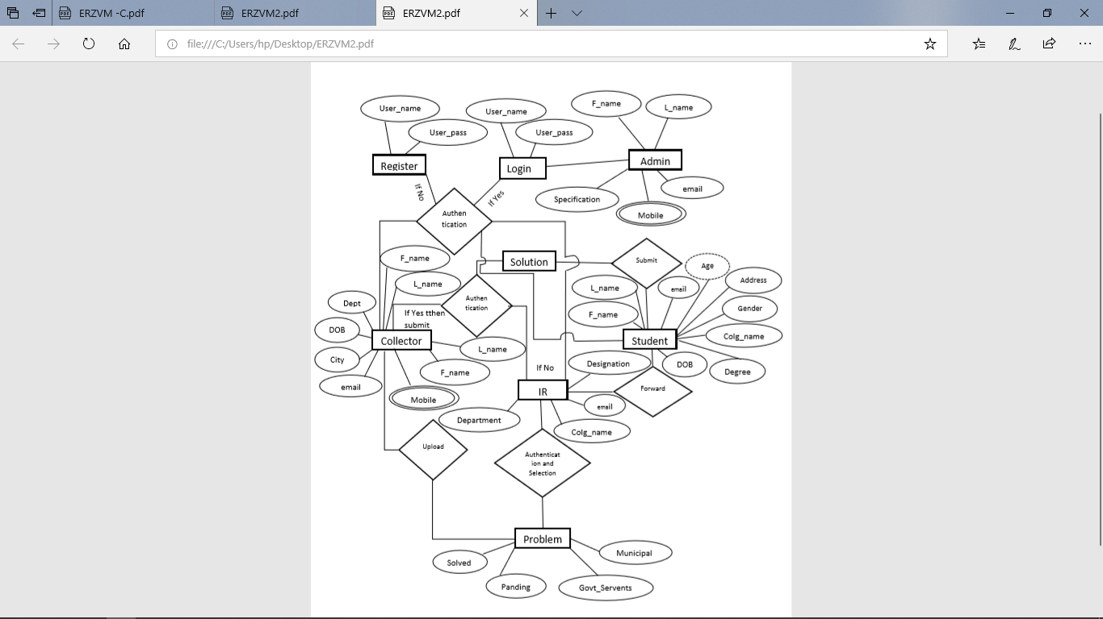

**Fig 2 : ER Diagram**

* **DFD:**

Collector

Admin

IR Representative

Student

Admin

**DFD Level 0**

**Fig 3.1**

**DFD Level 1**

Co_pro

**5.1**

**5.2**

**3.1**

IR Representative

Collector

Student

IR _pro

IR_sol

Stu_sol

**2.1**

**4.1**

**4.2**

Login

Admin

**1.1**

Register

**2.2**

**Fig 3.2 :DFD Level 1**

**Chapter IV**

**IMPLEMENTATION**

* 1. **Coding:**

**AllStudentsForStudents.jsp**

<%@page import="Bean.ShowAllStudentsBean"%>

<%@page import="java.util.ArrayList"%>

<%@page import="DAO.MethodDeclarations"%>

<%@page import="DAO.MethodOperation"%>

<%@page import="Bean.StudentSolutionsBean"%>

<%@page import="Bean.IRTableBean"%>

<%@page import="Bean.ProblemsUpByCABean"%>

<%@page import="java.util.ListIterator"%>

<%@page import="java.util.List"%>

<%@page import="java.sql.ResultSet"%>

<%@page contentType="text/html" pageEncoding="UTF-8"%>

<!DOCTYPE html>

<html>

<head>

<meta charset="UTF-8">

<meta http-equiv="X-UA-compatible" content = "IE-edge">

<meta name="viewport" content="width=device-width, initial-scale=1">

<link rel ="stylesheet" type ="text/css" href="bootstrap.min.css">

<script src="jquery-3.3.1.min.js"></script>

<script type = text/javascript src="bootstrap.min.js"></script>

<link rel="stylesheet" href="https://maxcdn.bootstrapcdn.com/bootstrap/4.2.1/css/bootstrap.min.css">

<script src="https://ajax.googleapis.com/ajax/libs/jquery/3.3.1/jquery.min.js"></script>

<script src="https://cdnjs.cloudflare.com/ajax/libs/popper.js/1.14.6/umd/popper.min.js"></script>

<script src="https://maxcdn.bootstrapcdn.com/bootstrap/4.2.1/js/bootstrap.min.js"></script>

<jsp:include page="title.jsp" />

<link rel=stylesheet type = text/css href="https://stackpath.bootstrapcdn.com/font-awesome/4.7.0/css/font-awesome.min.css">

<!--<link rel="stylesheet" type="text/css" href="https://cdn.datatables.net/1.10.19/css/jquery.dataTables.css">

<script type="text/javascript" charset="utf8" src="https://cdn.datatables.net/1.10.19/js/jquery.dataTables.js"></script>

-->

<link rel="stylesheet" type="text/css" href="http://ajax.aspnetcdn.com/ajax/jquery.dataTables/1.9.4/css/jquery.dataTables.css">

<script type="text/javascript" src="http://ajax.aspnetcdn.com/ajax/jQuery/jquery-1.8.2.min.js"></script>

<script type="text/javascript" src="http://ajax.aspnetcdn.com/ajax/jquery.dataTables/1.9.4/jquery.dataTables.min.js"></script>

<style>

#frame_size{

width: 500px;

height: 500px;

}

.uploaded_problems_sticky{

position:sticky;

top:0;

}

</style>

<style>

.collapsible_button1{

background-color:#112d32;

color:white

}

.active, .collapsible_button1:hover {

background-color: #1b474f;

// color: lightgreen;

}

.collapsible_button1:after{

content: '\002B';

font-size:60px;

color:white;

}

.active:after{

content: "\2212";

}

@media screen and (max-width:1600px){

div.card_width{

width:90%;

}

div.font_size{

font-size:20px;

}

table.table_fontsize{

font-size:3vw;

}

}

@media screen and (min-width:1601px){

div.card_width{

width:60%;

}

div.font_size{

font-size:30px;

}

table.table_fontsize{

font-size:1vw;

}

}

</style>

</head>

<body>

<%

response.setHeader("Cache-Control","no-cache,no-store,must-revalidate");

if(session.getAttribute("aadharidFromStudentHome")!=null && session.getAttribute("passwordFromStudentHome")!=null){

%>

<jsp:include page="studentNavbar.jsp" />

<div class="container-fluid" style = "margin-top : 95px;" >

<div class="row" >

<div class="col-lg-12" style="height:899px;background-color: #88bdbc;overflow-y:scroll;padding:0px;">

<div class="uploaded_problems_sticky" style="z-index:1;margin-top:40px;margin-bottom:40px;width:100%;" >

<div class="card shadow-lg" style="background-color:rgba(23,67,88,0.5);color:white;padding:40px;" >

<h2 align="center"><i>All Students</i></h2>

</div>

</div>

<%

MethodDeclarations md=new MethodOperation();

List lisacapwirt = md.selectAllStudents();

if (lisacapwirt != null) {

ListIterator lit = lisacapwirt.listIterator();

while (lit.hasNext()) {

ShowAllStudentsBean sasb = (ShowAllStudentsBean) lit.next();

%>

<!--

<button data-toggle="collapse" data-target="#demo" >

</button>

-->

<div align="center">

<div class="card shadow-lg card_width" align="center" style="background-color:#f3f8f8;padding-left:20px;padding-right:0px;font-size:20px;margin-top:30px;border:none;padding-top:0px;padding-bottom:0px;" >

<div class="card-body " >

<table align="left" width="60%">

<tr><td ><img src="image_ddp/<%=sasb.getF_Name()%>" class="rounded-circle " style="height:200px;width:200px;margin-top:0px;" ></td><td ><div align="center" class="font_size"><%=sasb.getUsername()%><br><%=sasb.getCollege()%></div> </td></tr>

</table>

<div class="card collapsible_button1 rounded-square" style="width:10%;cursor:pointer;max-height: 100px;margin-top:70px;" data-toggle="collapse" data-target="#IndividualStudent<%=sasb.getAadharid()%>" ></div>

</div>

</div>

<div class="collapse" id="IndividualStudent<%=sasb.getAadharid()%>">

<div class="card card_width" align="center" style="background-color:#f3f8f8;padding-left:20px;padding-right:20px;font-size:20px;min-height:450px;margin-bottom:40px;border:none;" >

<div class="card-body">

<div class="row">

<table style="margin-top:0px;width:90%" align="center" class="table_fontsize">

<tr><td><hr>Second Member</td><td><hr><%=sasb.getSecond_m()%></td></tr>

<tr><td>Third Member</td><td><%=sasb.getThird_m()%></td></tr>

<tr><td>Institute Representative</td><td><%=md.getUserName(sasb.getReferenceid())%></td></tr>

<tr><td>Email Address</td><td><%=sasb.getEmailadd()%></td></tr>

<tr><td>Contact No.</td><td><%=sasb.getContactno()%></td></tr>

<tr><td>Address</td><td><%=sasb.getAddress()%></td></tr>

<tr><td>City</td><td><%=sasb.getCity()%></td></tr>

<tr><td>State</td><td><%=sasb.getState()%></td></tr>

</table>

</div>

</div>

</div>

</div>

</div>

<%

}

}else if(lisacapwirt==null){

%>

<div align="center">

<div class="card shadow-lg" align="center" style="background-color:white;padding-left:20px;padding-right:20px;font-size:20px;min-height:450px;width:80%;margin-top:80px;" >

<div class="card-body">

<span ><i class="fa fa-folder-open fa-10x " style="color:lightgrey;margin-top:60px;"></i></span>

<h1 align="center" style="color:lightgrey;"> No students to show !! </h1>

</div>

</div>

</div>

<%

}

%>

<script>

var coll = document.getElementsByClassName("collapsible_button1");

var i;

for (i = 0; i < coll.length; i++) {

coll[i].addEventListener("click", function() {

this.classList.toggle("active");

var content = this.nextElementSibling;

if (content.style.maxHeight){

content.style.maxHeight = null;

} else {

content.style.maxHeight = content.scrollHeight + "px";

}

});

}

</script>

</div>

</div>

</div>

<%

}else{

response.sendRedirect("StudentLogin.jsp?value=0");

}

%>

</body>

</html>

**Chapter VI**

**USER MANUAL**

**6.1 Software Requirement:**

* **Java Language** :

Java is a [general-purpose](https://en.wikipedia.org/wiki/General-purpose_language) [programming language](https://en.wikipedia.org/wiki/Programming_language) that is [class-based](https://en.wikipedia.org/wiki/Class-based_programming), [object-oriented](https://en.wikipedia.org/wiki/Object-oriented_programming), and specifically designed to have as few implementation [dependencies](https://en.wikipedia.org/wiki/Dependency_(computer_science)) as possible. It is intended to let [application developers](https://en.wikipedia.org/wiki/Application_developer) "[write once, run anywhere](https://en.wikipedia.org/wiki/Write_once,_run_anywhere)" (WORA), meaning that [compiled](https://en.wikipedia.org/wiki/Compiler) Java code can run on all platforms that support Java without the need for recompilation. Java applications are typically compiled to ["bytecode"](https://en.wikipedia.org/wiki/Java_bytecode) that can run on any [Java virtual machine](https://en.wikipedia.org/wiki/Java_virtual_machine) (JVM) regardless of the underlying [computer architecture](https://en.wikipedia.org/wiki/Computer_architecture). The [syntax](https://en.wikipedia.org/wiki/Syntax_(programming_languages)) of Java is similar to [C](https://en.wikipedia.org/wiki/C_(programming_language)) and [C++](https://en.wikipedia.org/wiki/C%2B%2B), but it has fewer [low-level](https://en.wikipedia.org/wiki/Low-level_programming_language) facilities than either of them. As of 2018, Java was according to [GitHub](https://en.wikipedia.org/wiki/GitHub) one of the most [popular programming languages in use](https://en.wikipedia.org/wiki/Measuring_programming_language_popularity), particularly for [client-server](https://en.wikipedia.org/wiki/Client%E2%80%93server) [web applications](https://en.wikipedia.org/wiki/Web_applications), with a reported 9 million developers.

Java was originally developed by [James Gosling](https://en.wikipedia.org/wiki/James_Gosling) at [Sun Microsystems](https://en.wikipedia.org/wiki/Sun_Microsystems) ([which has since been acquired by Oracle](https://en.wikipedia.org/wiki/Sun_acquisition_by_Oracle)) and released in 1995 as a core component of Sun Microsystems' [Java platform](https://en.wikipedia.org/wiki/Java_(software_platform)). The original and [reference implementation](https://en.wikipedia.org/wiki/Reference_implementation) Java [compilers](https://en.wikipedia.org/wiki/Compiler), virtual machines, and [class libraries](https://en.wikipedia.org/wiki/Library_(computing)) were originally released by Sun under [proprietary licenses](https://en.wikipedia.org/wiki/Proprietary_license). As of May 2007, in compliance with the specifications of the [Java Community Process](https://en.wikipedia.org/wiki/Java_Community_Process), Sun had [relicensed](https://en.wikipedia.org/wiki/Software_relicensing) most of its Java technologies under the [GNU General Public License](https://en.wikipedia.org/wiki/GNU_General_Public_License). Meanwhile, others have developed alternative implementations of these Sun technologies, such as the [GNU Compiler for Java](https://en.wikipedia.org/wiki/GNU_Compiler_for_Java) (bytecode compiler), [GNU Classpath](https://en.wikipedia.org/wiki/GNU_Classpath) (standard libraries), and [IcedTea](https://en.wikipedia.org/wiki/IcedTea" \o "IcedTea)-Web (browser plugin for applets).

The latest version is [Java SE 12](https://en.wikipedia.org/wiki/Java_version_history), released in March 2019. Since Java 9 is no longer supported, [Oracle](https://en.wikipedia.org/wiki/Oracle_Corporation) advises its users to "immediately transition" to Java 12. Oracle released the last public update for the [legacy](https://en.wikipedia.org/wiki/Legacy_software) Java 8 LTS, which is free for commercial use, in January 2019. Java 8 will be supported with public updates for personal use up to at least December 2020. Oracle and others "highly recommend that you uninstall older versions of Java" because of serious risks due to unresolved security issues. [Oracle](https://en.wikipedia.org/wiki/Oracle_Corporation) extended support for Java 6 ended in December 2018.

* **Net Beans IDE 7.0.1:**

The NetBeans IDE is an award-winning integrated development environment available for Windows, Mac, Linux, and Solaris. The NetBeans project consists of an [open-source IDE](https://netbeans.org/features/index.html) and an [application platform](https://netbeans.org/features/platform/index.html) that enable developers to rapidly create web, enterprise, desktop, and mobile applications using the Java platform, as well as PHP, JavaScript and Ajax, Groovy and Grails, and C/C++.

* **MySQL Server:**

MySQL is an [open-source](https://en.wikipedia.org/wiki/Open-source_software) [relational database management system](https://en.wikipedia.org/wiki/Relational_database_management_system) (RDBMS). Its name is a combination of “My”, the name of co-founders [Michael Widenius](https://en.wikipedia.org/wiki/Michael_Widenius)'s daughter, and "[SQL](https://en.wikipedia.org/wiki/SQL)", the abbreviation for [Structured Query Language](https://en.wikipedia.org/wiki/Structured_Query_Language).

MySQL is [free and open-source software](https://en.wikipedia.org/wiki/Free_and_open-source_software) under the terms of the [GNU General Public License](https://en.wikipedia.org/wiki/GNU_General_Public_License), and is also available under a variety of [proprietary](https://en.wikipedia.org/wiki/Proprietary_software) licenses. MySQL was owned and sponsored by the [Swedish](https://en.wikipedia.org/wiki/Sweden) company [MySQL AB](https://en.wikipedia.org/wiki/MySQL_AB), which was bought by Sun Microsystems (now [Oracle Corporation](https://en.wikipedia.org/wiki/Oracle_Corporation)). In 2010, when Oracle acquired Sun, Widenius [forked](https://en.wikipedia.org/wiki/Fork_(software_development)) the [open-source](https://en.wikipedia.org/wiki/Open-source) MySQL project to create [MariaDB](https://en.wikipedia.org/wiki/MariaDB).

MySQL is a component of the [LAMP](https://en.wikipedia.org/wiki/LAMP_(software_bundle)) [web application](https://en.wikipedia.org/wiki/Web_application) [software stack](https://en.wikipedia.org/wiki/Software_stack) (and [others](https://en.wikipedia.org/wiki/List_of_AMP_packages)), which is an acronym for [Linux](https://en.wikipedia.org/wiki/Linux), [Apache](https://en.wikipedia.org/wiki/Apache_HTTP_Server), MySQL, [Perl](https://en.wikipedia.org/wiki/Perl)/[PHP](https://en.wikipedia.org/wiki/PHP)/[Python](https://en.wikipedia.org/wiki/Python_(programming_language)). MySQL is used by many database-driven web applications, including [Drupal](https://en.wikipedia.org/wiki/Drupal), [Joomla](https://en.wikipedia.org/wiki/Joomla), [phpBB](https://en.wikipedia.org/wiki/PhpBB" \o "PhpBB), and [WordPress](https://en.wikipedia.org/wiki/WordPress). MySQL is also used by many popular [websites](https://en.wikipedia.org/wiki/Website), including [Facebook](https://en.wikipedia.org/wiki/Facebook).

**6.2 Hardware Requirement:**

* **Operating System : Windows 10**
* **Hard disk : 40GB**
* **RAM : 256 MB**
* **Processor : Intel Core i3**

**6.3 Steps to RUN the project:**

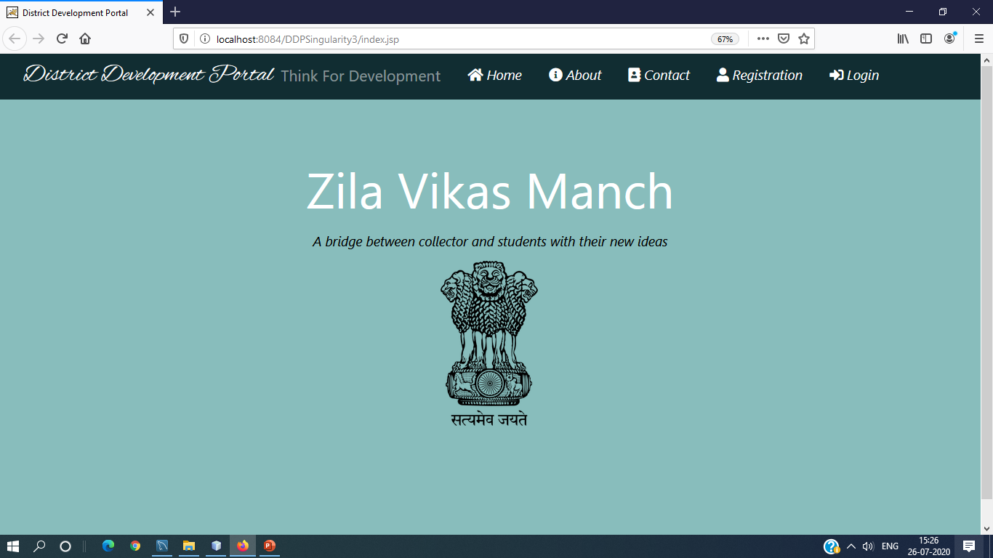

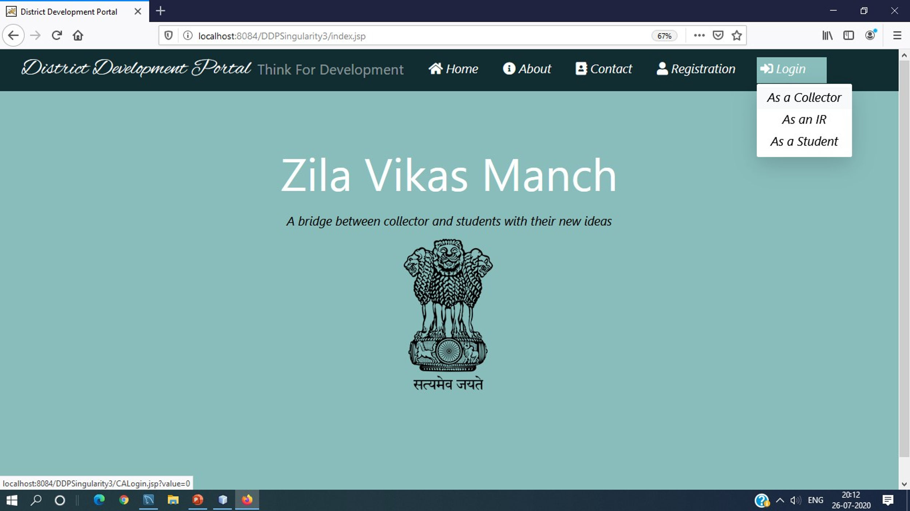

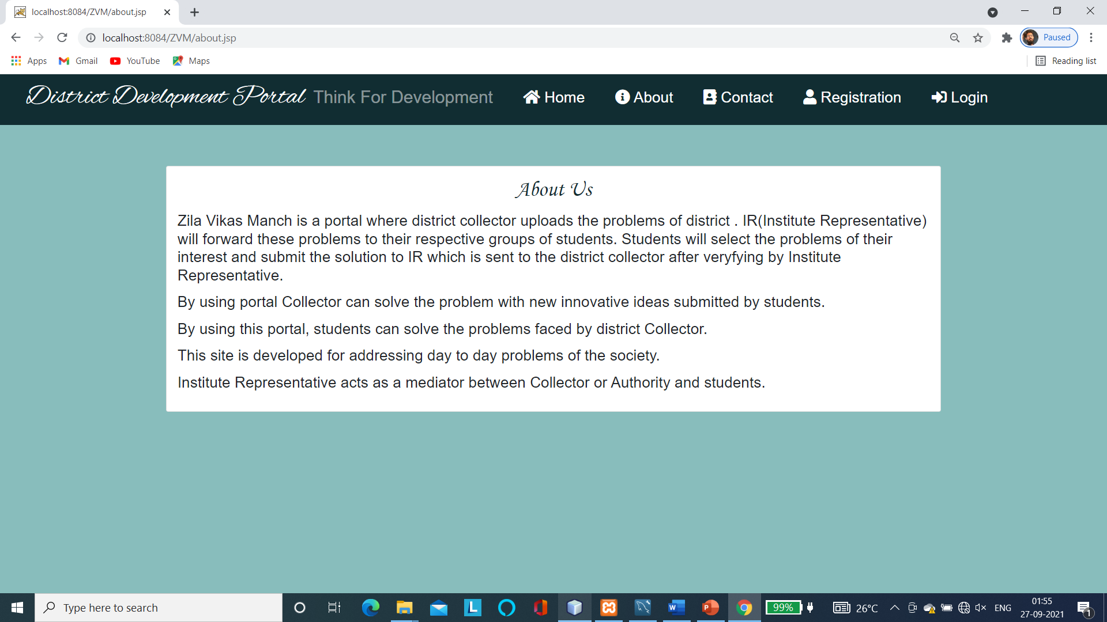

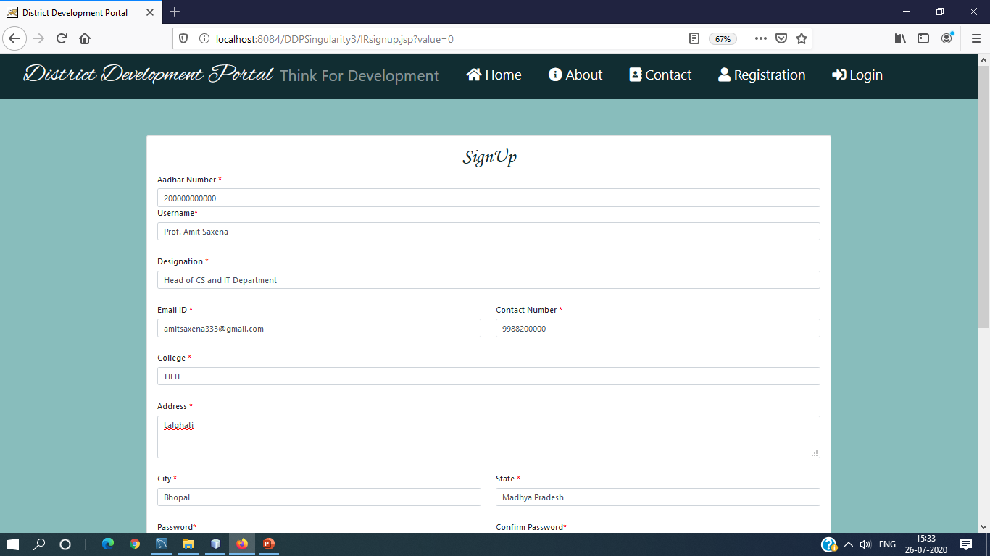

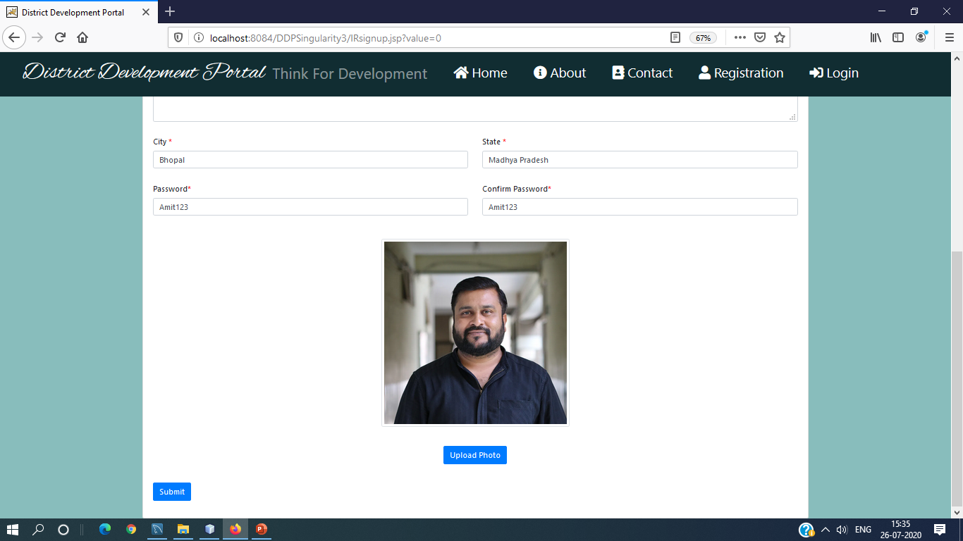

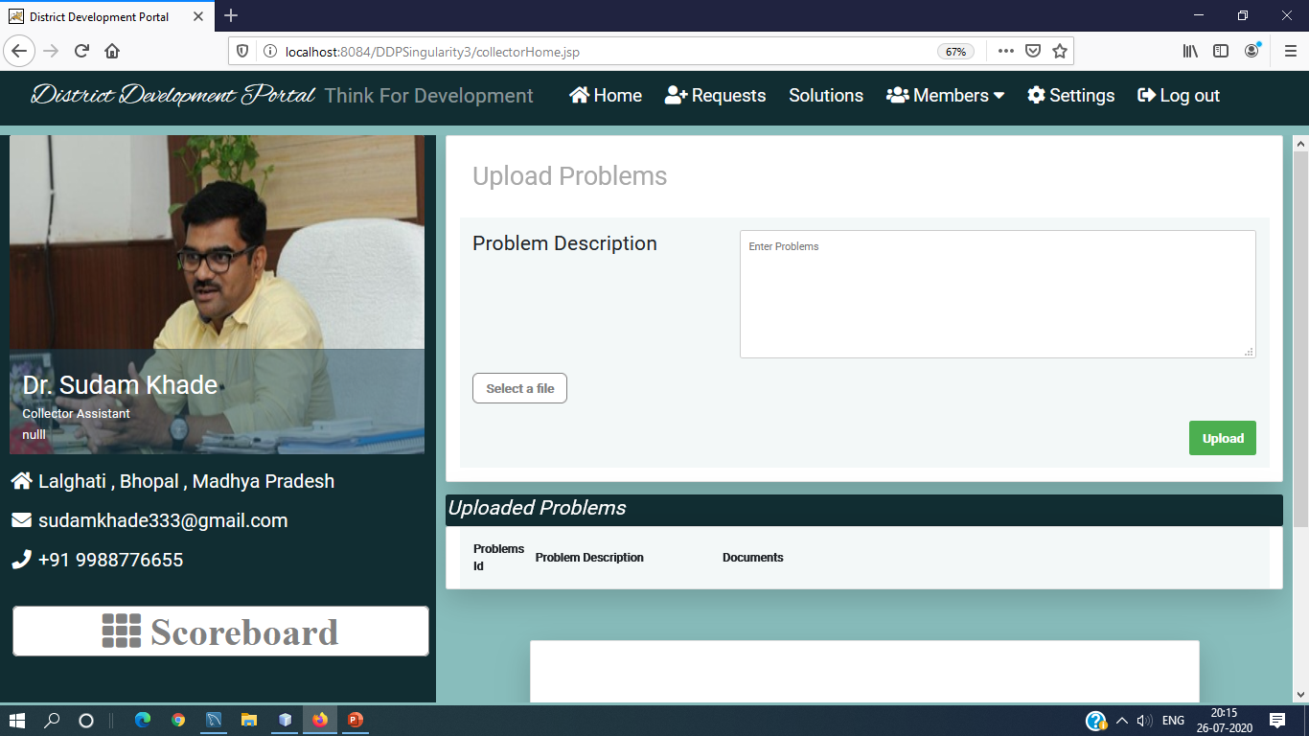

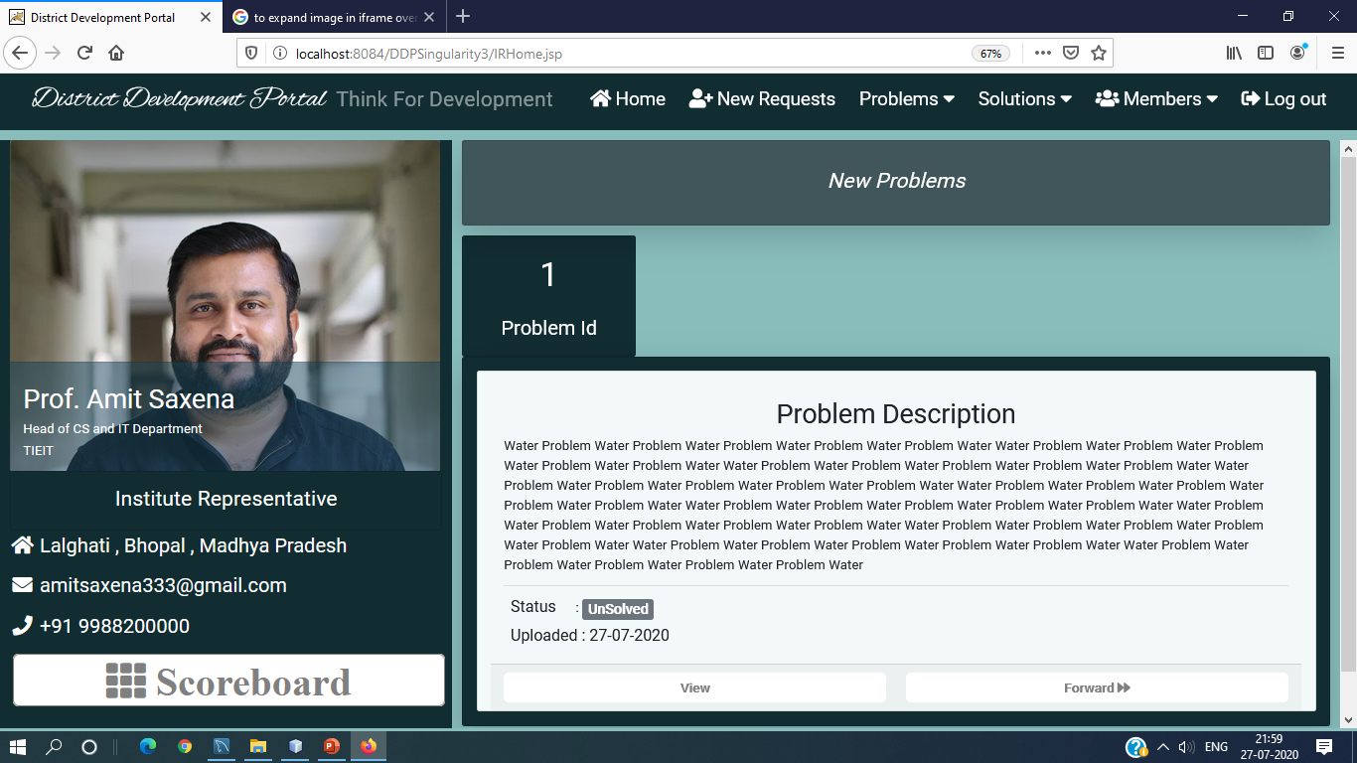

**Chapter VII**

**CONCLUTION & FUTURE SCOPE**

**7.1 Conclusion:**

The proposed system is designed to provide fast response serving ,to solve real time problems the improvement of the efficiency and design cost was considered . Using this system design the efficiency can be easly enhanced for many applications .Complexity reductions that envolves with the time and space increase the efficiency of the overall system used .

It would be fruitul for collector and would help in making decision for district development better. And students can take part in district development.