Course Two

Go Beyond the Numbers: Translate Data into Insights


Instructions
Use this PACE strategy document to record decisions and reflections as you work through this end-of-course project. You can use this document as a guide to consider your responses and reflections at different stages of the data analytical process. Additionally, the PACE strategy documents can be used as a resource when working on future projects.

Course Project Recap
Regardless of which track you have chosen to complete, your goals for this project are:
- Complete the questions in the Course 2 PACE strategy document
- Answer the questions in the Jupyter notebook project file
- Clean your data, perform exploratory data analysis (EDA)
- Create data visualizations
- Create an executive summary to share your results

Relevant Interview Questions
Completing the end-of-course project will help you respond to these types of questions that are often asked during the interview process:
- How would you explain the difference between qualitative and quantitative data sources?
Quantitative data is numeric and measurable (e.g., fare amount); qualitative data is descriptive or categorical (e.g., interview feedback, payment type).
- Describe the difference between structured and unstructured data.
Structured data fits rows and columns with a set schema (this taxi CSV); unstructured data has no fixed format (text, images, audio).
- Why is it important to do exploratory data analysis?
EDA reveals data quality issues, patterns and outliers before modelling, so decisions and models are based on reliable data.
- How would you perform EDA on a given dataset?
Follow the six practices: discover, structure, clean, join, validate and present.
- How do you create or alter a visualization based on different audiences?
Match detail to the audience: key takeaways and simple charts for executives; distributions, statistics and code for technical teams.
- How do you avoid bias and ensure accessibility in a data visualization?
Use honest axes and full context; use colorblind-safe, high-contrast colours, large labels and descriptive alt text.
- How does data visualization inform your EDA?
Charts quickly expose distributions, outliers and trends (e.g., the box plot of trip distance) that summary tables can hide.
Reference Guide
This project has six tasks; the visual below identifies how the stages of PACE are incorporated across those tasks.
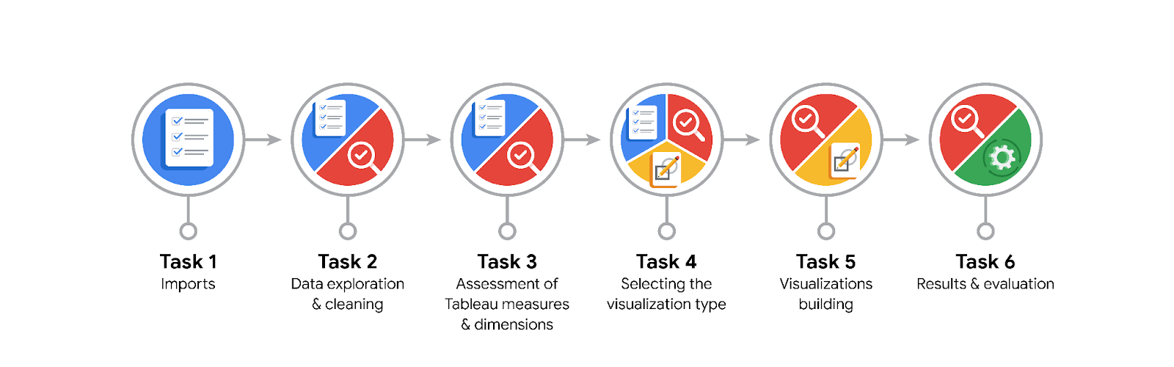
Data Project Questions & Considerations

PACE: Plan Stage
- What are the data columns and variables and which ones are most relevant to your deliverable?
• 18 columns, 22,699 trips (2017 TLC yellow taxi sample): IDs, vendor, pickup/drop-off times, passenger count, trip distance, rate code, store-and-forward flag, pickup/drop-off zone IDs, payment type and fare components.
• Most relevant: trip_distance, pickup/drop-off datetimes (to derive duration, month, day), fare_amount, total_amount, RatecodeID, PU/DOLocationID.

- What units are your variables in?
Distance in miles; fare, tip, tolls, taxes and total in US dollars; datetimes as timestamps (duration derived in minutes); location, vendor, rate and payment fields are categorical codes.

- What are your initial presumptions about the data that can inform your EDA, knowing you will need to confirm or deny with your future findings?
Fare should rise mainly with distance and duration; most trips are short, intra-Manhattan rides; some extreme values (very long/zero trips, negative fares) are likely data-entry or refund records.

- Is there any missing or incomplete data?
No missing values (0 nulls) and no duplicate rows. However, some records are incomplete/invalid: 148 zero-distance trips, 14 negative fares and 27 trips with zero or negative duration.

- Are all pieces of this dataset in the same format?
No. Pickup/drop-off datetimes load as text and must be converted to datetime; codes are numeric but categorical; the rest are numeric (int/float).

- Which EDA practices will be required to begin this project?
Discovering, structuring (datetime conversion, new duration/month/day columns), cleaning (outliers, invalid values), validating and presenting.

PACE: Analyze Stage
- What steps need to be taken to perform EDA in the most effective way to achieve the project goal?
Inspect (info, describe, nulls, duplicates) → convert dates and derive duration/month/day → check outliers with box plots and IQR → aggregate rides and revenue by month, quarter and day → summarise distance by drop-off zone → visualise and document findings.

- Do you need to add more data using the EDA practice of joining? What type of structuring needs to be done to this dataset, such as filtering, sorting, etc.?
No join is needed for this stage. Structuring needed: grouping by month/quarter/day and drop-off zone, sorting (e.g., by mean distance) and filtering invalid or extreme records. A taxi-zone lookup could later be joined to name the locations.

- What initial assumptions do you have about the types of visualizations that might best be suited for the intended audience?
Simple, high-contrast charts with large labels: box plots for distance/duration/fare spread, bar charts for rides and revenue by month and day, and a scatter plot for distance vs fare. Colorblind-safe palettes and alt text for accessibility.

PACE: Construct Stage
- What data visualizations, machine learning algorithms, or other data outputs will need to be built in order to complete the project goals?
Box plots, histograms, bar charts (monthly/daily rides and revenue), scatter plot (distance vs fare) and an executive summary; later a multiple linear regression fare-estimation model.

- What processes need to be performed in order to build the necessary data visualizations?
Import and clean data, convert datetimes, engineer duration/month/day features, aggregate with groupby, then plot with matplotlib/seaborn (or Tableau) and add titles, labels and alt text.

- Which variables are most applicable for the visualizations in this data project?
trip_distance, duration (from pickup/drop-off times), fare_amount, total_amount, pickup month/day, and DOLocationID.

- Going back to the Plan stage, how do you plan to deal with the missing data (if any)?
There are no nulls. Invalid values (negative fares, zero distance, non-positive durations) will be flagged and removed or imputed; extreme outliers (e.g., $999.99 fare, ~24-hour trips) will be capped or confirmed with TLC before modelling.

PACE: Execute Stage
- What key insights emerged from your EDA and visualizations(s)?
• Most trips are short: median 1.61 miles, 11.2 minutes, $9.50 fare.
• Distance strongly drives fare (r = 0.76); duration is weak (r = 0.13) until outliers are cleaned.
• Demand is seasonal: Q3 (Jul–Sep) is the lowest quarter (5,155 rides, $82.6K) vs Q2 highest (5,996, $98.8K); Thu/Fri are busiest, Mon/Sun quietest.
• Data needs cleaning: 14 negative fares, 148 zero-distance trips, 27 invalid durations and extreme values (max fare $999.99).

- What business and/or organizational recommendations do you propose based on the visualization(s) built?
Clean outliers before modelling; use trip distance as the core fare-model feature and add duration, rate code and time features; account for seasonal and weekday demand when planning supply.

- Given what you know about the data and the visualizations you were using, what other questions could you research for the team?
Why do July–September rides dip? What drives the long trips to certain zones (e.g., zone 23 averages 24.3 miles)? How do fares and tips differ by time of day, rate code (airport flat fares) and payment type?

- How might you share these visualizations with different audiences?
Non-technical stakeholders: a one-page executive summary with a few large, labelled, high-contrast charts and alt text. Data team: the full notebook with code, statistics and outlier details.

