ipl_sentiment_small_dataset
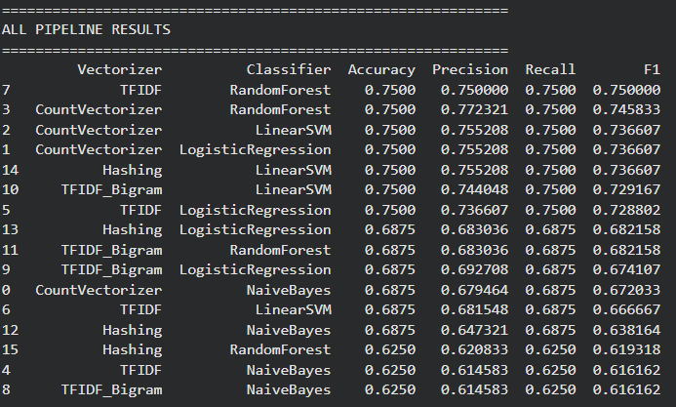
ipl_posts_keyword_sentiment_sanitized_40_each (1)
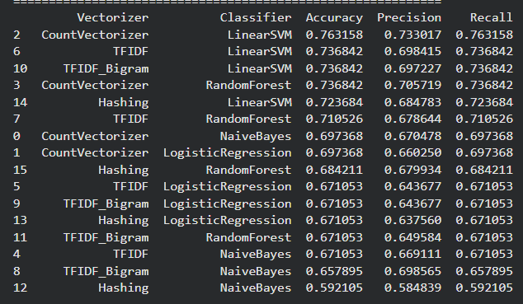
ipl_300R_indian_english_sentiment_dataset
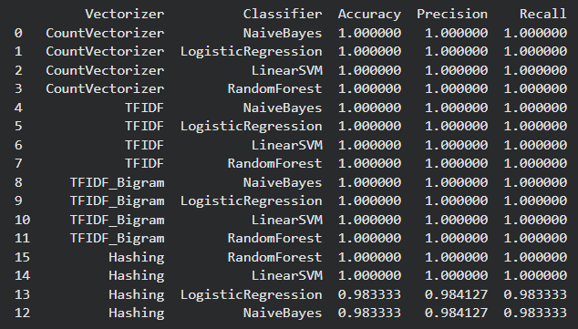

Waitage system: 80+300+380 = 760
80r = 80/760 x 100%
300r = 300/760 x 100%
380r = 380/760 x 100%

Note:- you can use the model “Pipeline_testing” and different datasets to get these results

