1: System Startup

1.1 Bash functions
docker-compose -f docker-compose.yml build
docker-compose -f docker-compose.yml up

1.2 Deploy on 3 VM:
cd /media/sf_ev
docker compose -f docker-compose-kafka-central.yml up -d –-build
(in browser) http://192.168.56.103:8000
docker compose -f docker-compose-chargepoints.yml up -d –-build
docker compose -f docker-compose-drivers.yml up -d --build

1.3 I'm starting the entire distributed system using Docker Compose.
This will launch:
- Kafka message broker for event streaming
- Central control server with REST APIs
- Registry service for CP authentication
- Two charging points (CP-001 and CP-002) with monitors
- Weather monitoring service
- Two drivers (manual and automated)
- Web UI dashboard"

1.4 Verify Startup
The system is now fully operational. All charging points have authenticated with the Registry and connected to Central. The weather service is monitoring temperatures.

2: Basic Functionality

2.1 Open Web Dashboard (Web)

http://localhost:8000

This is the central monitoring dashboard. It shows all charging points in real-time via WebSocket connection. Currently both CPs are available for charging

2.2 Request a Charge (Web)

I've requested 15 kWh at CP-001. Watch how the system authorizes the charge, and the CP begins supplying energy. The progress bar shows real-time consumption. After 14 seconds, the charge will complete automatically
docker attach driver_1

2.3 View Charging History (Central)

The charging session completed successfully. The driver received a final ticket with total energy and cost. This data is persisted to the audit log.

3: Security Features

3.1 Show Authentication (Engine)

Each CP must authenticate with the Registry before connecting to Central. The Registry issues unique credentials (username/password) for each CP. Without valid credentials, a CP cannot register.

3.2 Show Encryption (Central)

All messages between Central and CPs are encrypted using AES-256 symmetric encryption. Each CP has a unique encryption key derived from its password

3.3 Show Audit Log (VS code)

The system maintains a comprehensive audit log of all events: authentication attempts, charging sessions, faults, and state changes. Each entry includes timestamp, source IP, action, and parameters as required by the specification.

3.4. Explain protocol.py message encoding/decoding (VS code)
- It standardizes communication so every component understands the same message names.
- Each group shows who sends the message and who receives it.

4: REST API

4.1 Register New CP via API (web)

I've registered a new charging point using the REST API. The system geocodes the city to coordinates and stores it in the Registry. A real CP engine could now connect using the issued credentials.

4.2 Query Registry (VS code)

The Registry API allows querying all registered CPs. Each CP has unique credentials stored securely (password hashed with SHA-256).

5: Weather Integration

5.1 Check Weather Service (weather)

The Weather service polls OpenWeatherMap API every 4 seconds. When temperature drops below 0°C, it sends an alert to Central via REST API. Central automatically takes the CP out of service to prevent cold-weather damage. When temperature rises, the CP is restored.

5.2 Simulate Weather Recovery

When weather improves, the CP is automatically restored to service. Any in-progress charging sessions would complete before shutdown.

Show .env file with OPENWEATHER_API_KEY (VS code)

Change weather locations via Weather menu
docker attach weather

6. Resilience testing

Service-Oriented Architecture: Central control server, Registry service, Weather service, Web UI

REST APIs: For CP registration and weather alerts

Socket-based Communication: Real-time messaging between Central and CPs

Event Streaming: Kafka for asynchronous logging

Security: Authentication via Registry, encrypted CP communications, comprehensive audit logging

The architecture is resilient - components can fail and recover independently without crashing the entire system
- Kill CP-001 engine → show isolation
- Restart CP-001 → show recovery
- Kill monitor → show engine independence
- Restart Central → show full recovery
- Test Driver Auto-Recovery

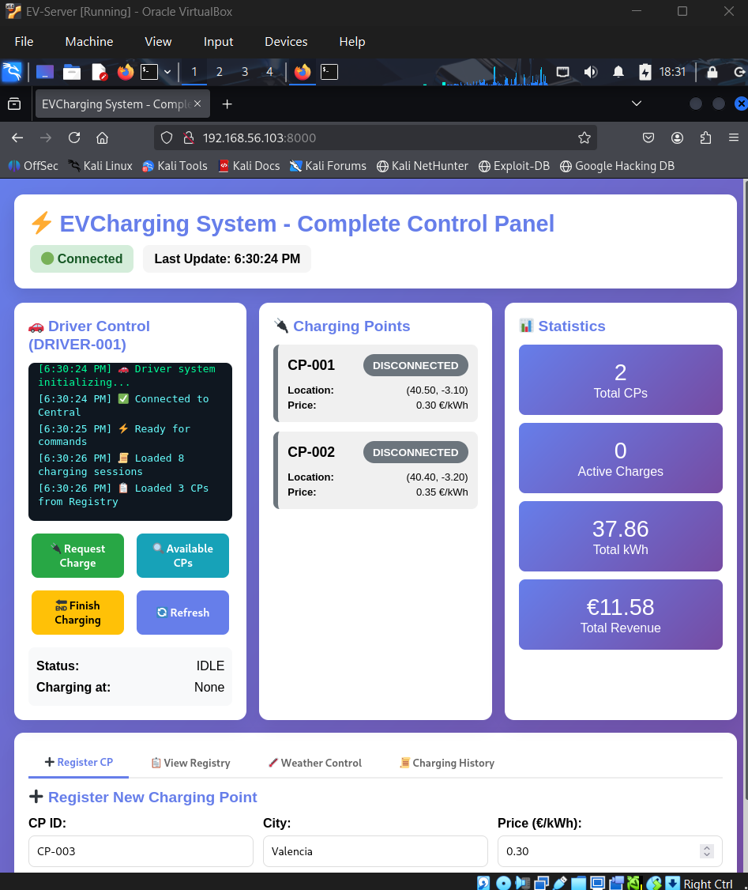

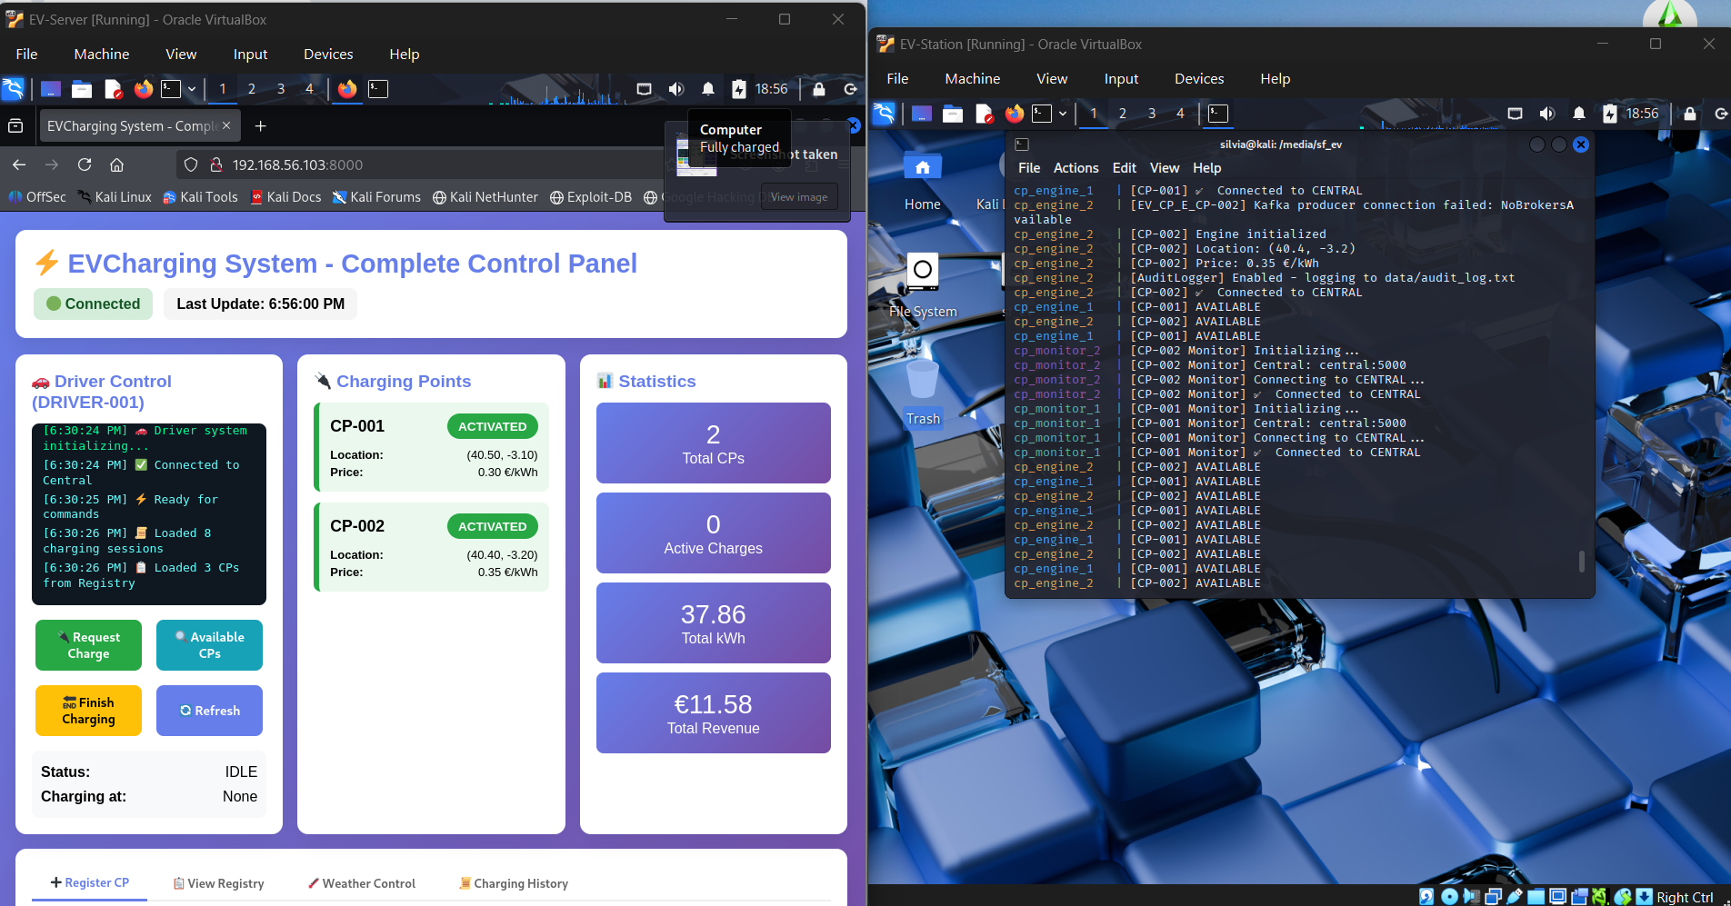

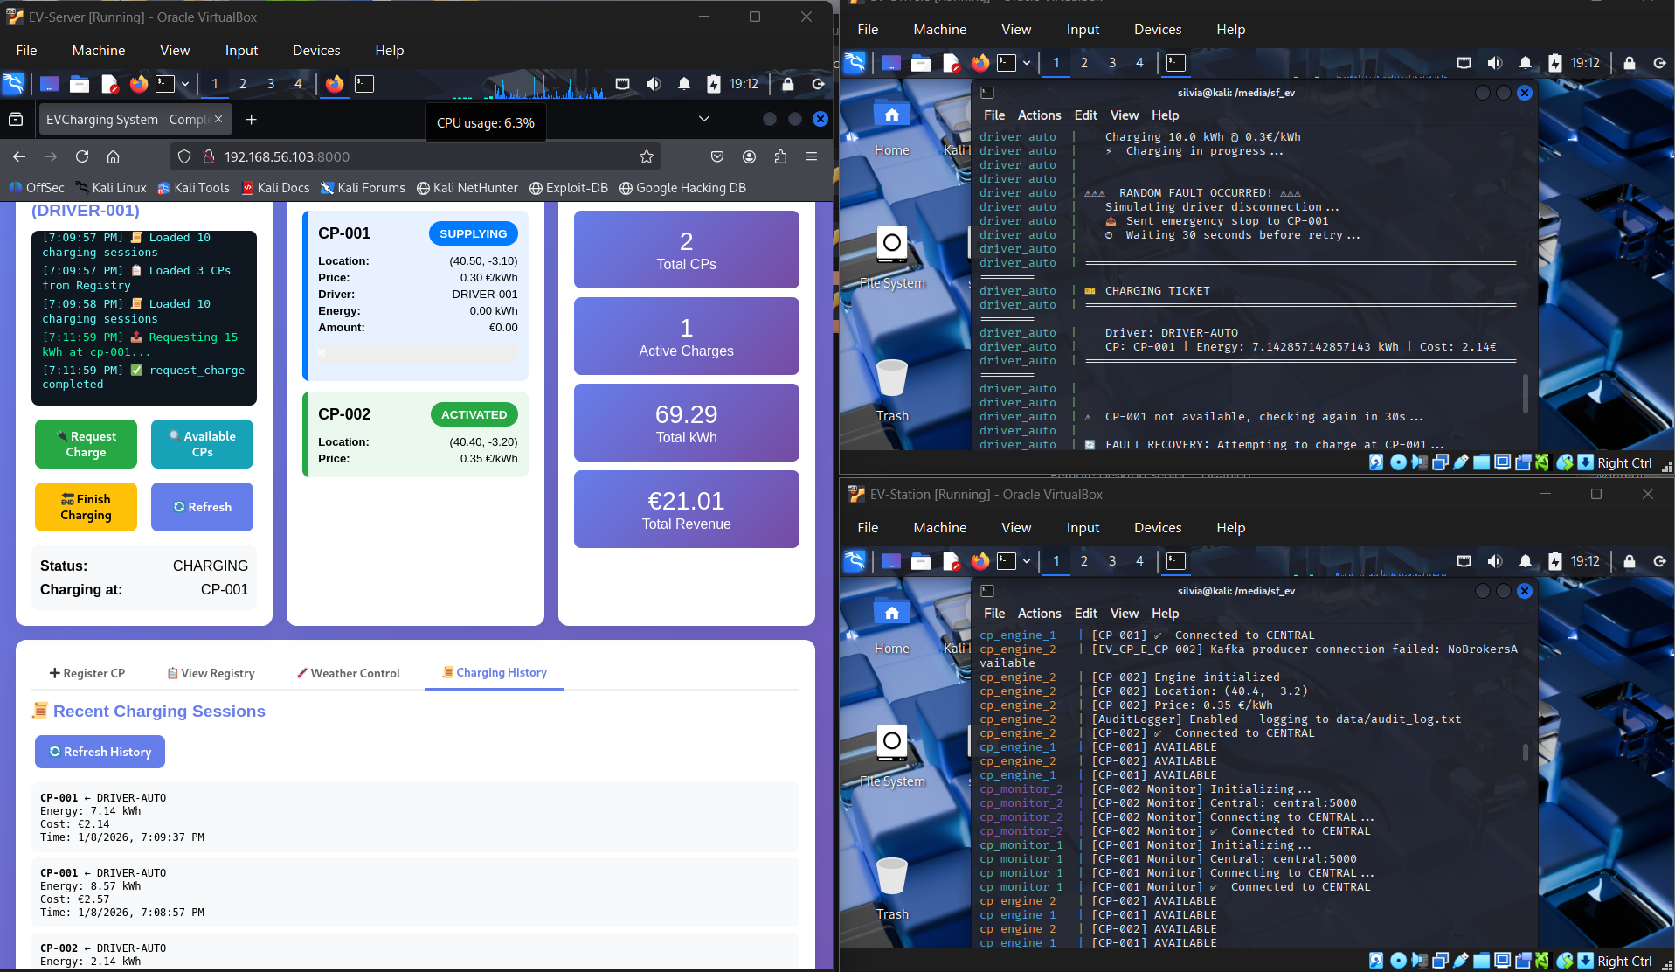

Connect to the internet:
sudo systemctl restart NetworkManager

sudo nmcli device connect eth0

ip route

