National Parks Road Trip

# **Stops:**

1. Arches
2. Bryce
3. Grand Canyon
4. Zion
5. Canyonlands

# **Directions:**

To Dalton Wells Camping Area, north-west of entrance to **Arches** (38.717797, -109.689383):

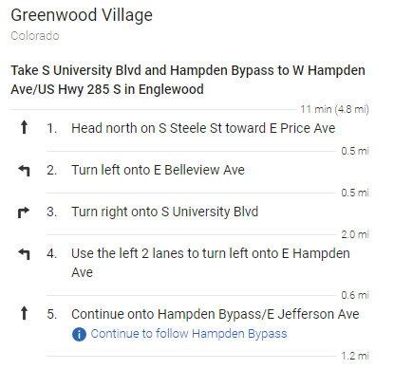

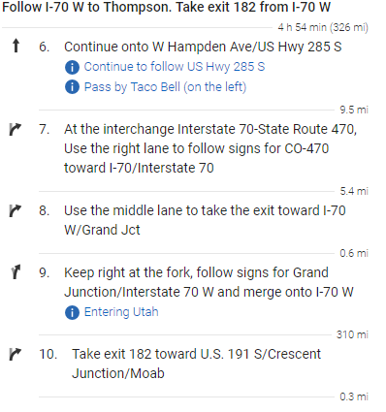

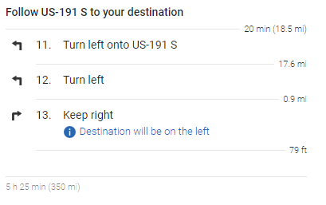

Alternative camping grounds:

- Willow Springs Road (38.696832, -109.6981)  
- Dispersed camping (38.717671, -109.785491)

­­­­­­­­­­­­­­­­­To FR 090 Free Camping Site north of **Bryce** Canyon (37.656008, -112.164194):

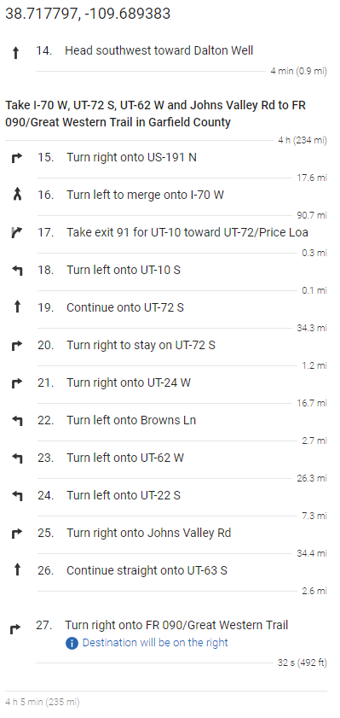

Alternative camping grounds:

- FR088 South (37.626331, -112.228073)  
- Pines Rest Area (37.708304, -112.205794)  
- Tom’s Best Spring Road Dispersed Camping (37.721502, -112.254688)

­­­­­­­­­­­­­­­­­

To FR22 Free campsite 5 miles north of **Grand Canyon** North Rim (36.397933, -112.124183):

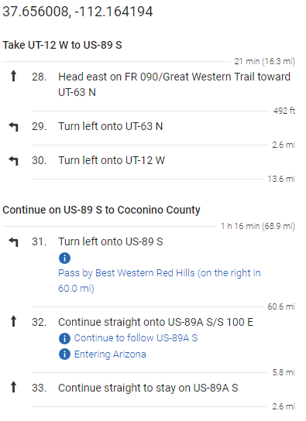

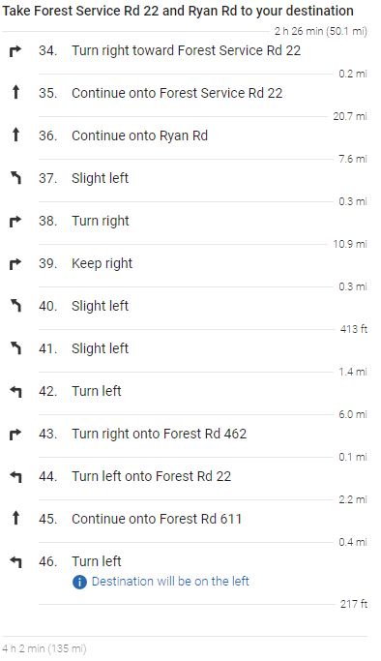

Alternative camping grounds:

- Forest Route 207T (36.401567, -112.137511)  
- Kaibab Nat’l Forest East Viewpoint (36.413164, -112.09266)  
- Marble (36.402541, -112.062378)

­­­­­­­­­­­­­­­­­To BLM Lands east of **Zion**, south of Highway 9 (37.249128, -112.778939):

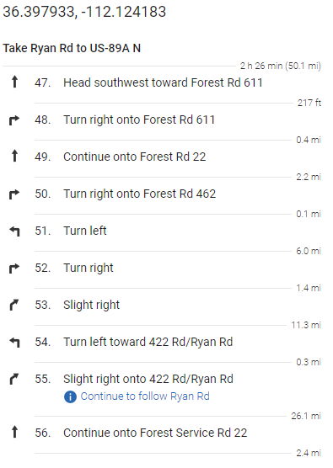

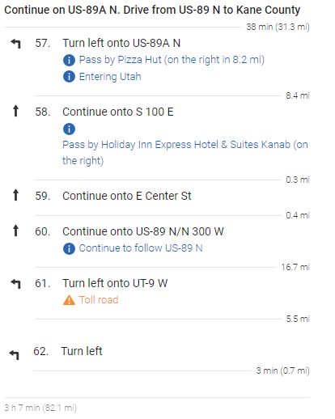

Alternative camping grounds:

- Kane Dispersed Campsite (37.254758, -112.770044)  
- Twin Hollows Canyon (37.2071, -112.6893)

­­­­­­­­­­­­­­­­­

To Free Campsite Horsethief Trail (Mineral Rd) north of **Canyonlands** (38.590363, -109.840694):

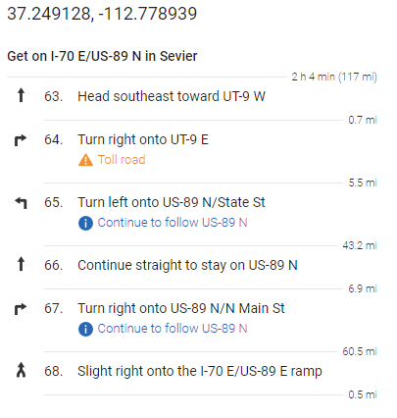

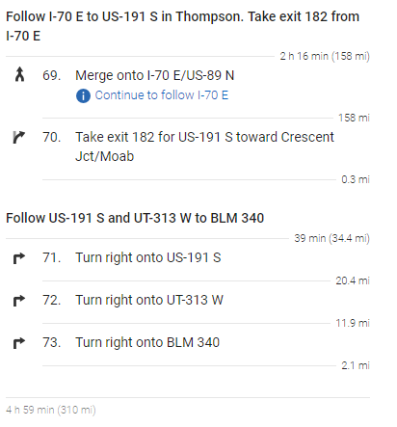

Alternative camping grounds:

- Small Pullout off of BLM Rd 137 (38.641008, -109.814553)  
- Long Canyon Dispersed Camping (38.539848, -109.71217)

­­­­­­­­­­­­­­­­To **Home** from camping ground near Canyonlands:

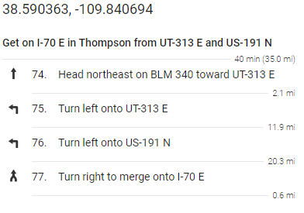

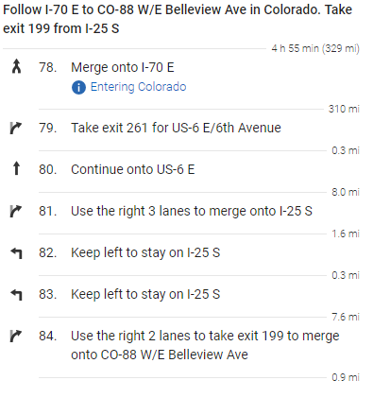

# ­­­­­­­­­­­­­­­­**Trails:**

**Arches:**

* Double O Arch at Devils Garden  
  4.5 miles (6.8 km), 2.5 hours;  
  Beyond Landscape Arch (listed above), the trail is more challenging as it climbs over sandstone slabs. Footing is rocky; there are narrow ledges with exposure to heights. Spur trails lead to Partition and Navajo arches. Dark Angel is 0.5 miles (0.8 km) farther. Trail guide available at trailhead.
* Primitive Trail at Devils Garden  
  7.2 miles (11.6 km), 4 hours;  
  The Primitive Trail is an alternative route to or from Double O Arch. It involves narrow ledges, uneven surface hiking and scrambling on slickrock. **Not recommended when rock is wet or snowy**, or for those uncomfortable with heights or exposure. Trail guide available at trailhead.
* Tower Arch  
  3.4 miles (5.5 km), 2.5 hours;  
  Trail climbs a steep, short rock wall, cuts across a valley and then meanders through sandstone fins and sand dunes. An alternate, shorter trail (0.3 mile [0.5 km] one way), begins at the end of the four-wheel-drive road on the west side of Tower Arch. Unpaved roads wash out quickly in rainstorms; check road conditions before heading out.
* Delicate Arch*  
  3 miles (4.8 km) , 2.5 hours;  
  Open slickrock with no shade. The first half mile is a well defined trail. Follow the rock cairns. The trail climbs steadily and levels out toward the top of this rock face. Just before you get to Delicate Arch, the trail traverses a narrow rock ledge for about 200 yards (183 m). Take at least 2 quarts (2 L) of water per person.
* Landscape Arch at Devils Garden  
  1.6 miles (2.6 km), 50 minutes;  
  Park at Devils Garden trailhead. A relatively flat, gravel-surfaced trail leads to a spectacular ribbon of rock, whose span is more than a football field in length. Some steep slopes may be accessible to wheelchairs with assistance. Short side trips to Tunnel and Pine Tree arches. Trail guide available at trailhead. After Landscape Arch, the Devils Garden trail becomes difficult, with rock scrambling, narrow ledges, and exposure to heights.

**Bryce:**

* 8 Loop Trail*  
  Combines Navajo Loop, Peek-A-Boo Loop and Queens Garden  
  6.4 mi. round-trip;  
  Possibility to shorten to 2.9 mi. round-trip by omitting the Peek-A-Boo Loop and connecting the Navajo Loop and the Queens Garden Loop.
* Navajo Trail  
  1.3 mi / 2.2 km round trip;  
  The Navajo Loop begins at Sunset Point and goes down into Bryce Amphitheater through a "slot" canyon where large Douglas Fir trees are stretching to reach sunlight high above.

**Grand Canyon:**

* Windforss Trail*  
  10 mi. / 16 km round-trip; 6 hours approximate round-trip hiking time. Blends forest and canyon scenery. Even a short walk can be very satisfying. Take the dirt road 1/4 mile/0.4 km south of Cape Royal Road for 1 mile / 1.6 km to the Widforss Trail parking area. Self-guiding trail brochure available at trailhead.
* Transept Trail  
  3.0 mi. / 4.8 km round-trip; 1.5 hours approximate round-trip hiking time. Follows the canyon rim from Grand Canyon Lodge to the North Rim Campground.
* Uncle Jim Trail  
  5.0 mi. / 8.0 km round-trip; 3 hours approximate round-trip hiking time. Winds through the forest to a point overlooking the canyon and the North Kaibab Trail switchbacks. Begins at the North Kaibab Trail parking lot. This trail is also used by mules.
* Cape Final Trail  
  4.0 mi. / 6.4 km round-trip; 2 hours approximate round-trip hiking time. A 2-mile walk from dirt parking area to Cape Final. This trail offers a view of the canyon.

**Zion:**

* Angels Landing*  
  Angels Landing via West Rim Trail  
  Location: The Grotto | Distance: 5.4 miles/approx. 4 hours  
  Arguably the most iconic landmark in Zion, Angels Landing is written on the bucket lists of travelers all over the world. Owning one of the most incredible views you will ever see, this hike is challenging and not for the faint of heart. Long drop-offs, including a final section along a steep, narrow ridge to the summit render this hike not suitable for small children or anyone with a fear of heights. Angels Landing is certainly a day hike lasting around 4-5 hours so an early start is recommended. Your legs will burn but you will never forget it! Tens of thousands of visitors return to Springdale every year to conquer the Landing over again because it’s just that incredible!
* Lower Emerald Pool Trail  
  Location: Zion Lodge | Distance: 1.2 miles/approx. 1 hour  
  One of the most popular hikes in Zion National Park, the path to the lower section of Emerald Pools is extremely rewarding considering its short length. The hike is just over a mile in length (one way) which shouldn’t take very long at all, even with young children in your group. The water that rolls off the cliffs creating light waterfalls is captivating, as are the shining pools and lush vegetation that develop as a result. All ages can enjoy this particular hike which is one reason it remains a perennial favorite. Truthfully, you could probably get away with bringing a baby stroller on this one, requiring a little maneuvering here and there, but not to the middle and upper Emerald Pool levels. There are some minor drop-offs so keep an eye on the kiddos. Continue on the trail past the lower section for a longer and more strenuous hike up to both the middle and upper sections. This hike also connects to the Kayenta Trail.
* Canyon Overlook Trail  
  Location: Zion-Mt. Carmel Hwy | Distance: 1 mile/approx. 1 hour  
  There are not very many official trails in the upper East Canyon, but this is one of them. At about 1 mile in length, this hike isn’t long, but it packs a punch. On this maintained trail, you’ll get great views of the Pine Creek slot canyon as well as stunning views of the main canyon once you get to the viewpoint at the end, not to mention the cool (temperature cool) alcove that is a favorite resting spot on this trail. This trail is a bit rocky and there are some high drop-offs, but the trail is mostly fenced. This hike must find a place on every first-time visitor’s list to Zion National Park! It starts just east of the Zion-Mt. Carmel Tunnel.

**Canyonlands (Island in the Sky):**

|  |  |  |  |
| --- | --- | --- | --- |
| **Trail** | **Distance (round-trip)** | **Average Time** | **Description** |
| ***Easy*** | | | |
| Mesa Arch* | 0.5 miles (0.8 km) | 30 minutes | Short walk to arch on cliff edge. Popular sunrise photograph. |
| White Rim Overlook | 1.8 miles (2.8 km) | 1.5 hours | Walk to an east-facing overlook for views of the Colorado River, Monument Basin, and La Sal Mountains. Very limited trailhead parking. |
| Grand View Point* | 2 miles (3.2 km) | 1.5 hours | Easy walk along canyon edge to end of Island in the Sky mesa. Panoramic views. |
| Murphy Point | 3.6 miles (5.8 km) | 2 hours | Passes historic corral, ends with panoramic views |
| ***Moderate*** | | | |
| Upheaval Dome | 1 mile (1.5 km) to first overlook | 30 minutes | View of intriguing rock formation. Hiking to second overlook adds 1 mi/1.5 km and 50 ft/15 m. One-hundred-foot elevation change (30 m) |
| Whale Rock | 1 mile (1.6 km) | 1 hour | Short climb up Whale Rock leads to views of Upheaval Done and surrounding area. Elevation change: 100 feet / 30 m |
| Aztec Butte | 2 miles (3 km) | 1.5 hours | Steep climb leading to ancestral Puebloan granaries and view of Taylor Canyon. Elevation change: 225 feet / 68 m |
| Neck Spring | 5.8 miles (9.3 km) | 3-4 hours | Loop trail passes historic ranching features, two seep springs, and diverse plant life. Elevation change: 300 feet / 91 m |
| ***Strenuous*** | | | |
| Gooseberry Canyon | 5.4 miles (8.6 km) | 4-6 hours | Very steep switchbacks descend into canyon and return. Starts at White Rim Overlook. Elevation change: 1,400 feet / 427 m |
| Syncline Loop* | 8.3 miles (13.3 km) | 5-7 hours | This challenging trail follows the canyons around Upheaval Dome and requires route-finding, climbing and scrambling through boulder fields, and steep switchbacks with 1,300-feet (396 m) of elevation change. **Not recommended in July and August.**Carry a map, extra gallons of water, food, and a flashlight. Hike this trail clockwise for more afternoon shade. |
| Murphy Loop | 10.8 miles (17.4 km) | 5-7 hours | Descends into canyon, crosses hogback along White Rim Road, then returns via rocky wash. Elevation change: 1,400 feet / 427 m |
| Alcove Spring | 11.2 miles (18 km) | 6-7 hours | After descending 1,300 feet (396 m) past a large alcove, the trail meanders in a wide canyon to the base of the notable Moses and Zeus towers. |
| Wilhite Canyon | 12.2 miles (19.6 km) | 6-8 hours | Switchback descent into rocky wash, then return. Elevation change: 1,600 feet / 488 m |