**ALGORİTMA SEMASI:**

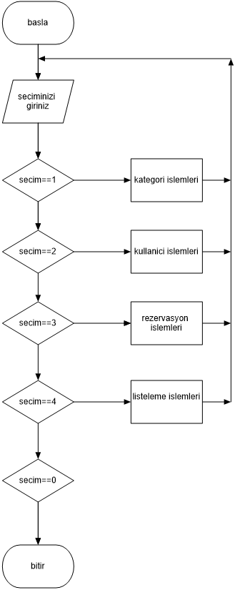

**EKRAN ÇIKTILARI:**

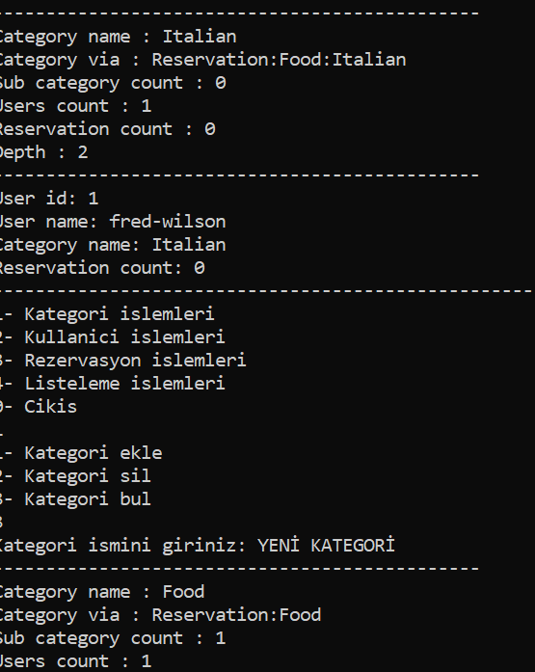 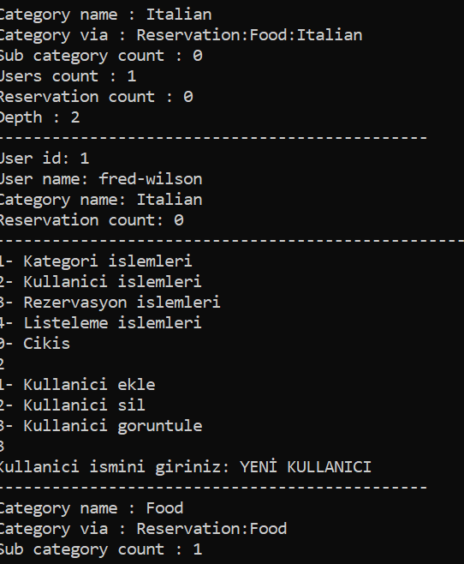

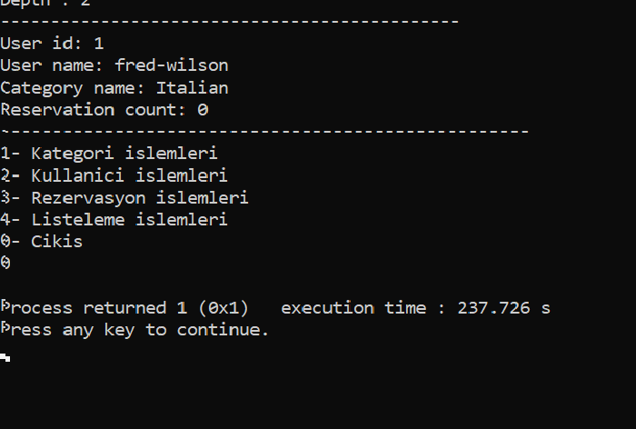

**KAYNAKÇA=**

1. <https://www.algoritmauzmani.com/veri-yapilari/ikili-arama-agaci-eleman-silme-islemi/>
2. <http://hpss.endustri.cu.edu.tr/ders/ENS255/7.Hafta_Btree.pdf>
3. <https://www.blogkafem.net/2014/01/tek-yonlu-bagli-listeler.html>
4. <http://web.karabuk.edu.tr/hakankutucu/BLM227/VER%C4%B0%20YAPILARI%20v.6.3.pdf>
5. <http://web.ogu.edu.tr/Storage/egulbandilar/Uploads/A%C4%9Fa%C3%A7-veri-modeli.pdf>
6. <http://bilgisayarkavramlari.sadievrenseker.com/category/veri-yapilari/>