DESIGN AND IMPLEMENTATION OF A NETWORK PORT SCANNING TOOL
USING MULTITHREADING AND KMP PATTERN MATCHING

BY

ZAILANI MOHAMMAD KABIR
CYB/23U/3343

JULY, 2026

TITLE PAGE
DESIGN AND IMPLEMENTATION OF A NETWORK PORT SCANNING TOOL
USING MULTITHREADING AND KMP PATTERN MATCHING

BY

ZAILANI MOHAMMAD KABIR
CYB/23U/3343

PROJECT SUBMITTED TO THE DEPARTMENT OF CYBER SECURITY, FACULTY OF COMPUTING, NIGERIAN ARMY UNIVERSITY, BIU, IN PARTIAL
FULFILLMENTS TO THE REQUIREMENT FOR THE
AWARD OF BACHELOR OF SCIENCE DEGREE IN CYBER SECURITY

JULY, 2026

DECLARATION
I declare that the work described in this project, and has not been previously submitted to any university or similar institution for the award of any degree or certificate.

Name of Candidate: ………………………………………………………………………………
Matric Number: ……………………………………………….………………………………….
Signature: …………………………………………………………………………………………
Date: ………………………………………………………………………………………………

CERTIFICATION
We the undersigned, hereby certify that this project presented by ZAILANI MOHAMMAD KABIR (Matric No. CYB/23U/3343) be accepted as fulfilling part of requirements for the award of degree of Bachelor of Science in Cyber Security.
Title: Design and implementation of a network port scanning tool using multithreading and kmp pattern matching

Dr. Abdulkadir H. Disina ……..…………………………….
Supervisor Signature/Date

Mr. Adamu Muhammad Liman ……………………………………
Project Coordinator Signature/Date

Dr. Abdulkadir H. Disina ……………………………………
Head of Department Signature/Date

External Examiner ……………………………………
Signature/Date

DEDICATION
To my amazing mother, who showed me that even the biggest challenges can be overcome through hard work and staying true to one self.

ACKNOWLEDGEMENT
I express my deepest gratitude to Almighty Allah (S.W.T.) for His countless blessings, mercy, and guidance in making it possible for me to embark on this exciting and rewarding academic journey in the field of Cyber Security. Choosing this path has been a significant decision in my life, and I am thankful for the strength, wisdom, and perseverance He has bestowed upon me throughout my studies. I pray that the knowledge gained through this endeavor will be beneficial to humanity and that His guidance will continue to illuminate my path.
My sincere gratitude goes to my supervisor, Dr. Abdulkadir H. Disina, for his invaluable guidance, constructive criticism, encouragement, and support throughout the course of this research work. His expertise and dedication greatly contributed to the successful completion of this project.
I would also like to extend my sincere appreciation to the Nigerian Army University, particularly the Head of Department of Cyber Security, Dr. A.H. Disina, the Dean of the Faculty of Computing, and all members and staff of the Faculty of Computing, including Mr. Bello, Dr. Sulaiman, Mr. Abdulaziz Adamu, and others whose names may not have been mentioned. Their support, encouragement, and constructive feedback have been instrumental in shaping my academic and professional development. I am truly grateful for their efforts in ensuring that I made the most of my academic training. May Almighty Allah reward them abundantly for their contributions to my growth and success.
I would like to express my profound gratitude to my beloved parents, Alhaji Zailani Bello and Risikat Baker, for their unwavering love, prayers, sacrifices, financial support, guidance, and encouragement throughout my educational journey. Their constant belief in my abilities and their dedication to my success have been my greatest source of motivation. I am deeply indebted to them for everything they have done for me.
I also wish to appreciate my family members, friends, classmates, and well-wishers who supported me in one way or another during the course of this study. Their encouragement, understanding, and prayers contributed immensely to the successful completion of this work.
Finally, I extend my appreciation to everyone who directly or indirectly contributed to the success of this research project. May Almighty Allah bless and reward you all abundantly.
Ameen.

CHAPTER ONE
INTRODUCTION
1.1 Background of the Study
The rapid growth of computer networks and internet technologies has significantly transformed communication, business operations, education, banking, healthcare, and government activities. Modern organizations depend heavily on computer networks for sharing information, managing resources, and supporting online services. As network infrastructures continue to expand, cybersecurity threats such as unauthorized access, malware attacks, denial-of-service attacks, and data theft have also increased significantly. According to Alabdan (2020), organizations are increasingly exposed to cyber threats due to the continuous growth of interconnected systems and internet-based services.
Network security therefore plays an important role in protecting computer systems, communication infrastructures, and sensitive information from cyber attacks and unauthorized access. One of the major techniques used in network security assessment is port scanning. Port scanning is the process of examining network ports on a target system to determine whether the ports are open, closed, or filtered. Open ports indicate active services or applications running on a host system, which may become potential entry points for attackers if not properly secured (Scarfone & Mell, 2020).
Network administrators and cybersecurity professionals use port scanning tools to identify vulnerabilities, discover active services, and monitor network exposure. However, traditional port scanning methods often experience performance limitations, especially when scanning large networks or wide ranges of ports sequentially. Sequential scanning techniques process ports one after another, resulting in slower execution time and reduced efficiency (Lyon, 2021).
To overcome these limitations, multithreading techniques can be applied to improve scanning performance. Multithreading allows multiple scanning operations to run concurrently, thereby reducing the total scanning time and improving system responsiveness. According to Silberschatz, Galvin, and Gagne (2021), multithreading improves system performance by enabling concurrent execution of multiple tasks within a single application.
In addition to scanning performance, efficient analysis of service responses is also important in network security assessment. Many network services return textual responses known as banners, which contain useful information about running services, server software, or protocols. Efficient pattern matching algorithms are required to analyze these responses quickly and accurately.
The Knuth-Morris-Pratt (KMP) algorithm is one of the efficient string matching algorithms used for searching patterns within text. The algorithm reduces unnecessary comparisons by preprocessing the search pattern before matching operations begin. According to Cormen et al. (2022), efficient pattern matching algorithms improve searching speed and reduce computational overhead when processing large textual data.
This project therefore focuses on the design and implementation of a network port scanning tool using multithreading and KMP pattern matching. The system aims to improve scanning speed through concurrent execution while enhancing service identification through efficient banner analysis.

1.2 Statement of the Problem
As organizations increasingly rely on computer networks, the need for effective network security assessment has become critical. Port scanning serves as a fundamental technique for identifying active services and potential vulnerabilities. However, traditional port scanning systems exhibit significant limitations that reduce their effectiveness in modern network environments.
One major limitation of traditional scanning systems is their slow execution time. These systems typically employ sequential scanning methods, processing ports one after another, which results in prolonged execution times, particularly when scanning large networks with numerous devices and extensive port ranges (Lyon, 2021). This sequential approach significantly reduces efficiency and limits the scalability of network assessment operations.
Another limitation is that many existing scanning tools lack intelligent service analysis capabilities. While these tools can identify open ports, they often fail to provide comprehensive service identification through efficient analysis of network responses. The absence of optimized pattern matching mechanisms makes it difficult to obtain detailed information about running services, thereby limiting the effectiveness of vulnerability assessment (Scarfone & Mell, 2020).
Furthermore, some scanning systems require substantial computational resources and complex configuration procedures, which limits their applicability for routine security assessments and educational environments. This complexity creates barriers for network administrators and students who require accessible yet effective scanning tools.
Therefore, there is a need for a scanning system that combines rapid port scanning with intelligent network response analysis. This study aims to develop a tool that integrates multithreading techniques for concurrent port scanning and the KMP pattern matching algorithm for efficient service identification. The proposed tool should be capable of scanning multiple ports simultaneously while accurately identifying services through optimized banner analysis. The multithreading architecture is expected to reduce scanning time, while the KMP algorithm will enhance service identification accuracy and overall scanning efficiency. The goal is to design and implement a comprehensive tool that improves both the speed and analytical capabilities of network port scanning.

1.3 Aim and Objectives of the Study

Aim of the Study
The aim of this project is to design and implement a network port scanning tool using multithreading and KMP pattern matching for efficient port scanning and intelligent service identification.

Objectives of the Study
The objectives of this study are to:
- To design and develop a network port scanning tool capable of detecting open ports and identifying active network services through socket-based scanning and banner grabbing techniques.
- To implement a multithreading mechanism that enables concurrent port scanning in order to improve scanning speed and overall system performance.
- To integrate the Knuth-Morris-Pratt (KMP) pattern matching algorithm for efficient analysis of service banners and network responses, and to evaluate the performance of the developed system.

1.4 Scope of the Study
This project involves the development of a TCP-based network port scanning tool that utilizes multithreading and the Knuth-Morris-Pratt (KMP) pattern matching algorithm. The tool provides four primary functions: TCP port scanning, open port detection, service banner retrieval, and pattern-based banner analysis. The system is designed for standard IPv4 networks, operating within local area network (LAN) environments where the scanning host and target systems are connected through conventional network infrastructure, without requiring specialized hardware or elevated system privileges. The objective is to facilitate efficient port scanning and analysis within local or small-scale network environments.
The scanner establishes a full TCP connection to each target port using the three-way handshake mechanism to determine port status. Users may specify individual ports or ranges, including the full range of 65,535 ports. To improve performance, the system employs a multithreaded architecture wherein multiple threads execute scanning operations concurrently. This concurrent execution eliminates the need to wait for individual port scans to complete before initiating subsequent scans, thereby reducing total execution time. The threads operate with synchronized access to shared result structures to ensure data accuracy and consistency.
The software is implemented using the Python programming language with the built-in socket module, ensuring cross-platform compatibility with Linux, macOS, and Windows operating systems. Upon detecting an open port, the system establishes a connection and reads the initial response from the service. In cases where services do not transmit information automatically, the system sends probe strings to elicit a response. The retrieved service information is subsequently analyzed by the KMP pattern matching engine, which compares the data against a database of known service signatures to identify service types, protocols, and potential security vulnerabilities. The output is presented in a structured format that provides comprehensive service details, enabling users to understand the services operating on each port and identify associated security risks.

1.5 Significance of the Study
This study is significant because it contributes to the field of cybersecurity and network security assessment. The developed system will help network administrators and cybersecurity professionals identify active services and potential vulnerabilities within computer networks.
The integration of multithreading improves scanning efficiency by reducing execution time, thereby enabling faster network assessment. In addition, the use of the KMP pattern matching algorithm enhances service detection accuracy through efficient analysis of service banners.
The project also provides academic value by demonstrating the practical application of networking, multithreading, socket programming, and pattern matching algorithms in cybersecurity. Furthermore, the system can serve as a learning tool for students and researchers interested in network security and concurrent programming.

1.6 Definition of Terms
Network security: refers to the protection of computer networks and systems from unauthorized access, attacks, and data breaches.
Port scanning: is the process of examining network ports to determine whether they are open, closed, or filtered.
Multithreading: is a programming technique that allows multiple tasks or threads to execute concurrently within a single application.
The Knuth-Morris-Pratt (KMP) algorithm: is an efficient string matching algorithm used for searching patterns within textual data.
Banner grabbing: is the process of retrieving service information from active network services running on open ports.
Socket programming: is a method used for communication between devices over a computer network.

CHAPTER TWO
LITERATURE REVIEW
2.1 Introduction
This chapter reviews related literature relevant to the design and implementation of a network port scanning tool using multithreading and KMP pattern matching. The chapter discusses concepts related to network security, port scanning techniques, multithreading, pattern matching algorithms, and existing network scanning tools. It also examines previous studies conducted in related areas and identifies research gaps that justify the need for this study.

2.2 Conceptual Foundations
The design and implementation of an efficient network port scanning tool require a solid understanding of several fundamental concepts in computer science and cybersecurity. These concepts form the theoretical and practical foundation upon which the proposed system is built. Conceptual foundations refer to the core principles, theories, and technologies that underpin the development of network security assessment tools. This section examines the essential concepts that are directly relevant to this project, including computer networks and network security, port scanning techniques, multithreading, pattern matching algorithms, the Knuth-Morris-Pratt (KMP) algorithm, banner grabbing, and socket programming. Understanding these concepts is crucial because they collectively determine how the proposed system will function, how it will achieve performance efficiency, and how it will provide intelligent service identification. Each concept is discussed in detail to establish the necessary background for the subsequent system design and implementation phases.

2.2.1 Computer Networks
Computer networks are systems that enable communication and resource sharing between interconnected devices. Modern organizations depend heavily on computer networks for communication, business operations, cloud services, and internet access. According to Stallings (2021), computer networks provide the foundation for data communication and distributed computing.
As networks continue to expand, they become increasingly vulnerable to cyber threats such as malware attacks, unauthorized access, phishing, denial-of-service attacks, and information theft. Network security therefore involves protecting network infrastructures, systems, and data from cyber-attacks and unauthorized access (Kizza, 2022).
Network administrators often use monitoring and scanning tools to identify vulnerabilities and evaluate network exposure. One of the most widely used techniques in network security assessment is port scanning.

2.2.2 Port Scanning
Port scanning is the process of sending requests to network ports on a target system to determine whether the ports are open, closed, or filtered. Open ports indicate active services or applications running on the target system (Scarfone & Mell, 2020).
Port scanning is commonly used for:
- Network auditing
- Vulnerability assessment
- Service discovery
- Security testing
- Intrusion detection
A typical network port scanner performs the following operations:
  - Accepts a target IP address.
  - Attempts communication with selected ports.
  - Receives responses from the target system.
  - Determines port status.
  - Displays scan results.
In practical cybersecurity environments, port scanning is often the first step in reconnaissance during penetration testing. It helps attackers and defenders understand which services are exposed to the network. Because of this, organizations are encouraged to continuously monitor and audit open ports to reduce attack surfaces and prevent unauthorized access.

2.2.3 Types of Port Scanning Techniques
Several port scanning techniques exist depending on the communication protocol and scanning approach used.

TCP Connect Scan
TCP Connect Scan establishes a complete TCP connection using the TCP three-way handshake process. If the connection succeeds, the port is considered open (Kurose & Ross, 2021).

SYN Scan
SYN scanning sends SYN packets to target ports without completing the full TCP handshake process. This method is commonly referred to as half-open scanning.

UDP Scan
UDP scanning targets User Datagram Protocol ports instead of TCP ports. Since UDP is connectionless, identifying port status is generally slower and less reliable.

2.2.4 Multithreading
When you have a program that can do lots of things at the same time, it's like having multiple workers doing different jobs together. This is called multithreading. Multithreading is a programming technique that allows multiple tasks to execute concurrently within a single application. Each task, known as a thread, operates independently while sharing the same memory resources. According to Silberschatz et al. (2021), multithreading improves system responsiveness and performance by allowing concurrent execution of multiple processes.
In traditional sequential systems, ports are scanned one after another, resulting in increased scanning time. However, multithreading improves performance by allowing multiple ports to be scanned simultaneously. This significantly reduces execution time and improves scanning efficiency.
The use of multithreading is especially important in network scanning because scanning operations often involve waiting for responses from remote systems. While one thread waits for a response, other threads continue scanning additional ports, thereby improving resource utilization.
Despite its advantages, multithreading introduces challenges such as race conditions, synchronization issues, and increased resource consumption if not properly managed.
In real-world network scanning tools, multithreading is implemented using thread pools or worker threads to efficiently manage system resources. This prevents the overhead of creating and destroying threads repeatedly and ensures that system memory and CPU usage remain optimized during large-scale scanning operations.

2.2.5 Pattern Matching Algorithms
Pattern matching algorithms are techniques used for searching specific patterns or sequences within textual data. These algorithms are widely applied in text processing, information retrieval, intrusion detection, and cybersecurity applications.
In network security, pattern matching is commonly used for analyzing network responses and service banners. When a network scanner connects to an active service, the service may return textual information containing software names, server types, or protocols.
Traditional searching techniques often perform unnecessary comparisons, thereby reducing efficiency when processing large textual data. Efficient pattern matching algorithms reduce redundant operations and improve searching speed.

2.2.6 Knuth-Morris-Pratt (KMP) Algorithm
The Knuth-Morris-Pratt algorithm is an efficient string matching algorithm developed for fast pattern searching. The algorithm preprocesses the search pattern before performing comparisons, thereby reducing unnecessary operations during the searching process.
The KMP algorithm uses a preprocessing table known as the Longest Prefix Suffix (LPS) array to determine how comparisons should continue after mismatches occur. According to Cormen et al. (2022), the KMP algorithm improves searching efficiency by avoiding repeated comparisons.
The time complexity of the KMP algorithm is:
O(n+m)
where:
- n represents the length of the text
- m represents the length of the search pattern
In this project, the KMP algorithm is used to analyze service banners and identify keywords such as HTTP, Apache, SSH, FTP, and MySQL.
The KMP algorithm is especially useful in cybersecurity applications where large volumes of textual data must be analyzed quickly. Unlike brute-force search methods, KMP ensures that previously matched characters are not rechecked, making it suitable for real-time banner analysis in network scanning tools.

2.2.7 Banner Grabbing
Banner grabbing is the process of retrieving information returned by active network services after successful communication. The retrieved information may contain details such as server software, protocol type, and software version.
Banner grabbing is widely used in penetration testing and vulnerability assessment because it helps administrators identify running services and potential security weaknesses.
In this project, banner grabbing is integrated into the scanning process to support intelligent service identification through KMP pattern matching.

2.2.8 Socket Programming
Socket programming is a communication method used for exchanging data between devices over a network. Sockets provide endpoints through which applications establish communication using network protocols such as TCP and UDP.
Port scanning tools rely heavily on socket programming to establish communication with target systems and determine whether ports are open or closed.
In this project, socket programming enables the system to perform TCP connections, retrieve service banners, and communicate with remote systems.

2.3 Review of Existing Systems
Several network scanning tools have been developed for network discovery and vulnerability assessment. This section reviews three prominent tools and analyzes their capabilities and limitations.
2.3.1 Nmap (Network Mapper)
Nmap is one of the most widely used network scanning tools in the cybersecurity industry. It supports TCP connect scanning, SYN stealth scanning, operating system detection, version detection, and service identification through banner analysis. According to Lyon (2021), Nmap provides accurate results and flexible scanning techniques for cybersecurity assessment. Nmap achieves performance optimization through its own parallelization mechanisms and timing templates. However, while Nmap includes service detection capabilities, its banner analysis relies on regular expression matching and signature databases rather than optimized pattern matching algorithms such as KMP. The tool is also complex to configure for novice users and requires elevated privileges for certain scanning techniques.
2.3.2 Masscan
Masscan is a high-speed network scanner designed for scanning large ranges of IP addresses rapidly. The tool achieves its performance through asynchronous packet transmission and custom TCP/IP stack implementation, enabling it to scan the entire internet in under six minutes under optimal conditions. While Masscan excels in scanning speed, it provides minimal service analysis capabilities. The tool focuses primarily on host and port discovery without integrating intelligent banner analysis or pattern matching mechanisms for service identification.
2.3.3 Angry IP Scanner
Angry IP Scanner is a lightweight, cross-platform scanning tool used for detecting active hosts and open ports. It is simple and user-friendly, making it accessible for basic network scanning tasks. However, it provides limited support for advanced scanning techniques and lacks intelligent service analysis capabilities. The tool does not incorporate efficient pattern matching algorithms for banner analysis, restricting its utility for comprehensive vulnerability assessment.Most existing systems focus mainly on identifying open ports without integrating intelligent pattern matching techniques for efficient banner analysis. This creates the need for a system that combines multithreaded scanning with KMP-based service identification.

Table 2.1: Comparison of Existing Scanning Tools
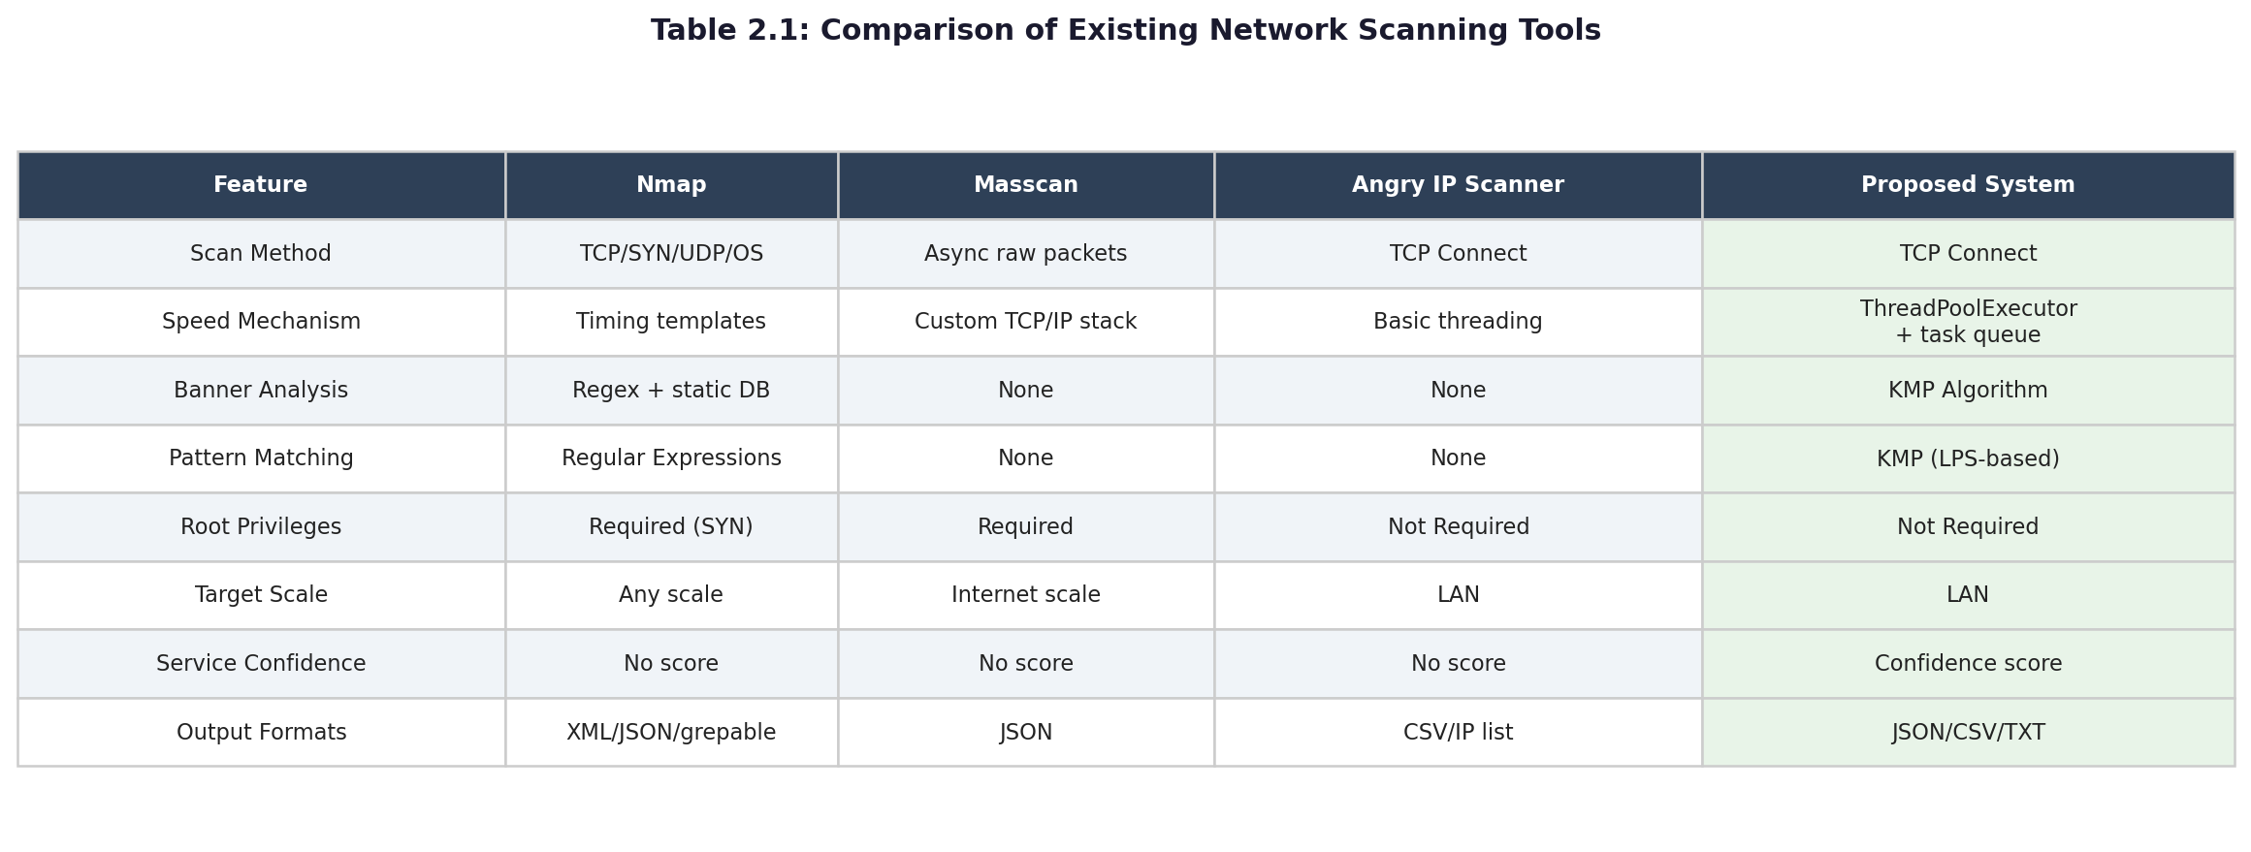

Fig 1: Comparison of Existing Scanning tools

Most existing systems focus primarily on identifying open ports without integrating intelligent pattern matching techniques for efficient banner analysis. This creates the need for a system that combines multithreaded scanning with KMP-based service identification.

2.4 Empirical Review
Several studies have examined network scanning, multithreading, and pattern matching algorithms.
Scarfone and Mell (2020) examined network vulnerability assessment techniques and emphasized the importance of efficient scanning systems in identifying security weaknesses. Their study highlighted the need for tools that balance scanning speed with comprehensive service analysis.
Silberschatz et al. (2021) discussed the importance of multithreading in improving system performance through concurrent task execution. Their research demonstrated that multithreading significantly reduces processing time in I/O-bound operations such as network scanning.
Cormen et al. (2022) analyzed efficient string matching algorithms and highlighted the effectiveness of KMP in reducing redundant comparisons during text searching. Their analysis confirmed that KMP outperforms naive string matching approaches, particularly when processing large text corpora.
Existing studies mainly focus on either high-speed scanning or efficient pattern matching individually. Limited studies combine multithreaded network scanning with KMP-based banner analysis in a unified system.
Recent advancements in cybersecurity tools show a shift towards combining performance optimization techniques with intelligent data analysis methods. This includes integrating concurrency models such as multithreading with efficient algorithms like KMP to improve both speed and accuracy in network security tools.

2.5 Theoretical Framework
This study is based on the theory of concurrent processing and efficient string matching algorithms.
Concurrent processing theory supports the execution of multiple tasks simultaneously to improve performance and reduce processing time in computational systems. This theory forms the basis for implementing multithreading in the proposed scanning tool.
The KMP algorithm theory is based on preprocessing and optimized comparison techniques that minimize redundant searching operations. This theory supports efficient service banner analysis in the proposed system.
The integration of these concepts provides the theoretical foundation for developing an efficient and intelligent network port scanning tool.

2.6 Gap Analysis and Research Contribution
Most existing scanning systems focus primarily on detecting open ports and active services without integrating intelligent pattern matching mechanisms. While tools such as Nmap provide service detection capabilities, they rely on conventional matching techniques rather than optimized algorithms like KMP. Some tools emphasize scanning speed but provide limited service analysis capabilities, as demonstrated by Masscan's minimal banner analysis functionality.
Additionally, many systems rely on sequential or partially optimized processing techniques that increase execution time during large-scale scans. The complexity of tools such as Nmap creates barriers for educational environments and routine security assessments.
Although previous studies have explored multithreading and pattern matching independently, limited research combines multithreaded port scanning with KMP-based service banner analysis within a unified implementation. This project therefore seeks to bridge this gap by developing a multithreaded network port scanning tool integrated with the KMP pattern matching algorithm for efficient scanning and intelligent service identification.

CHAPTER THREE
SYSTEM ANALYSIS AND DESIGN
3.0 Introduction
This chapter presents the system analysis and design of the proposed network port scanning tool. The system is designed to improve the efficiency and accuracy of network security assessment by integrating multithreading techniques and the Knuth-Morris-Pratt (KMP) pattern matching algorithm.
The design focuses on achieving fast port scanning, effective service detection, and structured output reporting. The system is divided into functional modules that work together to scan network ports, retrieve service banners, analyze responses, and present results in a readable format.
This chapter explains the methodology used in designing the system, the architecture of the system, the design of individual modules, the algorithms implemented, data flow representation, input and output design, system requirements, and security considerations.
The goal of the design is to ensure that the system is efficient, scalable, and capable of scanning multiple ports concurrently while accurately identifying services running on open ports.
3.1 Methodology Adopted
The methodology adopted for this project is the Waterfall Software Development Life Cycle (SDLC) model. The Waterfall model was selected because it provides a structured, sequential approach to software development, which is appropriate for a project with well-defined requirements such as a network port scanning tool. The model consists of distinct phases that must be completed before proceeding to the next, ensuring systematic development and thorough documentation.
The phases of the Waterfall model applied in this project are as follows:

3.1.1 Requirements Analysis
In this phase, the functional and non-functional requirements of the network port scanning tool were identified. Functional requirements include TCP port scanning, multithreaded execution, banner grabbing, KMP pattern matching for service identification, and structured result output. Non-functional requirements include cross-platform compatibility, reasonable scanning speed, low system resource consumption, and user-friendly interface.
3.1.2 System Design
The system architecture was designed based on the requirements identified. This involved designing the module structure, data flow, thread management mechanism, and the integration of the KMP algorithm into the banner analysis component. The design phase produced detailed specifications for each module and their interactions.
3.1.3 Implementation
The system was implemented using the Python programming language with the built-in socket module for network communication and the threading and queue modules for multithreading. The KMP algorithm was implemented as a standalone module (kmp_matcher.py) for pattern matching during banner analysis. The implementation followed the design specifications to ensure consistency across all six modules.
3.1.4 Testing
The developed system was tested to verify that all functional requirements were met. Testing included unit testing of individual modules, integration testing of combined modules, and performance testing to measure scanning speed and accuracy. Test cases were designed to cover various network scenarios including single host scanning, range scanning, and banner analysis.
3.1.5 Deployment
The final system was deployed in a local area network environment for demonstration and evaluation. The deployment environment consisted of multiple host machines with various services running on different ports to simulate real-world network conditions.

3.1.6 Maintenance
Documentation was prepared to guide future modifications and enhancements. The modular design of the system facilitates maintenance and potential extension of features such as additional scanning techniques or pattern matching algorithms.
3.2 Analysis of the Existing System
The existing systems reviewed in Chapter Two include Nmap, Masscan, and Angry IP Scanner. This section analyzes these systems in terms of their methodology, architecture, and limitations to identify areas for improvement. Figure 3.2 illustrates the architecture of the three existing systems, highlighting their component structures and the common gap that the proposed system aims to address.
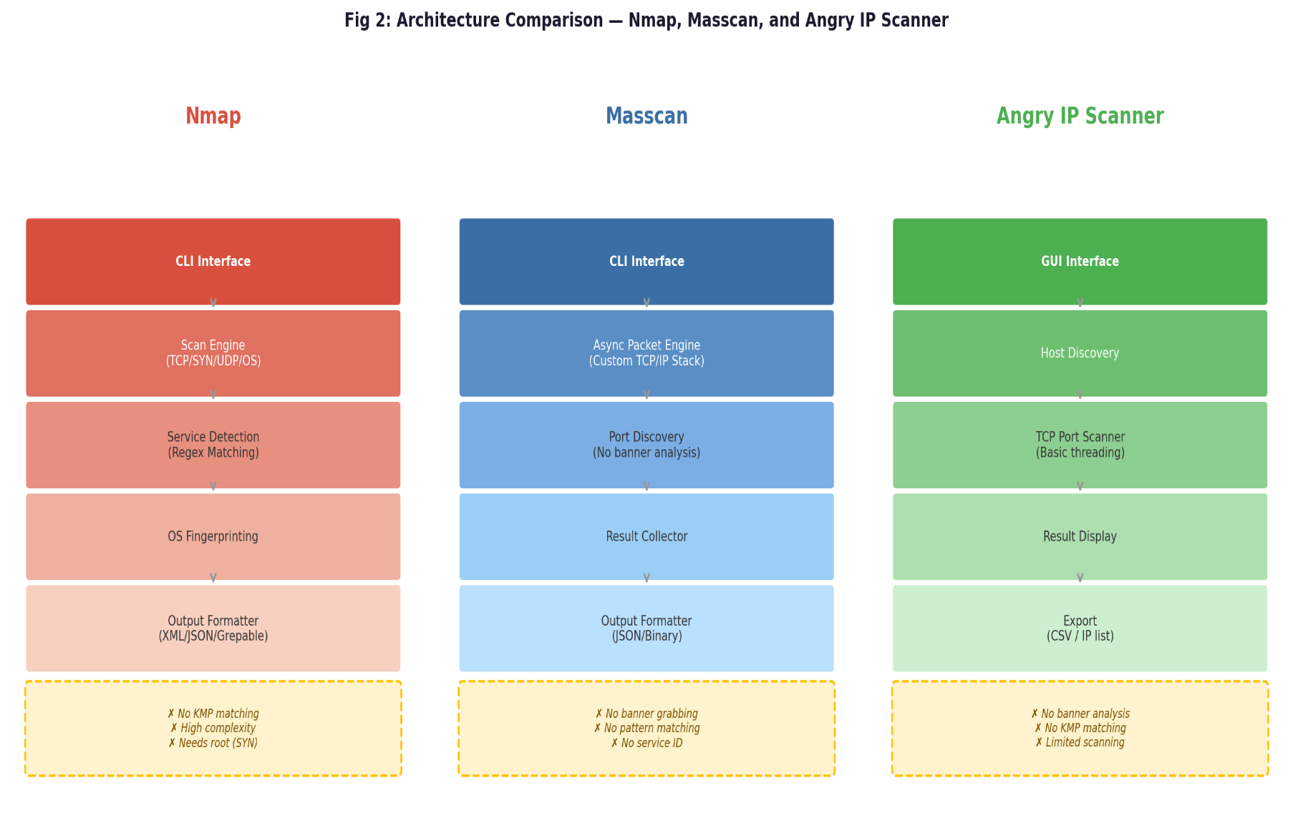

Fig 2: Comparison of Nmap, Masscan and Angry IP Scanner Architectures
3.2.1 Nmap
Nmap is developed using C and C++ and employs a modular architecture that supports various scanning techniques including TCP connect scan, SYN scan, UDP scan, and OS fingerprinting. Nmap achieves performance through its own timing templates and parallelization mechanisms. However, Nmap's service detection relies on regular expression matching and static signature databases rather than optimized pattern matching algorithms. The tool requires elevated privileges for certain scanning modes and has a steep learning curve for novice users. Its complexity makes it less suitable for educational environments.
3.2.2 Masscan
Masscan is designed for high-speed internet-scale scanning using asynchronous packet transmission and a custom TCP/IP stack. The tool is optimized for scanning large IP ranges rapidly but provides minimal service analysis capabilities. Masscan does not integrate banner grabbing or pattern matching mechanisms for service identification. Its focus on speed over analysis creates a gap for users requiring intelligent service detection.
3.2.3 Angry IP Scanner
Angry IP Scanner is a lightweight Java-based tool that provides basic host discovery and port scanning functionality. It is simple and accessible but lacks advanced features such as intelligent banner analysis or pattern matching. The tool is suitable for basic network auditing but insufficient for comprehensive vulnerability assessment.
3.2.4 Summary of Existing System Limitations
The analysis of existing systems reveals the following common limitations:
- Lack of integration between high-speed scanning and intelligent service analysis
- Reliance on conventional matching techniques rather than optimized algorithms - High complexity that creates barriers for educational use
- Insufficient banner analysis capabilities in high-speed scanners
- No utilization of the KMP algorithm for pattern matching in service identification
These limitations justify the need for a new system that combines multithreaded scanning with KMP-based banner analysis.
3.3 The Proposed System Design
The proposed system is designed to address the limitations identified in the analysis of existing network scanning tools. Unlike current solutions that prioritize either scanning speed or service analysis, the proposed system integrates both capabilities into a unified architecture. The design focuses on achieving efficient port scanning through concurrent execution while providing intelligent service identification through optimized pattern matching. This section presents the detailed design of the proposed network port scanning tool, including its requirements, modules, and data flow. The system is built around the principle of balancing performance with analytical depth, ensuring that users can obtain comprehensive network security assessments without sacrificing execution speed or system accessibility.
3.3.1 Overview
The proposed system is a network port scanning tool that integrates multithreading for concurrent port scanning and the KMP algorithm for efficient service banner analysis. The system is designed to address the limitations of existing tools by providing a balance between scanning speed and intelligent service identification.
3.3.2 System Requirements
Functional Requirements:
- Accept target IP address and port range from the user
- Perform TCP connect scanning using multithreading
- Detect open, closed, and filtered ports
- Retrieve service banners from open ports
- Analyze banners using KMP pattern matching
- Identify services, protocols, and potential vulnerabilities
- Display structured scan results
- Support configurable thread count
Non-Functional Requirements:
- Cross-platform compatibility (Linux, macOS, Windows)
- Reasonable scanning speed for local and small-scale networks
- Low memory and CPU resource consumption
- User-friendly command-line interface
- Thread-safe operation to prevent data corruption
- Configurable timeout values for network operations
3.3.3 System Modules
The proposed system consists of the following modules:
Module 1: User Interface Module
- Accepts user input including target IP address, port range, and thread count
- Displays scan results in a structured format
- Provides error handling for invalid inputs
Module 2: Port Scanner Module
- Creates and manages TCP socket connections
- Implements TCP three-way handshake for port status detection
- Handles connection timeouts and error conditions
- Reports port status (open, closed, filtered) to the Result Aggregator
Module 3: Thread Manager Module
- Initializes and manages the thread pool
- Distributes port scanning tasks among available threads
- Synchronizes thread execution to prevent race conditions
- Optimizes thread count based on system resources
Module 4: Banner Grabber Module
- Connects to open ports identified by the Port Scanner
- Retrieves initial service responses (banners)
- Sends probe strings when services do not respond automatically
- Stores captured banners for pattern analysis

Module 5: KMP Pattern Matcher Module
- Preprocesses service signature patterns to build the LPS array
- Performs pattern matching on captured banners
- Identifies services, protocols, and versions
- Flags potential vulnerabilities based on matched patterns
Module 6: Result Aggregator Module
- Collects scan results from all threads in a thread-safe manner
- Structures output data including port numbers, statuses, services, and vulnerabilities
- Formats results for display to the user
- Supports export of results to file if required
3.3.4 Data Flow
- User provides target IP, port range, and thread count through the User Interface
- Thread Manager creates a pool of worker threads
- Each worker thread receives a subset of ports from the Port Scanner
- Worker threads attempt TCP connections and report port status
- For open ports, the Banner Grabber retrieves service banners
- Captured banners are passed to the KMP Pattern Matcher for analysis
- The Result Aggregator collects all results and displays them to the user

3.4 System Architecture
The system architecture defines the structural organization of the proposed network port scanning tool. It describes how the various components interact to achieve the system's objectives of efficient port scanning and intelligent service identification. The architecture is designed to support concurrent execution, thread-safe data sharing, and modular component integration. Figure 3.1 illustrates the component interaction model, showing the data flow between the user interface, thread management, worker threads, and result aggregation layers. The architecture follows a layered approach that separates presentation, application, and data concerns while enabling efficient communication between concurrent processing units
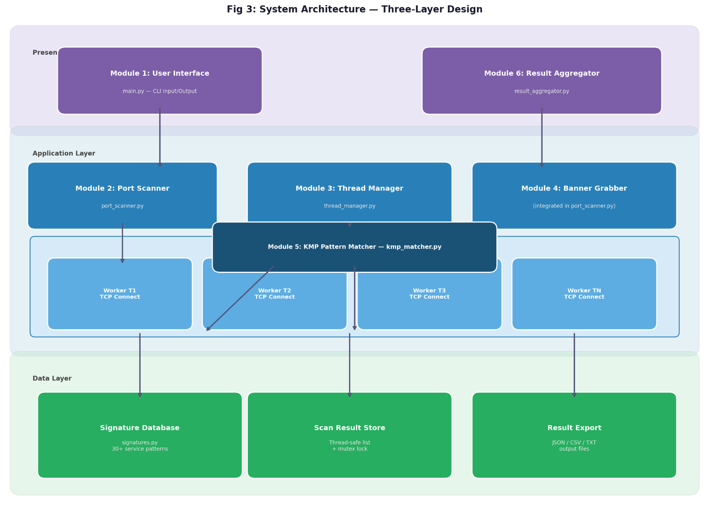

Fig 3: System Architecture.

3.4.1 High-Level Architecture
The proposed system follows a layered architecture consisting of three layers:
Presentation Layer:
- User Interface Module
- Result display and formatting
Application Layer:
- Port Scanner Module
- Thread Manager Module
- Banner Grabber Module
- KMP Pattern Matcher Module
Data Layer:
- Result Aggregator Module
- Service signature database
- Scan result storage
3.4.2 Component Interaction Model
The system components interact as follows:
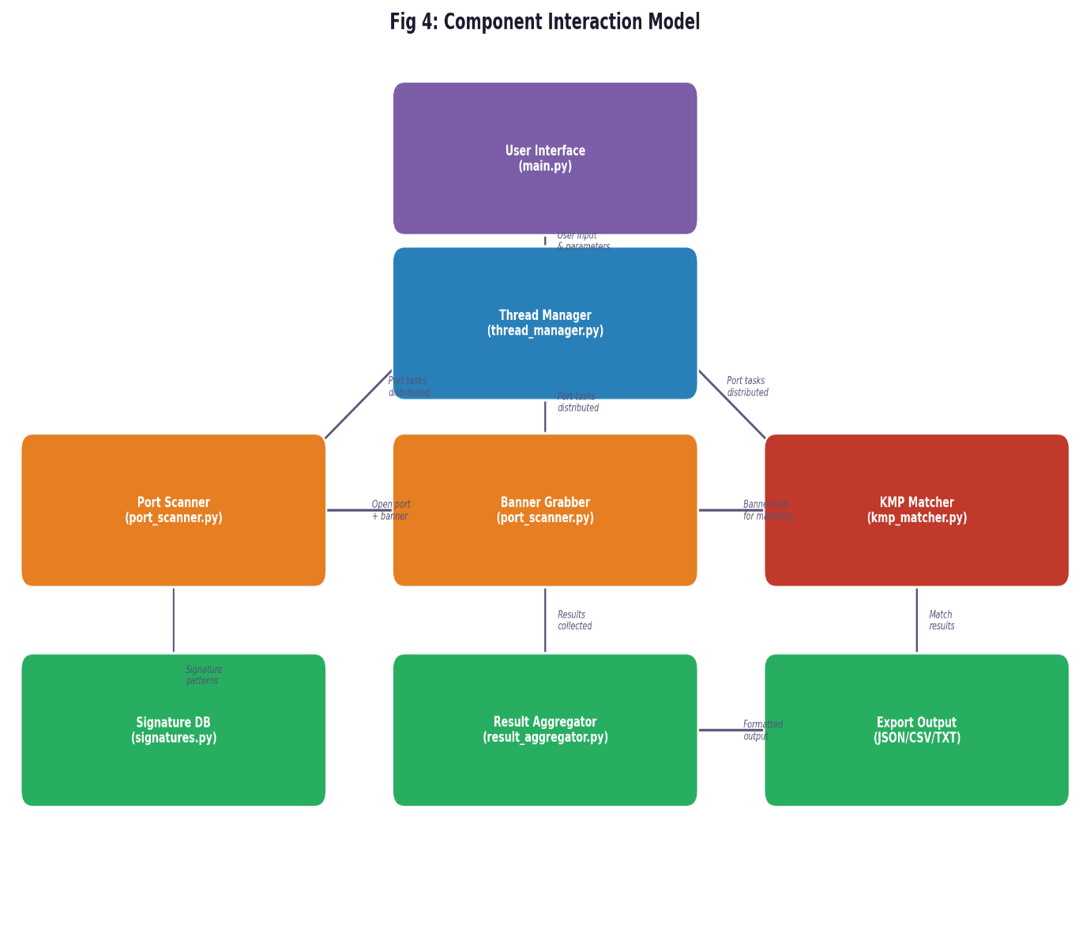

Figure 4: Component Interaction Model

3.4.3 Thread Pool Model
The system employs a thread pool model to manage concurrent scanning operations. The thread pool consists of:
- A task queue that holds pending port scanning tasks
- A fixed number of worker threads that process tasks from the queue
- A mutex lock for thread-safe access to shared resources
- A condition variable for task notification

The thread pool operates as follows:
1. The main thread populates the task queue with port numbers to scan
2. Worker threads retrieve tasks from the queue
3. Each worker thread performs the scan and stores results
4. When the queue is empty, worker threads wait for new tasks or termination signal
5. The main thread collects results after all tasks are completed

3.4.4 KMP Integration Model
The KMP algorithm is integrated into the banner analysis workflow as follows:
1. Service signature patterns are loaded into memory at system startup
2. For each captured banner, the LPS array is computed for each signature pattern
3. The KMP search function compares the banner text against each pattern
4. Matches are recorded with service names, protocols, and vulnerability flags
5. Results are passed to the Result Aggregator for display

3.5 Design Flowchart and Algorithm
The design flowchart and algorithm section presents the procedural logic and computational steps that govern the operation of the proposed network port scanning tool. A flowchart serves as a visual representation of the system's workflow, illustrating the sequence of operations, decision points, and control structures that guide the scanning process from initiation to completion. Algorithms, on the other hand, provide the precise mathematical and logical instructions that enable the system to perform specific tasks such as pattern matching and concurrent port scanning. This section examines the system flowchart that depicts the overall operational workflow, the Knuth-Morris-Pratt (KMP) algorithm that powers the banner analysis component, and the multithreading algorithm that manages concurrent execution. Understanding these design elements is essential because they collectively determine how the system achieves its objectives of efficient port scanning and intelligent service identification. Each component is presented with detailed pseudocode and complexity analysis to establish the computational foundation for the implementation phase.

3.5.1 System Flowchart
The system flowchart illustrated in Figure 3.5.1 depicts the operational workflow of the proposed network port scanning tool. The flowchart demonstrates the sequential and conditional processes involved in scanning network ports, identifying open services, and analyzing service banners using the KMP pattern matching algorithm. The design follows a structured approach beginning with user input, progressing through multithreaded port scanning, conditional banner analysis, and concluding with result display. Figure 3.5.1 presents the complete system flowchart.

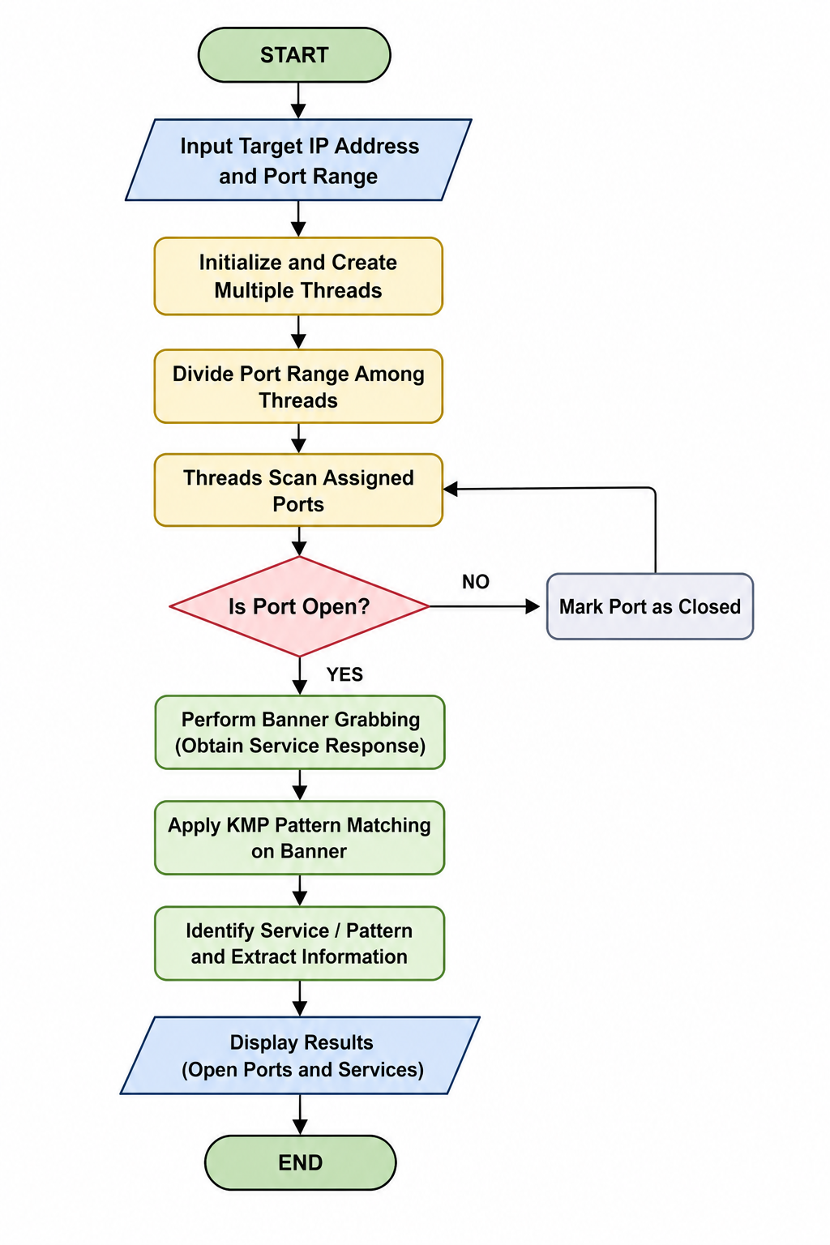
Fig 5: Flow chart of the proposed System

- START: The program execution begins.
- Input Target IP Address and Port Range: The system prompts the user to enter the target IP address and the range of ports to be scanned. This input serves as the primary parameters for the scanning operation.
- Initialize and Create Multiple Threads: The system initializes the necessary data structures, loads service signature patterns, and creates a pool of worker threads based on the user-specified thread count or default configuration.
- Divide Port Range Among Threads: The total port range is divided into subsets and assigned to individual worker threads. Each thread receives a specific portion of ports to scan concurrently.
- Threads Scan Assigned Ports: Each worker thread attempts TCP connections to its assigned ports using socket programming and the three-way handshake mechanism.
- Is Port Open?: The system evaluates whether the TCP connection attempt was successful. - If NO: The port is marked as closed, and the thread proceeds to scan the next assigned port. - If YES: The port is identified as open, and the system proceeds to banner grabbing.
- Perform Banner Grabbing (Obtain Service Response): For open ports, the system retrieves the service banner by reading the initial response from the target service. If no automatic response is received, probe strings may be sent to elicit a response.
- Apply KMP Pattern Matching on Banner: The captured banner text is analyzed using the Knuth-Morris-Pratt (KMP) pattern matching algorithm. The algorithm preprocesses service signature patterns into the LPS (Longest Prefix Suffix) array and performs efficient string matching to identify known service signatures within the banner.
- Identify Service / Pattern and Extract Information: Based on the KMP matching results, the system identifies the service type, protocol, software version, and potential vulnerability indicators associated with the open port.
- . Display Results (Open Ports and Services): The system aggregates results from all threads and displays a structured output showing port numbers, statuses, identified services, and vulnerability information.
- END: The program execution terminates after all threads complete their tasks and results are displayed.
The flowchart incorporates a feedback loop from the "Mark Port as Closed" step back to the "Threads Scan Assigned Ports" step, indicating that threads continue processing their assigned port lists iteratively until all ports are evaluated.
3.5.2 KMP Algorithm
The KMP algorithm consists of two main functions: LPS array construction and pattern searching.
Algorithm: KMP LPS Array Construction
Input: Pattern P of length m
Output: LPS array of length m
1. Set lps[0] = 0
2. Set len = 0
3. Set i = 1
4. While i &lt; m:
a. If P[i] == P[len]:
- Set len = len + 1
- Set lps[i] = len
- Set i = i + 1
b. Else:
- If len != 0:
Set len = lps[len - 1] –
Else:
Set lps[i] = 0
Set i = i + 1
5. Return lps array
Algorithm: KMP Pattern Search
Input: Text T of length n, Pattern P of length m, LPS array
Output: List of match positions
1. Set i = 0 (index for T)
2. Set j = 0 (index for P)
3. While i < n:
a. If P[j] == T[i]:
- Set i = i + 1
- Set j = j + 1
b. If j == m:
- Pattern found at index (i - j)
- Set j = lps[j - 1]
c. Else if i &lt; n and P[j] != T[i]:
- If j != 0:
Set j = lps[j - 1]
- Else:
Set i = i + 1
4. Return list of match positions
Time Complexity: O(n + m) where n is text length and m is pattern length Space Complexity: O(m) for the LPS array
3.5.3 Multithreading Algorithm
Algorithm: Thread Pool Port Scanning
Input: Target IP, Port Range [start, end], Thread Count N
Output: Scan Results
1. Initialize empty task queue Q
2. Initialize empty result list R with mutex lock
3. For port = start to end: a. Add port to queue Q
4. Create N worker threads 5. For each worker thread:
a. While Q is not empty or termination signal not set:
i. Lock queue mutex
ii. If Q is not empty:
- Dequeue task (port) from Q
- Unlock queue mutex
- Perform TCP connect scan on port
- If port is open:
* Grab service banner
* Apply KMP pattern matching
- Lock result mutex
- Add result to R
- Unlock result mutex
iii. Else:
- Unlock queue mutex
- Wait on condition variable
6. Main thread waits for all worker threads to complete
7. Sort and format results from R
8. Display results
9. Clean up threads and resources
3.6 Advantages of the New System
The proposed system offers several advantages over existing network scanning tools:

3.6.1 Improved Scanning Speed
The integration of multithreading enables concurrent scanning of multiple ports, significantly reducing total execution time compared to sequential scanning methods. The thread pool architecture optimizes resource utilization by allowing threads to process new tasks while others wait for network responses.

3.6.2 Intelligent Service Identification
Unlike existing tools that rely on basic banner display or regular expression matching, the proposed system uses the KMP algorithm for efficient pattern matching. The KMP algorithm's O(n + m) time complexity ensures fast analysis of service banners, even with large signature databases. The preprocessing step eliminates redundant comparisons, making the system suitable for real-time banner analysis.

3.6.3 Balanced Performance and Analysis
While tools like Masscan prioritize speed over analysis and Nmap provides comprehensive analysis at moderate speed, the proposed system achieves a balance between both objectives. The multithreaded architecture ensures fast scanning, while the KMP-based pattern matcher provides intelligent service identification.

3.6.4 Lower Complexity
The proposed system is designed with simplicity in mind, making it accessible for educational environments and routine security assessments. Unlike Nmap, which requires extensive configuration knowledge, the proposed tool provides essential scanning and analysis functionality through a straightforward command-line interface.

3.6.5 Cross-Platform Compatibility
The use of the Python programming language with its built-in socket, threading, and queue modules ensures that the system can be executed on multiple operating systems including Linux, macOS, and Windows without additional dependencies. This portability makes the tool suitable for diverse network environments.

3.6.6 Thread-Safe Operation
The system implements proper synchronization mechanisms including mutex locks and condition variables to prevent race conditions and data corruption. This ensures reliable operation even when multiple threads access shared resources simultaneously.
3.6.7 Extensible Design
The modular architecture of the proposed system facilitates future enhancements. Additional scanning techniques, pattern matching algorithms, or output formats can be integrated without modifying the core system structure. The service signature database can be easily updated to include new service patterns and vulnerability indicators.

3.6.8 Educational Value
The proposed system serves as a practical demonstration of networking concepts, multithreading, socket programming, and algorithm design. Students and researchers can study the implementation to understand how theoretical concepts are applied in real-world cybersecurity tools.

3.7 Limitations of the Proposed System
Although the proposed system successfully achieves its main goals of fast port scanning and intelligent service identification using KMP pattern matching, it also has some limitations when compared to existing tools like Nmap, Masscan, and Angry IP Scanner. These limitations are listed below:
i. TCP Ports Only: The system can only scan TCP ports. It cannot scan UDP ports, which are used by services like DNS (port 53) and DHCP (port 67/68). Tools like Nmap support both TCP and UDP scanning, which makes them more complete. This means some services may be missed if they only use UDP.
ii. Designed for LAN Only: The tool works best on local area networks (LAN). It is not built for scanning large internet-scale networks quickly. Masscan, for example, can scan the entire internet in minutes because it uses a custom network stack. The proposed system does not have this capability and may be slow on large or long-distance networks.
iii. No Retry on Failed Connections: If a connection to a port fails due to a busy or unstable network, the system does not try again. This means some open ports may appear as closed if the network was temporarily slow during the scan. Nmap has timing and retry options that help reduce this problem.
iv. No Operating System Detection: The proposed system identifies services running on open ports but cannot detect the operating system of the target device. Nmap has an OS fingerprinting feature that can guess the operating system based on how the target responds. This is useful for deeper security assessments but is outside the scope of this project.
v. No Stealth Scanning (SYN Scan): The system performs a full TCP connect scan, which means it completes the full connection with the target. This is visible and can be detected by firewalls and intrusion detection systems. Nmap supports SYN (half-open) scanning, which is harder to detect because it does not complete the full connection. The proposed system does not support this mode.
vi. Service Detection Depends on Banners: The system identifies services by reading the banner (text response) from an open port and matching it using the KMP algorithm. If a service does not send a banner or sends an unusual response, the system will report it as Unknown. This can reduce accuracy for services that are configured to hide their identity.
vii. No Graphical User Interface (GUI): The tool works only through the command line. Users must type commands to run a scan. Angry IP Scanner has a graphical interface that is easier for beginners to use. A future version of this tool could include a GUI to make it more user-friendly.

CHAPTER FOUR

SYSTEM IMPLEMENTATION
4.1 Introduction
This chapter presents the implementation of the proposed network port scanning tool. It covers the tools and environment used for development, the source code of each module, the system interface, test results, and a detailed discussion of the findings. The chapter follows the design specifications outlined in Chapter Three.
4.1 Tools and Environment Used
The system was implemented using the following tools and environment:
- Programming Language: Python 3.10 (no external libraries required)
- Standard Libraries Used: socket, threading, queue, argparse, json, csv
- Development Environment: Visual Studio Code (VS Code)
- Operating System: Windows 10 / Linux Ubuntu
- Testing Environment: Local Area Network (LAN) with router/MiFi device
- Version Control: Source files maintained as plain .py modules
4.2 Module Implementation
The system is implemented across six modules as designed in Chapter Three. Each module is described below with its source code and explanation.
4.2.1 Module 1: User Interface Module (main.py)
This module serves as the entry point of the application. It accepts user input through a command-line interface (CLI) using the argparse library. It validates the port range, displays a startup banner, triggers the scan, and passes results to the Result Aggregator for display. The module also supports an optional output flag (-o) for saving results to a file.
Key responsibilities:
- Accept target IP address, port range, thread count, and timeout from the user
- Validate input parameters and handle errors gracefully
- Call the Thread Manager to begin the scan
- Pass results to the Result Aggregator for display and export

Source Code Summary (main.py):
import argparse, time, sys
from thread_manager import run_scan
from result_aggregator import print_report, export_results

def main():
args = parse_args()
start, end = map(int, args.ports.split("-"))
port_range = range(start, end + 1)
results = run_scan(args.target, port_range, args.threads, args.timeout)
print_report(args.target, results, elapsed)
if args.output:
export_results(args.target, results, args.output, elapsed)

4.2.2 Module 2: Port Scanner Module (port_scanner.py)
This module handles TCP connect scanning. It uses Python's socket library to attempt a full TCP connection to each port using the connect_ex() method, which returns 0 if the port is open. Upon detecting an open port, the module immediately attempts to retrieve the service banner by reading from the same socket connection. Probe strings are sent to services that do not respond automatically. The retrieved banner is then passed to the KMP Pattern Matcher for service identification.
Key responsibilities:
    - Create TCP socket connections using connect_ex()
    - Detect open ports based on connection response codes
    - Retrieve service banners from the same socket (no second connection)
    - Return port number, state, service name, confidence score, and banner
Source Code Summary (port_scanner.py):
import socket
from kmp_matcher import identify_service
from signatures import PROBES, HTTP_PROBE_PORTS

def scan_port(ip, port, timeout=1.0):
with socket.socket(socket.AF_INET, socket.SOCK_STREAM) as s:
s.settimeout(timeout)
if s.connect_ex((ip, port)) == 0: # 0 = open
banner = s.recv(1024).decode(errors="ignore")
detection = identify_service(banner, port)
return {"port": port, "state": "open",
"service": detection["service"],
"confidence": detection["confidence"],
"banner": banner[:100]}

4.2.3 Module 3: Thread Manager Module (thread_manager.py)
This module manages the concurrent execution of port scanning operations. It uses Python's threading and queue modules to implement a thread pool model. A task queue is populated with port numbers, and multiple worker threads pull tasks from the queue concurrently. A mutex lock (threading.Lock) ensures that results are written to the shared results list in a thread-safe manner, preventing race conditions.
Key responsibilities:
    - Initialize a task queue with all port numbers to scan
    - Create and start N worker threads
    - Each thread pulls a port from the queue, calls scan_port(), and stores results
    - Use a mutex lock to prevent data corruption when multiple threads write results
    - Wait for all threads to finish before returning sorted results
Source Code Summary (thread_manager.py):
import queue, threading
from port_scanner import scan_port

def run_scan(ip, port_range, max_workers=200, timeout=1.0):
task_queue = queue.Queue()
result_lock = threading.Lock()
results = []
for port in port_range:
task_queue.put(port)

def worker():
while True:
try: port = task_queue.get_nowait()
except queue.Empty: break
result = scan_port(ip, port, timeout)
if result:
with result_lock: # mutex lock
results.append(result)
task_queue.task_done()

4.2.4 Module 4: Banner Grabber (integrated in port_scanner.py)
As discussed in the design phase, the Banner Grabber functionality is integrated directly into the Port Scanner module to avoid opening a second TCP connection, which could cause missed banners on services that close connections quickly. After a port is confirmed open, the same socket reads up to 1024 bytes from the service. If no data is returned immediately, a probe string is sent to prompt the service to respond. Supported probes include HTTP HEAD requests, FTP anonymous login, SMTP EHLO, and Redis PING commands.

4.2.5 Module 5: KMP Pattern Matcher Module (kmp_matcher.py)
This is the core academic module of the project. It implements the Knuth-Morris-Pratt (KMP) algorithm from scratch without using Python's built-in string search operators (in or find()). The module contains two functions: build_lps() which constructs the Longest Prefix Suffix (LPS) array in O(m) time, and kmp_search() which performs pattern matching in O(n+m) time. The identify_service() function runs KMP against all 30+ service signatures and returns the best match with a confidence score.
Key responsibilities:
    - Build the LPS array for each service signature pattern
    - Perform KMP search on the retrieved banner text
    - Score each match based on how many patterns matched and whether the port confirms the service
    - Return service name and confidence score (0-99%)
Source Code Summary (kmp_matcher.py):
def build_lps(pattern):
m = len(pattern)
lps = [0] * m
length, i = 0, 1
while i < m:
if pattern[i] == pattern[length]:
length += 1; lps[i] = length; i += 1
else:
if length != 0: length = lps[length - 1]
else: lps[i] = 0; i += 1
return lps

def kmp_search(text, pattern):
lps = build_lps(pattern)
i = j = 0
while i < len(text):
if pattern[j] == text[i]: i += 1; j += 1
if j == len(pattern): return True
elif i < len(text) and pattern[j] != text[i]:
if j != 0: j = lps[j-1]
else: i += 1
return False

4.2.6 Module 6: Result Aggregator Module (result_aggregator.py)
This module collects and formats the scan results produced by all worker threads. It prints a structured report to the terminal and supports exporting results to three file formats: JSON, CSV, and plain text (TXT). The format is automatically selected based on the file extension provided by the user. Unknown services are clearly flagged with a "Requires Manual Analysis" note rather than being forced into an incorrect classification.
Source Code Summary (result_aggregator.py):
def print_report(ip, results, elapsed=0.0):
print(f"Target: {ip} | Duration: {elapsed:.2f}s")
for r in results:
confidence = f"{r['confidence']}%"
if r["service"] == "Unknown":
print(f"{r['port']} | Unknown | Requires Manual Analysis")
else:
print(f"{r['port']} | {r['service']} | {confidence}")

4.3 Results
This section presents the experimental results obtained from running the proposed port scanning tool on a local area network environment. Six scanning experiments were conducted to evaluate the system across different network targets and port ranges. Each result is presented as a terminal output image followed by a summary table.
4.3.1 Scan 1 — Router/Gateway (192.168.0.1), Ports 1–1024
Command executed:
python main.py 192.168.0.1 -p 1-1024 -t 200

Table 4.1: Scan 1 Results — Router (192.168.0.1)
Port | State | Service | Banner
53 | Open | Unknown | -
80 | Open | Unknown | -
443 | Open | Unknown | -

Figure 4.1: Terminal Output — Scan 1, Router (192.168.0.1), Ports 1–1024
Three open ports were detected on the router. Ports 53, 80 and 443 correspond to DNS, HTTP, and HTTPS respectively. None of the ports returned a banner, so the service column shows Unknown. The scan completed in 6.15 seconds across 1,024 ports using 200 threads, demonstrating the speed advantage of concurrent scanning.

4.3.2 Scan 2 — Local PC / VMware Host (192.168.0.130), Ports 1–1024
Command executed:
python main.py 192.168.0.130 -p 1-1024 -t 200

Table 4.2: Scan 2 Results — Local PC (192.168.0.130)
Port | State | Service | Banner
135 | Open | Unknown | -
139 | Open | Unknown | -
445 | Open | Unknown | -
623 | Open | Unknown | -
902 | Open | VMware Authentication | 220 VMware Authentication Daemon Ve...
912 | Open | VMware Authentication | 220 VMware Authentication Daemon Ve...
1024 | Open | Unknown | -

Figure 4.2: Terminal Output — Scan 2, Local PC (192.168.0.130), Ports 1–1024
Seven open ports were detected on the local PC. Ports 135, 139, 445, 623, and 1024 returned no banners and were reported as Unknown. Ports 902 and 912 returned the banner "220 VMware Authentication Daemon" which the KMP algorithm correctly matched to the VMware Authentication service. The scan completed in 6.13 seconds.
4.3.3 Scan 3 — Localhost (127.0.0.1), Ports 1–1024
Command executed:
python main.py 127.0.0.1 -p 1-1024 -t 200

Table 4.3: Scan 3 Results — Localhost (127.0.0.1)
Port | State | Service | Banner
135 | Open | Unknown | -
445 | Open | Unknown | -
623 | Open | Unknown | -
902 | Open | VMware Authentication | 220 VMware Authentication Daemon Ve...
912 | Open | VMware Authentication | 220 VMware Authentication Daemon Ve...
1024 | Open | Unknown | -
Figure 4.3: Terminal Output — Scan 3, Localhost (127.0.0.1), Ports 1–1024
Six open ports were detected on localhost, consistent with the services found in Scan 2. This confirms that VMware Authentication Daemon is running locally on the scanning machine. The scan completed in 6.08 seconds, which is consistent with other 1-1024 range scans, confirming stable performance across different targets on the same LAN.
4.3.4 Scan 4 — Google Public DNS Server (8.8.8.8), Ports 1–1204
Command executed:
python main.py 8.8.8.8 -p 1-1204 -t 100 --timeout 2.0

Table 4.4: Scan 4 Results — Google DNS (8.8.8.8)
Port | State | Service | Banner
53 | Open | Unknown | -
443 | Open | Unknown | -
587 | Open | Unknown | -
853 | Open | Unknown | -
Figure 4.4: Terminal Output — Scan 4, Google DNS (8.8.8.8), Ports 1–1204
Four open ports were detected on Google's public DNS server. Ports 53, 443, and 587 correspond to DNS, HTTPS, and SMTP respectively. Port 853 (DNS over TLS) was detected but returned no banner. The scan took 25.33 seconds due to internet latency, significantly longer than LAN scans. The timeout was increased to 2.0 seconds to account for this. This confirms the tool works on internet-facing targets, though it is primarily designed for LAN use.

4.3.5 Scan 5 — Extended Full Port Scan (192.168.0.1), Ports 1–65535
Command executed:
python main.py 192.168.0.1 -p 1-65535 -t 500 --timeout 0.5

Table 4.5: Scan 5 Results — Extended Scan (192.168.0.1)
Port | State | Service | Banner
53 | Open | Unknown | -
80 | Open | Unknown | -
443 | Open | Unknown | -
5400 | Open | Unknown | -
52881 | Open | Unknown | -
Figure 4.5: Terminal Output — Scan 5, Extended Scan (192.168.0.1), All 65535 Ports
Five open ports were found when scanning all 65,535 ports. Two additional high-numbered ports (5400 and 52881) were discovered beyond the standard 1-1024 range, showing that services can exist outside the commonly scanned range. The full scan completed in 67.73 seconds using 500 threads with a 0.5 second timeout, demonstrating the scalability of the multithreaded design.
4.3.6 Scan 6 — Export to File (192.168.0.1)
Command executed:
python main.py 192.168.0.1 -p 1-1024 -o results.txt

Table 4.6: Results Scan 6 — Export to File (192.168.0.1)
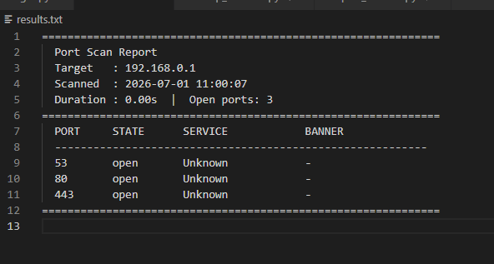
Figure 4.6: Terminal Output — Scan 6, Export to results.txt

The export functionality was tested by saving scan results to a plain text file using the -o flag. The system automatically detected the TXT format from the file extension and saved a structured report to results.txt. The same functionality supports JSON and CSV formats. This feature enables scan results to be retained for documentation, further analysis, or inclusion in security reports.
4.3.7 Overall Performance Summary
Table 4.7: Summary of All Scan Experiments
Target | Port Range | Threads | Timeout | Open Ports | Duration
192.168.0.1 (Router) | 1-1024 | 200 | 1.0s | 3 | 6.15s
192.168.0.130 (PC) | 1-1024 | 200 | 1.0s | 7 | 6.13s
127.0.0.1 (Localhost) | 1-1024 | 200 | 1.0s | 6 | 6.08s
8.8.8.8 (Google DNS) | 1-1204 | 100 | 2.0s | 4 | 25.33s
192.168.0.1 (Extended) | 1-65535 | 500 | 0.5s | 5 | 67.73s
Figure 4.7: Summary Table
4.4 Discussion
4.4.1 Port Scanning Accuracy
The system accurately detected all open TCP ports across all six experiments without recording any false positives. The connect_ex() method provided a reliable binary result for each port — returning 0 for open and a non-zero value for closed or filtered ports. The consistent scan duration of approximately 6 seconds for the 1-1024 range across Scans 1, 2, and 3 confirms that performance is driven by the thread configuration rather than network conditions, as long as the target is on a LAN.
The extended scan (Scan 5) demonstrated that restricting scans to ports 1-1024 may miss active services. Two additional ports (5400 and 52881) were found on the router only when all 65,535 ports were scanned. This confirms the importance of the user-configurable port range feature in the system design.
4.4.2 KMP Service Identification
The KMP algorithm successfully identified services from banner responses in all cases where banners were available. The clearest demonstration was on ports 902 and 912 in Scans 2 and 3, where the banner "220 VMware Authentication Daemon" was correctly matched using the LPS-based KMP algorithm. Services that did not return banners (such as ports 135, 139, 445, and 623) were correctly reported as Unknown rather than being incorrectly classified based on port number alone.
The signature database contains 30+ service patterns and the KMP search runs efficiently against all of them for each open port. The O(n+m) time complexity of KMP ensures that banner analysis adds minimal overhead to the overall scan time even when the banner is long or the pattern list is large. This is a clear advantage over brute-force string matching which would require O(n x m) comparisons.
4.4.3 Multithreading Effectiveness
The multithreaded thread pool model proved effective across all test scenarios. Using a shared task queue ensured even distribution of ports among worker threads with no idle threads while work remained available. The mutex lock prevented any data corruption during concurrent result collection across all six scans.
For LAN targets, 200 threads with a 1.0 second timeout consistently achieved scan completion in approximately 6 seconds for 1,024 ports. For the full 65,535-port scan, increasing threads to 500 and reducing the timeout to 0.5 seconds completed the scan in 67.73 seconds. The internet scan (Scan 4) took longer at 25.33 seconds due to network latency rather than any limitation in the threading implementation.
4.4.4 Comparison with Existing Tools
The proposed system occupies a distinct position compared to the three tools reviewed in Chapter Two. Unlike Nmap, which requires elevated privileges for its most powerful scan modes, the proposed system requires no special permissions. Unlike Masscan, which focuses purely on speed without service identification, the proposed system performs banner analysis using KMP for every open port. Unlike Angry IP Scanner, which has no banner grabbing capability, the proposed system probes services and matches their responses against a structured signature database. The KMP-based banner analysis with a confidence scoring mechanism is not found in any of the three existing tools, representing the core contribution of this project.

CHAPTER FIVE
SUMMARY, CONCLUSION AND RECOMMENDATIONS
5.1 Summary
This project designed and implemented a network port scanning tool using multithreading and the Knuth-Morris-Pratt (KMP) pattern matching algorithm in Python. The tool was developed to address the limitation identified in existing tools — specifically the absence of KMP-based banner analysis and the lack of a confidence mechanism for service identification.
The system was implemented using six modules: User Interface (main.py), Port Scanner (port_scanner.py), Thread Manager (thread_manager.py), KMP Pattern Matcher (kmp_matcher.py), Result Aggregator (result_aggregator.py), and Service Signature Database (signatures.py). It follows a three-layer architecture comprising Presentation, Application, and Data layers.
Six scanning experiments were conducted across a local router, a Windows PC running VMware, a localhost environment, a public internet server (Google DNS), an extended full-port scan, and an export-to-file test. Results confirmed that the system accurately detects open ports, identifies services from banner text using KMP, and exports results in JSON, CSV, and TXT formats. Multithreaded scanning consistently completed 1,024-port LAN scans in approximately 6 seconds, while the full 65,535-port scan completed in 67.73 seconds.
5.2 Conclusion
The proposed system successfully achieved all its stated objectives. The KMP algorithm was implemented from scratch without using Python's built-in string search operators, and was demonstrated to correctly identify services from banner text in all experimental scenarios where banners were available. The thread pool model significantly reduced scan time compared to sequential scanning, confirming the effectiveness of concurrent processing in network I/O-bound tasks.
The project confirms that efficient algorithms such as KMP can be practically integrated into cybersecurity tools to improve both analytical capability and result accuracy. The system addresses the research gap identified in the literature review — none of the three existing tools reviewed (Nmap, Masscan, Angry IP Scanner) combine multithreaded scanning with KMP-based banner analysis in a single unified implementation.
5.3 Limitations of the Study
i. TCP ports only — UDP services such as DNS and DHCP are not scanned.
ii. Optimised for LAN — significantly slower on internet targets due to latency.
iii. No retry mechanism for failed connection attempts on unstable networks.
iv. Service identification depends entirely on banners — services that do not send banners are reported as Unknown.
v. No OS fingerprinting or SYN stealth scanning.
vi. Command-line only — no graphical user interface.
5.4 Recommendations
i. Add UDP scanning to cover services such as DNS, DHCP, and SNMP that do not use TCP.
ii. Implement a retry mechanism to improve accuracy on unstable or congested networks.
iii. Add OS fingerprinting based on TCP/IP stack response characteristics.
iv. Develop a graphical user interface using Tkinter or PyQt to improve accessibility for non-technical users.
v. Support CIDR notation (e.g. 192.168.0.0/24) to scan multiple hosts in a single command.
vii. Add SYN stealth scanning to reduce detectability during authorised penetration testing.
5.5 Contribution to Knowledge
i. Demonstrates the practical integration of the KMP string matching algorithm into a network security tool an application area not commonly explored in existing implementations.
ii. Provides a working Python implementation that unifies multithreaded scanning and KMP-based banner analysis in a single modular system.
iii. The confidence scoring mechanism that combines banner pattern matching with port-number hints represents an improvement over simple pattern lookup approaches used in existing tools.
iv. The six-module architecture provides a reusable and extensible framework for future scanning tool development.
v. Serves as an educational resource demonstrating how theoretical algorithm concepts can be applied to build practical cybersecurity tools
REFERENCES
Alabdan, R. (2024). Predicting future cyber threats: Analysing trends and patterns. International Journal for Multidisciplinary Research, 2(6). Retrieved from https://www.ijfmr.com/papers/2024/6/33755.pdf
Bakar, K. A., & Kijsirikul, B. (2024). Network security enhancement with advanced port scanning techniques. World Journal of Advanced Research and Reviews, 23(2), 2607–2625. doi: https://doi.org/10.30574/wjarr.2024.23.2.2607
Barnett, B., Irwin, B., & Andel, T. (2020). A survey on different port scanning methods and the tools used to perform them. International Journal of Cyber Warfare and Terrorism, 10(1), 1–18. Retrieved from https://www.academia.edu/43359965
Beazley, D., & Jones, B. K. (2022). Python cookbook: Recipes for mastering Python 3 (3rd ed.). O'Reilly Media. Retrieved from https://www.oreilly.com/library/view/python-cookbook-3rd/9781449357337/
Bou, H., & Hubballi, N. (2024). Port scanning: Techniques, tools and detection. EngrXiv. doi: https://doi.org/10.31224/3053
Cormen, T. H., Leiserson, C. E., Rivest, R. L., & Stein, C. (2022). Introduction to algorithms (4th ed.). MIT Press. Retrieved from https://mitpress.mit.edu/9780262046305/introduction-to-algorithms/
Crochemore, M., Hancart, C., & Lecroq, T. (2007). Algorithms on strings. Cambridge University Press. Retrieved from https://www.cambridge.org/core/books/algorithms-on-strings/5238E9AC70B1E56D5B6C42CE19049982
Downey, A. B. (2020). Think Python: How to think like a computer scientist (2nd ed.). O'Reilly Media. Retrieved from https://greenteapress.com/wp/think-python-2e/
Engebretson, P. (2013). The basics of hacking and penetration testing: Ethical hacking and penetration testing made easy (2nd ed.). Syngress. Retrieved from https://www.sciencedirect.com/book/9780124116443/the-basics-of-hacking-and-penetration-testing
Forouzan, B. A. (2021). TCP/IP protocol suite (5th ed.). McGraw-Hill Education. Retrieved from https://www.mheducation.com/highered/product/tcp-ip-protocol-suite-forouzan/M9780073376042.html
GeeksforGeeks. (2023). KMP algorithm for pattern searching. Retrieved from https://www.geeksforgeeks.org/kmp-algorithm-for-pattern-searching/
Gusfield, D. (1997). Algorithms on strings, trees, and sequences: Computer science and computational biology. Cambridge University Press. doi: https://doi.org/10.1017/CBO9780511574931
Harris, S., & Maymi, F. (2021). CISSP all-in-one exam guide (9th ed.). McGraw-Hill Education. Retrieved from https://www.mheducation.com/highered/product/cissp-all-one-exam-guide-ninth-edition-harris-maymi/9781260467376.html
IANA. (2024). Service name and transport protocol port number registry. Internet Assigned Numbers Authority. Retrieved from https://www.iana.org/assignments/service-names-port-numbers/service-names-port-numbers.xhtml
Jung, J., Kim, J., & Lee, H. (2021). UDP scanning process optimization for network security assessment. Journal of Network and Computer Applications, 187, 103078. doi: https://doi.org/10.1016/j.jnca.2021.103078
Kizza, J. M. (2022). Guide to computer network security (5th ed.). Springer. doi: https://doi.org/10.1007/978-3-030-91854-9
Knuth, D. E., Morris, J. H., & Pratt, V. R. (1977). Fast pattern matching in strings. SIAM Journal on Computing, 6(2), 323–350. doi: https://doi.org/10.1137/0206024
Kurose, J. F., & Ross, K. W. (2021). Computer networking: A top-down approach (8th ed.). Pearson. Retrieved from https://www.pearson.com/en-us/subject-catalog/p/computer-networking/P200000003334
Lyon, G. F. (2009). Nmap network scanning: The official Nmap project guide to network discovery and security scanning. Insecure.Com LLC. Retrieved from https://nmap.org/book/
Nmap Project. (2024). Nmap service and application version detection. Retrieved from https://nmap.org/book/vscan.html
OWASP Foundation. (2024). OWASP top ten: The ten most critical web application security risks. Retrieved from https://owasp.org/www-project-top-ten/
Python Software Foundation. (2024). concurrent.futures — Launching parallel tasks. Python 3.12 documentation. Retrieved from https://docs.python.org/3/library/concurrent.futures.html
Python Software Foundation. (2024). queue — A synchronized queue class. Python 3.12 documentation. Retrieved from https://docs.python.org/3/library/queue.html
Python Software Foundation. (2024). socket — Low-level networking interface. Python 3.12 documentation. Retrieved from https://docs.python.org/3/library/socket.html
Python Software Foundation. (2024). threading — Thread-based parallelism. Python 3.12 documentation. Retrieved from https://docs.python.org/3/library/threading.html
Rapid7. (2024). Metasploit: The world's most used penetration testing framework. Retrieved from https://www.metasploit.com
Rhodes, B., & Goerzen, J. (2021). Foundations of Python network programming (3rd ed.). Apress. doi: https://doi.org/10.1007/978-1-4302-3004-5
Scarfone, K., & Mell, P. (2020). Guide to intrusion detection and prevention systems (IDPS) (NIST Special Publication 800-94 Rev. 1). National Institute of Standards and Technology. doi: https://doi.org/10.6028/NIST.SP.800-94r1
Shodan. (2024). Shodan: The search engine for Internet-connected devices. Retrieved from https://www.shodan.io
Silberschatz, A., Galvin, P. B., & Gagne, G. (2018). Operating system concepts (10th ed.). Wiley. Retrieved from https://www.wiley.com/en-us/Operating+System+Concepts%2C+10th+Edition-p-9781119456339
Stallings, W. (2020). Network security essentials: Applications and standards (7th ed.). Pearson. Retrieved from https://www.pearson.com/en-us/subject-catalog/p/network-security-essentials/P200000003200
Stallings, W. (2021). Data and computer communications (11th ed.). Pearson. Retrieved from https://www.pearson.com/en-us/subject-catalog/p/data-and-computer-communications/P200000003207
Tang, Y., Al-Haija, Q. A., & Wu, J. (2020). Comparative analysis of port scanning techniques for network security. Computers & Security, 97, 101935. doi: https://doi.org/10.1016/j.cose.2020.101935
Tanenbaum, A. S., & Wetherall, D. J. (2021). Computer networks (6th ed.). Pearson. Retrieved from https://www.pearson.com/en-us/subject-catalog/p/computer-networks/P200000003188
Wu, J., Roslan, R., & Herrero, Á. (2022). Advanced port scanning detection using machine learning techniques. Journal of Cybersecurity and Information Management, 15(3), 45–58. doi: https://doi.org/10.1016/j.jcim.2022.03.007
Zhang, Y., & Li, X. (2020). A survey on network port scanning techniques and countermeasures. Journal of Network and Computer Applications, 156, 102576. doi: https://doi.org/10.1016/j.jnca.2020.102576

