**Lip Reading**

**Mentor : Dr.T.Raghuveera**

|  |  |  |  |
| --- | --- | --- | --- |
| **REG NO** | **NAME** | **EMAIL ID** | **PHONE** |
| 2016103017 | Bharath Kumar R | maxmod98@gmail.com | 7358010086 |
| 2016103527 | Hari Krishnan S | sharikrishnan374@gmail.com | 9094242908 |
| 2016103592 | Silambarasan J | silam.7a@gmail.com | 9498375195 |

**Problem Statement:**

Lipreading is the process of interpreting spoken word by observing lip movement. It plays a vital role in human communication and speech understanding, especially for hearing impaired individuals. Automated lipreading approaches have recently been used in such applications as biometric identification, silent dictation, forensic analysis of surveillance camera capture, and communication with autonomous vehicles.

**Related Work:**

Lip reading has traditionally been posed as a classification task where words or short phrases from a limited dictionary are classified based on features extracted from lip movements. In this section, we outline various existing approaches to lip reading. Notably, Goldschen [2] was the first to do visual-only sentence-level lip reading using hidden Markov models (HMMs) in a limited dataset, using hand-segmented phones.

Later, Neti [3] were the first to do sentence-level audio visual speech recognition using an HMM combined with hand-engineered features, on the IBM Via Voice dataset. The authors improve speech recognition performance in noisy environments by fusing visual features with audio ones. Recently, there has been a surge in end-to-end deep learning approaches for lip reading. Wand, Assael [1], Chung and Zisserman focused on either word level or sentence-level prediction using a combination of convolutional and recurrent networks.

**References:**

[1] Assael, Yannis M, et al. "LipNet: End-to-End Sentence-level Lipreading." (2016).

[2] I Goldschen, Alan J., O. N. Garcia, and E. D. Petajan. Continuous Automatic Speech Recognition by Lipreading. George Washington University, 1993.

[3] Neti, G. Potamianos, J. Luettin, I. Matthews, H. Glotin, D. Vergyri, J. Sison, and A. Mashari. Audio visual speech recognition. Technical report, IDIAP, 2000.

[4] Youda Wei, Xiaodong Hu. "Text Recognition from Silent Lip Movement Video." (2018).

[5] Hassan Akbari, Himani Arora, Liangliang Cao, Nima Mesgarani. "LIP2AUDSPEC: SPEECH RECONSTRUCTION FROM SILENT LIP MOVEMENTS VIDEO." (2018)

[6] Ahsan Adeel , Mandar Gogate, Amir Hussain, and William M. Whitmer. "Lip-Reading Driven Deep Learning Approach for Speech Enhancement." (2019)

**High Level Block Diagram:**

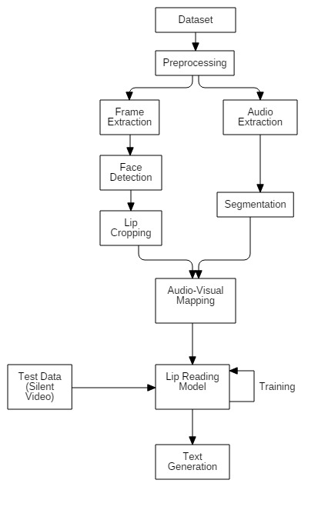

**Input:**

The input to the model is the video of lip movement of the user.

**Output:**

The output would be the recognised text corresponding to the lip movement of the user.