การบ้าน #3 Sub Query

SELECT student_id, students.name, SUM(price), COUNT(*)

FROM (

select * from enrolls

INNER JOIN courses ON enrolls.course_id = courses.id

) as new_table

INNER JOIN students ON students.id = new_table.student_id

GROUP BY new_table.student_id

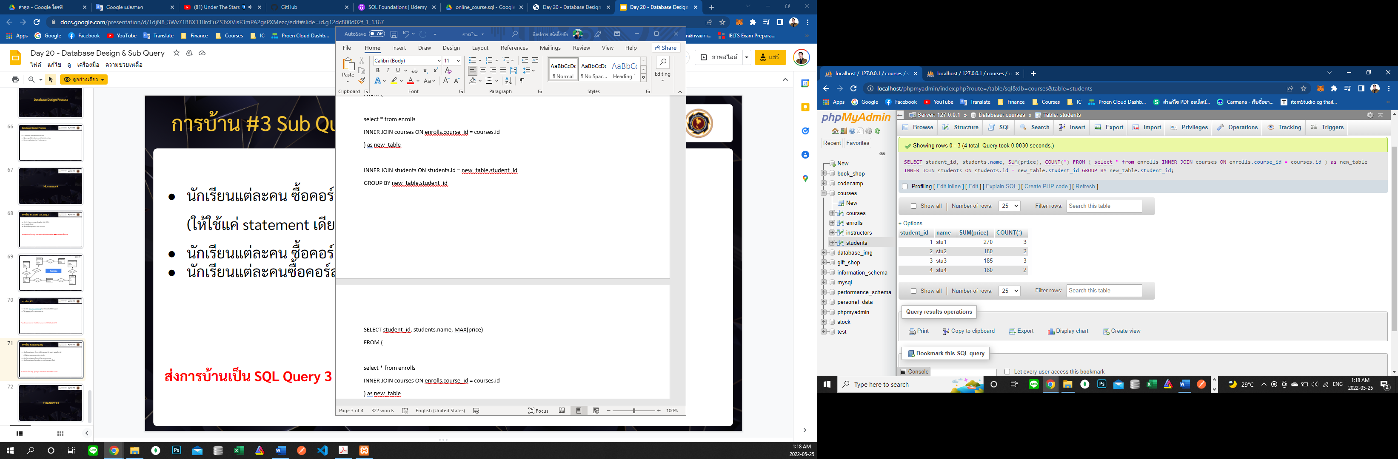

SELECT student_id, students.name, MAX(price)

FROM (

select * from enrolls

INNER JOIN courses ON enrolls.course_id = courses.id

) as new_table

INNER JOIN students ON students.id = new_table.student_id

GROUP BY new_table.student_id

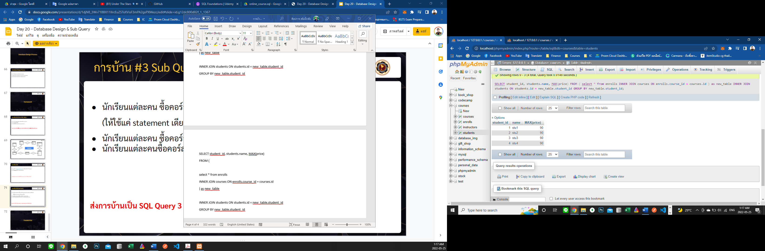

SELECT student_id, students.name, AVG(price)

FROM (

select * from enrolls

INNER JOIN courses ON enrolls.course_id = courses.id

) as new_table

INNER JOIN students ON students.id = new_table.student_id

GROUP BY new_table.student_id

