MATHEMATICAL ENGINEERING · MODELLING AND NUMERICAL SIMULATION
Computational haemodynamics of a stenosed artery
Mixed P2–P1 finite elements, IPCS projection scheme, Newtonian and Carreau–Yasuda blood
Silas HOUESSOU
September 2026

Abstract
This report builds, validates and interprets an incompressible blood-flow model in a two-dimensional stenosed arterial channel. The starting point is not a patient-specific geometry. It is an elementary exact solution — plane Poiseuille flow — used as a certificate for the solver. Once that certificate is obtained, the channel is deformed by a cosine constriction of amplitude 0%, 50% and 75%, and two constitutive laws are compared: a constant-viscosity Newtonian fluid, and a shear-thinning Carreau–Yasuda blood model.
Four findings structure the campaign. First, the finite-element solver recovers the analytic Poiseuille state to machine-relevant accuracy on pressure drop and peak velocity. Second, wall shear stress at the throat is not linear in stenosis severity: it follows, to within a few percent, the lubrication scaling with the inverse square of the residual half-height. Third, Carreau blood is not a shifted Newtonian fluid. It thickens the quiet channel and thins in the jet, two effects of opposite sign living in the same constitutive law. Fourth, nine mesh refinements show that the peaks reported on the 120×36 campaign grid are not discretisation artefacts.

1. Scientific context

1.1 Why wall shear stress
Wall shear stress (WSS) is the tangential traction exerted by blood on the endothelium. Since the work of Fry and of Ku and co-authors, abnormally low, oscillatory, or abruptly elevated WSS has been associated with the initiation and progression of atherosclerotic lesions [1, 2]. A stenosis is therefore not merely a hydraulic obstacle. It redistributes WSS: a peak at the throat, a depression on the shoulders, and sometimes a recirculating wake. The purpose of the computation is that map, not a coloured velocity field for its own sake.
In a design-engineering sense the question is quantitative. If the lumen height at the throat is halved, does the wall loading double, or does it do something much more violent? Lubrication theory already suggests the second answer. The numerical model is here to check whether that suggestion survives convection, a cosine (not slowly varying) wall, and a non-linear rheology.

1.2 An engineer’s modelling stance
A three-dimensional patient-specific lumen with a compliant wall and clinically calibrated blood is beyond the scope of this first study. The strategy adopted here is the opposite one: a domain simple enough that a reference solution exists, rich enough that a stenosis changes the flow qualitatively, and a code modular enough that geometry, rheology or mesh can be swapped without rewriting the variational forms. That is the method of a modelling engineer: isolate mechanisms, measure them, bound them.
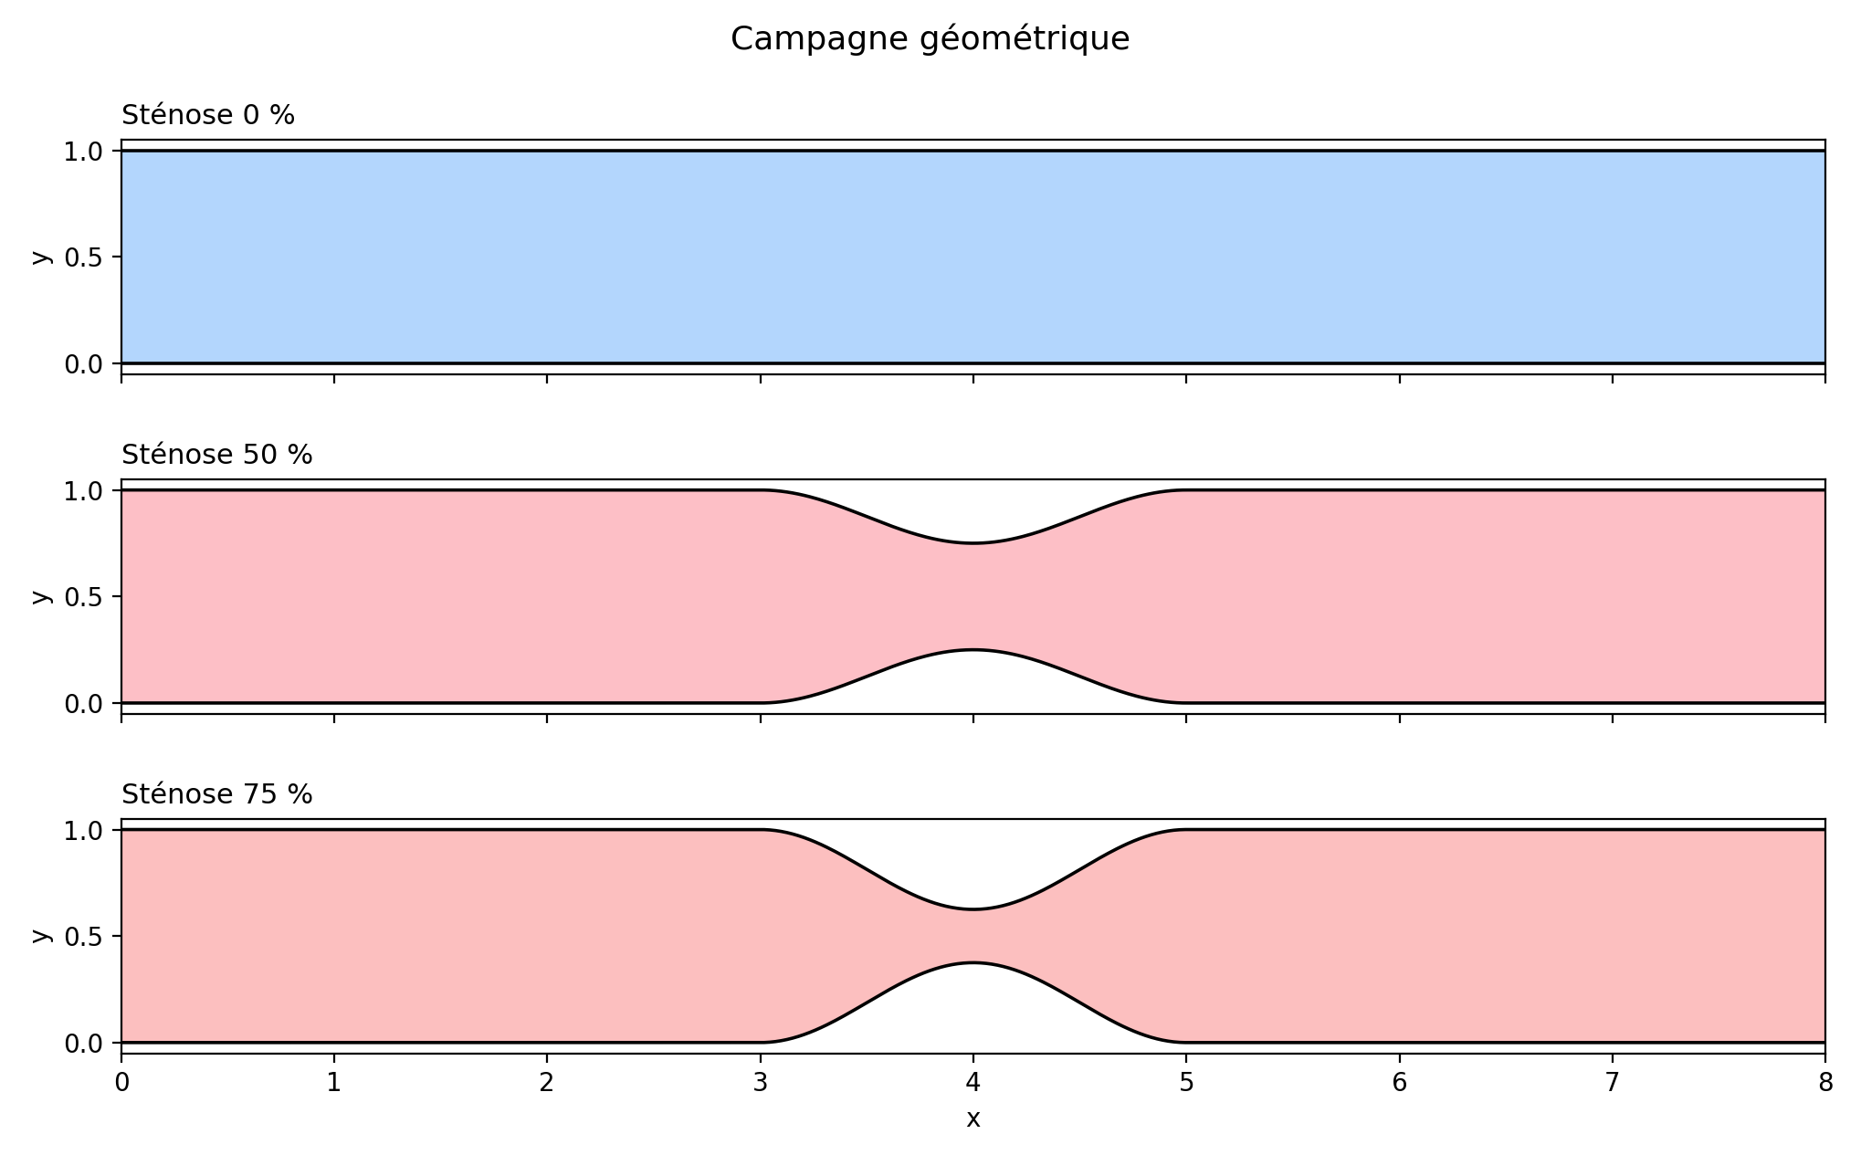
Figure 1. Geometry family. Only the cosine amplitude changes; every other modelling choice is frozen.

2. Mathematical model

2.1 Conservation laws
Let Ω ⊂ ℝ² be the lumen, of length L = 8 and height H = 1 in reduced units. Blood is treated as an incompressible fluid of constant density ρ. The velocity u and the pressure p satisfy the Navier–Stokes equations
$ρ \left(\frac{∂u}{∂t} + (u · ∇) u\right) = ∇ · σ(u, p)$ (2.1)
$∇ · u = 0$ (2.2)
Equation (2.2) is not a side constraint. It makes pressure a Lagrange multiplier for incompressibility, and it forbids a naive equal-order finite-element pair. The Cauchy stress of a generalised Newtonian fluid is
$σ(u, p) = 2μ ε(u) - p I, ε(u) = \frac{∇u + (∇u)ᵀ}{2}$ (2.3)
Throughout the dossier ρ = 1 and the inlet scale is Umax = 1. For Newtonian μ = 1 the reference Reynolds number Re = ρ Umax H / μ equals 1. This is a viscous laminar regime, consistent with a reduced arterial model, and — more importantly — compatible with an exact validation.

2.2 Boundary conditions
On the inlet Γin (x = 0) a plane Poiseuille profile is imposed. It is both a physiologically acceptable controlled-flow condition and the exact solution of the straight channel:
$u_{x}(0, y) = 4 U_max \frac{y (H - y)}{H^{2}}, u_{y} = 0$ (2.4)
On the walls Γw one imposes no-slip, u = 0. At the outlet Γout the pressure is set to zero. Discharge is therefore data; the pressure drop
$Δp = p_in - p_out$ (2.5)
is an unknown of the problem. That is the correct hydraulic observer: if the throat narrows, Δp must rise in order to push the same volume flux through a smaller section.

2.3 Two constitutive laws
The Newtonian model takes μ = 1 constant. Whole blood is shear-thinning: its apparent viscosity falls as the deformation rate rises, because red-cell aggregates break up. The Carreau–Yasuda law [3, 4] captures that transition with a bounded plateau at low shear and a power-law branch at high shear,
$μ(γ̇) = μ∞ + (μ0 - μ∞){[1 + (λ γ̇)^a]}^{(n-1)/a}$ (2.6)
$γ̇ = √(2 ε(u) : ε(u))$ (2.7)
The parameters used here are in model units and deliberately contrasted so that the mechanism is readable, not fitted to a clinical haematocrit: μ0 = 2, μ∞ = 0.5, λ = 1, n = 0.4, a = 2. Viscosity is evaluated at the previous velocity uⁿ, explicitly, so that the IPCS split remains a sequence of linear problems. The expected physics, which the computation must confirm, is local. At the throat γ̇ is large and μ approaches μ∞. In the quiet parts of the channel γ̇ is small and μ climbs back toward μ0.
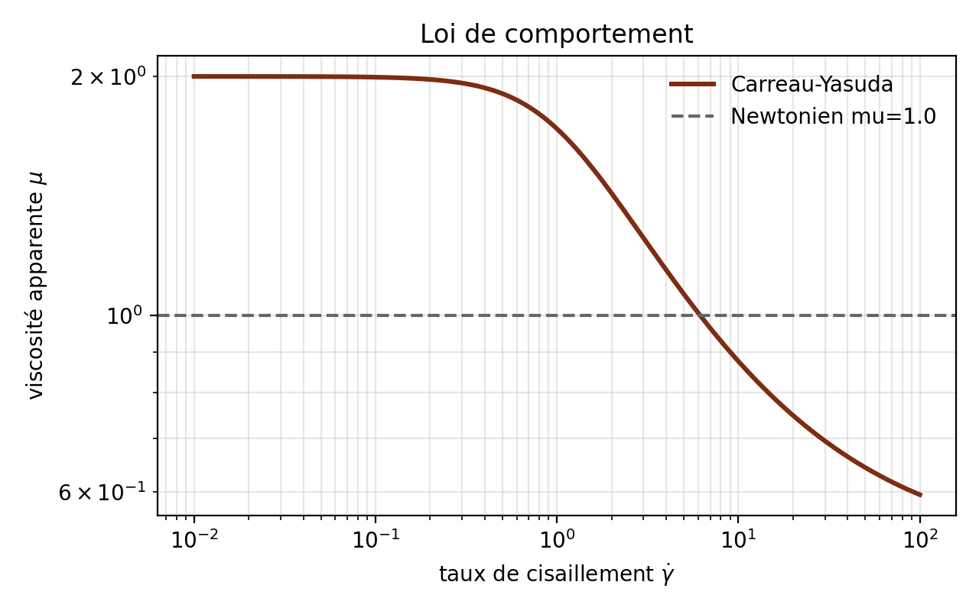
Figure 2. Law (2.6) as implemented in the code, compared with the Newtonian line μ = 1.

3. Finite-element discretisation

3.1 Weak form and the Taylor–Hood pair
Multiplying (2.1)–(2.2) by test functions (v, q), integrating by parts and inserting the Dirichlet data yields a mixed velocity–pressure weak form. One seeks uh in a discrete space Vh ⊂ [H¹(Ω)]² and ph in Qh ⊂ L²(Ω). The pair chosen is Taylor–Hood [5]: vector Lagrange elements of order 2 for velocity, scalar Lagrange elements of order 1 for pressure, on the same triangular mesh. That pair satisfies the Babuška–Brezzi inf-sup condition. A plain P1–P1 equal-order pair does not, unless extra stabilisation is added [6]. The implementation is a genuine finite-element method: Sobolev spaces, UFL variational forms, assembly and JIT compilation through DOLFINx / FFCx [7].
This point is worth stressing for a jury in mathematical engineering. Incremental Pressure Correction is a time-splitting device. It is not a replacement for finite elements. Space is still discretised by a mixed Galerkin method; time is what IPCS decouples.

3.2 The IPCS scheme
A monolithic saddle-point solve at every step is expensive. The system is split by an Incremental Pressure Correction Scheme, in the line of the projection methods of Chorin and Temam [8, 9] and of Goda’s incremental variant [10]. One time step consists of (i) a tentative velocity with explicit convection and the previous pressure, (ii) a pressure Poisson problem that restores (2.2), and (iii) a projection of the velocity. The scheme is first-order in time. Here Δt = 0.02 and T = 8, hence 400 steps. On every case reported below the flow is already steady near t ≈ 4, so the last time slice is a stationary haemodynamic state, not a transient snapshot.

3.3 Geometry and mesh
The rectangle [0, L] × [0, H] is triangulated in a structured way and then morphed: the y-coordinate is rescaled to the local cosine half-height of the stenosis, centred at x = L/2, of length 2. No external mesh generator is called. The campaign grid uses 120 × 36 subdivisions, that is 8,640 triangles and 4,477 geometry vertices. Elements compress in the throat. That compression is visible, and it is intended: that is where ∇u is largest.
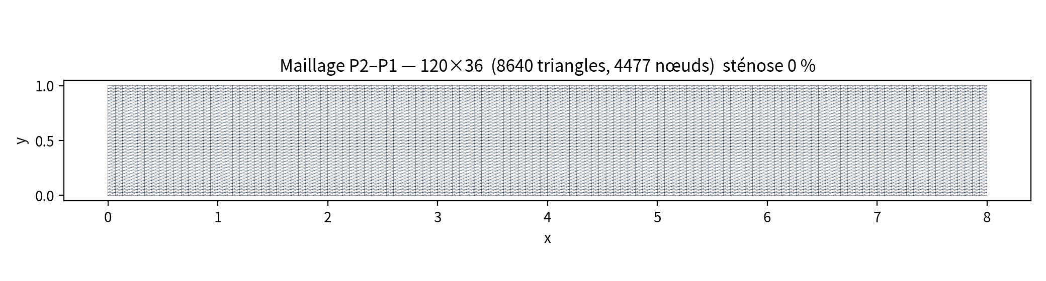
Figure 3. Mesh at 0% stenosis — a straight channel.
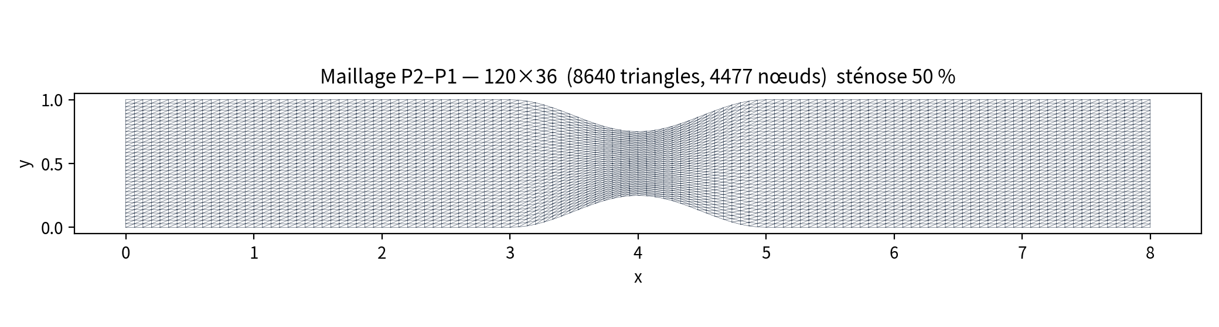
Figure 4. Mesh at 50% stenosis — elements gather in the throat.
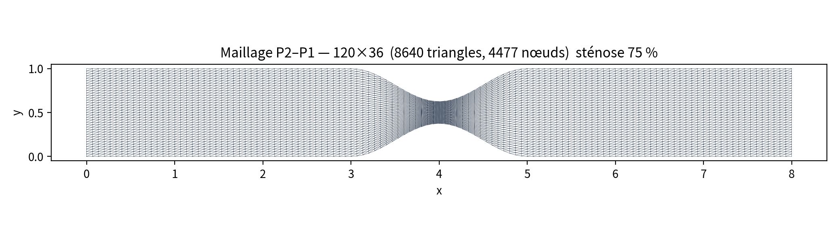
Figure 5. Mesh at 75% stenosis — same topology, tighter throat.

4. Finding 1 — the straight channel certifies the code
When the stenosis amplitude is zero, (2.1)–(2.4) admit the exact steady Poiseuille state
$u_{x} = 4 y (1 - y), u_{y} = 0, \frac{dp}{dx} = -8$ (4.1)
hence Δp = 8L = 64 and an analytic wall shear τw = 4. If the solver cannot reproduce these three numbers, nothing computed on a stenosed geometry can be trusted. The 120×36 Newtonian run returns Umax = 1.0005, Δp = 64.01 and a post-processed WSS of 3.922. Discharge and pressure drop match to the thousandth. The WSS gap is not a defeat of the P2 space. Wall traction is estimated by a first-order one-sided difference
$τ_{w} ≈ μ \frac{|u(x + δ n)|}{δ}, δ = 0.02 H$ (4.2)
On three successive meshes that estimator stays locked between 3.92 and 3.93. The bias belongs to (4.2), not to a lack of convergence of uh. Distinguishing a post-processing model error from a finite-element error is one of the sentences this dossier is willing to defend.
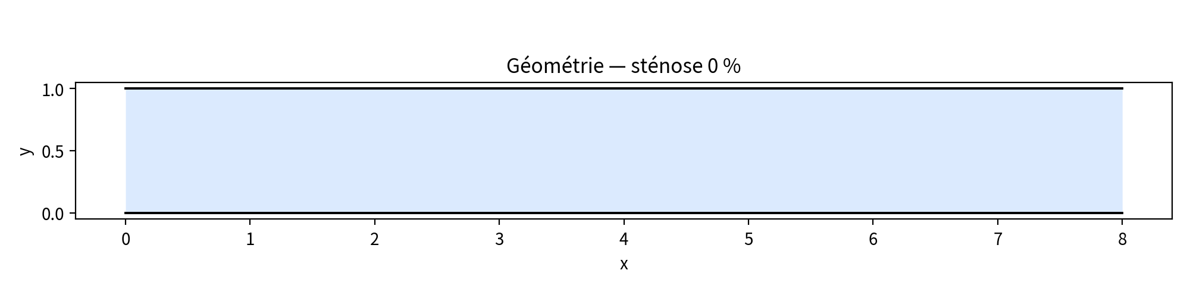
Figure 6. Geometry at 0%.
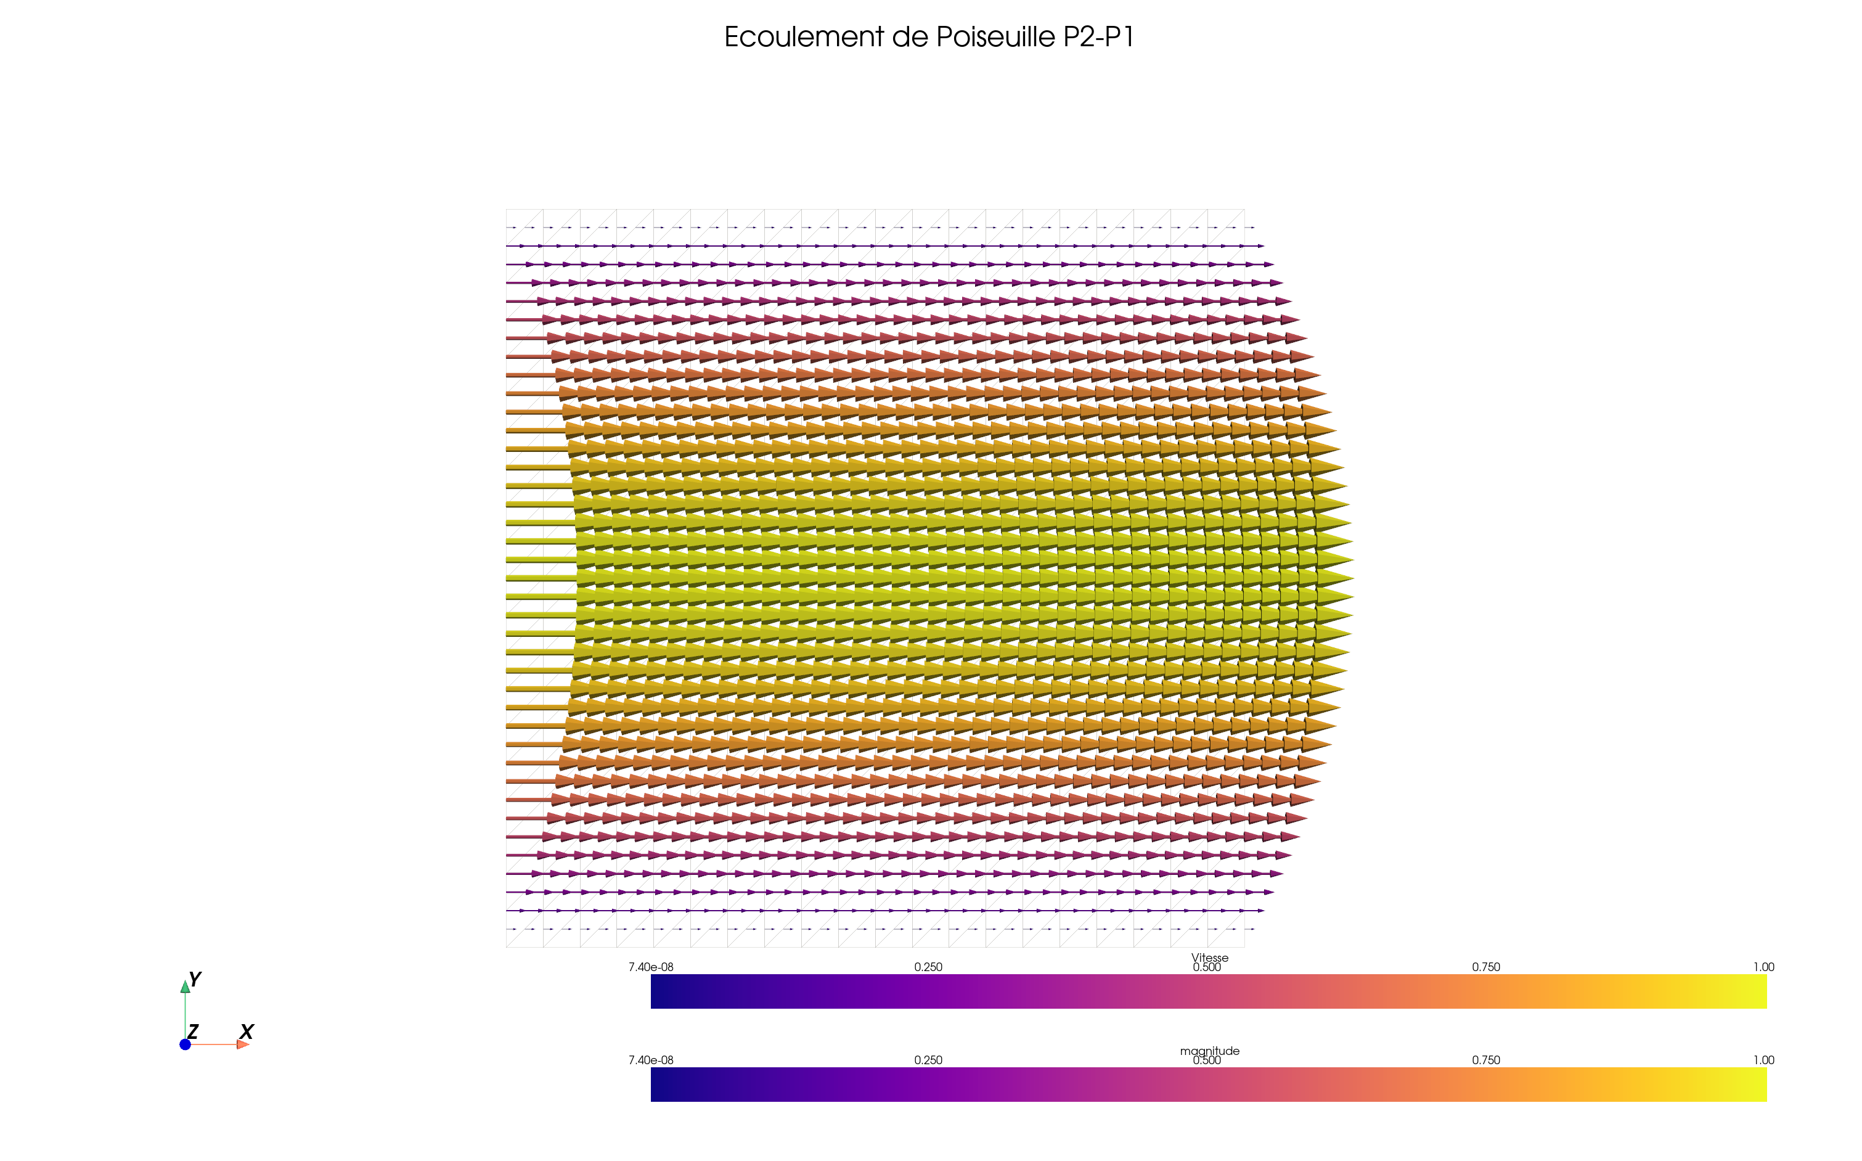
Figure 7. P2–P1 glyphs on the straight channel: a parabola, |u|max = 1.
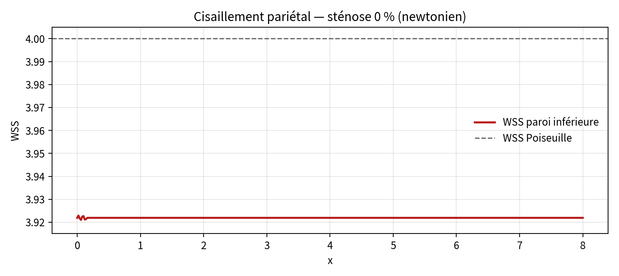
Figure 8. Newtonian WSS at 0%. The vertical axis is deliberately tight around 3.92–4.00.
A second, quieter certificate sits in the same run: the velocity glyphs are parallel to the walls, vanish on them, and peak on the centreline. There is no numerical jet, no spurious cross-flow, no checkerboard in the pressure that would have survived into Δp. The code is allowed to leave the square cavity of the original tutorial.

5. Finding 2 — throat WSS follows 1/h²

5.1 What lubrication already says
In a slowly varying channel of local half-height h(x), a flux balance under a quasi-Poiseuille profile yields Umax(x) ∝ 1/h(x) and the wall scaling
$τ_{w}(x) ∼ μ \frac{U H}{h^{2}(x)}$ (5.1)
With H = 1, μ = 1, U = 1 one obtains, at 50% stenosis, hcol = 0.25 and τw ∼ 16; at 75%, hcol = 0.125 and τw ∼ 64. The law is not linear in the clinical percentage. Dividing the height by four multiplies the shear by sixteen. The numerical question is whether a fully non-linear finite-element solution, with convection and a cosine wall that is not slowly varying in the strict lubrication sense, still recovers that order of magnitude.

5.2 The 50% case
The Newtonian 120×36 run gives Umax = 1.9475 against a lubrication value of 2, Δp = 105.56, and a peak WSS of 16.99 against 16. Agreement is at the level of a few percent. The two troughs near x = 3 and x = 5 are not noise. They sit on the shoulders, where the fluid first accelerates and then decelerates, and where the wall normal is no longer vertical. A model that produced a single isolated spike with no shoulders would be missing that geometry.
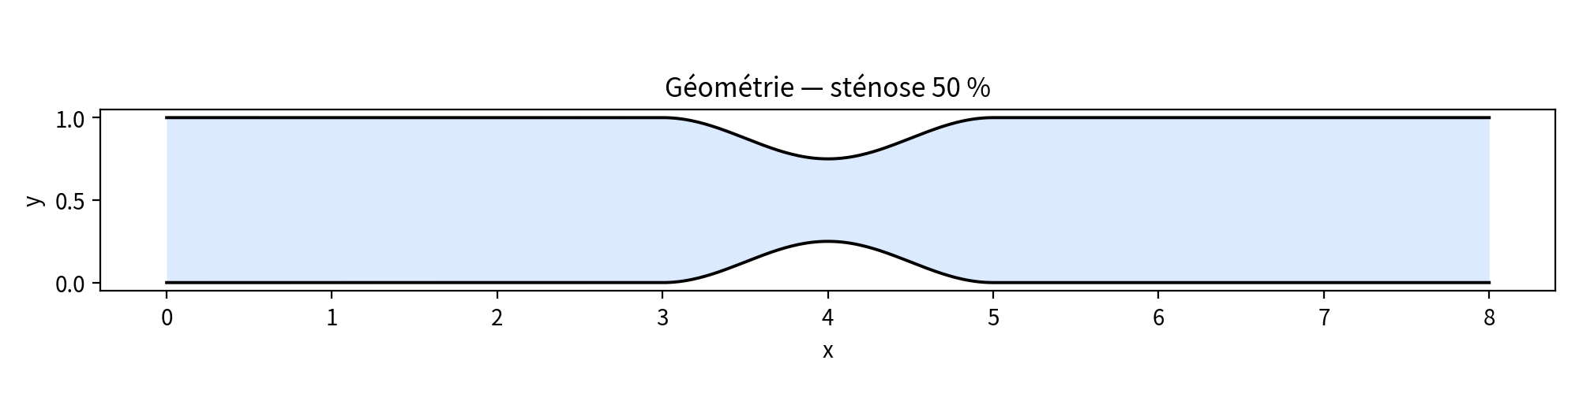
Figure 9. Geometry at 50%.
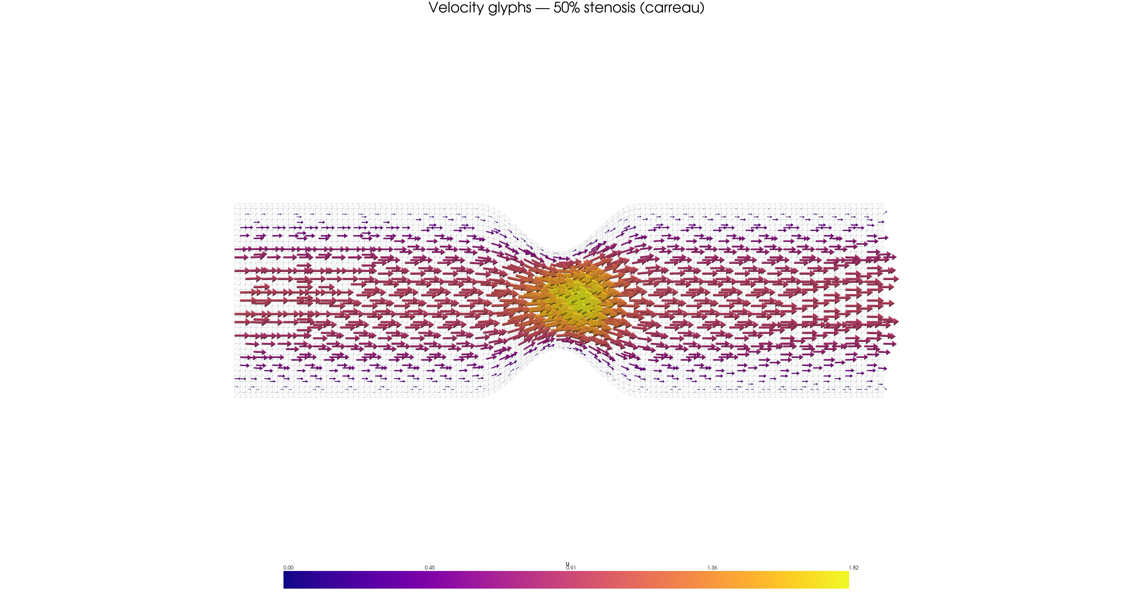
Figure 10. Jet at the 50% throat. The figure is a Carreau run (|u|max ≈ 1.82); the Newtonian pattern is the same at |u|max ≈ 1.95.
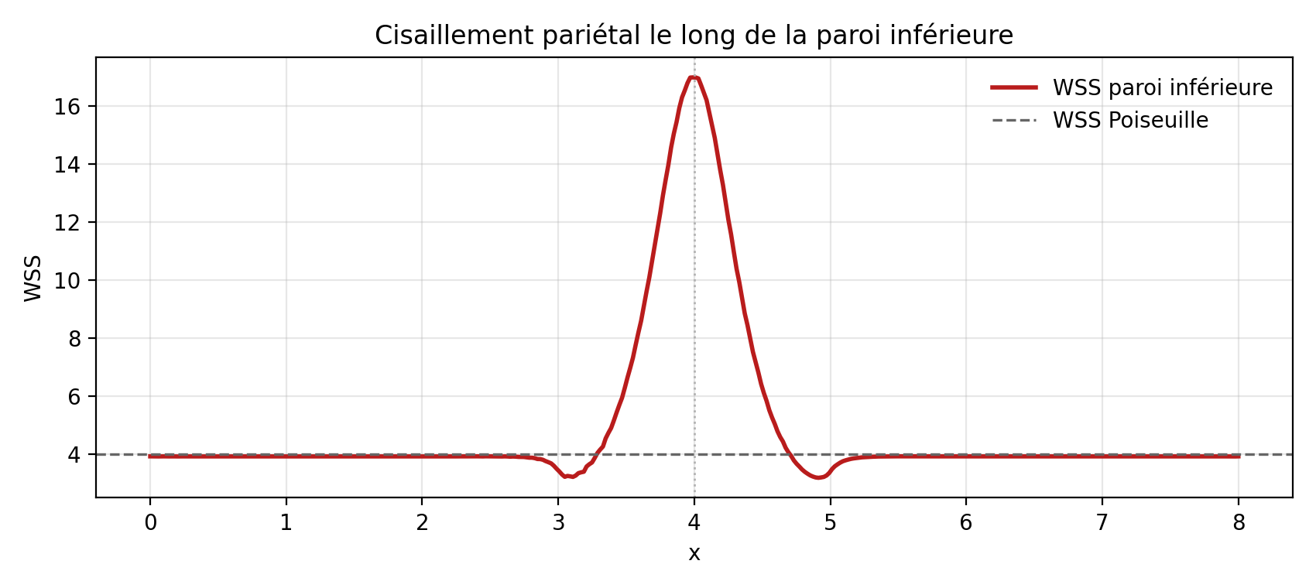
Figure 11. Newtonian WSS at 50%. Peak ≈ 17, plateau = 4.

5.3 The 75% case
The Newtonian 120×36 run gives Umax = 3.905 against 4, Δp = 305.84, and a peak WSS of 63.31 against 64. Agreement on the peak is even tighter than at 50%. Pressure drop, however, is no longer a small correction: it is almost five times the straight-channel value. The 75% throat is a genuine hydraulic strait. Looking at the glyphs, the jet is thinner, faster, and more localised. Looking at the WSS curve, the shoulders are deeper. Severity does not merely scale a bump; it changes the shape of the loading.
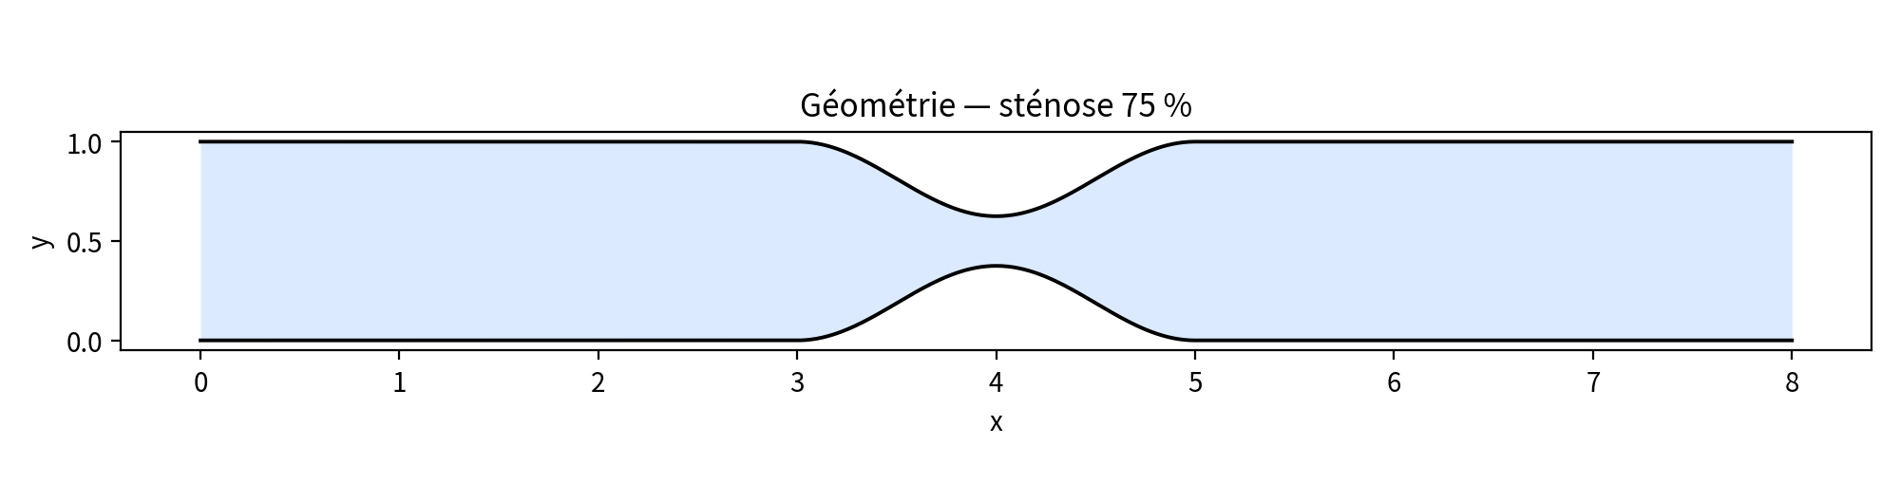
Figure 12. Geometry at 75%.
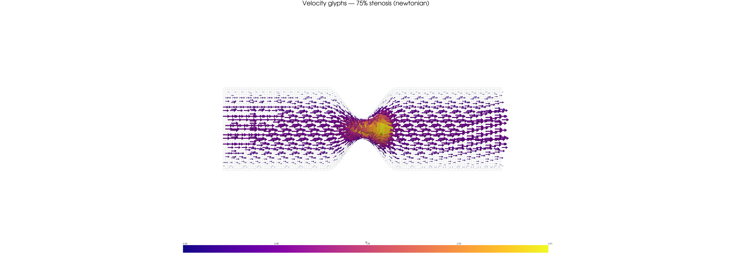
Figure 13. Newtonian glyphs at 75%, |u|max ≈ 3.91.
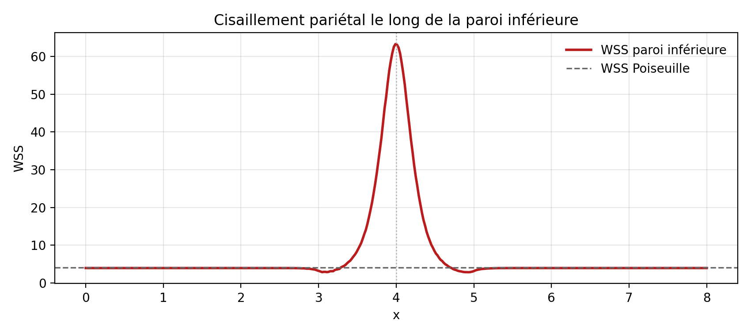
Figure 14. Newtonian WSS at 75%. Peak ≈ 63.

5.4 Reading the three severities together
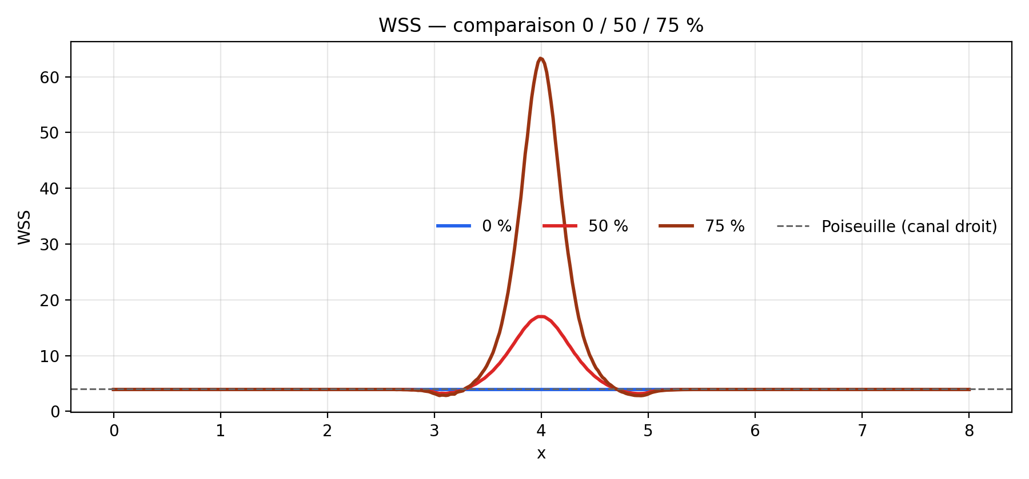
Figure 15. Superimposed Newtonian WSS at 0 / 50 / 75%. Away from the throat every curve returns to Poiseuille.
Table 1. Newtonian campaign on the 120×36 mesh.
Stenosis | Umax | Δp | WSS max | Umax (5.1) | WSS (5.1)
0% | 1.0005 | 64.01 | 3.92 | 1 | 4
50% | 1.9475 | 105.56 | 16.99 | 2 | 16
75% | 3.9054 | 305.84 | 63.31 | 4 | 64

The finding, in one sentence: the non-linear code recovers law (5.1) at the throat and recovers Poiseuille away from it. A stenosis behaves as a choke point, not as a decorative notch in the wall.

6. Finding 3 — Carreau is not a shifted Newtonian fluid
If Carreau blood were only a larger μ, every WSS curve would rise. That is not what the runs do. At 0%, Δp climbs from 64 to 80 and the plateau WSS from 4 to 5.5: quiet blood feels μ0 = 2. At 75%, Δp falls from 306 to 252 and the peak WSS from 63 to 42: in the throat, μ has dropped toward μ∞ = 0.5. Both effects coexist in one fluid, on one time step. That is precisely the content of (2.6), and it is the reason a constant-viscosity model is not a conservative envelope of the non-Newtonian one. It overestimates the dangerous peak and underestimates the dissipation of the healthy channel.
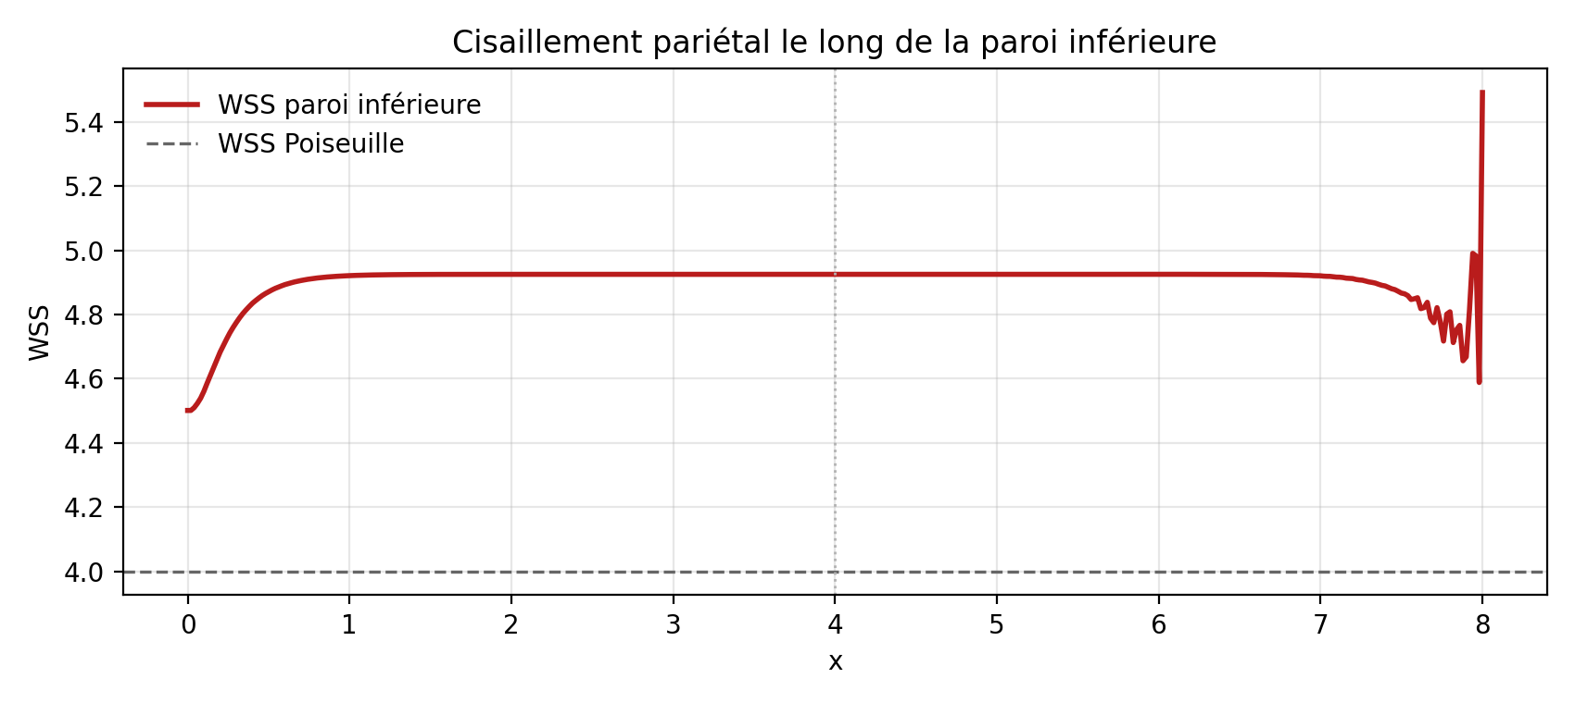
Figure 16. Carreau WSS at 0%. Raised plateau. The wiggles at x = 8 are an outlet artefact and are not interpreted.
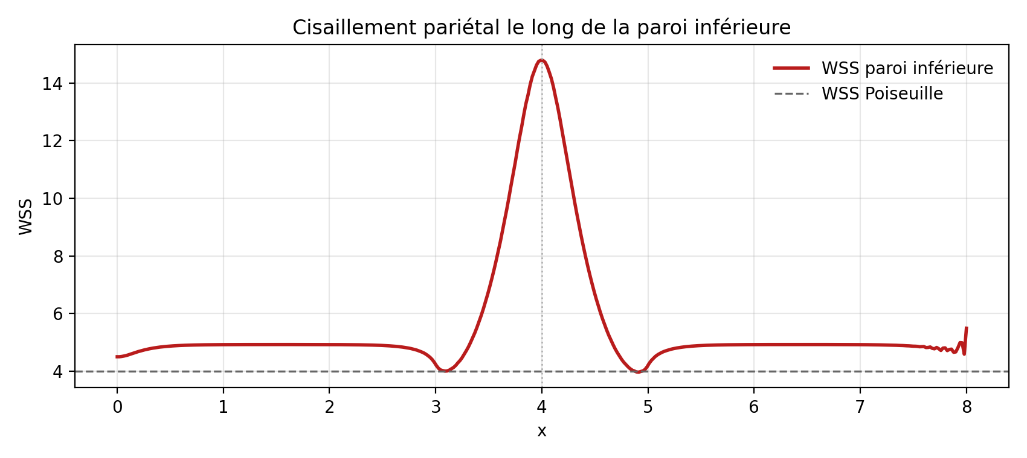
Figure 17. Carreau WSS at 50%. Peak lowered to about 15.
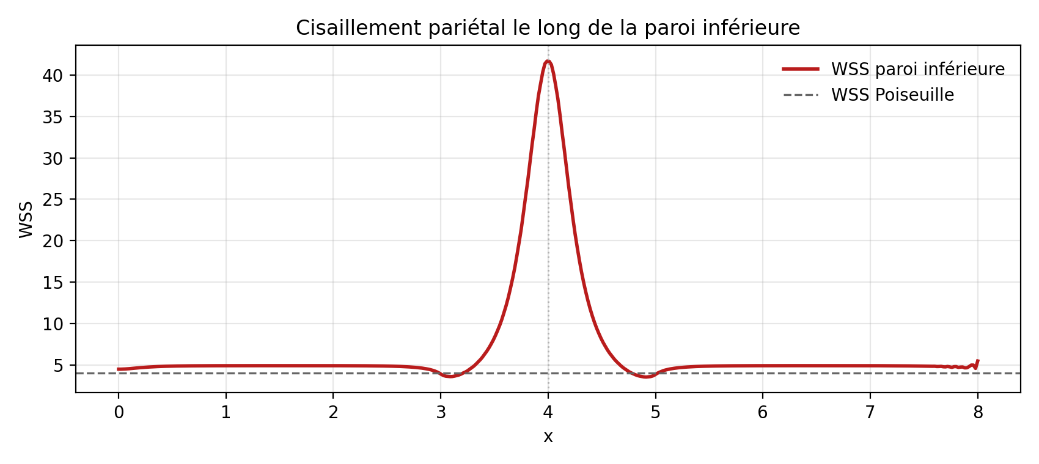
Figure 18. Carreau WSS at 75%. Peak about 42 against 63.
Table 2. Carreau campaign, same 120×36 mesh.
Stenosis | Umax | Δp | WSS max
0% | 1.000 | 79.91 | 5.49
50% | 1.819 | 116.23 | 14.79
75% | 3.731 | 252.02 | 41.68

Table 3. Carreau-to-Newtonian ratio.
Stenosis | Umax | Δp | WSS max
0% | ×1.00 | ×1.25 | ×1.40
50% | ×0.93 | ×1.10 | ×0.87
75% | ×0.96 | ×0.82 | ×0.66

The ratio WSS(75%)/WSS(0%) is about 16 for Newtonian blood and 7.6 for Carreau blood. Geometric non-linearity survives; rheology damps it. Gijsen and co-authors already insisted that non-Newtonian properties change large-artery flow [14]. The present campaign makes that statement local and numerical: the correction is small on velocity, moderate on Δp, and large on the quantity that loads the wall.

7. Finding 4 — the campaign mesh is enough
A WSS spike on an under-resolved throat is not a scientific finding; it is an artefact. The Newtonian problem is therefore recomputed on three grids — 60×18, 120×36, 180×54 — for each of the three severities. The size indicator is h = L/nx. Nine runs share the same Δt and the same final time.
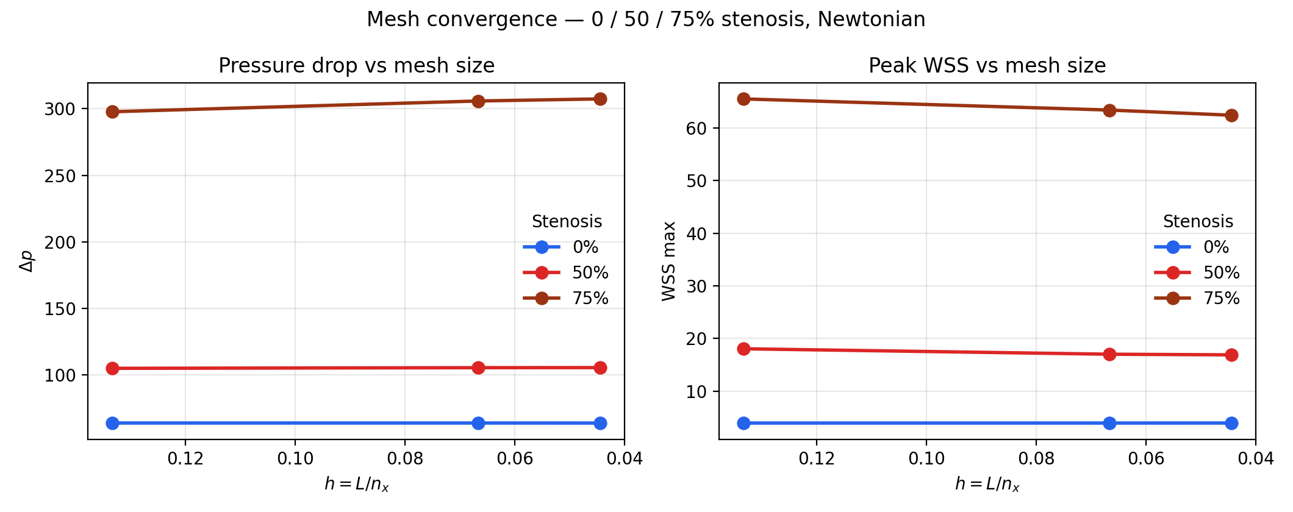
Figure 19. Mesh convergence of Δp and of peak WSS. Mesh size h decreases to the right.
Table 4. Full convergence set.
Stenosis | nx×ny | h | Umax | Δp | WSS max
0% | 60×18 | 0.1333 | 1.0001 | 63.9985 | 3.9235
0% | 120×36 | 0.0667 | 1.0001 | 63.9920 | 3.9238
0% | 180×54 | 0.0444 | 1.0001 | 63.9669 | 3.9276
50% | 60×18 | 0.1333 | 1.9387 | 105.0560 | 18.0348
50% | 120×36 | 0.0667 | 1.9486 | 105.5376 | 16.9992
50% | 180×54 | 0.0444 | 1.9501 | 105.6039 | 16.8792
75% | 60×18 | 0.1333 | 3.8404 | 297.7329 | 65.5110
75% | 120×36 | 0.0667 | 3.9086 | 305.8037 | 63.3933
75% | 180×54 | 0.0444 | 3.9197 | 307.3616 | 62.4105

At 0% nothing moves: P2 captures Poiseuille already on the coarsest grid. At 50%, Δp changes by +0.5% from coarsest to finest, and WSS settles between 120 and 180 (−0.6%). At 75%, the hardest case, Δp still gains +3.2% from 60×18 to 180×54 but only +0.5% from 120 to 180. Peak WSS falls 65.5 → 63.4 → 62.4, toward the lubrication value 64. The design rule is then simple. The campaign mesh 120×36 already carries the engineering quantities. The 75% case would be the first candidate for 180×54 if a peak to the percent were required.
One must not misread the left panel of Figure 19. Because Δp for the three severities shares a common axis, the 0% and 50% curves look perfectly flat. They are flat on the scale that matters. Zooming the axis, as was done in an earlier single-case plot, turns a half-percent drift into an apparent slope. That is a figure-design remark, not a change of conclusion.

8. Limitations
The model is two-dimensional. The wall is rigid. IPCS is first-order in time. Estimator (4.2) is first-order in space. The Carreau parameters are not an SI fit to a given haematocrit. The regime is established rather than pulsatile, so there is no Womersley number and no oscillatory shear index. Wiggles of WSS next to x = L on some Carreau plots are outlet artefacts born from p = 0 together with (4.2); they are reported and then ignored. Stating these limits does not weaken the four findings. It draws their domain of validity.

9. Outlook
The natural next steps, in that order, are: a WSS reconstruction from the P2 gradient of uh, more honest than (4.2); a pulsatile inlet and a Womersley number [11]; an SI calibration of (2.6); a bifurcation. Three-dimensional patient-specific geometries and fluid–structure interaction [12, 13] are another project, not the immediate continuation of this one.

10. Conclusion
A mixed P2–P1 finite-element solver with an IPCS split recovers plane Poiseuille flow. On a cosine stenosis it also recovers the lubrication law (5.1) at the throat and the Poiseuille plateau away from it. Carreau blood is not a shifted Newtonian fluid: it thickens the quiet lumen and thins in the strait. Nine refinements show that those peaks survive the mesh size. The dossier is no longer a unit-square tutorial. It is a short, reproducible, and discussable numerical campaign.

References
[1] Fry D.L., Acute vascular endothelial changes associated with increased blood velocity gradients, Circulation Research, 22, 165–197, 1968.
[2] Ku D.N., Giddens D.P., Zarins C.K., Glagov S., Pulsatile flow and atherosclerosis in the human carotid bifurcation, Arteriosclerosis, 5, 293–302, 1985.
[3] Carreau P.J., Rheological equations from molecular network theories, Transactions of the Society of Rheology, 16, 99–127, 1972.
[4] Yasuda K., Armstrong R.C., Cohen R.E., Shear flow properties of concentrated solutions of linear and star branched polystyrenes, Rheologica Acta, 20, 163–178, 1981.
[5] Taylor C., Hood P., A numerical solution of the Navier–Stokes equations using the finite element technique, Computers & Fluids, 1, 73–100, 1973.
[6] Brezzi F., Fortin M., Mixed and Hybrid Finite Element Methods, Springer, 1991.
[7] Baratta I.A. et al., DOLFINx: the next generation FEniCS problem solving environment, preprint, 2023.
[8] Chorin A.J., Numerical solution of the Navier–Stokes equations, Mathematics of Computation, 22, 745–762, 1968.
[9] Temam R., Sur l'approximation de la solution des équations de Navier–Stokes par la méthode des pas fractionnaires, Archive for Rational Mechanics and Analysis, 32, 135–153, 1969.
[10] Goda K., A multistep technique with implicit difference schemes for calculating two- or three-dimensional cavity flows, Journal of Computational Physics, 30, 76–95, 1979.
[11] Womersley J.R., Method for the calculation of velocity, rate of flow and viscous drag in arteries, Journal of Physiology, 127, 553–563, 1955.
[12] Quarteroni A., Veneziani A., Vergara C., Geometric multiscale modeling of the cardiovascular system: from blood circulation to biochemical transport, reviews in computational haemodynamics, 2000s–2016.
[13] Formaggia L., Quarteroni A., Veneziani A. (eds.), Cardiovascular Mathematics, Springer MS&A, 2009.
[14] Gijsen F.J.H., van de Vosse F.N., Janssen J.D., The influence of the non-Newtonian properties of blood on the flow in large arteries, Journal of Biomechanics, 32, 601–608, 1999.
[15] Donea J., Huerta A., Finite Element Methods for Flow Problems, Wiley, 2003.

