Where to put the Windmills?

Conscientious placement planning of future offshore wind farms in Danish waters

_________

Silas Christian Wilhelm-Leth

Cultural Data Science, Spatial Analytics

Aarhus University, June 2025

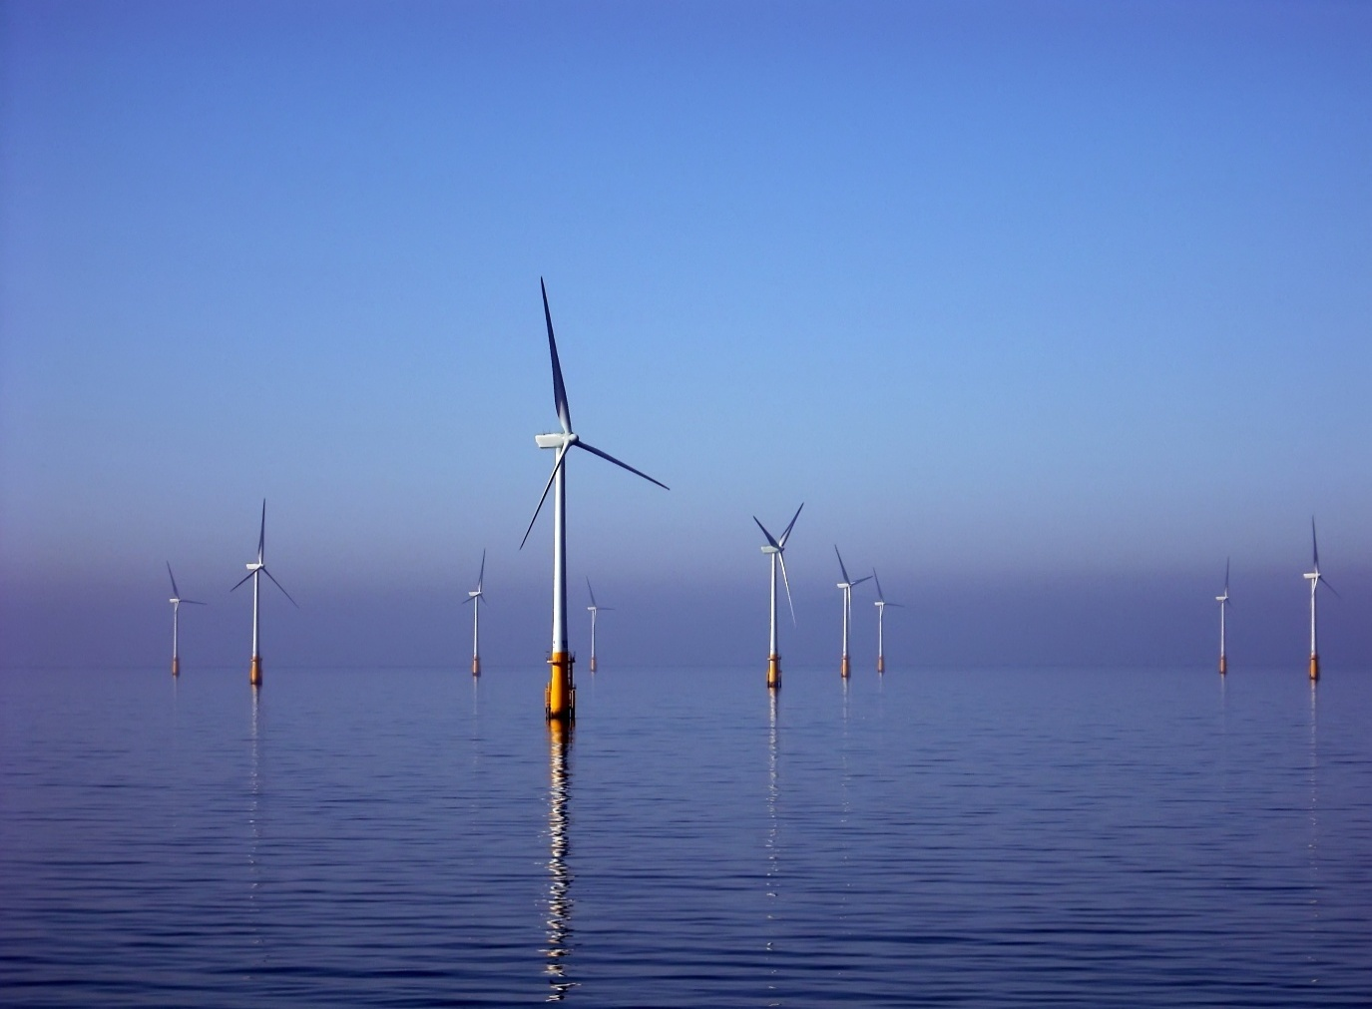

Fig. 1: Photo by Andy Dingley, Wikimedia Commons[1]

Number of characters, excluding list of contents and bibliography: 12657 (= 5,3 pages).

Contents

Introduction 3

Depth 3

Protected areas 4

Shipping lanes 5

Wind conditions 5

Wake effect 5

Wind power 6

Results 7

Critical evaluation on data & methodology 8

Interpretation 8

Conclusions 9

Bibliography 10

References 10

Data 10

Metadata 11

# Introduction

RQ: Ensuring a largely non-harmful, smooth and economically effective implementation of the green transition is of high importance, and wind energy will prove a crucial part. How then can geographic data be combined in a process of elimination, in order to quickly, effectively and in an internationally reproducible way, identify the best areas for new offshore wind turbines?

The Danish government agency »Energistyrelsen« is, as of writing, conducting a screening process in collaboration with academia and interest groups. The screening, lasting from Q2 2023 to Q2 2025, will reevaluate areas of interest for construction of new offshore wind farms, by compiling existing data from a broad range of fields, and collecting new data to fill important gaps in current knowledge. The screening covers the factors: birds, marine mammals, fish, bats, ocean floor conditions, wind, hydrodynamics, distance to coast, geology and ocean depth and take competing area interests into consideration.[2]

My project will consist of a proof-of-concept of a process of elimination, narrowing down a »suitable zone« by ruling out non-suitable (or less suitable) areas, combining and cross-referencing data in various fields. Results will certainly have some value, but as I’m only using currently and publicly available data, its most important result will be to serve as proof-of-concept of what the screening commission could do, with higher accuracy. I’ll be looking at the following factors: Depth, Natura2000, shipping lanes, wake effect and wind power. With each step, I’ll be closing in on the most suitable, or rather, the least harmful areas for construction of future offshore wind farms.

In the following, I’ll go over each step, briefly explaining the thoughts and work behind each narrowing-down of the zone. Note that I will not be following the order of the script. I’ll visually present the results before reflecting on problems with data and methods used and finally interpret and analyze what the results do tell us.

# Depth

A 2009 assessment deemed depths greater than 50 meters as »not suitable for wind energy development«.[3] Still in 2022, DTU wind energy researcher, Professor Henrik Bredmose expressed »Right now, for example, we don’t expect that it will ever pay off to use bottom-fixed offshore wind turbines at depths over 60 meters«.[4] In fig. 2. I’ve plotted data from the 2009 report, showing a fairly significant impact of depth on installation and foundation costs.

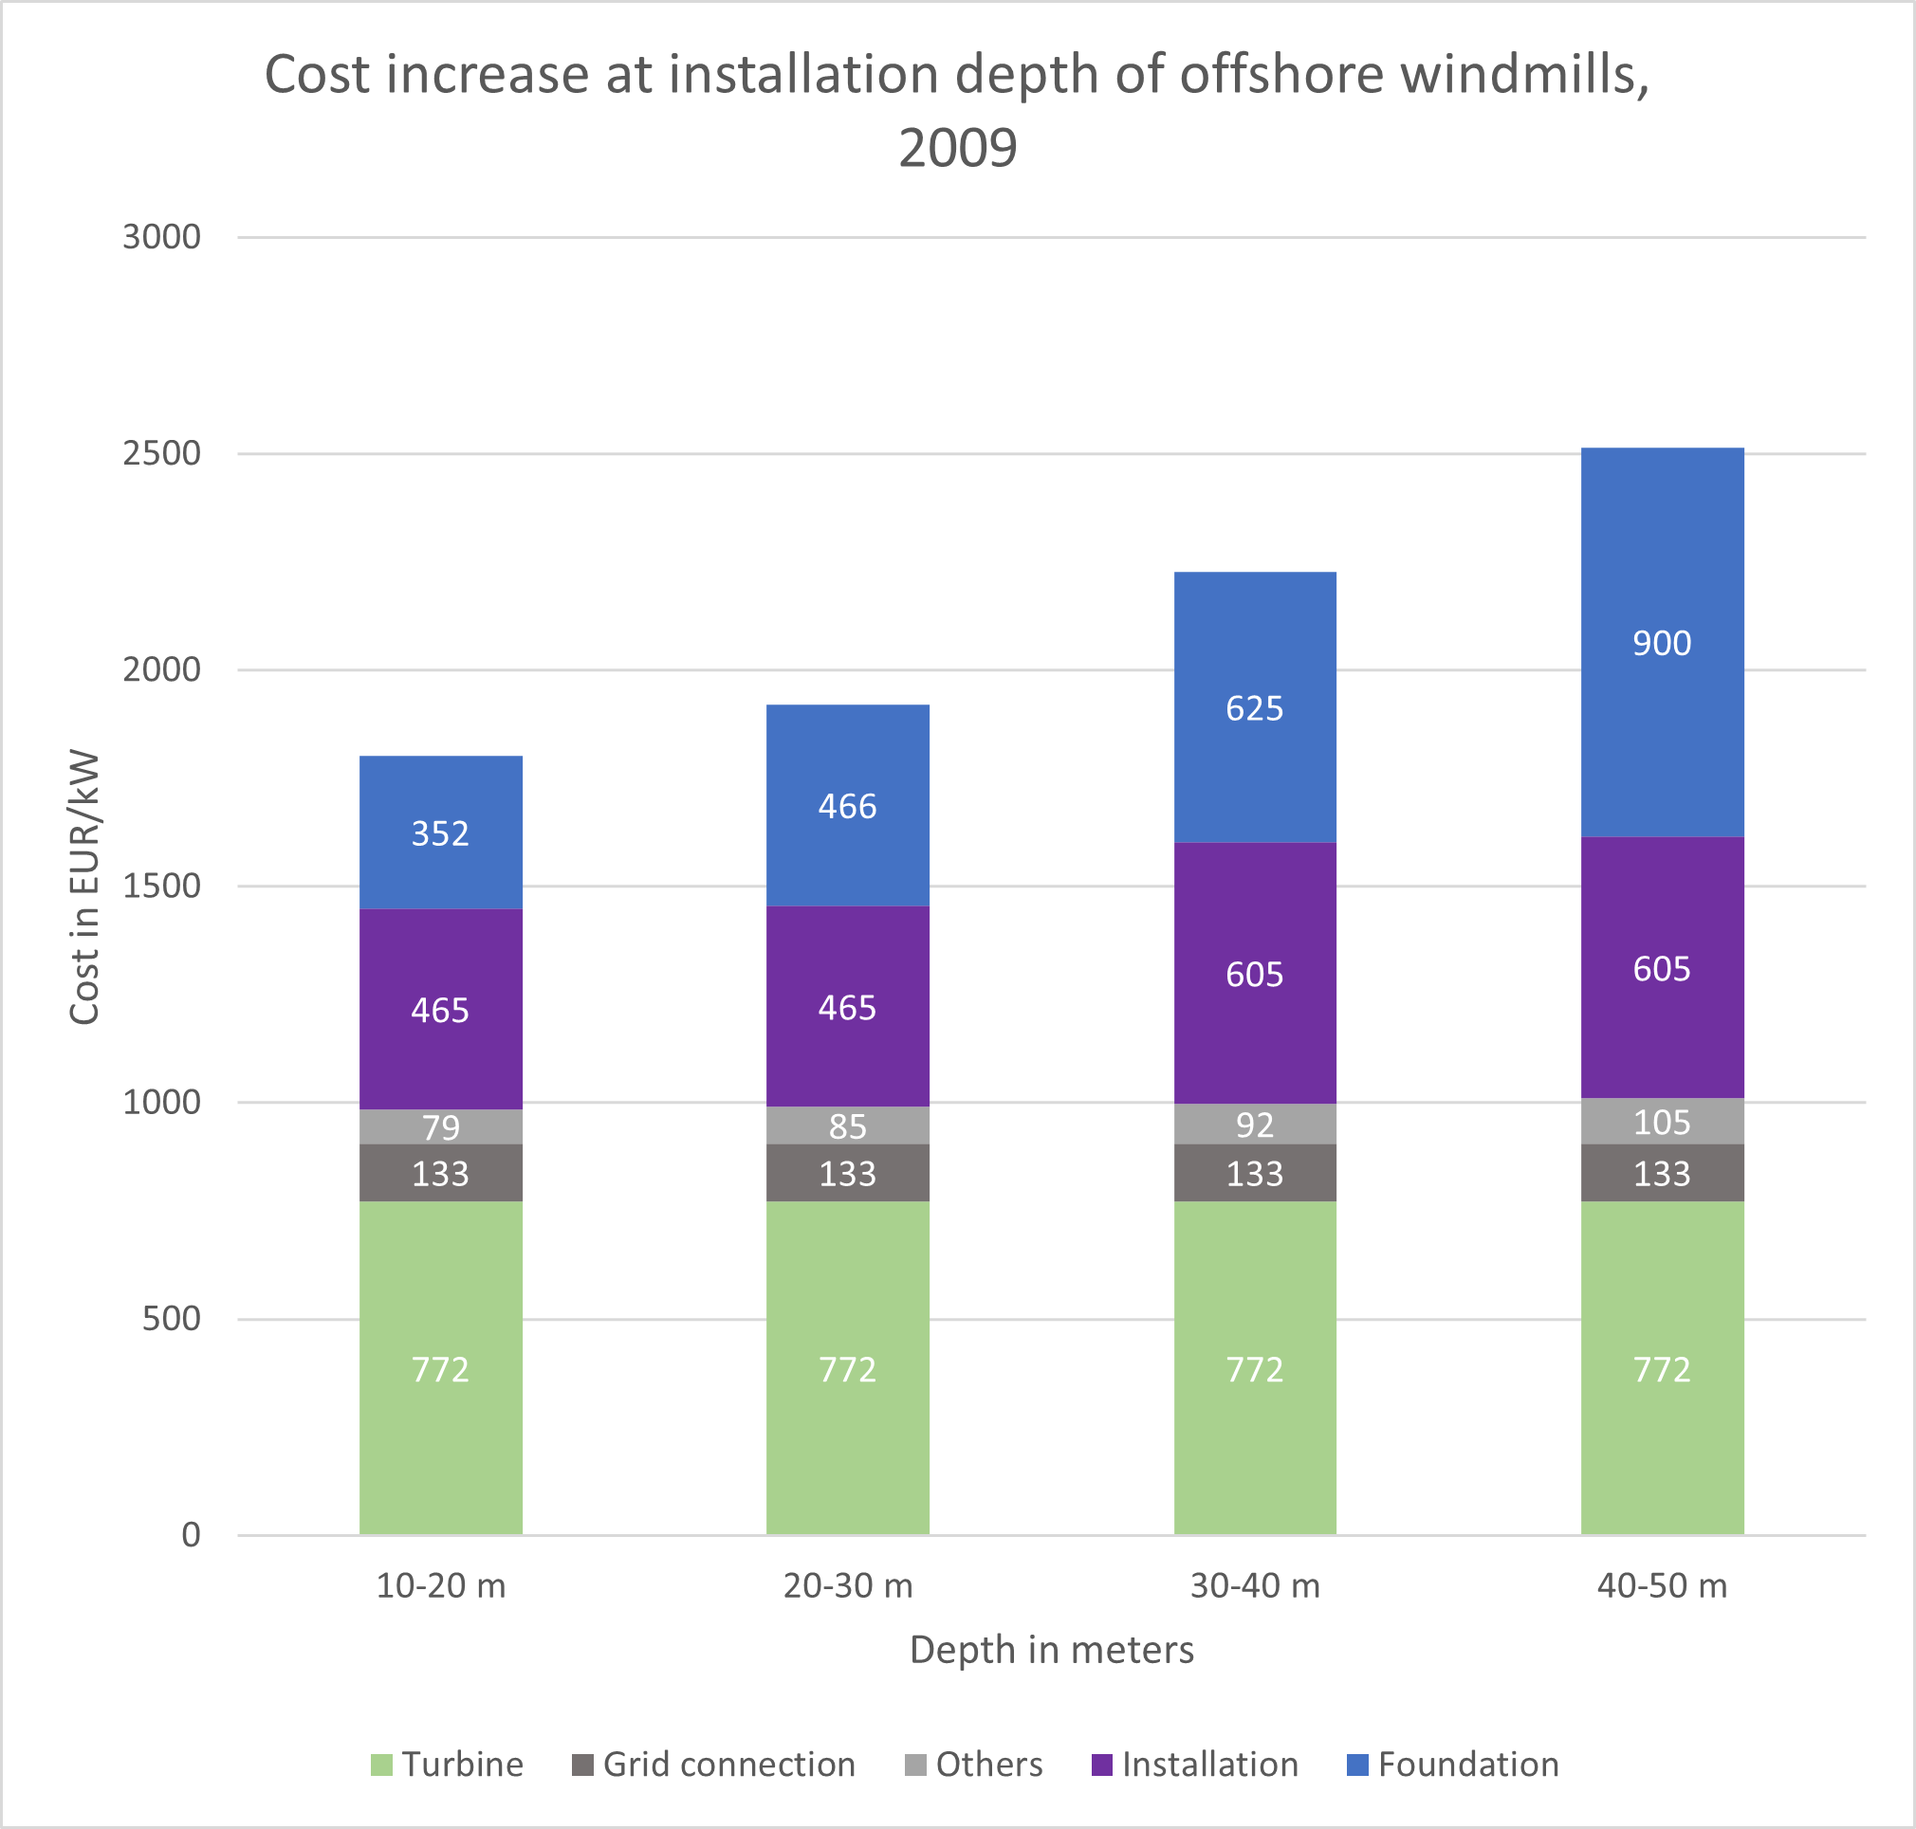

Fig. 2: Cost increase at installation depth of offshore windmills, as of 2009. Plot by author, data from EEA.[5]

Construction technology might have improved since 2009, but I could find no more recent data. Therefore, I will be sticking to the 10–50-meter range and mapping four depth zones in different colors, enabling the downsides of higher cost to be visually weighed against upsides in the same areas, namely wind conditions and distance to shipping.

**Code:** I plotted a bathymetry raster of Danish waters,[6] defined depth classes by values as above (the bathymetry already being in meters) and ignoring areas deeper or shallower.

# Protected areas

The Energistyrelsen screening listed nature preservation among its factors taken into consideration. This is one of the areas in which they will not only compile existing data but also gather new information. This project does not have the same time and resources, but by ruling out the highly protected Natura 2000 areas, we *can* conduct the first and likely largest filtering-out of areas, which a process like this should entail.

**Code:** I used a shapefile of Natura 2000 zones[7] to mask these areas out of my depth-based suitability zone (depths between 10 and 50 meters).

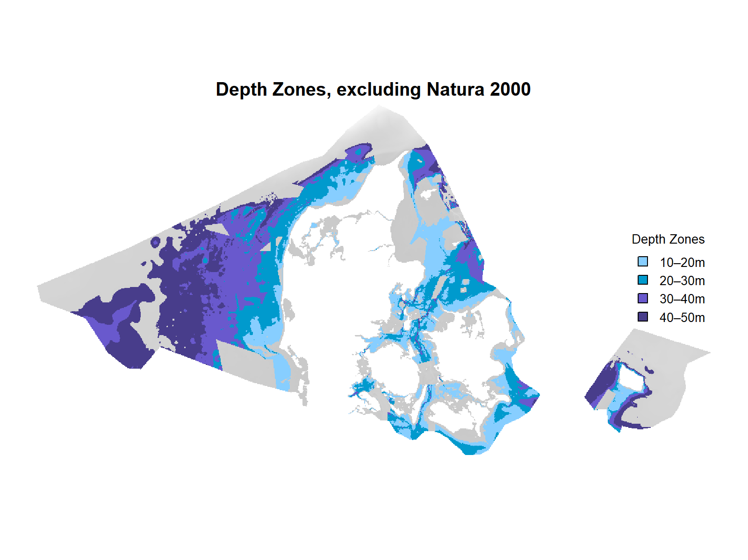

Fig. 3: Preliminary results, showing depth zones and excluding Natura 2000 areas as well as depths below 10 and above 50 meters.

# Shipping lanes

Shipping lane width is not standardized and can be hard to determine. One suggestion, looking at fairly busy traffic of multiple large cargo ships in the same lane, suggests an overall width of 5,7 nautical miles (= 9,26 km), consisting of the lane itself (1,7nm, 3200m), holding up to 4 ships side-by-side, and a 2nm (3700m) buffer zone on each side in order to not crash if control is lost.[8] This is just one interpretation, and conditions likely vary widely. In inner Danish waters for instance, such wide lanes are often impossible.

**Code:** I used QGIS to trace a 2021 map of shipping traffic,[9] creating a shapefile with the most important routes present as thin straight lines. I then created a buffer of 4600 meters around the lines and masked out these now 5,7 nautical mile wide lanes, from the depth zones map.

# Wind conditions

## Wake effect

The wake effect is a term describing the increased turbulence and reduced speed created after wind has passed through the blades of a wind turbine. The wake effect has to be taken into account, as it can reduce energy production as well as the lifespan of turbines placed too close to others. This problem is already present within turbines in the same wind farm, although some precautions such as placement in relation to common wind directions are taken (others, such as height variation, might be implemented more frequently in future projects). When more wind farms are established, however, the consequences would become both larger and less predictable, with wind farms essentially sabotaging each other, if placed too close.[10] A 2022 simulation-based study predicted that despite wakes persisting for tens of kilometers, 95% of the undisturbed wind speed will usually be recovered at around 5,5 km downstream.[11]

**Code:** I created 5,5 km buffers around every offshore turbine, isolated from point data of all windmills in Denmark.[12] This has narrowed down our results by another chunk, and importantly, ruled out some suitable but already covered areas.

## Wind power

Kinetic energy potential of wind depends on speed and smoothness. Wind passing land will slow down and become turbulent for some distance, much like what happens with the wake effect, described above. As the largest open ocean is west of Denmark, and most common wind direction is the same – the ocean west of Jutland will not only yield more power, but turbines here will be exposed to less turbulence, ensuring they will last longer.

**Code:** Mapping wind power raster data[13] onto my remaining depth zone area was fairly straight-forward and gave me the final results: Two suitability maps, one for depths and one for wind power, both with depth, natura 2000 areas, wake effect and shipping lanes taken into account and masked out.

# Results

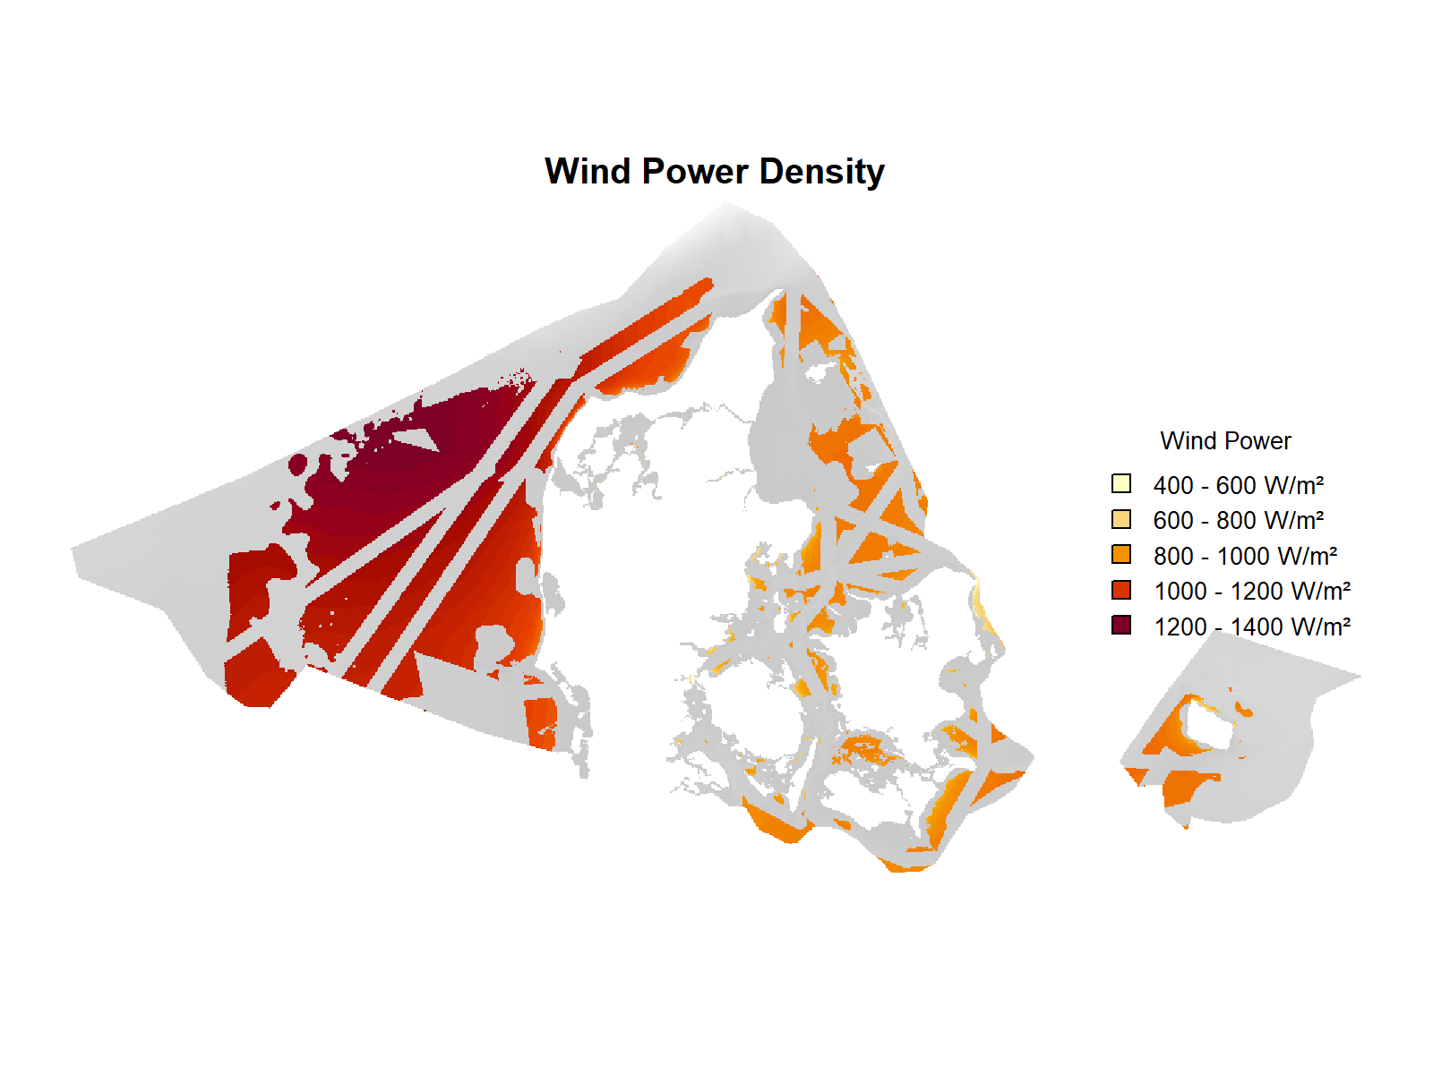Fig. 4. & 5. (below): Depth-based and wind-power-based suitability, mapped on the final mask.

# Critical evaluation on data & methodology

While much more detail would require non-publicly available data or even not yet existing, there are also a number of improvements which I could have made to my handling of the data.

I could have considered military zones and visual noise. Ocean floor makeup, meanwhile, is one of the largely undocumented areas in which the screening commissions newly gathered data will prove crucial. It would have been possible for me to go more into detail with shipping lanes and nature preservation by deepening research. At the moment, shipping lanes might be a lot harsher than they need to be, especially in the inner waters, where lanes are currently fairly narrow, as the deeper undersea channels themselves are quite narrow. More research on ship traffic density and frequency, as well as on whether some current routes can be redirected, could prove significantly more generous than my analysis. As to wind power, I am quite happy with the results, although there is a chunk of data missing in the very west of the map. With more time, I could also have done more research on, and possibly mapping of, the briefly mentioned factors of distance to shore and connection to existing power grids, as these will affect maintenance and cable laying costs.

# Interpretation

Both in theory and practice, as analysis showed, wind speeds and turbulence conditions are optimal west of the Jutland peninsula. Cross-referencing where lower (cheaper) depths match the higher speeds, the two strips highlighted on fig. 6. stand out. Distance from shore wouldn’t be cheap, but in no way impossible, even it’s furthest point would only be about the same distance from shore as Kriegers Flak in Eastern Denmark, while several wind farms off of Germany and the United Kingdom are several times further from shore.[14]

Fig. 6. (left): High wind-power zones below 30-meter depth to the west of Thy.

Fig. 7. (right): The extensive, medium wind power area immediately west of Jutland.

A large area further south (see fig. 7.) has weaker winds, but this downside might be outweighed by the possibility of connecting new turbines to existing grids of the wind farms Vesterhav Nord, Vesterhav Syd and Horns Rev 1-3, saving resources during installation. I have not looked into this, but if connection to the Nordlink or Skagerrak connections is possible, this could greatly reduce the length of cable needed, not least for the northwestern, higher wind-power areas.[15]

## Conclusions

The analysis has proved the utility of the process of elimination when identifying advantageous and non-harmful locations for wind turbine construction. The simple cross-referencing of a number of major factors should prove reproducible internationally, as long as similar data is at hand. It’s also been a proof of concept for the benefits of a multi-perspective screening, such as the one currently being conducted by Energistyrelsen. In this specific Danish case, I’ve been able to point out a few areas, most importantly the areas west of Thy, where new turbines would see very effective use with no major detriments to surrounding nature or infrastructure.

# Bibliography

## References

**Dong, Guodan & Zhaobin LI, Jianhua Qin, Xiaolei Yang**: »How far the wake of a wind farm can persist for?«, in *Theoretical and Applied Mechanics Letters*, 12 (2022), 2021. (<https://www.sciencedirect.com/science/article/pii/S2095034921001215>)

**Energistyrelsen**: »Screening af havvindpotentialet i Danmark. Overordnet opgavebeskrivelse (forkortet)«, 13. september 2023.

**European Environment Agency**: »Europe’s onshore and offshore wind energy potential. An assessment of environmental and economic constraints«, (»EEA Technical report No 6/2009«), Copenhagen, 2009.

**Patraiko, David & Paul Holthus**: »The Shipping Industry and Marine Spatial Planning. A professional approach«, 2013.

**Sharaf, Selma**: »Offshore Wind Wake Effects Are Real: We Should Plan for Them«, synapse-energy.com, 2023. (<https://www.synapse-energy.com/offshore-wind-wake-effects-are-real-we-should-plan-them> – retrieved, 2. June 2025).

**U.S. Department of Energy**: »How a Wind Turbine Works – Text Version«, (<https://www.energy.gov/eere/wind/how-wind-turbine-works-text-version> - retrieved, May 2025).

**U.S. Department of Energy**: »Wind Turbines: the Bigger, the Better«, (<https://www.energy.gov/eere/articles/wind-turbines-bigger-better> - retrieved, May 2025).

**Westerlund, Malin**: »Offshore wind turbines at a depth of 800 meters are not a utopia«, in: *Ingeniøren*, 2022. (<https://ing.dk/artikel/offshore-wind-turbines-depth-800-meters-are-not-utopia> − retrieved, 2. June 2025).

## Data

(D1) **Danmarks Dybdemodel**, CC BY Klimadatastyrelsen, dataforsyningen.dk, (<https://dataforsyningen.dk/data/4817> − retrieved, May 2025). (download GEOTIFF)

(D2) **Natura 2000 planer 2022-2027**, Miljøstyrelsen (license not declared, most likely CCO[16]), mst.dk, (<https://mst.dk/erhverv/tilskud-miljoeviden-og-data/data-og-databaser/miljoegis-data-om-natur-og-miljoe-paa-webkort/hent-data-udstillet-paa-miljoegis> − retrieved, May 2025). (download np3_2022 in ESRI format – shp)

(D3) **Vindkraftanlæg**, CC BY Klimadatastyrelsen, dataforsyningen.dk, (<https://dataforsyningen.dk/data/3814> − retrieved, May 2025).

(D4) **Det Marine Danmarkskort**, CC BY Geodatastyrelsen, geodatastyrelsen.maps.arcgis.com, (<https://geodatastyrelsen.maps.arcgis.com/apps/mapviewer/index.html?webmap=e5495e2f2f674b528c5e74feb3635410> – retrieved, May 2025).

(D5) **Global Wind Atlas**, »Mean Power Density« (Denmark), CC BY Global Wind Atlas, globalwindatlas.info, (<https://globalwindatlas.info/en/area/Denmark> − retrieved, May 2025).

(D6) **Open Infrastructure Map**, CC BY-SA 2.0 OpenStreetMap, openinframap.org, (<https://openinframap.org/#7.43/55.9/7.909> − retrieved, May 2025).

# Metadata

***Table 1 – Software metadata***

|  |  |  |
| --- | --- | --- |
| **Nr** | **Software metadata description** |  |
| S1 | Current software version | R 4.3.1, RStudio 2024.09.1+394 |
| S2 | Permanent link to your code in your Github repository | My files exceeded the GitHub 1 GB limit. |
| S3 | Legal Software License | GNU General Public License |
| S4 | Computing platform / Operating System | Microsoft Windows 11 running on my Legion Pro 5 16IRX8 |
| S5 | Installation requirements & dependencies for software not used in class | No special software used. |
| S6 | If available Link to software documentation for special software | See above. |
| S6 | Support email for questions | See above. |

***Table 2 – Data metadata***

Data Licenses:

D1: CC BY 4.0

D2: Undeclared, likely CCO[17]

D3: CC BY 4.0

D4: CC BY 4.0

D5: CC BY 4.0

D6: CC BY-SA 2.0

|  |  |  |
| --- | --- | --- |
| **Nr** | **Metadata description** |  |
| D1 | DK_Dybdemodel_2024 | <https://dataforsyningen.dk/data/4817> - <https://dataforsyningen.dk/terms> |
| D2 | np3_2022_N2000plan3_endelig_shp | <https://mst.dk/erhverv/tilskud-miljoeviden-og-data/data-og-databaser/miljoegis-data-om-natur-og-miljoe-paa-webkort/hent-data-udstillet-paa-miljoegis> |
| D3 | ens_vindkraftanlaeg.gpkg | <https://dataforsyningen.dk/data/3814>  <https://dataforsyningen.dk/terms> |
| D4 | shipping_routes_3034.shp (traced on D4, not directly used) | <https://geodatastyrelsen.maps.arcgis.com/apps/mapviewer/index.html?webmap=e5495e2f2f674b528c5e74feb3635410>  <https://dataforsyningen.dk/terms> |
| D5 | DNK_power-density_100m.tif | <https://globalwindatlas.info/en/area/Denmark>  <https://globalwindatlas.info/en/about/TermsOfUse> |
| D6 | NA | <https://openinframap.org/#7.64/55.84/7.926>  <https://www.openstreetmap.org/copyright> |

1. By Barrow_Offshore_wind_turbines.jpg: Andy Dingleyderivative work: Papa Lima Whiskey 2 (talk) - This file was derived from: Barrow Offshore wind turbines.jpg:, CC BY-SA 3.0, <https://commons.wikimedia.org/w/index.php?curid=18361928>
2. Energistyrelsen: »Screening af havvindpotentialet i Danmark. Overordnet opgavebeskrivelse (forkortet)«, 13. september 2023.
3. European Environment Agency: »Europe’s onshore and offshore wind energy potential. An assessment of environmental and economic constraints« (»EEA Technical report No 6/2009«), Copenhagen, 2009. p. 24.
4. Westerlund, Malin: »Offshore wind turbines at a depth of 800 meters are not a utopia«, in: Ingeniøren, 2022. (<https://ing.dk/artikel/offshore-wind-turbines-depth-800-meters-are-not-utopia> − retrieved, 2. June 2025). Bredmose also predicts floating turbines (able to anchor at 100+ meters, depth in fact being an advantage for them) to become of crucial global importance, once they have undergone the same price reduction as the foundation mills have. However, as he does not see a likelihood of them ever being used in Danish waters, I will leave them out.
5. European Environment Agency, 2009, p. 39.
6. Danmarks Dybdemodel, CC BY Klimadatastyrelsen, dataforsyningen.dk, (<https://dataforsyningen.dk/data/4817> − retrieved, May 2025).
7. Natura 2000 planer 2022-2027, Miljøstyrelsen (license not declared), mst.dk, (<https://mst.dk/erhverv/tilskud-miljoeviden-og-data/data-og-databaser/miljoegis-data-om-natur-og-miljoe-paa-webkort/hent-data-udstillet-paa-miljoegis> − retrieved, May 2025). (download np3_2022 in ESRI format – shp).
8. Patraiko, David & Paul Holthus: »The Shipping Industry and Marine Spatial Planning. A professional approach«, 2013, p. 6.
9. (D4) Det Marine Danmarkskort, CC BY Geodatastyrelsen, geodatastyrelsen.maps.arcgis.com, (<https://geodatastyrelsen.maps.arcgis.com/apps/mapviewer/index.html?webmap=e5495e2f2f674b528c5e74feb3635410> – retrieved, May 2025). (layer: AIS Fragtskibe 2021)
10. Sharaf, Selma: »Offshore Wind Wake Effects Are Real: We Should Plan for Them«, synapse-energy.com, 2023. (<https://www.synapse-energy.com/offshore-wind-wake-effects-are-real-we-should-plan-them> – retrieved, 2. June 2025).
11. Dong, Guodan & Zhaobin LI, Jianhua Qin, Xiaolei Yang: »How far the wake of a wind farm can persist for?«, in Theoretical and Applied Mechanics Letters, 12 (2022), 2021. (<https://www.sciencedirect.com/science/article/pii/S2095034921001215>).
12. Vindkraftanlæg, CC BY Klimadatastyrelsen, dataforsyningen.dk, (<https://dataforsyningen.dk/data/3814> − retrieved, May 2025).
13. Global Wind Atlas, »Mean Power Density« (Denmark), CC BY Global Wind Atlas, globalwindatlas.info, (<https://globalwindatlas.info/en/area/Denmark> − retrieved, May 2025).
14. See: Open Infrastructure Map, CC BY-SA 2.0 OpenStreetMap, openinframap.org, (<https://openinframap.org/#7.43/55.9/7.909> − retrieved, May 2025).
15. See links and existing wind farms (where data is public) at: Open Infrastructure Map, CC BY-SA 2.0 OpenStreetMap, openinframap.org, (<https://openinframap.org/#7.43/55.9/7.909> − retrieved, May 2025).
16. Compare: <https://digst.dk/data/videreanvendelse-af-offentlige-data/licens-og-brugsvilkaar-for-offentlige-data/>
17. Compare: <https://digst.dk/data/videreanvendelse-af-offentlige-data/licens-og-brugsvilkaar-for-offentlige-data/>