Exercise sheet: Decision Tree Learning II Group 24
Christopher Schmidt
Gerd Mund
Maren Pielka

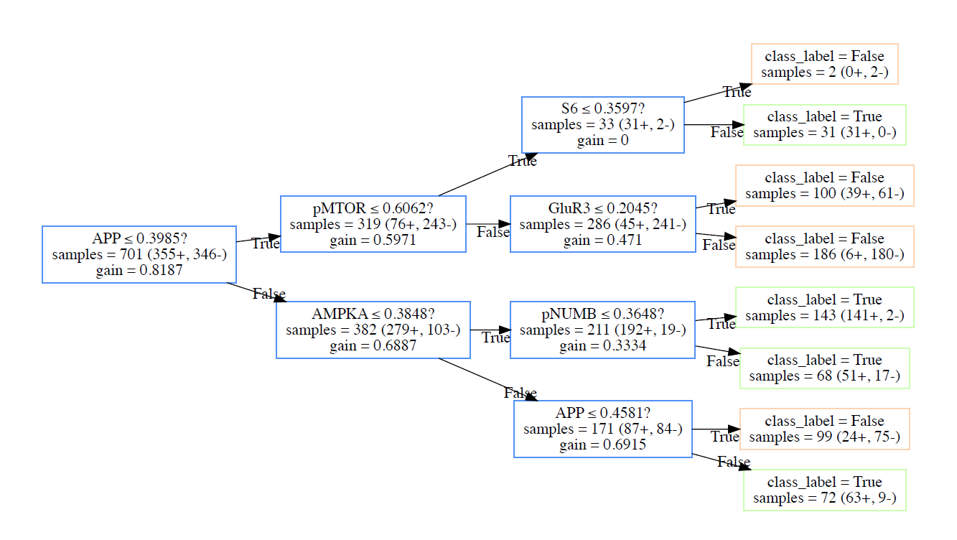
Exercise 4:

(ii)

(iii)

The accuracy on the test data of our learned Decision Tree above is 86.71 %

(iv)

In the table below you can see the genes of our Decision Tree and the corresponding number of returned scientific papers.

Gene | APP | pMTOR | AMPKA | S6 | GluR3 | pNUMB
Number | 23100 | 18 | 8 | 3600 | 70 | 4

The gene APP has with 23100 returned article the highest rate of all genes of our tree and of the full screening.

Are the expression levels of APP and AMPKA both high but nearly at the same level then the mouse is trisomeric.
Are the expression levels of APP and AMPKA both high but the level of APP is much higher as the level of AMPKA then the mouse is healthy.
Are the expression levels of APP low and the expression levels of pMTOR high then the mouse is healthy.
Are the expression levels of APP and pMTOR both low but the expression level of S6 is high then the mouse is trisomeric.
Are the expression levels of APP and pMTOR both low and the expression level of S6 is also low then the mouse is healthy.

With respect to the results of the table above our Decision Tree could be right. We need a high expression level at APP or S6 and these two genes have high response in the search on GoogleScholar.

