**Example input:**

5 3

X Y

0.029394902328, 0.951299438575

0.176318878234, 0.493630156084

0.235041868262, 0.438197791997

0.376508963445, 0.437693410334

0.948798695015, 0.352125307881

**Example output:**

0.381410589193

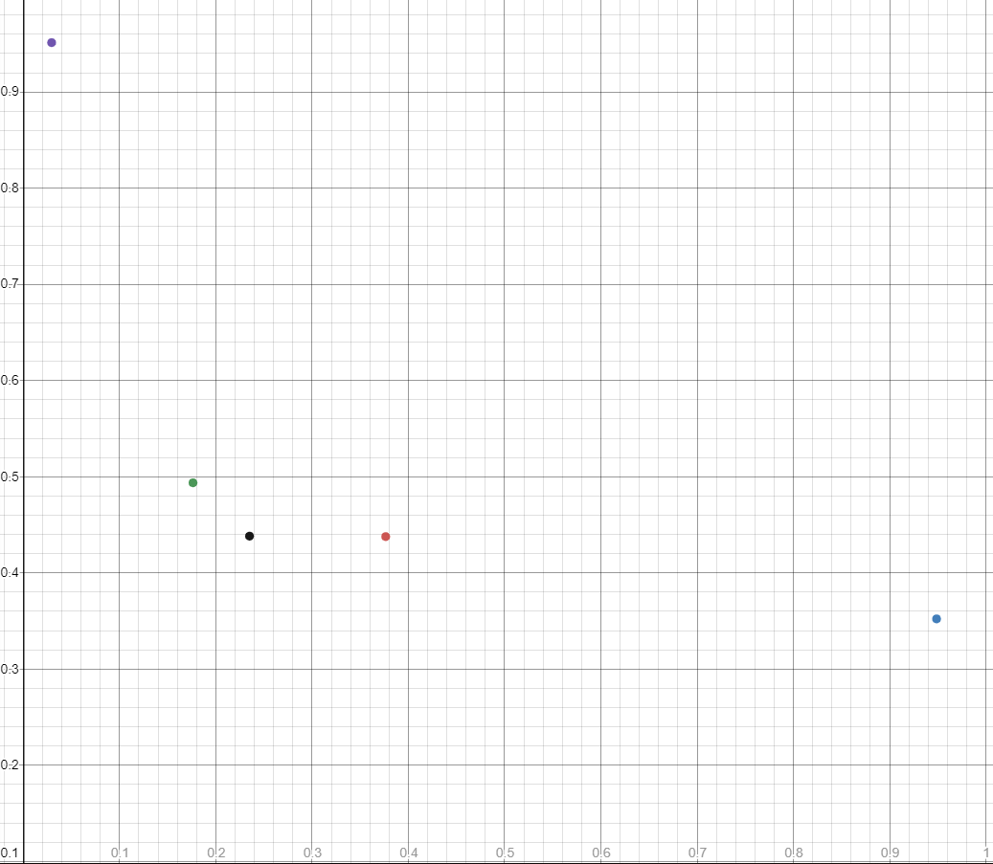

|  |  |  |  |  |  |  |
| --- | --- | --- | --- | --- | --- | --- |
|  | 0 | 1 | 2 | 3 | 4 | 5 |
| 0 | 0 | 0 | 0 | 0 | 0 | 0 |
| 1 | 0 | 0,0279633540815934 | 0,0870363153832052 | 0,1029904457213382‬ | 0,1647954922315614‬ | 0,3340960325992479‬ |
| 2 | 0 | 0,35170869764846235 | 0.359046008699 | 0.354326670072 | 0.3663131 | 0.3663131 |
| 3 | 0 | 0.381410589193 | 0.376175894420 | 0.369409242857 | 0.381410589193 | 0.366313190158  (0.381410589193) |

2 Pontos

P 1 + P 2 =0,10048945924055405 P 2 + P 3 = 0,11276859995293666 P 3 + P 4 = 0.164914043040 P 4 + P 5 = 0.3663131

P 1 + P 3 =0,11807740048475449 P 2 + P 4 = 0.174658196494 P 3 + P 5 = 0.354326670072

P 1 + P 4 =0,17989289126677763 P 2 + P 5= 0.359046008699

P 1 + P 5 =0,35170869764846235

**Example input2:**

5 3

X Y

1 8

3 6

4 5

6 3

7 2

**Example output:**

29

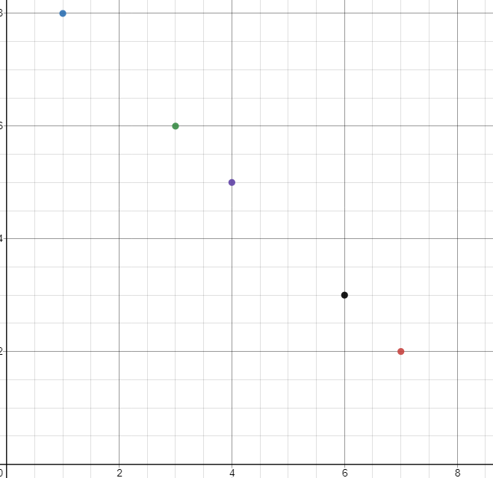

|  |  |  |  |  |  |  |
| --- | --- | --- | --- | --- | --- | --- |
|  | 0 | 1 | 2 | 3 | 4 | 5 |
| 0 | 0 | 0 | 0 | 0 | 0 | 0 |
| 1 | 0 | 8 | 18 | ‬20 | ‬18 | ‬14 |
| 2 | 0 | 23 | 27 | 26 | 27 | 26 |
| 3 | 0 | 29 | 29 | 29 | 29 | 29 |

2 Pontos

P 1 + P 2 = 20 P 2 + P 3 = 23 P 3 + P 4 = 26 P 4 + P 5 = 20

P 1 + P 3 = 23 P 2 + P 4 = 27 P 3 + P 5 = 26

P 1 + P 4 = 23 P 2 + P 5= 26

P 1 + P 5 = 20

3 Pontos

P 1 + P 3 +P 4 = 29 P 2 + P 4 + P 3 = P 3 + P 4 + P5 = P 4 + P 5 =

P 1 + P 3 +P 5 = 29 P 2 + P 4 + P 5 =

P 1 + P 3 + P 2 = 25