Benchmark Optimization Functions Using Genetic  
Algorithms

# Description of the selected functions and their plots

For this assignment I chose the Bukin Function N.6 and the Drop-Wave Function. Here are their definitions and the plots I made using pyplot.

* Bukin Function N.6:

f : [-15, 5] x [-3, 3] -> R

f(x) = 100√|x2-0.01x12|+0.01|x1+10|

global minimum: f(x*)=0, at x*=(-10,1)

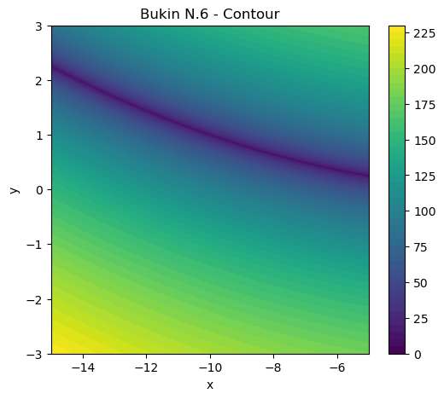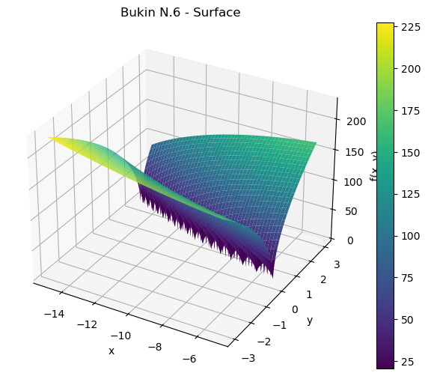

* Drop-Wave Function:

f : [-5.12, 5.12] x [-5.12, 5.12] -> R

f(x)=-(1+cos(12√x12+x22))/(0.5(x12+x22)+2)

global minimum: f(x*)=-1, at x*=(0,0)

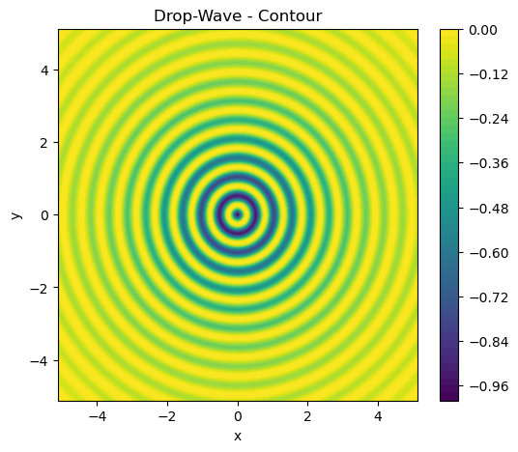 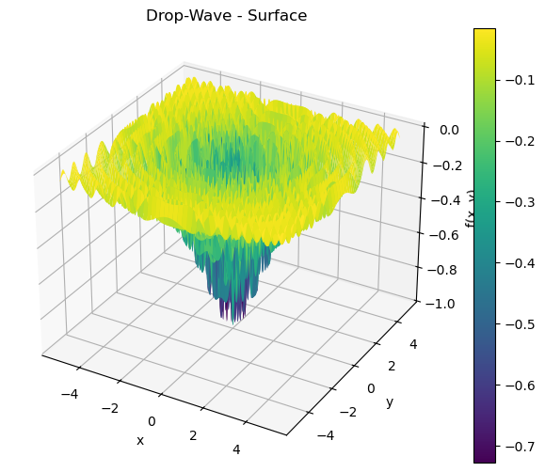

# Explanation of GA configurations

First of all, I randomly generated the initial population, both real and binary, each individual having two chromosomes which reflect in the phenotype as the two coordinates of a point. In particular, to achieve this, the binary individuals require a decoding function that transform the two binary strings into two real numbers.

Each crossover function I implemented takes two individuals as parameters and mixes their genotypes according to the lecture notes, each returning two new individuals, the children.

Each run is configurable in that I can choose the fitness function (i.e. Bukin or Drop-Wave), the bounds specific to that function, the population size, the number of generations, the crossover method and rate, and the mutation rate.

I split the runs into two functions, so that on the real run one can only choose arithmetic or blx crossovers and on the binary run one can only choose between one- or two-point crossovers.

# Tables and plots of experimental results

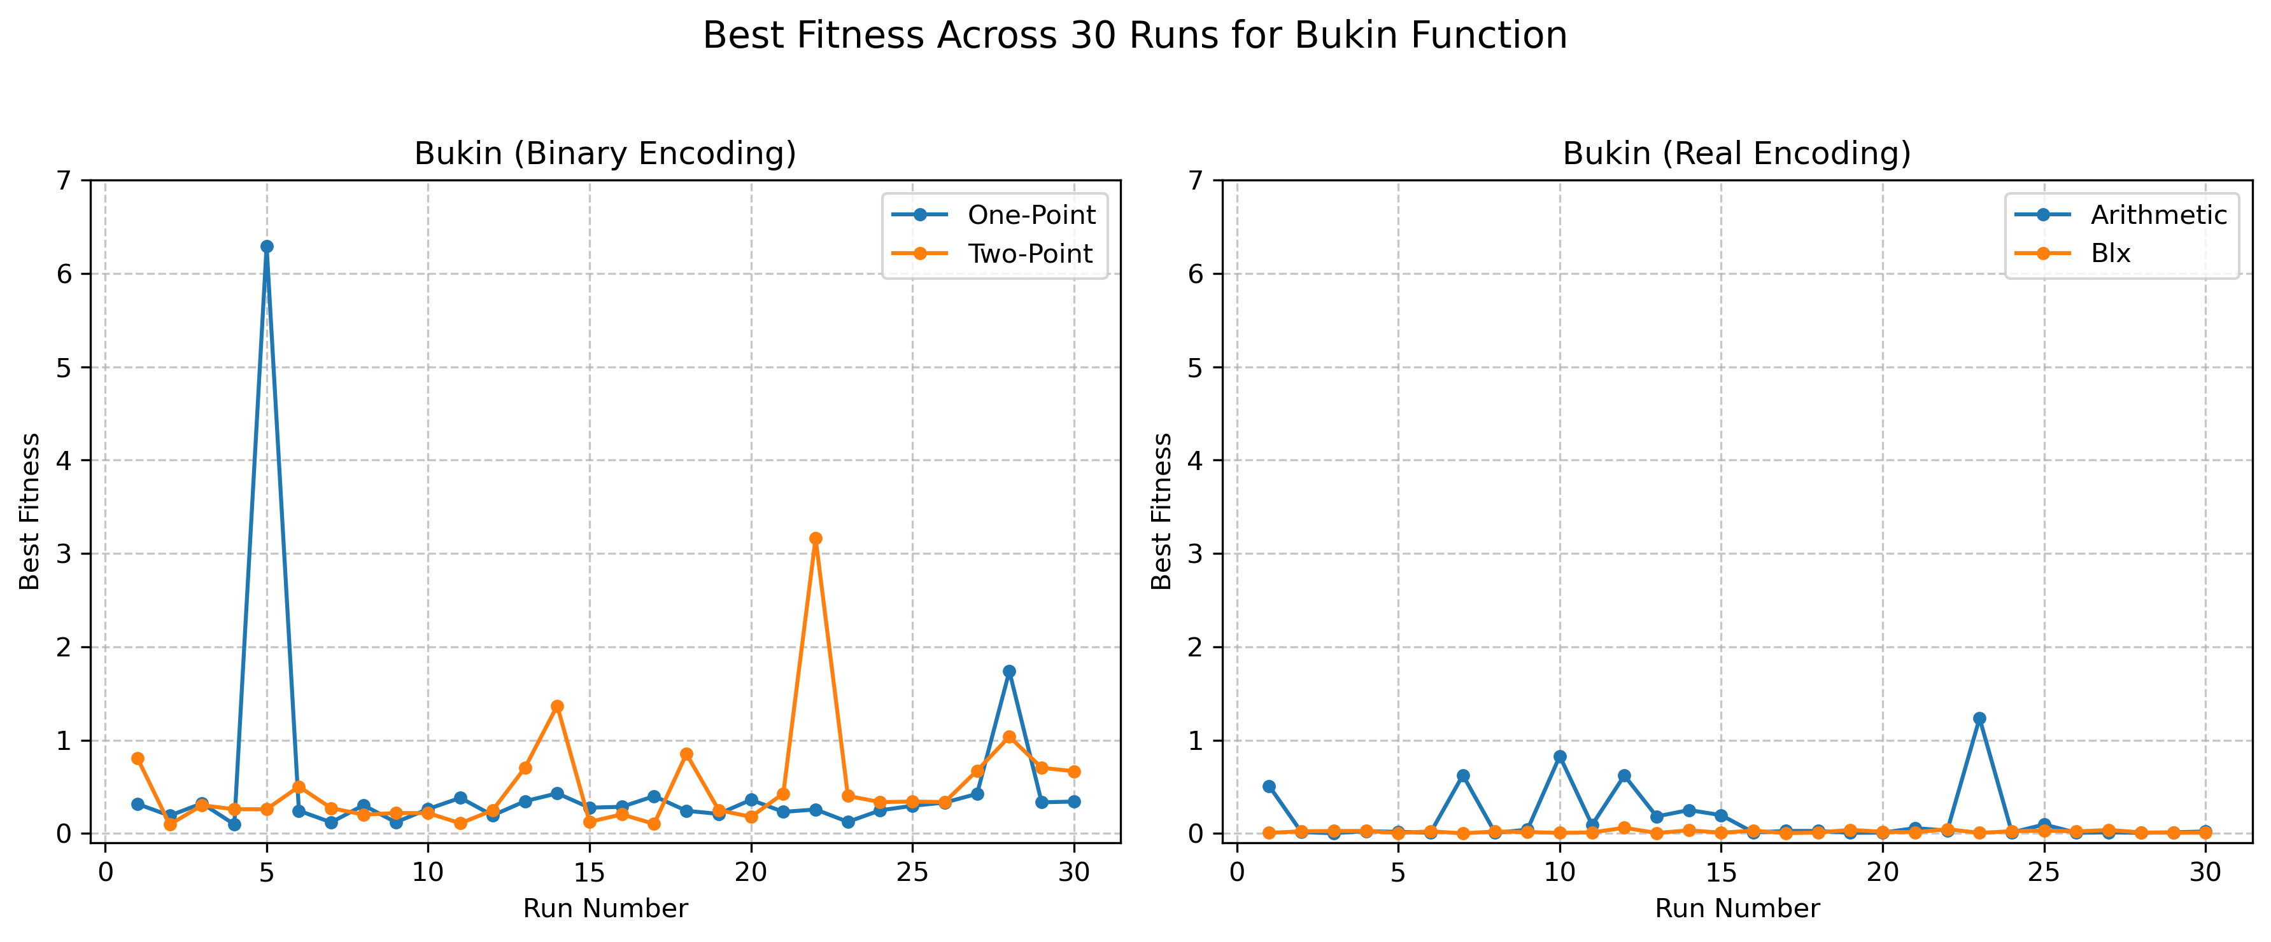

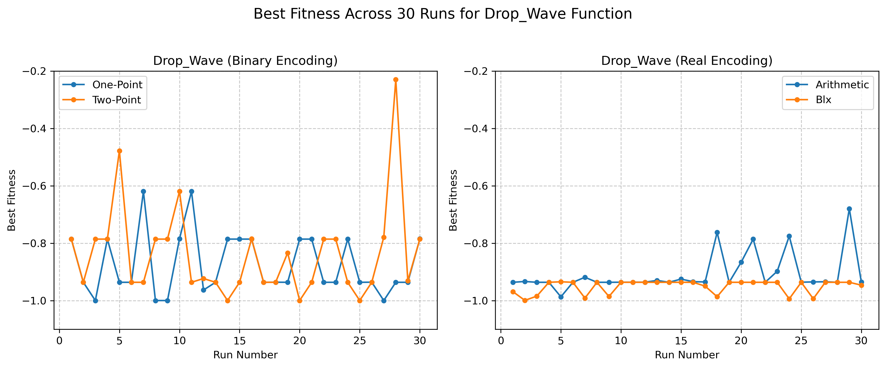

We can observe that the variance in the Drop-Wave using Binary Encoding is very high, while in the other configurations it is relatively low. It can also be seen that the Real Encoding worked much more better than the Binary Encoding across the board.

|  |  |  |  |  |  |  |
| --- | --- | --- | --- | --- | --- | --- |
| Function | Encoding | Crossover | Generations | Mean | Std | Min |
| bukin | binary | one_point | 30 | 0.524818 | 1.125297 | 0.098691 |
| bukin | binary | two_point | 30 | 0.512981 | 0.585996 | 0.096330 |
| bukin | real | arithmetic | 30 | 0.167148 | 0.298127 | 0.003607 |
| bukin | real | blx | 30 | 0.020240 | 0.014318 | 0.001940 |
| drop_wave | binary | one_point | 30 | -0.874252 | 0.106561 | -0.999831 |
| drop_wave | binary | two_point | 30 | -0.838762 | 0.163611 | -0.999831 |
| drop_wave | real | arithmetic | 30 | -0.908016 | 0.067017 | -0.986934 |
| drop_wave | real | blx | 30 | -0.950746 | 0.023453 | -0.999250 |

# Statistical comparison and conclusions

I ran t-tests using the scipy library and the data from the total of 240 runs and I compared, two by two, the crossover methods for each representation and function, and the representations for each function. Results:

T-test for Bukin (Representation): Binary vs. Real

T-statistic: 3.593

P-value: 0.0006

Conclusion: The difference is significant (p < 0.05).

T-test for Drop_Wave (Representation): Binary vs. Real

T-statistic: 3.806

P-value: 0.0003

Conclusion: The difference is significant (p < 0.05).

T-test for Bukin (Crossover (Binary)): One-Point vs. Two-Point

T-statistic: 0.051

P-value: 0.9595

Conclusion: The difference is not significant (p < 0.05).

T-test for Bukin (Crossover (Real)): Arithmetic vs. BLX

T-statistic: 2.696

P-value: 0.0115

Conclusion: The difference is significant (p < 0.05).

T-test for Drop_Wave (Crossover (Binary)): One-Point vs. Two-Point

T-statistic: -0.996

P-value: 0.3243

Conclusion: The difference is not significant (p < 0.05).

T-test for Drop_Wave (Crossover (Real)): Arithmetic vs. BLX

T-statistic: 3.296

P-value: 0.0022

Conclusion: The difference is significant (p < 0.05).

In conclusion, the BLX crossover seems to be working better for each of the functions and representations. The binary representation got closer to the result for the Drop-Wave function, while the real representation worked better for the Bukin function.