Hello world

启动程序

tohello1

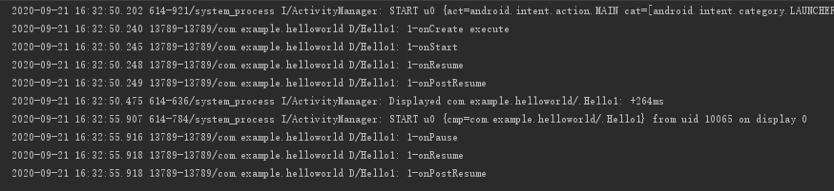

tohello 2

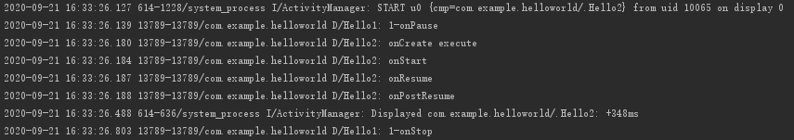

tohello 2

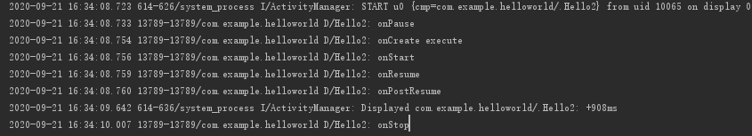

tohello 3

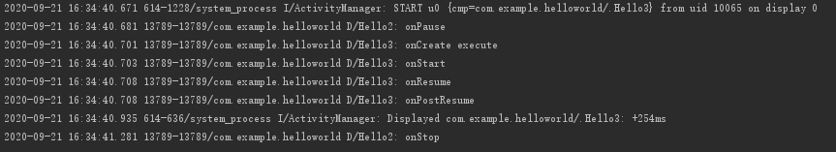

tohello 3

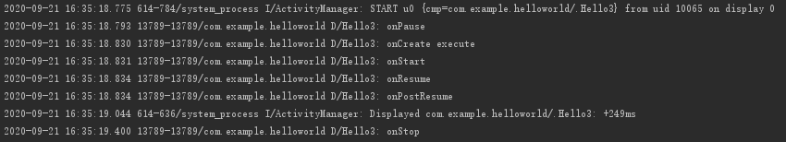

Back

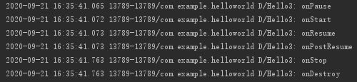

Back

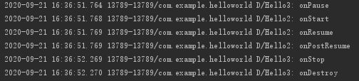

Back

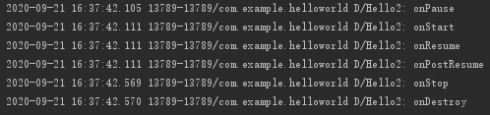

Back

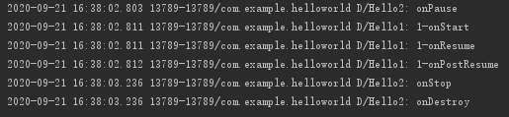

Back to home



Home to tohello1

