**silenced.co**

**A Foundation of Sand**



**The Lie of British Israelism**

**Introduction**

British Israelism is a lie.

Many tenets of religion can exist purely within the realm of faith, some of them unfalsifiable and open to interpretation. But not the cornerstone of Armstrongism, the thread that binds COG beliefs into a coherent system where the elect are destined to rule the cosmos.

British Israelism’s entire premise — that the Western European nations and the United States are direct biological descendants of the “Lost Ten Tribes of Israel” — is complete and utter rubbish that is easily disproved by history, archaeology, common sense, modern genetics studies and even the Bible itself.

So why do COG members cling to it so staunchly?

That’s easy: Armstrongism makes even less sense without it. In fact, the theology cannot logically exist without British Israelism. Herbert W. Armstrong called it the “key” to Bible prophecy and therefore centered everything in the COG’s universe around it.

This is a paper unraveling the lies behind British Israelism.

**Chapter I: Logic**

[British Israelism](http://en.wikipedia.org/wiki/British_Israelism) appeared in the United States and Britain in the 1870. However, the concept itself has been around since the 2nd Century BCE. [John Sadler](https://en.wikipedia.org/wiki/John_Sadler_(1615-1674)) was the first to link British and Israelite genealogies in 1649. [Richard Brothers](https://en.wikipedia.org/wiki/Richard_Brothers) and [John Wilson](https://en.wikipedia.org/wiki/John_Wilson_(British_Israelite)) turned it into a fully-formed ideology — the former of which was committed to an insane asylum due to alleged mental health issues — and they were the first ones known to link Europeans to Scythian tribes.

[Edward Hine](https://en.wikipedia.org/wiki/Edward_Hine) and [Edward Wheeler Bird](https://en.wikipedia.org/wiki/Edward_Wheeler_Bird) helped the ideology hit its stride in the late 19th and early 20th centuries, Hine being the first to equate Britain with Ephraim and America with Manasseh.

[Millenarianists](https://en.wikipedia.org/wiki/Millenarianism) and various Pentecostals latched onto the ideology and used it to fuel the fires of imminent prophetic fulfillment, since it allowed them to easily apply ancient pronouncements concerning Israel into the present day.

As the British Empire spread, more and more people believed in British Israelism’s tenets since the country’s growth of power was seen as divine blessing.

**In a Nutshell**

In short, British Israelism claims the Celto-European people, whose descendants are found in the United States, United Kingdom, and Western Europe, are actually the descendants of the “Lost Ten Tribes of Israel.”

In the Old Testament, upon the collapse of the Kingdom of Israel, the northern ten tribes were taken into captivity by the Assyrians. Proponents of British Israelism claim there was then an Israelite diaspora and centuries of nomadic wanderings, which ended during the [Barbarian Invasions of Ancient Rome](http://en.wikipedia.org/wiki/Barbarian_Invasions) (300-700 CE) when Celtic and Germanic tribes flooded into Western Europe. Basically, proponents believe that because one group of people “disappeared without a trace” and another “appeared out of nowhere,” they must be the same people.

Anyway, they believe America and the British Empire’s emergence on the world scene is the fulfillment of an ancient prophecy and promise made concerning the two sons of Joseph, Ephraim and Manasseh. It is believed that when Ephraim was predicted to be a “company of nations,” it was a reference to the British Empire, and Manasseh afterwards was prophecized to give birth to a “great nation” that would become the United States of America.

**Armstrongism’s Backbone**

Today, British Israelism is largely defunct as a movement, confined to various small Pentecostal groups, some Christian Scientists, fringe Internet “scholars” and, of course, the COG.

British Israelism was a fundamental tenet of Herbert W. Armstrong’s teachings and was even allegedly part of what got him kicked out of COG-7. He clung to the idea and made it an integral part of his patchwork theology, because the concept on its face is tied to Millenarianism. He also added his own hypothesis to the ideology, including the assertion that Germans were descended from ancient Assyrians.

British Israelism is the lens through which the COG views prophecy. It allows them to translate nearly every endtime prophecy regarding Israel or its tribes to the modern day by substituting the United States, Britain and Western Europe for ancient nations. British Israelism is the time portal through which archaic Biblical prophecies are applied in the current day by the COG faithful.

Other denominations typically either eschew literal prophetic interpretations or attempt to equate today’s Christian adherents as “spiritual Israel” instead of literal Israel (if they’re white European Caucasians). But this takes away the impact of the literal predictions spewed by Armstrong and his doomsaying acolytes. It changes everything the COG has been watching for on the world scene for the past 70 or so years.

Some COG groups, like UCG, have downplayed British Israelism in recent years, but booklets on the subject are still silently in circulation, because they cannot simply jettison the teaching without offending the veteran faithful, and because deep down, they know church teachings unravel without it.

So the COG needs British Israelism to retain its traditional belief, to keep playing the prophecy game, to keep its members happy and to keep sapping the flock of its time and money. Without it, the scheme falls apart entirely.

**The First Bucket of Water**

The nice thing about sand castles is that they’re easy to build and even easier to destroy.

One of the most common assertions made by proponents — that because the lost tribes suddenly “disappeared” and the barbarians “suddenly appeared” they must be the same peoples — is easily challenged with British Israelism’s first weakness: **correlation does not imply causation.**

Proponents base nearly all of their assertions and “evidence” on the faulty notion that correlation or similarity can be substituted for causation or sameness. The COG’s foundation of sand doesn’t even have a cornerstone to lean on, since it lacks anything in the way of direct links.

Across the next series of posts, we’ll review everything that is scientifically, historically and logically wrong with this longstanding tenet of Armstrongism and how its theology crumbles without it.

**Chapter II: Scripture**

British Israelism, [Armstrongism’s backbone](http://silenced.co/2013/12/a-foundation-of-sand-part-i" \t "_blank), is a total lie based on the faulty assumption that correlation implies causation.

All of its claims fall within the sphere of that logical fallacy, but in addition, most also fail other tests of logic and are contradicted by hard, established evidence.

Of course, British Israelism’s core arguments are drawn from interpretations of biblical scriptures, which are compared and contrasted against historical timelines and genealogies. The “primary evidence” for British Israelism is determined through the “identification marks” listed in the Bible, which proponents claim strongly apply to Britain and America.

These arguments are easily undone.

**Point, Counterpoint**

Here are the supposed identifying markers that supposedly predict the rise of the United States and United Kingdom, followed by some actual facts to shoot them down:

**The twelve tribes would lose all traces of their lineage (Isiah 42:19, Hosea 1:9).**

Fact: This is a convenient claim, since it exonerates proponents of producing much evidence. However, we know the lineages of the British and Western Europeans, so traces have not been lost, and they contradict British Israelism.

We will delve into genetics and their ultimate dismissal of British Israelism in a future segment in this series. For now, sufficed to say these scriptures are only relevant if one makes the assumption that the tribes were lost in the first place. Additionally, we do know the lineages of Israelites and their [transition to modern-day populations.](https://en.wikipedia.org/wiki/Israelites#Transition_into_modern_ethnic_groups)

Long story short, their lineages are definitely not lost.

**Israel will be a great and mighty nation (Genesis 12:2, 18:18, Deuteronomy 4:7-8).**

Fact: There have been countless great and mighty nations throughout history, ones that have lasted longer than the United States and Britain currently have. These verses are so wide open to interpretation they’re rendered virtually irrelevant.

To have called Israel a “mighty nation” at any point in its ancient history is a joke, because despite the suggestions of the Bible, we historically know it to [have been very small.](https://en.wikipedia.org/wiki/Northern_Kingdom_of_Israel)

**Israel will be named “Great,” i.e. Great Britain (Genesis 12:2).**

Fact: Searching through all of the nations of history, we are bound to find some calling themselves “great.” In Britain’s case, it was originally in reference to the island of Great Britain as Britannia major (“Greater Britain”), to distinguish it from Britannia minor (“[Lesser Britain](http://en.wikipedia.org/wiki/Brittany)“). In this case, “great” does not mean fantastic, amazing, or wondrous as it seems the Bible meant it. It simply means “bigger.” The prophecy that Israelite tribes will someday inhabit a swath of island territory that is larger than an adjacent landmass doesn’t quite hold as much power or relevance.

**Israel will be a blessing to other nations (Genesis 12:2-3).**  
Fact: In a lot of cases, indigenous populations were glad to be rid of American, British, and French invaders. Most countries have done admirable things in their pasts, and the United States and Britain are no exception. Yet, they have also done some fairly horrible things, and continue to.

Some might point to the relative success of [former British and European colonies](https://en.wikipedia.org/wiki/List_of_former_European_colonies) as evidence that this prophecy was fulfilled through America, Britain and other colonizing powers, but there are plenty of exceptions to this, such as Haiti and Pakistan just to name two big ones. Also, relatively thriving in the aftermath of a colonizing power establishing a base of wealth and infrastructure isn’t surprising. The Romans did that all over the place. Would the Bible have also referred to the Roman Empire as a “blessing to other nations?”

**Israel will become many nations (Genesis 17:4).**  
Fact: Most smaller nations from the ancient past have descendants found in many nations. The initial African tribes that spread through the world have their descendants literally everywhere.

**Israel’s descendants will be Kings and rulers (Genesis 35:11).**  
Fact: While there have been world leaders with Jewish blood, DNA examinations of bloodlines shows this claim is untrue for the most part. It’s also true that many Western European rulers have been interrelated, but this isn’t surprising considering the efforts royalty the world over makes to insure “pure” bloodlines, complete with rampant incest.

The most common claim along these lines is that Queen Elizabeth is a direct descendant of Israelite King David. First, it isn’t even strongly established that [David ever existed at all.](https://en.wikipedia.org/wiki/King_david#Historicity)Secondly, we know that Queen Elizabeth II, as a member of the House of Windsor, [is a descendant of Queen Victoria](http://all-that-is-interesting.com/post/5019101017/the-lineage-of-the-british-royal-family), a member of the [German House of Hanover.](https://en.wikipedia.org/wiki/House_of_Hanover) By Armstrongite reckoning, that makes Elizabeth II an Assyrian, not an “Israelite” at all, much less a descendant of King David.

**Israel’s blessings on his sons match perfectly to modern nations (Genesis 48-49).**

Fact: This is a matter of looking at a conclusion and then trying to find facts to fit into it, the exact opposite of the scientific process. Any other set of nations could be made to connect to each of the blessings and curses put on the sons of Israel.

**Israel will keep the Sabbath (Exodus 31:13).**  
Fact: Aside from the Jews, what nations have kept the Old Testament, seventh day Sabbath? If anything, this verse is evidence against British Israelism, as Western Europeans have been predominantly Catholic and Protestant throughout their histories and therefore observant of Sunday as a day of religious worship.

**Israel will be a missionary nation (Isiah 49:6, 66:19).**  
Fact: British and American missionaries have indeed been all over the world, yet they haven’t exactly been preaching the religion of the Old Testament Bible. Also, many nations have been “missionary nations” taking state religion to conquered peoples, like the Islamic caliphates of old.

**Israel will rule over others (Genesis 27:29, Deuteronomy 15:6).**  
Fact: If anything, Israel has been dominated by other nations throughout its history, being conquered by Assyrians, Babylonians and Romans throughout history. Many Western European nations have been conquered over and again by various imperialist powers. Even Britain has been stomped all over throughout history. Even the rise and fall of the British Empire was a flash in the pan. While the United States had about 70 years of dominance as a global superpower, its strength and influence is unarguably waning fast. So who is Israel ruling over? What other nations does it command?

**Israel will be envied and feared (Deuteronomy 2:25, 4:8, 28:10).**  
Fact: Most powerful, aggressive nations throughout history have been feared and envied for their wealth and power. Rome, Greece, Persia and the U.S.S.R. were hated just as much as the United Kingdom and United States in their heyday for their strength. This isn’t a unique marker and is therefore meaningless.

**Israel will lend to other nations (Deuteronomy 15:6).**  
Fact: The United States and Britain have loads of foreign debt they owe to other nations and have for a very long time. Just ask the Chinese. Plus, just about all nations have both debtors and owed debts. Foreign debts and loans are usually two-way streets. A nation lends to another nation and in turn owes a third nation money. This marker is also therefore meaningless.

**Israel will inhabit the isles of the sea (Isiah 24:15).**  
Fact: In many cases, indigenous people and other nations have gotten there first. British explorers certainly spread across the world and colonized tiny islands all over the planet’s oceans. But aboriginal sailors arrived first anciently. Additionally, this verse is often taken out of context by proponents of British Israelism, as the surrounding verses give this the context of God passing judgment on the Earth rather than pinpoint Israelites as future owners of island colonies:

“14 They raise their voices, they shout for joy; They cry out from the west concerning the majesty of the LORD. 15 Therefore glorify the LORD in the east, The name of the LORD, the God of Israel, In the coastlands of the sea. 16 From the ends of the earth we hear songs, “Glory to the Righteous One,” But I say, “Woe to me! Woe to me! Alas for me! The treacherous deal treacherously, And the treacherous deal very treacherously.”

There’s a lot of logical gymnastics at play to pull “Israel’s gonna have a lot of beachfront property” from these verses.

**Israel’s new home will be northwest of Eretz Israel (Isiah 49:12), and that it would spread abroad (Gen. 49:22).**  
Fact: The Northern Kingdom of Israel was never lost, as we will later discuss. Also, while these verses do talk about the restoration of Israel, the scriptures actually says this:

“11 “I will make all My mountains a road, And My highways will be raised up. 12 “Behold, these will come from afar; And lo, these will come from the north and from the west, And these from the land of Sinim.” 13 Shout for joy, O heavens! And rejoice, O earth! Break forth into joyful shouting, O mountains! For the LORD has comforted His people And will have compassion on His afflicted.”

It mentions coming from both the north and the west, but also mentions Israelites coming from the “[land of Sinim](https://en.wikipedia.org/wiki/Sinim)” which would likely have been a reference to Phoenicia (spread across the Middle East and North Africa today) or the [deserts of Sinai](https://en.wikipedia.org/wiki/Sinai_Peninsula) (modern day Egypt), neither of which proponents of British Israelism count as the “new home” of lost Israelite tribes, aside from the modern state of Israel itself.

**The Rolling Tides**

As can be clearly seen, Biblical support for the doctrine of British Israelism is weak and murky at best. That the Bible even predicts the rise of Israel in the form of any modern-day nation is a stretch of interpretation within itself. But the Bible itself hosts other problems for the ideology as well, which should give the average COG member pause since they claim to take their tenets straight from scripture.

We will tackle this in the next installment, then open fire with the canons of science and history to seal British Israelism’s fate for good.

**Chapter III: Conquest**

In the previous installment, we discussed how many of the Biblical passages or markers users to supposedly identify the “Lost Ten Tribes of Israel” don’t hold up under scrutiny or are being completely taken out of context upon further (or any) analysis.

But the Bible not only doesn’t actually prophecize the rise of Israel as the United States, Great Britain or any other modern nation, but it actually contains explicit evidence against those claims, ones that are supported by historical and archaeological finds.

Armstrongites are faced with a conundrum if they’re looking to biblical scripture for the backbone of doctrine if those same doctrines are undone at the source. It’s an example of “grocery cart” Bible thumping, something the COG claims it decries when discussing mainstream Christianity. As usual, the COG finds itself sitting in the realm of hypocrisy.

**The Lost Ten Tribes Were Never Lost**

The biblical evidence against British Israelism undermines its very core, that being the very existence of ten “lost” Israelite tribes in the first place. Proponents of British Israelism believe that the “lost” tribes made their way to the Caucuses where they became Scythians, Celts and other “barbarians” in the view of the Roman Empire, which if true, would certainly mean that the tribes of Western Europe were descended from Israelites. Unfortunately for proponents, this isn’t even close to true.

In 2 Chronicles 34:9, it talks about the reign of King Josiah, after the conquest of Sargon: “And when they came to Hilkiah the high priest, they delivered the money that was brought into the house of God, which the Levites that kept the doors had gathered of the hand of Manasseh and Ephraim, **and of all the remnant of Israel**, and of all Judah and Benjamin; and they returned to Jerusalem.”

Detractors say that “archaeological evidence indicates that the ‘remnant’ mentioned in 2 Chron. 34:9 was not a small group. According to recent archaeological findings, as the Northern Kingdom fell, thousands of refugees fled south to Judah in order to escape the Assyrians. From the death of Solomon until the end of the eighth century BCE the city of Jerusalem grew very little. But suddenly, around the end of the eighth century, the population exploded, expanding three or four times its original size, growing from 7,500 to about 24,000. The evidence for an influx of refugees is not confined to Jerusalem. Numerous settlements in the Judean hills around Jerusalem, in the Negev, in the Judean desert and along the Dead Sea were heavily settled for the first time in the eighth century BCE. Therefore the lost tribes are found where the Assyrians left them: in the land of Palestine.” ([Nettlehorst](http://www.theology.edu/journal/volume4/BritishIsraelism.htm)) [Israel Finkelstein](http://en.wikipedia.org/wiki/Israel_Finkelstein), a respect Jewish scholar, estimated only a fifth of Northern Israel’s population — about 40,000 — was actually resettled during the deportations of Tiglath-Pileser III and Sargon II. Many of the northern tribes fled south to Jerusalem, which as already mentioned, appears to have expanded greatly in size during this period. ([The Bible Unearthed](http://www.amazon.com/The-Bible-Unearthed-Archaeologys-Ancient/dp/0684869136))

Sargon the Great’s [record of the conquest of Samaria](http://www.theology.edu/journal/volume4/BritishIsraelism.htm) makes it clear that most of the Northern Israelite people were not taken to Assyria as captives: “I besieged and conquered Samaria [Sa-me-ri-na], led away as booty 27,290 inhabitants of it. I formed from among them a contingent of fifty chariots and made remaining [inhabitants] assume their [social] positions.” Scattering the Israelites to the wind would have been against [Assyrian resettlement policy](http://www.ucl.ac.uk/sargon/essentials/governors/massdeportation/). Here’s a helpful map of the Assyrian deportation of Israelites, which flies in the face of claims made by proponents that the tribes were relocated to the Russian Steppes:

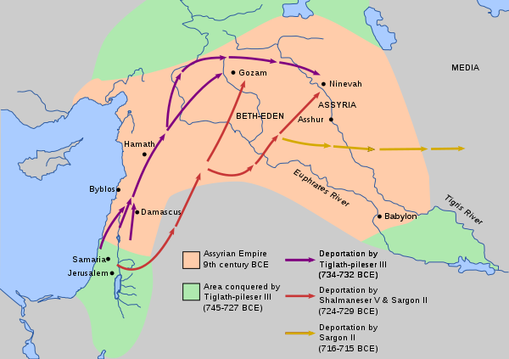

Source: [Wikipedia](http://en.wikipedia.org/wiki/Assyrian_captivity_of_Israel)

To drive another nail into British Israelism’s coffin, [2 Chronicles 30:1-11](http://tools.wmflabs.org/bibleversefinder/bibleversefinder.php?book=2%20Chronicles&verse=30:1-11&src=HE) specifically mentions members of Israelite tribes who had been spared by Assyrians conquerors, representing Dan, Ephraim, Manasseh, Asher and Zebulun, the latter three returning to the Temple of Jerusalem to worship. So along with Judah and Benjamin in the south, the number of accounted-for Israelite tribes rises to **seven**, more than half the entire number. The “Five Lost Tribes of Israel” isn’t as catchy, is it? And of course, as already mentioned, those tribes were not lost, merely shifted around within the region, eventually finding their way back into the south.

And despite being a “lost tribe”, somehow Asher makes it into the New Testament as an intact tribe with an explicit mention. In Luke 2:36 it says: “There was also a prophet, Anna, the daughter of Penuel, **of the tribe of Asher.** She was very old; she had lived with her husband seven years after her marriage.” How is there a “tribe of Asher” in the days of Jesus if these tribes are supposedly lost or gallivanting around the outskirts of Ancient Rome?

Also, if the Lost Ten Tribes of Israel were both actually lost and the bulk of Western European populations, that’s news to the Jews. Both the Jews and the Arabs claim they originally came from Abraham 3,700 years ago. The Western Europeans have never made any such claim, nor do the Jews or Arabs recognize their ancestors as having anything to do with the Europeans.

These are some of the major contradictions against British Israelism found in the Bible, and it provides a nice transition into next analyzing the true identities of “barbarian” tribes and challenging the alleged connections between the “lost” tribes (which is not a thing) and the actual ancestors of Western European nations.

**Chapter IV: Migrations**

Thus far we’ve seen that the claims of British Israelism are based entirely on the fallacy that correlation implies causation, biblical scriptures that are either distorted of their context or directly contradict the ideology, or simple lunacy.

Most “scholars” of British Israelism are entirely unqualified as experts in any field of study, much less archaeology, linguistics, art, history, science or even scripture. This lack of expertise truly shines when proponents attempt to make connections between the ancient Israelite tribes and the ancient tribes that would flood into Western Europe. The complete and utter lack of knowing even the basics of timelines, culture or language are mind-boggling for people who claim to have it all figured out.

One of British Israelism’s huge claims, as already mentioned, is to connect the “suddenly disappearing” lost Israelite tribes (that were not lost) to the “suddenly appearing” barbarian tribes (that did not really suddenly appear) as the same groups of people. This, of course, makes no sense when even a modicum of facts are applied.

**The Scythians and Cimmerians Were Not Israelites**

It is claimed by proponents that the [Behistun Inscription](http://en.wikipedia.org/wiki/Behistun_Inscription) connects the invading Scythians with the Cimmerians, and therefore, in their minds, to Israel. This is important because the Assyrians referred to the Kingdom of Israel in their records as the “House of Khumri”, named after Israel’s King Omri of the 8th century BCE. Phonetically “Khumri”, “Omri”, and “Gimiri” are similar. ([Capt](http://www.amazon.com/Bible-Prophecy-2010-Revised-Expanded/dp/B001NPTX2M/ref=sr_1_11?ie=UTF8&qid=1313341270&sr=8-11)) “We have reasonable grounds for regarding the Gimirri, or Cimmerians, who first appeared on the confines of Assyria and Media in the seventh century BCE, and the Sacae of the Behistun Rock, nearly two centuries later, as identical with the Beth-Khumree of Samaria, or the Ten Tribes of the House of Israel.” ([Rawlinson](http://www.amazon.com/Kings-Israel-Judah-George-Rawlinson/dp/1458886964/ref=sr_1_1?ie=UTF8&qid=1313341428&sr=8-1)) But the biggest problem is that the inscription isn’t about the Assyrians, their conquests and the Lost Ten Tribes, as mistakenly proposed by [Sir Robert Ker Porter](https://en.wikipedia.org/wiki/Robert_Ker_Porter), but it is instead a multilingual Rosetta Stone-type document detailing the life and conquests of Darius the Great.

Proponents also assert that the Scythians migrated north and west after Cyrus the Great conquered the city of Babylon. History suggests that these Scythians were forced further north and then west by invading Sarmatians. The Sarmatians were also called “Scythians” by the Greeks. To differentiate between the two, Herodotus suggests that the former “Scythians” were called “Germain Scythians” (meaning “True Scythian”), while the Sarmatians were still merely called “Scythians.” This theory suggests the term “Germain Scythian” is synonymous with “Germanii” or in modern times “Germanic” or “German.” Historically, however, the terms Cimmerian and Scythian were not, in fact interchangeable. To further endanger this claim, DNA evidence shows that the Scythians were of [mixed Iranian-Mongloid origin](http://www.ncbi.nlm.nih.gov/pubmed/12376844), meaning they were from Eastern Eurasia. There is no genetic similarity between Scythians and Israelites, or a relationship to the Cimmerians, [who were thought to be Thracians](http://en.wikipedia.org/wiki/Cimmerians) (Greeks) and spread to Denmark and Prussia.

**Celtic Discrepancies**

Proponents of British Israelism also claim that, obviously, the British and Celts and the tribes that comprise them were of Israelite origin. But it’s important to note that Celts were in Britain two centuries (900 BCE) before the collapse of the Northern Kingdom (720 BCE), and long before the start of the Barbarian Invasions (300 CE): “In the fourth century CE, the Angles and Saxons began raids on Britain, bothering the Romans who were already there. When the Romans finally abandoned Britain the Angles, Saxons and Jutes moved in. They soon became the masters of the island, driving out or enslaving the Celts who were already there. They remained the masters until 1066 when the Normans arrived and subjugated the Angles and Saxons. It is clear, therefore, that the people of Great Britain are not from any one stock of ancestors but are as much a mixture as their language.” ([Nettlehorst](http://www.theology.edu/journal/volume4/BritishIsraelism.htm))

The ancient scholars Bede and Tacitus both agreed that before the time of Christ, German and Teutonic tribes migrated to the British Isles, forcing the early Britons to the western portion of the isles. The earliest of these Germanic settlers were the Angles and Jutes, before the time of Christ, followed by the “Great Saxon Invasion” between 450 and 600 CE, which culminating with the “Danish Conquest” 787-1070 CE.

Of the history of the British peoples, Nettlhorst adds: “The history of England, like the history of Israel, lends no support to the view that the descendants of Abraham invaded the island. Arthur Cross tells us that the Celts, one of the earliest groups that invaded Britain, first arrived 1,000 years before Christ was born and more than 200 years before the Northern Kingdom fell. Not only that, but from the history of the English language itself it is clear that there is no relation between it and Hebrew, or the English people and the Israelites.” ([Nettlehorst](http://www.theology.edu/journal/volume4/BritishIsraelism.htm))

Furthermore, London was not founded by Celts as some proponents of British Israelism often claim, but by the Romans in 43 CE as [Londinium](http://en.wikipedia.org/wiki/Londinium" \t "_blank).

Proponents also claim the [Stone of Scone](https://en.wikipedia.org/wiki/Stone_of_Scone), or the Scottish coronation stone, is [Jacob’s Pillar](https://en.wikipedia.org/wiki/Stone_of_Jacob), an ancient Israelite relic. But this also makes no sense: “Despite the claims of British Israelism that the Stone of Scone or Stone of Destiny was Jacob’s pillar, the stone did not originate in Palestine at all, nor is the Stone of Scone the Lia-Fail of Ireland. It is just a piece of sandstone from Scotland.” ([Nettlehorst](http://www.theology.edu/journal/volume4/BritishIsraelism.htm))

Also along the lines of distorting Celtic history is the story of Tea-Tephi, a legendary princess described in British Israelism’s literature from the 19th century. The 1861 “England, the Remnant of Judah, and the Israel of Ephraim” claimed Tea-Tephi was one of Zedekiah’s daughters (Tamara) who escaped death (Jeremiah 43: 6), traveled to Ireland and married local High King of Ireland in the 6th century BCE and therefore became linked to the British Monarchy.  [J. H. Allen](https://en.wikipedia.org/wiki/J._H._Allen)‘s 1902 book “Judah’s Sceptre and Joseph’s Birthright” also made this claim, attempting to cement the already-proven faulty claim from Part II of this series that the British Monarchy is a continuation of the [Davidic line](https://en.wikipedia.org/wiki/Davidic_line). However, even the British Israel World Foundation [has admitted](http://www.pleaseconsider.info/images/tephi.gif) that Tea-Tephi was a forgery and [did not exist.](http://www.pleaseconsider.info/articles/bi/tea-tephi.htm)

**Imaginary Similarities of Traditions**

Proponents claim Germanic element came to Britain from the same region where the Scythians had settled in Northern Europe, and brought with them laws, art, and customs “remarkably similar” to the ancient Israelites. But the problem is there are very few examples of ancient Israelite art, therefore comparisons to Scythian and Celtic artwork is laughable, especially since Scythian and Celtic art do not even resemble one another, much less Middle Eastern artistic expression.

The customs of the ancient Israelites swayed, according to the Bible, between paganism and Jewish monotheism depending upon who was in charge. The paganism of the ancient Celts shares similarities with other ancient religions, but this was due largely to Roman interpretations of their beliefs, which they chose to view through the lens of what was familiar to them.

Proponents claim Israelite customs, laws and traditions were codified by Alfred the Great in his famous “Dooms” or the “Doom Book”, which theyclaim contained direct quotations from Exodus and Leviticus, which to proponents of British Israelism is somehow proof of something. However, the Doom Book was compiled in 5th century CE, long after Europe and the British Isles had been converted to Christianity, so Christian influence is quite apparent.

Proponents also claim the burial customs of the Scythians and Vikings show similarities to those of the ancient Israelites. Nowhere in the Bible, however, is anyone’s body set sail aboard a raft and set on fire, so this comparison is puzzling to people who actually know both the Bible and Norse history.

**Chapter V: Linguistics**

British Israelists usually sound pretty dumb, but they sound dumbest when talking about linguistics, partially because it’s when their failure to differentiate correlation and causality shines brightest.

The idea that because things sound the same, they therefore must be the same or interrelated, is absurd. Within the study of biological evolution, scientists don’t determine the ancestry of an organism by morphology alone, nor do linguists base the evolution of words and language by sound alone.

That doesn’t stop the British Israelist however, who seems to be the ultimate amateur hobbyist regarding any given subject.

**Problems of Language**

Proponents of British Israelism claim many links in historical linguistics and terminology between ancient Hebrew and various European place names and languages.

For instance, they claim that “British” is derived from the Hebrew words “Berit” and “Ish”, and should therefore be understood as “Covenant Man,” and they also claim that the terms “Cymry” (for Welsh) and “Cimmerian” are the same. However, both of these terms have completely different origins and mean entirely different things. The etymology of “Cymry” is now accepted by Celtic linguists as a derivative of the Brythonic word [“kom-brogos” meaning “compatriots.”](http://en.wikipedia.org/wiki/Cimmerians#cite_ref-16) It is also claimed by British Israelists that the legendary “[Tuatha Dé Danann](https://en.wikipedia.org/wiki/Tuatha_D%C3%A9_Danann" \t "_blank)” people can be translated to “Tribe of Dan,” instead of the actual translation of “People of the Goddess Danu.”

They also claim that Germanic languages are derived from Hebrew — even asserting that German is about 40 percent Hebrew — which contradicts academic linguistic research showing conclusively that English belongs to the Indo-European language family, along with basic common sense. Hebrew itself is a Semitic language in the Afro-Asiatic language family.

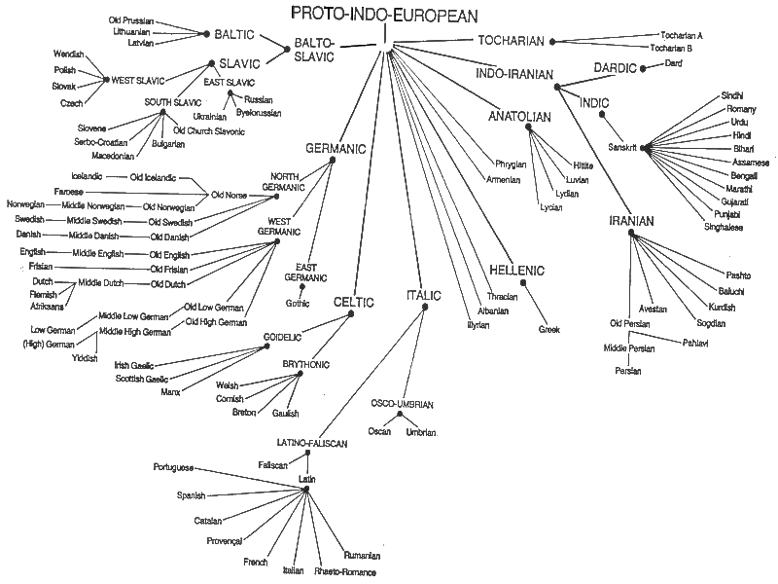

Notice the distinct lack of Hebrew in any proximity to European languages.

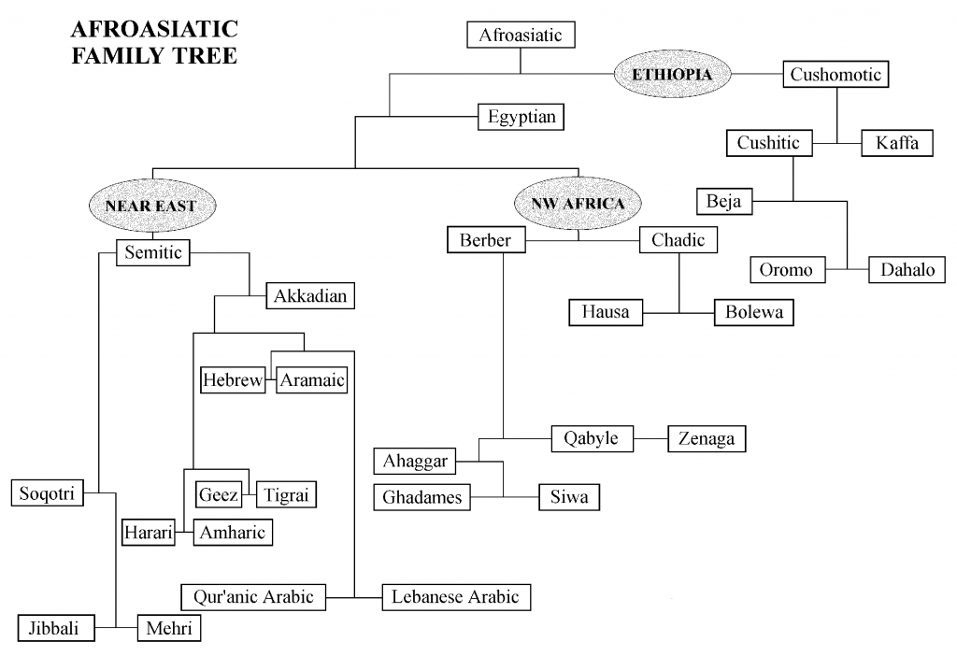

There is no trace of German, English, or any other Indo-European language sharing roots with Hebrew. Proponents of British Israelism, which constantly demonstrate they are not experts in anything, much less linguistics, have fallen into the trap of believing that simply because two words appear to be similar, they must therefore be related. Linguistics are far more complicated than that.

[Roland G. Kent writes](http://www.garretwilson.com/essays/languages/en/englishgreek.html), “The English language, despite its present simplicity and grammatical structure, is of an almost unbelievable complexity in its origins, in fact of a complexity quite unrivaled by any of the better known languages of any period.”

British Israelists overlook any sort of scientific consensus within any of the realms of “evidence” they attempt to conjure in support of their insane ideology.

**Chapter VI: Chronology**

Aside from the Bible, logic, history, culture and linguistics debunking British Israelism, the basic chronological order of events also has to get a few punches in.

Ever noticed that British Israelists tend to shy away from providing a simple timeline of their alleged events? Or charts or graphs plugging in their huge gaps of missing evidence, links between populations and events, or really anything at all? If British Israelism is so self-evident, as they claim, why not present it to us simply, instead of in a patchwork mess of quote mining, unfounded assertions, scripture taken out of context and misunderstanding of virtually every field of academic rigor?

Because when basic events are laid out — as backed by scientific, archaeological and historical consensus — British Israelists look even dumber.

**A Chronological Problem**

The following is a very simple, basic timeline of key events pertaining to common British Israelist claims. For British Israelism to work, chronology has to be a flexible, meaningless thing — something COG members have willingly accepted on different subjects — and centuries of timeline building by historians has to be entirely bunk.

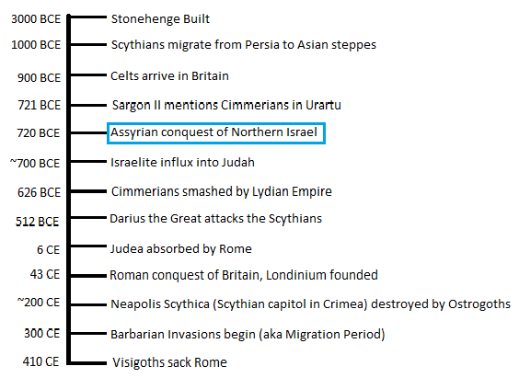

This basic sequence of events disproves British Israelist attempts to link “lost” tribes of Israelites to the Celts, Cimmerians, Scythians and constructs such as Stonehenge, which some proponents have posited were “markers” left behind by wandering Israelite nomads. British Israelism tends to work better when historical dates are fuzzy, undefinable things where they can just connect disparate events together under the homogeneous umbrella of “ancient times before Christ.”

Piecing more events together in a chronological string may reveal even more contradictions to British Israelist claims.

**Chapter VII: Scholarship**

Not only is every major claim of British Israelism easily debunked by basic facts, its own scholarship and history of publication is extremely suspect, compiled by lazy amateurs, unqualified hacks and outright plagiarists.

The questionable if not downright scandalous scholarship supporting British Israelism spanning from its earliest 18th Century origins to present day makes it quite clear why it hasn’t been taken seriously by any field of legitimate academic study.

Each and every major British Israelist publication was compiled by men with preconceived agendas.

**An Issue of Questionable Scholarship**

[The British-Israel-World Foundation](http://www.britishisrael.co.uk/) has long been the primary bastion of this crackpottery. While it has in the past enjoyed the high profile membership of British aristocrats, and even the Prime Minister of New Zealand, it is actually bereft of actual scholars and experts within the fields associated with the study. [W.H. Bennett](http://www.british-israel.com/resources.html), another commonly-cited author within the movement, equally lacks any real qualifications. Professor Tudor Parfitt wrote in his book “[The Lost Tribes: The History of a Myth](http://www.amazon.com/The-Lost-Tribes-Israel-History/dp/1842126652)” that British Israelism is “of a feeble composition even by the low standards of the genre.”

Even Grace Communion International, the former WCG, [admits today](http://www.gci.org/prophecy/usb): ”When reading Anglo-Israelite literature, one notices that it generally depends on folklore, legends, quasi-historical genealogies and dubious etymologies. None of these sources prove an Israelite origin for the peoples of northwestern Europe. Rarely, if ever, are the disciplines of archeology, sociology, anthropology, linguistics or historiography applied to Anglo-Israelism. Anglo-Israelism operates outside of the sciences.”

It doesn’t help that much of British Israelism’s groundwork was laid more than a century ago with books like Ezra Stiles’ “[The United States elevated to Glory and Honor](http://en.wikipedia.org/wiki/The_United_States_elevated_to_Glory_and_Honor)“ (1783), Richard Brothers’ “[A Revealed Knowledge of the Prophecies and Times](http://en.wikipedia.org/wiki/A_Revealed_Knowledge_of_the_Prophecies_and_Times)“ (1794), [John Wilson](http://en.wikipedia.org/wiki/John_Wilson_(British_Israelite))‘s “Our Israelitish Origins” (1840s), F.R.A. Glover’s  “England, the Remnant of Judah, and the Israel of Ephraim” (1861) or J.H. Allen’s “[Judah’s Sceptre and Joseph’s Birthright](http://en.wikipedia.org/wiki/J._H._Allen)” (1902). These are works based old misunderstandings of history, archaeology and anthropology and should not be considered as serious sources of legitimate knowledge.

Yet, more recent works have pulled very heavily from these very old, laughably dated books, often in ways that are suspect. Most authors writing about British Israelism in the 20th century simply cited older works without actually checking or peer reviewing their sources to see if those claims were even remotely factual. British Israelists have traditionally merely echoed one another without casting any sort of critical eye or doing much in the way of their own research. Even staunch proponents of the ideology [have admitted this shortcoming.](http://www.cai.org/bible-studies/tea-tephi-never-existed)

Of course, some authors have been even less honest than that. COG “Apostle” Herbert W. Armstrong wrote “The United States and Britain in Prophecy” in 1967, though it is now commonly accepted that HWA used J.H. Allen’s book not only as inspiration, but as material for his version’s very content, as in some places there’s word-for-word replication of sentences and paragraphs. [Armstrong Plagiarism Research](http://www.allen-armstrong.org/) has a sizable listing of instances.

The greatest source of British Israelist garbage currently being spewed online is [Yair Davidiy](http://britam.org/" \t "_blank), operator of one of the ugliest websites ever and a supposed Jewish “scholar” who pretends to be an expert in just about every science that would be needed to prove the ideology’s validity. He of course has shown himself to not be much of an expert in anything. This naturally has caused him to be somewhat of a celebrity among Armstrongites and assorted COG members who look to him for the “very latest” in British Israelist “findings.” Anyone with a critical eye can look at his writings and become an instant skeptic.

In short, the body of published works supporting British Israelism simply aren’t up to scientific standards of peer review and have not been subject to rigorous academic critique. They can be dismissed on their face.

**Chapter VIII: Genetics**

British Israelism has already been dragged through the minefields of biblical scholarship, historical consensus, logical rigor, cultural tradition, chronological orders of events and linguistic studies. It didn’t fare well at all.

In fact, it was kind of sadistic to subject British Israelism to such punishments, since we could have executed it quickly, cleanly and with much less pain involved. But honestly, that would have been far less fun or satisfying. We wanted it to suffer first, before ultimately being put out of its misery with a single, unblockable, lethal headshot right into its tiny brain pan.

It’s time for biological science to step into the ring and deliver its knockout punch.

**Genetic Evidence: BI’s Kryptonite**

British Israelism’s ultimate destruction lies with modern genetics research, which clearly demonstrates most modern Jews share origins with other peoples of the Middle East and are sharply genetically divergent from Britons and other Europeans.  This is a problem because the Jews and Levites are supposedly the tribes that were never lost, are supposedly related to the “Lost Ten Tribes” and should therefore, within the construct of malformed British Israelist logic, be closely related to Celto-European tribes — you know, the people who comprise most of Western Europe, the United States and United Kingdom and are considered to be the “heirs” of Israel’s blessings and front-and-center within the theater of end-time millennialist prophecies.

The [Human Genome Project](http://www.ornl.gov/hgmis/home.shtml) and [Dr. Michael F. Hammer](http://hammerlab.biosci.arizona.edu/michael_hammer.html) mapped races and traced their origins through DNA, absolutely refuting the notion that the United States, Britain and Western Europe descended through Abraham once and for all. Here’s some relevant reading on the subject:

* Paper: [Jewish and Middle Eastern non-Jewish populations share a common pool of Y-chromosome biallelic haplotypes](http://www.pnas.org/content/97/12/6769.full.pdf)
* Paper: [The Y Chromosome Pool of Jews as Part of the Genetic Landscape of the Middle East](http://bioanthropology.huji.ac.il/pdf/Nebel_2001b.pdf)
* Paper: [Reconstruction of Patrilineages and Matrilineages of Samaritans and Other Israeli Populations From Y-Chromosome and Mitochondrial DNA Sequence Variation](http://evolutsioon.ut.ee/publications/Shen2004.pdf)
* Article: [Y Chromosome Bears Witness to Story of the Jewish Diaspora](http://www.nytimes.com/2000/05/09/science/y-chromosome-bears-witness-to-story-of-the-jewish-diaspora.html)

Put simply, geneticists analyze unique [genetic markers](https://en.wikipedia.org/wiki/Single-nucleotide_polymorphism) that are passed down through the generations, allowing an individual’s ancestry to be determined. People sharing the same genetic markers are lumped by lineage into [haplogroups](https://en.wikipedia.org/wiki/Haplogroup" \t "_blank), or individuals who share a single common ancestor. So what happens when this data is used to trace the lineages of human populations?

The New York Times summarized the findings very well:

*Another finding, paradoxical but unsurprising, is that by the yardstick of the Y chromosome, the world’s Jewish communities closely resemble not only each other but also Palestinians, Syrians and Lebanese, suggesting that all are descended from a common ancestral population that inhabited the Middle East some four thousand years ago.*

*…*

*The ancestral pattern of lineages is recognizable in today’s Arab and Jewish populations, but is distinct from that of European populations and both groups differ widely from sub-Saharan Africans.*

That’s pretty cut-and-dried. As [humanity’s family tree is mapped](http://www-03.ibm.com/ibm/history/ibm100/us/en/icons/mappinghumanity/), it becomes increasingly clear how absurd the notion of Western Europeans descending directly from Semitic populations is, and how easily it can be dismissed.

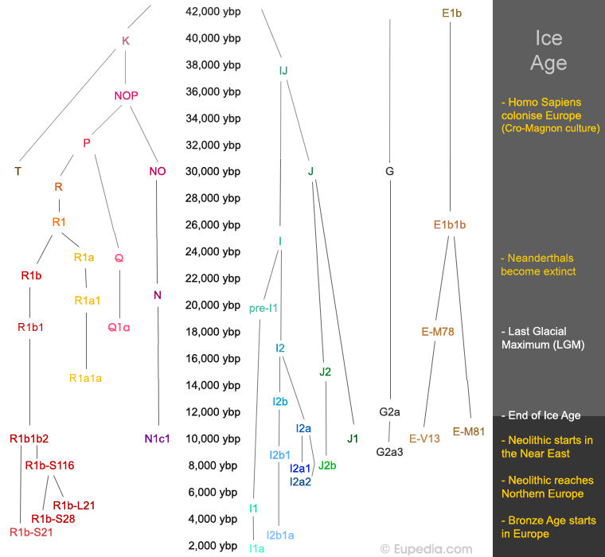

This single well-supported, peer reviewed, and frankly obvious fact destroys the entire backbone of British Israelism with a single blow. If ethnically Jewish people are a distinct population from Europeans, there’s no way they can be closely related. Arabs, Jews and others within the region are certainly interrelated. One needs to go back a long way, [some 45,000 years ago](http://www.eupedia.com/europe/origins_haplogroups_europe.shtml#Timeline), to find the common ancestors of Jews and Europeans (haplogroups J and R respectively).

J1 and J2 are the haplogroups associated with Middle Eastern and Mesopotamian peoples. [Check out these maps](http://www.eupedia.com/europe/origins_haplogroups_europe.shtml#J1) to see where [all the Israelite’s aren’t](http://www.eupedia.com/europe/origins_haplogroups_europe.shtml#J1) in any great abundance:

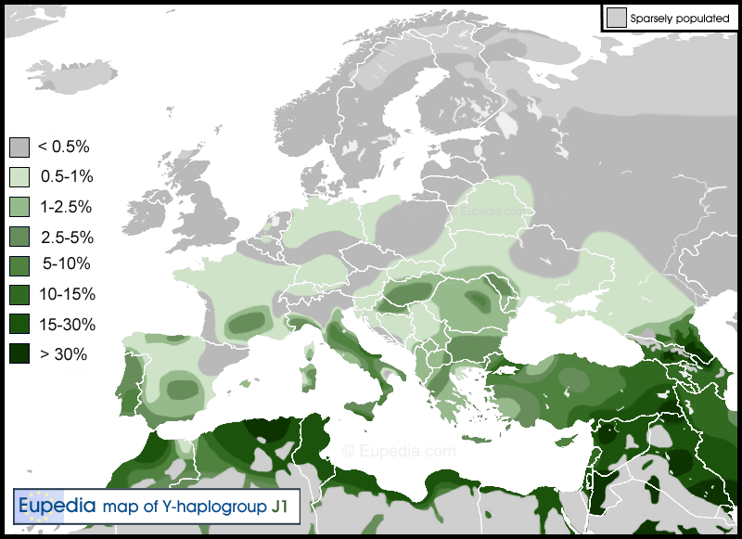 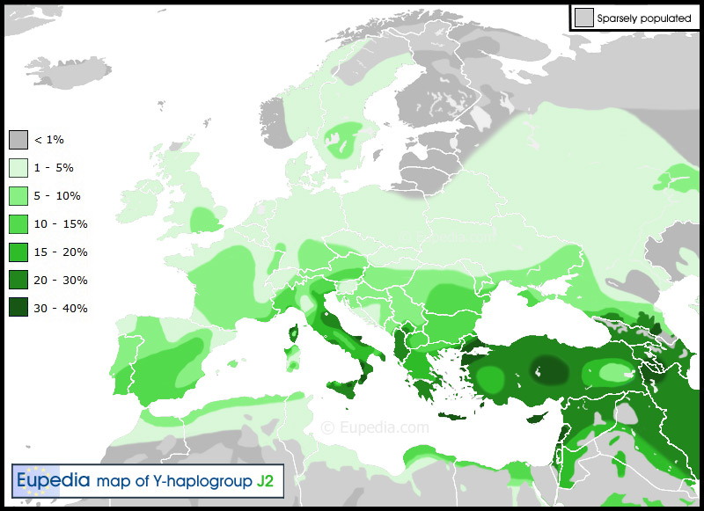

Now let’s contrast that with [haplogroup R1a](http://www.eupedia.com/europe/origins_haplogroups_europe.shtml" \l "R1a" \t "_blank) and [R1b](http://www.eupedia.com/europe/origins_haplogroups_europe.shtml#R1b), most associated with Europeans:

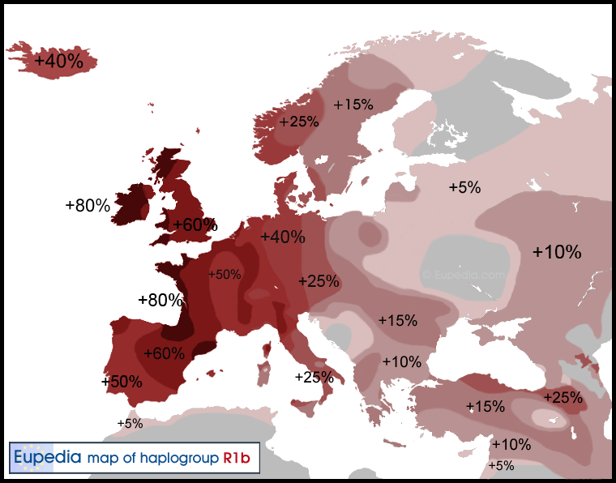

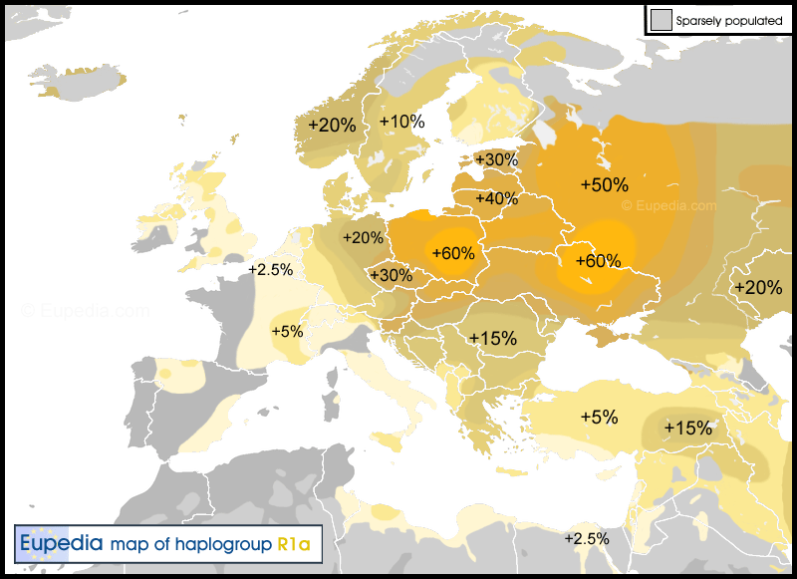

The conundrum facing British Israelists is this:

a.) if the Jews and Europeans are not closely related, then they cannot be descended from Israelite tribes, so British Israelism is false.

b.) if they try to claim that the “lost” tribes intermarried into other populations to cause them genetically diverge, unlike the Jews, then their prophecies are invalid, as Israel was supposed to be “sifted through the nations” according to [Amos 9:9](http://biblehub.com/amos/9-9.htm), a favorite scripture among British Israelists. If the Israelites lost their genetic purity, the whole game is over.

c.) the previous point is stupid because genetics still shows their claims are bunk, so British Israelists are toast in any scenario.

The whole ideology is founded upon a concept that is debunked by genetic science and was never supported by any facts anyway. It all falls apart.

**Conclusion**

Reviewing the “evidence” used to back the claims of British Israelism leaves it bereft of support from either science, linguistics, history, logic or even the Bible itself. It leaves the COG’s castle resting on a foundation of sand, to conjure a parable its ministers are so fond of. Unless the United States, Britain and Western Europe are actual physical descendants of the so-called Lost Ten Tribes of Israel, Armstrongism’s web of theology unravels on itself.

Armstrongites willfully ignore their religion’s flimsy groundwork because deep down they know it all falls apart. Everything in their world is subtly viewed through British Israelism’s lens. To remove that filter and force them to look upon the world as it actually is would be too shocking for most diehard COG members.

**The Crumbling Castle**

Yanking the stray thread of British Israelism unravels Armstrongism’s quilt. HWA called British Israelism the “key” to understanding prophecy and the Bible.

Unless the Western European peoples are the physical descendants of the children of Abraham, and therefore subject to the blessings and curses bestowed upon them in the Old Testament, which includes the blessings on Joseph’s sons Ephraim and Manasseh, whose descendants would have to be Britain and the United States respectively, then COG views of prophecy go completely out of whack. It means the U.S. and U.K. wouldn’t play a major role in prophecies that apply to Israel, meaning the end is it not soon because the prophecies bestowed on the children of Israel have either not yet come to pass or already did an extremely long time ago, meaning everything that Armstrongites have been preaching for 80-odd years is completely and utterly wrong.

And it shows. Armstrong made many false prophecies over his career. Not a single thing he predicted came to pass. If he thought British Israelism was the key to Bible prophecy, he was clearly jiggling it in the lock of the wrong door.

It also means this isn’t the “final era of the church” and therefore there’s no excuse for the COG to be failing as much as it is, because wouldn’t they logically still have a gospel to preach? And wouldn’t it also mean the bulk of its previous gospel is debunked, placing the cults back at square one of attempting to find spiritual understanding?

Without Armstrongism’s unique patchwork of theological ramblings, the COG no longer has a reason to exist. What does it have to offer that other seventh-day, millenialist or messianic Jewish groups don’t already? As the COG cults already struggle to find a wider identity in an world that’s passed them by, its irrelevance is even deeper without the cornerstone of British Israelism to rest upon. Decades of sermons and booklets and media campaigns are rendered obsolete and invalid.

Typically, criticizing religious beliefs can be very difficult because they tend to be rooted in faith — belief in the unseen or undetectable — and therefore cannot be falsified. These beliefs exist in a vacuum, claiming little to nothing in the way of physical evidence to back them. This typically leads to models of thinking that either resemble impenetrable circular logic or “pillars of faith” that support a belief, where knocking one down doesn’t bring the structure down. The other pillars support the individual’s faith until the damaged one is built back up.

British Israelism is not subject to such protections, since it long ago wandered into the battlefield of psychical sciences, cultural studies and academic rigor, attempting to flex its muscles in an arena where it arrived ill-equipped, unprepared and entirely ineligible to fight. It drags the believer from the relative safety and security of religion’s house and into the oncoming traffic of pseudoscientific claims, where its tenets can be measured, weighed, tested, scrutinized and easily dismissed.

Without British-Israelism, Armstrongism collapses, as does anything else with a foundation of sand.