Keanu Foltz

Module 1.2

10/27/24

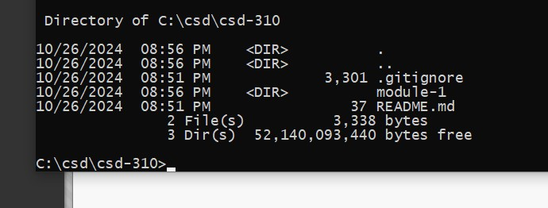

https://github.com/Silent-clippers/csd-310.git