Keanu Foltz

11/24/24

CSD-310

Run the SQL script:

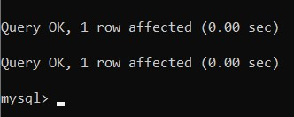

Show tables:

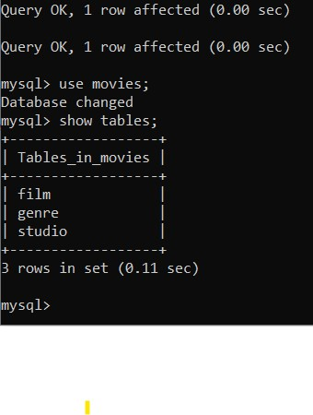

mysql_test.py:

