Cross-Sectional Momentum in Cryptocurrency:
A Net-of-Costs Replication on Tradable Binance Perpetuals (2020–2026)
Oleg Arefev
Independent Researcher
This version: September 2026

Abstract
Cross-sectional momentum is among the most extensively documented anomalies in asset pricing, and it has been documented in cryptocurrency markets on broad, market-cap-ranked samples. Almost all of that foundational evidence, however, is estimated on data drawn largely from 2014–2020, on universes that include an illiquid tail and are reported gross of trading costs. This note asks a narrower, practitioner-facing question: on a universe of instruments directly tradable by eligible retail participants on Binance USDⓈ-M perpetual futures, does a cross-sectional momentum spread remain statistically distinguishable from zero after realistic costs over the more recent 2020–2026 period? Using an independent replication (832 archived perpetual symbols, a daily-close panel, pre-committed J/K parameters, explicit survivorship handling, and three significance tests with different dependence assumptions), we find that neither of the two literature-backed specifications permitted under a pre-committed protocol (J=1/K=1 and J=2/K=2) yields a net-of-costs spread distinguishable from zero under any of the three tests. The gross J=1/K=1 spread (+0.573%/week) is of the same order of magnitude as realistic costs (0.40 pp/week) and disappears into noise once they are subtracted; the J=2/K=2 net spread additionally flips sign with an arbitrary choice of rebalancing phase. The contribution is a source-verified synthesis of the existing evidence, an independent net-of-costs test on an actually tradable universe, and a recency check against a literature whose base sample largely predates 2021. We do not claim momentum is a myth: we show that a deliberately constrained, cost-realistic implementation on a tradable universe does not translate directly from the academic literature into a tradable retail strategy.
Keywords: cryptocurrency; cross-sectional momentum; market microstructure; transaction costs; replication; retail trading; Binance perpetual futures.
JEL classification: G11, G12, G14.
License: CC BY-NC-ND 4.0. Replication code and figures: github.com/Silent47boryara/searching-for-edge.

1. Introduction
Cross-sectional momentum — buying recent winners and selling recent losers — is one of the most extensively documented anomalies in empirical asset pricing, documented across equities, currencies, commodity futures, and bonds over decades. In cryptocurrency it was documented systematically by Liu, Tsyvinski, and Wu (2022), where momentum is one of three factors in a model estimated on more than 1,700 coins. A distinctive feature of this literature is that the full chain can be traced: an academic finding, a practitioner adaptation by an asset manager (Starkiller Capital, 2023), and — in this note — an independent replication on a specific, actually tradable universe.
This note separates two questions that are easy to conflate. The first is scientific: does the momentum anomaly exist in crypto? The peer-reviewed literature provides substantial evidence that it has existed in broad cryptocurrency samples over multi-year windows, and nothing here disputes that evidence. The second is practical: can an ordinary trader capture it today, on the instruments actually available, after paying real costs? These are different questions with different answers, and the gap between them is the subject of this paper.

2. What the underlying literature claims
Liu, Tsyvinski, and Wu rank coins by past return over 1–4 week formation horizons. On the full universe, the long-short spread is significant across all four horizons at once: +2.7%/week (1 week), +3.3%/week (2 weeks), +4.1%/week (3 weeks; the strongest, t = 2.742), +2.5%/week (4 weeks). This whole-universe result is the paper's headline.
An additional double sort in the same paper conditions on coin size. Below-median-cap coins show a spread of 0.6%/week (insignificant); above-median-cap coins show 4.2%/week (significant). A presentation by the same author (Yukun Liu, Nov 2019, slide 20) gives a closely related result: large coins +4.2%/week (t = 2.834), small coins −1.1%/week (t = −0.563, not significant, opposite sign). A substantial share of the effect is thus concentrated among larger, more liquid coins — a narrower cut, not a summary of the headline.
The authors also state an operational limitation plainly (presentation, slide 27, verbatim): “Strategies require shorting coins – difficult or impossible to do.” Replacing the short leg with shorting Bitcoin and controlling for their own three-factor model, the momentum alpha nearly vanishes: r1,0 from +2.5% to −1.6%; r3,0 from +2.8% to −0.1%. These are limitations visible directly in the primary source.

3. The recency problem: when the evidence was measured
The central caveat of this note is temporal. Most of the foundational crypto-momentum evidence is estimated on data that largely predates 2021:
• Liu, Tsyvinski, Wu (2022): CoinMarketCap sample through roughly 2019.
• Grobys & Sapkota (2019): 143 coins over 2014–2018 — headline finding, verbatim, “momentum is insignificant in the 2014–2018 sample period.”
• Dobrynskaya (HSE working paper): ~2,000 CMC coins, 2014–2020.
• Li & Zhu (2024): in-sample 2014–2020, out-of-sample 2020–2023.
There is also an independent sign of decay in fresh data. Grobys et al. (2025) report that for large-cap coins over January 2016 – July 2020 momentum earned 1.74%/week (significant only at 10%), and that starting from the end of that window — after July 2020 — average momentum returns turn negative and statistically insignificant. In other words, the very period our replication covers (2020–2026) is precisely where independent work already finds the effect fading. That is the motivation for testing on recent, tradable, cost-realistic data rather than re-citing pre-2020 gross results.

4. Evidence from a practitioner implementation: Starkiller Capital
Starkiller Capital (Drogen, Hoffstein, Otte) published “Cross-sectional Momentum in Cryptocurrency Markets” in January 2023 (SSRN 4322637) — a professional asset manager, with an explicit in-sample/out-of-sample split spanning the 2021–2022 crash. Their out-of-sample result is not about making money but about losing less than the market: the top momentum quintile lost −2.35% annualized, against −29.93% for an equal-weighted market portfolio and −37.82% for Bitcoin. Momentum did not produce an absolute profit over this window, but clearly beat the market in relative terms — an economically meaningful, but different, form of value.
Several details are particularly relevant from a retail-trading perspective. The study identifies a concrete cost threshold at which the strategy stops being viable: at 125 basis points of total costs, the top quintile underperforms the benchmark. It chose long-only rather than long-short, stating directly that shorting the broad tail of coins is difficult and expensive. And the markedly better headline figures (93.3% annualized vs 37.8%; drawdown 45% vs 75%) come only after adding a regime overlay — exit to cash when Bitcoin's trend turns down — which the fund treats as a separate, independently tested layer on top of the bare momentum factor, not part of it. Even for a professional fund with a public track record, in other words, the plain factor was neither a free lunch nor its centerpiece: it required an overlay and delivered mainly relative, not absolute, value. We rely here on their published backtest, not on confirmed live execution.

5. Data and methodology
The replication (“Lab 06”) is a standalone test of the academic hypothesis, independent of the author's live detector. The universe is 832 Binance USDⓈ-M perpetual symbols on a daily-close panel, 2020-01-01 to 2026-07-31 (2,404 days). Restricting to Binance perpetuals is deliberate: a broader multi-exchange universe would introduce exchange-level survivorship bias (venues such as FTX no longer exist), and momentum returns on illiquid names evaporate once spreads and slippage are incorporated — Binance perpetuals physically exclude the most illiquid tail. Given the size-sorted evidence discussed in Section 2, restricting the universe to more liquid, derivatives-listed assets does not obviously bias the test against momentum.
Parameters were fixed before looking at results under a pre-committed protocol: ranking at Sunday close, entry at Monday open, exit at the following Monday open (for J=1/K=1); 7-day trailing momentum; equal-weighted quintile baskets, top-quintile long and bottom-quintile short; a fixed liquidity threshold of trailing 30-day median daily turnover ≥ $1,000,000 (an absolute number, not a relative decile); explicit rules for delisting or a missing entry/exit price (forced close at the last available price, reason tracked). Significance is assessed with three tests, each with a different dependence model: a weekly bootstrap confidence interval, a weekly sign-flip randomization test, and a within-week permutation test.
Two data-handling choices are particularly important for the validity of the result. First, the symbol list and history come from the public data.binance.vision archive rather than the live exchangeInfo endpoint, which returns only what trades today; the archive retained 832 symbols, 31 of them already delisted from exchangeInfo (e.g., AERGO, AKRO, ANC, ANT, BTCST, BZRX, BTT) — exactly the delisted short-leg names a naive pull would silently drop, biasing the result favorably. Second, the assembled panel passed five independent checks before any spread was computed, including a decisive test for hidden forward-fill: had missing prices been carried forward, the match rate between open[t] and close[t-1] would approach 100%; it was 42.5% (median discrepancy 0.0079%), confirming real, not forward-filled, values. Forward-fill is exactly the kind of hidden error that inflates statistical significance by manufacturing data where none exists.
One construction difference from the primary source is flagged in advance: the headline LTW quintile portfolios are value-weighted (“the mean returns are the time-series averages of weekly value-weighted portfolio excess returns”, repeated verbatim in each table caption), whereas this replication uses equal weights. Regime filters and stops are excluded by design — the tests below evaluate the bare momentum spread, following Starkiller's own separation of the overlay from the factor.

6. Gross result
Over the full history (338 independent weeks, 2020-02 to 2026-07; median universe after the liquidity filter, 175 coins), the headline spread before costs is +0.573%/week (mean), +0.413%/week (median), with 52.7% of weeks positive. Dispersion is large: the weekly standard deviation is 6.94 pp — roughly twelve times the average effect.
Leg | Mean/week | Median/week
LONG (top quintile) | +1.055% | −1.542%
SHORT (bottom quintile) | +0.482% | −1.000%
SPREAD (long − short) | +0.573% | +0.413%

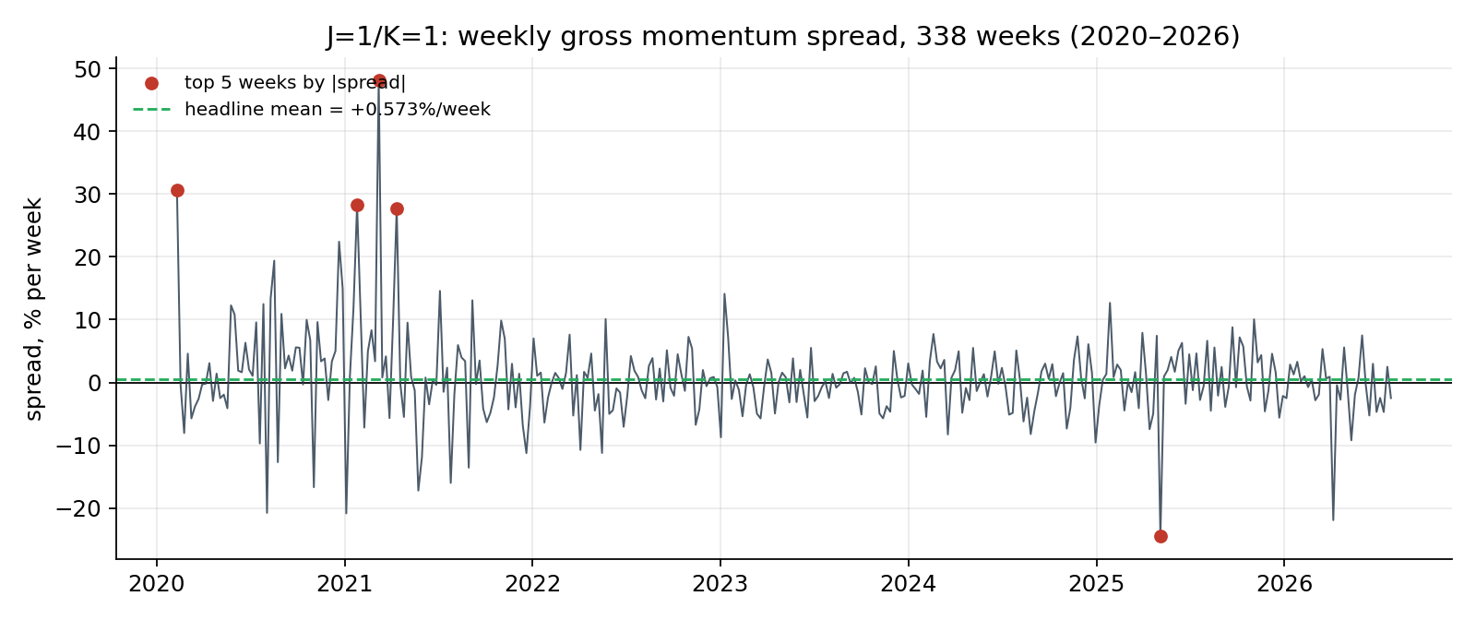
Figure 1. Weekly gross momentum spread, 338 weeks, 2020–2026. The headline mean (+0.573%/week) sits near zero against a range that reaches +48% and −24% in individual weeks.
The three significance tests disagree: the 95% bootstrap CI is [−0.147% … +1.340%] (covers zero); weekly sign-flip p = 0.134 (not significant); within-week permutation p = 0.035 (significant). One of three is significant. Consistent with the pre-committed protocol, the gate decision is made after costs, not on the gross number. An outlier/jackknife check finds no dependence of the sign on one or two weeks (leave-one-out range +0.432%…+0.647%).

7. Net of costs
The cost model was fixed before the calculation: a Binance USDⓈ-M taker fee of 0.05% per side (base, no VIP discount) plus an assumed 0.05% per side of slippage — 0.20% per leg round-trip, 0.40 pp on both legs per week. Taker, not maker, is used deliberately: scheduled weekly rebalancing requires entering at market. Funding is excluded rather than imputed: the available archives cover only 7.7% of positions and zero weeks with full basket coverage, so substituting zero would falsely assert funding was zero. The reported net returns should therefore be read as net of fees and assumed slippage, but not funding.
Series | Mean/wk | Median | Weeks>0 | Bootstrap CI95 | p sign-flip | p perm
GROSS | +0.573% | +0.413% | 52.7% | [−0.147 … +1.340] | 0.134 | 0.035
NET (fees+slippage) | +0.173% | +0.013% | 50.0% | [−0.551 … +0.941] | 0.653 | 0.804

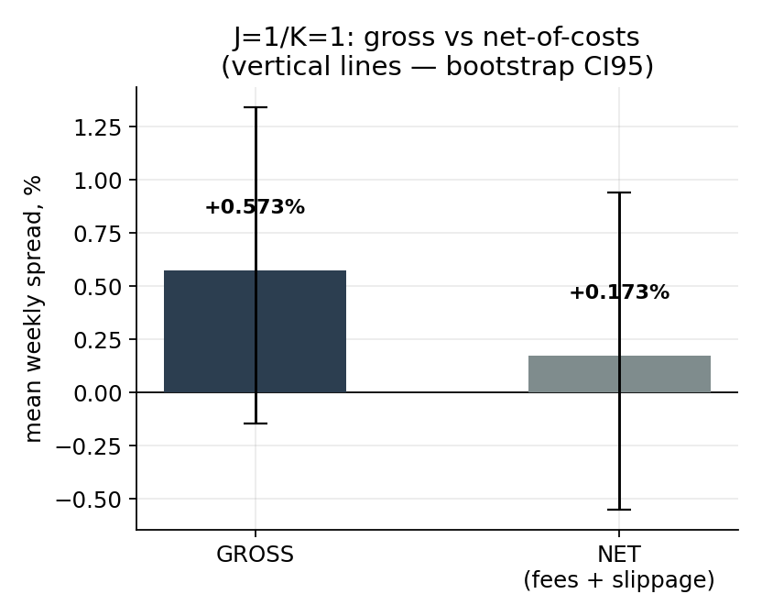
Figure 2. Gross vs. net-of-costs spread (J=1/K=1) with confidence intervals. After costs the interval shifts noticeably toward the negative region.
Costs absorb 0.40 of the 0.573 pp — roughly 70% of the gross spread. The remaining net spread is positive in sign but fails all three tests: the interval comfortably includes zero, both p-values are far past conventional thresholds, the median weekly spread is close to zero, and the share of profitable weeks falls to precisely 50.0%. An independent external check on a different universe agrees qualitatively: Dobrynskaya, on the same J=1/K=1 specification over ~2,000 CMC coins (2014–2020), finds a positive but insignificant effect (t = 0.80) — the weakness of the one-week horizon is not an artifact of this particular Binance implementation.

8. Why the significance statistics themselves deserve caution
Grobys et al. (2025) model the tail behavior of large-cap crypto momentum returns and find the variance statistically undefined — realized variance follows a power law with exponent α < 3, formally implying infinite theoretical variance; in their sample a single outlier (0.24% of observations) accounted for 37% of the strategy's total compounded return. Under such heavy tails, t-statistics, Sharpe ratios, and ordinary confidence intervals can lose their standard properties — not because the arithmetic is wrong, but because the finite-variance assumption behind their usual interpretation may not hold. This does not overturn our net result (already indistinguishable from zero across three tests); it is a reason to treat significance tooling with additional caution in both directions — for rejecting and for confirming.

9. The stronger horizon does not survive either: J=2/K=2
The second specification was not selected arbitrarily. Li & Zhu (2024), single-sort value-weighted quintiles across three periods, give the momentum group by horizon:
Horizon | In-sample | Out-of-sample | Full sample
r1,0 (1 wk) | 3.6% (t=2.64) | 1.6% (t=2.32) | 2.9% (t=3.16)
r2,0 (2 wk) | 4.0% (t=3.78) | 3.8% (t=4.94) | 3.9% (t=5.32)
r3,0 (3 wk) | 4.0% (t=3.83) | 2.2% (t=3.03) | 3.3% (t=4.66)
r4,0 (4 wk) | 3.1% (t=3.07) | 2.0% (t=2.74) | 2.7% (t=3.87)

The one-week horizon is significant in all three columns but is consistently the weakest of the group; the two-week horizon is the most robust (Li & Zhu themselves select two-week momentum for their own factor model). Dobrynskaya independently reaches the same ranking. Per the project's pre-committed rule (fixed 07.08, before the net result was known), exactly one literature-backed alternative is permitted if J=1/K=1 fails net-of-costs: J=2/K=2 (two-week formation and holding, non-overlapping periods). Non-overlapping periods split Mondays into two mutually exclusive phases, both declared in advance — Phase A headline, Phase B diagnostic — so that picking a phase after seeing results is not possible.
Series (net) | Per 2 wks | Per week | Median/2wk | Tests passed
Phase A (headline) | +0.858% | +0.429% | +0.071% | 0 of 3
Phase B (diagnostic) | −0.151% | −0.076% | −0.327% | 0 of 3

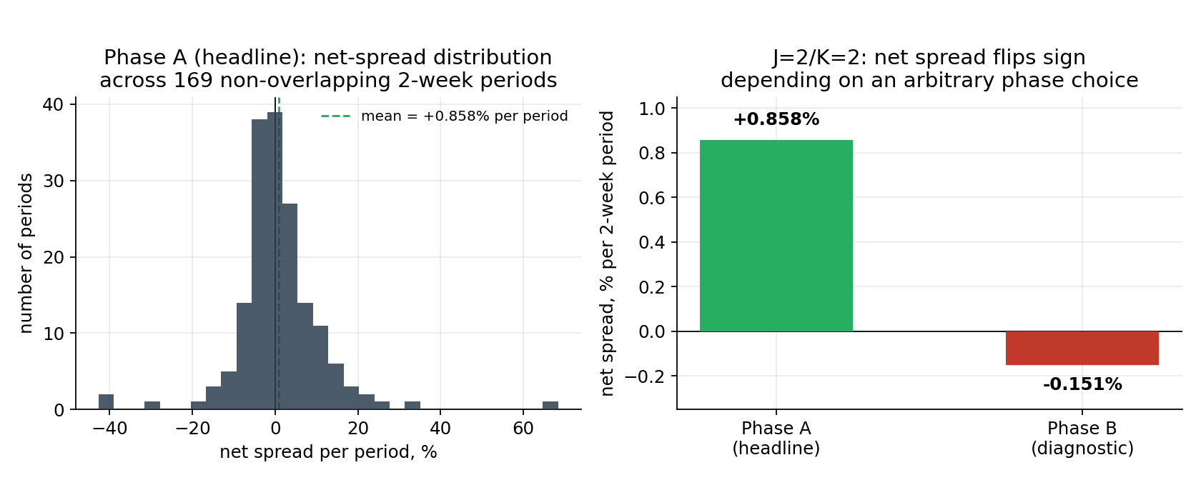
Figure 4. Left: net-spread distribution across 169 Phase-A periods — the positive mean is driven by a right tail (a few periods at +30–65%), consistent with heavy tails. Right: the sign reversal between Phase A and Phase B, whose only difference is which Monday the non-overlapping windows start from.
Neither phase passes any test. What is decisive for interpretation is not the insignificance but the difference between phases: a 1.0 pp/period gap whose only source is an arbitrary, information-free choice of start Monday, and which flips the sign of the result. Even had one phase passed formally, that number could not be trusted knowing an equally valid neighbor gives the opposite sign. J=2/K=2 does have lower relative costs (0.20 pp/week vs 0.40), but this is insufficient to alter the conclusion. With both permitted specifications run, the Momentum class is closed to further parameter variation under the protocol.

10. A post-hoc liquidity cut (hypothesis, not result)
A cut by liquidity group, devised only after seeing the weak headline (strictly post-hoc), points in a direction consistent with Liu's large-coin concentration: the highest-turnover group shows +1.638%/week gross, significant on all three tests. But the gradient across groups is non-monotonic and some “significant” groups are carried by their mean while the median is negative. This is a hypothesis for pre-committed testing on independent data, not a found effect.
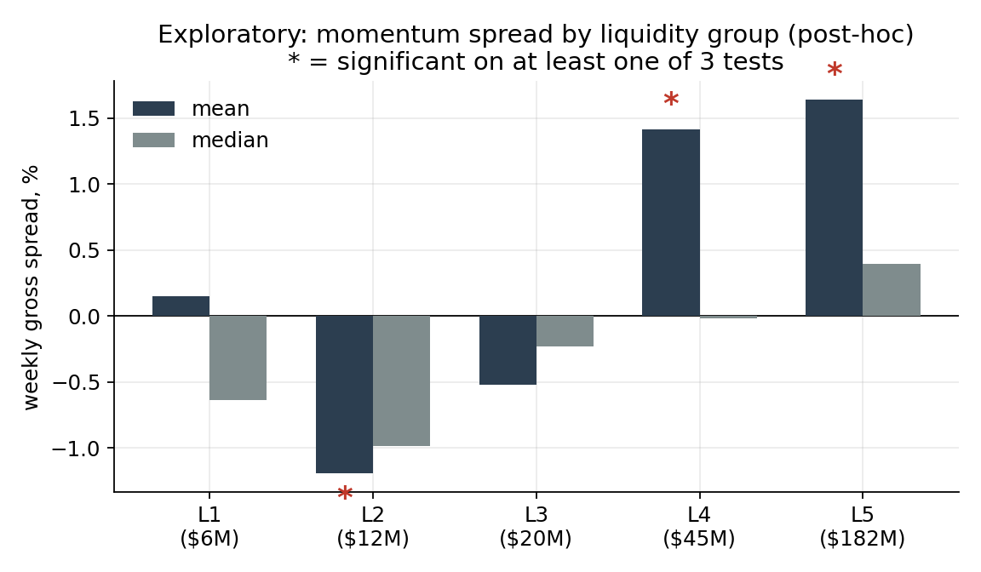
Figure 3. Gross momentum spread across five liquidity groups (post-hoc). The gradient is non-monotonic: L1 positive, L2–L3 negative, alignment with the “more liquid, stronger” story only from L4. Asterisks mark groups significant on at least one test (including L2, significant with the opposite sign).

11. Verdict
Academic evidence. Cross-sectional momentum has been documented as a statistically significant anomaly in broad cryptocurrency samples over multi-year periods, including evidence that the effect is stronger among larger coins. This paper does not dispute those findings.
Practitioner evidence. Starkiller Capital's published out-of-sample backtest delivered substantial relative value during 2021–2022 but negative absolute returns. Its stronger headline performance required a separately tested regime overlay, while the authors explicitly identified implementation costs and shorting constraints as material limitations.
Our replication. On 832 archived Binance USDⓈ-M perpetual symbols over 2020–2026, neither of the two pre-committed specifications produces a net-of-fees-and-slippage spread distinguishable from zero under any of the three statistical tests. For J=1/K=1, approximately 70% of the gross spread is absorbed by assumed implementation costs. J=2/K=2 is additionally unstable to an arbitrary rebalancing-phase choice.

12. Implications for a retail trader
The three levels point to the same conclusion: evidence that is well established in the academic literature does not necessarily translate into a practically exploitable retail strategy. The anomaly is well documented in the earlier academic evidence and had a real, measurable presence in that data — but a plain, cost-realistic implementation on the instruments actually accessible to eligible retail participants, over the recent window, does not clear the bar. The costs here are not a hypothetical haircut “for conservatism”; they are concrete numbers fixed before the calculation, and it is exactly they — not any flaw in the momentum hypothesis — that turn a formally positive gross spread into statistical noise.
This is not a claim that momentum is a myth, nor that a more elaborate build (longer horizons, a narrower liquid universe, a separately tested regime overlay in Starkiller's style) could not show a different result. It is a claim about the specific hypothesis tested here: a deliberately constrained implementation of an academic momentum hypothesis, on a real tradable universe, over recent data, net of realistic costs, is not a free lunch that can be lifted off a paper's page and run as-is. For a retail trader, that gap between “proven in a journal” and “capturable on my exchange after fees” is the entire point.
The result does not show that cryptocurrency momentum does not exist. It shows that evidence of an anomaly in historical market data is not equivalent to evidence of a currently tradable retail edge.

References
Dobrynskaya, V. “Cryptocurrency Momentum and Reversal.” HSE University working paper.
Drogen, L., Hoffstein, C., Otte, K. (2023). “Cross-sectional Momentum in Cryptocurrency Markets.” Starkiller Capital. SSRN 4322637.
Grobys, K., Kolari, J., Sandretto, D., Shahzad, S. J. H., Äijö, J. (2025). “Cryptocurrency momentum has (not) its moments.” Financial Markets and Portfolio Management, 39, 443–476.
Grobys, K., Sapkota, N. (2019). “Cryptocurrencies and momentum.” Economics Letters, 180, 6–10.
Li, J., Zhu, Y. (2024). “A LASSO Type Factor Model in Cryptocurrency.” Working paper.
Liu, Y., Tsyvinski, A., Wu, X. (2022). “Common Risk Factors in Cryptocurrency.” The Journal of Finance, 77(6). Also NBER Working Paper w25882.
Liu, Y. Conference presentation slides (Nov 2019). Double-sort size × momentum and shorting-constraint discussion.
Moskowitz, T., Ooi, Y. H., Pedersen, L. H. (2012). “Time Series Momentum.” Journal of Financial Economics, 104(2).
Han, Y., Zhou, G., Zhu, Y. “Taming Momentum Crashes: A Simple Stop-Loss Strategy.” SSRN 2407199.

