GPOS Provantis
User Manual
Comprehensive Operational Guide for Store Staff & Cashiers
Document Version: 1.0
Provided by: 5L Solutions Supply & Allied Services Corp.
System Version: GPOS Provantis v1.0

Table of Contents
Contents
1. What the dashboard looks like 4
2. Start a shift 7
3. Add items to the sale 9
Option A: Scan a barcode 9
Option B: Select from the product list 10
4. Change item quantity 11
5. Apply a discount 11
Remove a discount 13
6. Check the total 14
7. Charge the customer 14
8. Cash payment 15
9. E-payment 16
10. Split payment 18
11. Print the receipt 20
12. Use the Others menu 21
13. How to view and reprint receipts 22
14. How to use reports 24
15. How to use cash report 25
16. How to use view sold items 27
17. How to use re-print receipt 28
18. How to handle refunds 30
19. How to send an e-receipt 32
20. How to use cash drop 33
21. How to open the cash drawer 35
22. How to sync data 35
23. How to restart POS 36
24. End of shift 37
25. Common cashier tips 40
26. Common issues and what to do 40
The item does not show up after scanning 40
The customer wants a discount 40
The customer wants to pay partly in cash and partly by card 40
No receipt printed 40
Shift cannot be opened or closed 40
27. Quick reminder 41
28. Final note 41

This guide is for store staff and cashiers who use the dashboard every day. It explains the basic steps for selling items, applying discounts, taking payments, using the Others menu, and closing the shift. The instructions are simple and written for everyday use.

1. What the dashboard looks like
When you log in, you will see the dashboard. The main parts are:
- Product area: where items are shown and selected
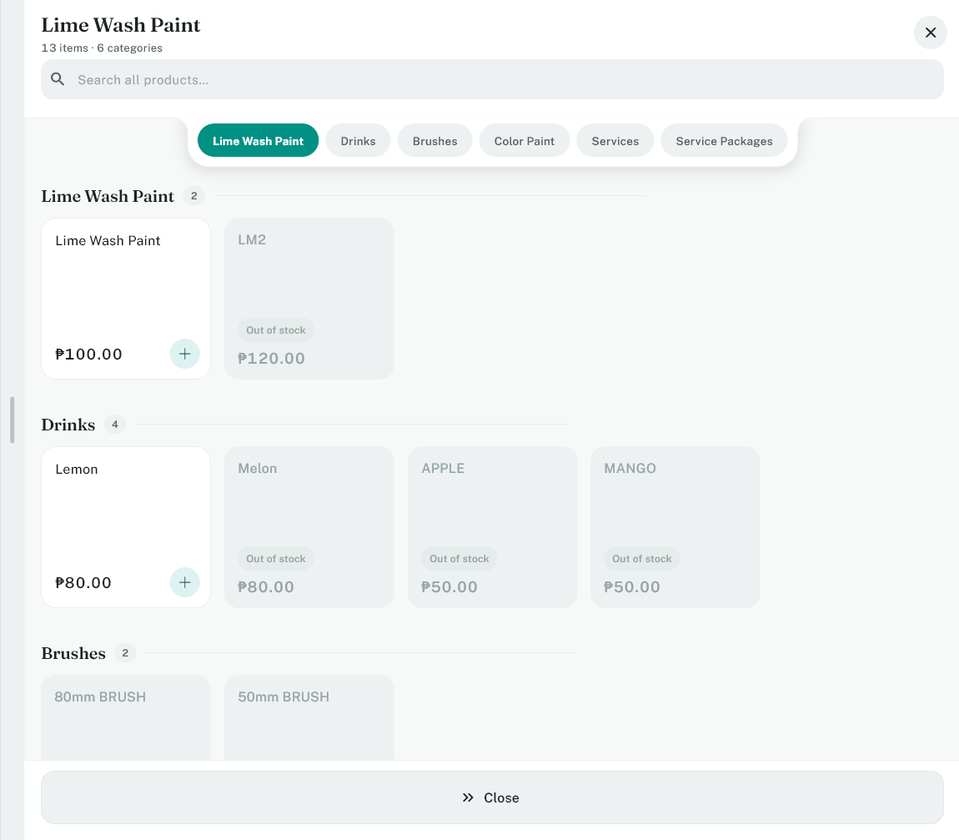

- Barcode field: where you scan or type a barcode
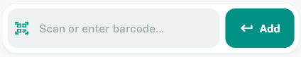

- Cart: where the selected items are listed
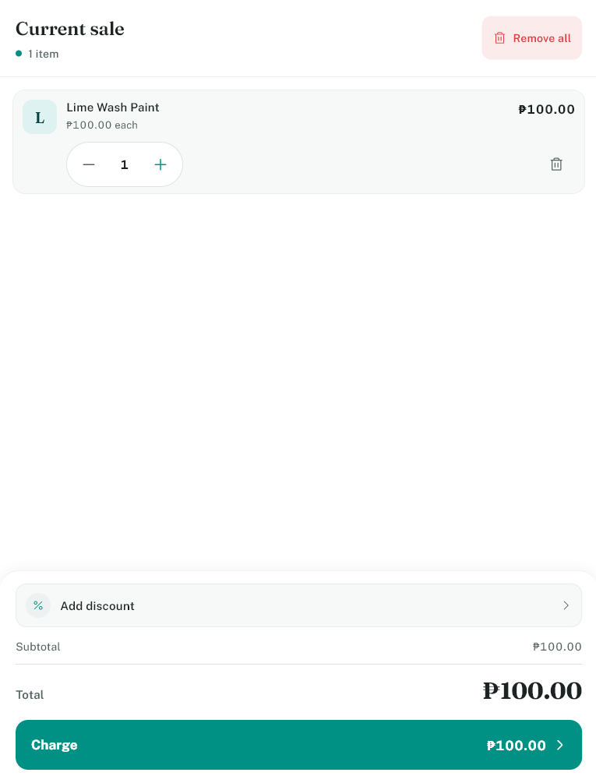

- Discount button: used to apply a discount
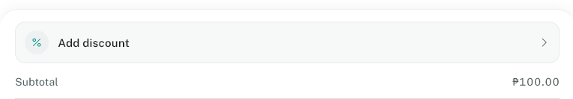

- Total area: shows the amount due
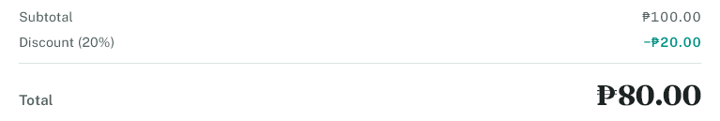

- Charge button: used to finish the sale
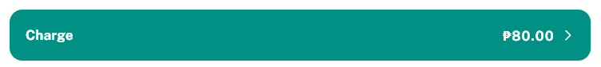

- Shift button: used to open or close the shift
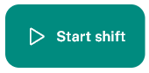

- Others button: used for extra actions like reports, cash drop, and printing
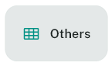

2. Start a shift
Before taking sales, you must open the shift.
How to do it:
1. Go to the dashboard.
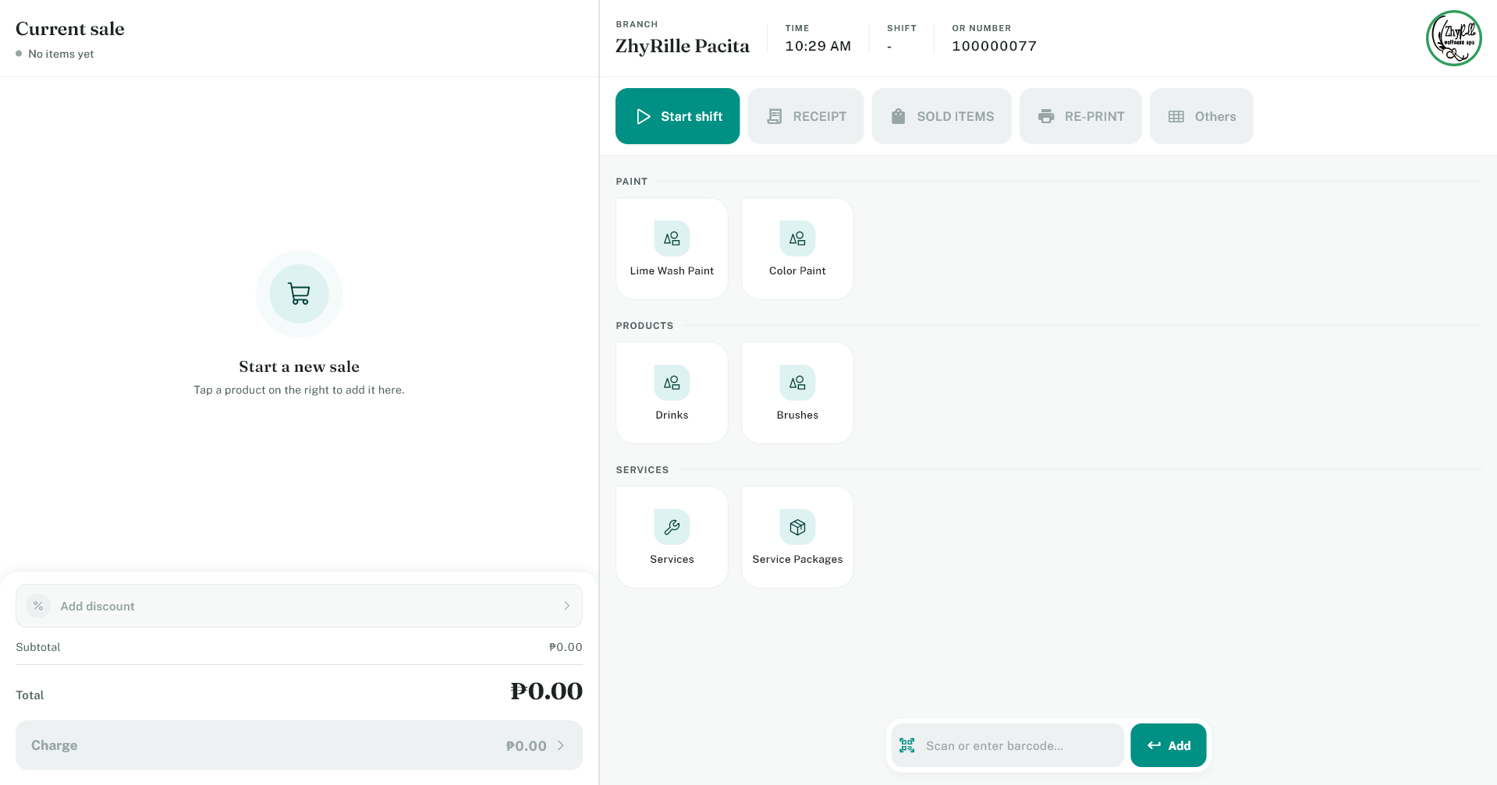

2. Tap the Start shift button.
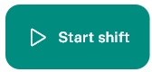
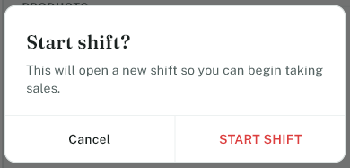

3. If prompted, enter the opening cash count.
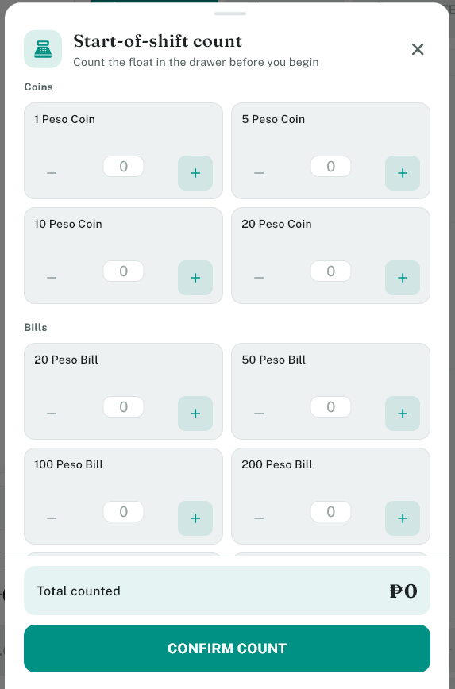
NOTE: This will only show up if the printer that is setup has Cash Drawer enabled.
4. Confirm the start.
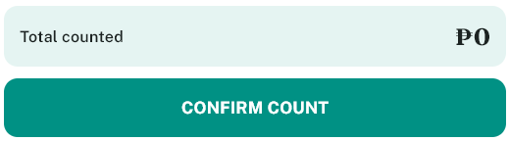

You are now ready to sell. When your work period ends, tap End shift to close it.
Important:
- Do not start selling before opening the shift.
- Always count cash before ending the shift.

3. Add items to the sale
There are two common ways to add products:

Option A: Scan a barcode
1. Place the item in front of the barcode scanner or type the barcode in the barcode field.
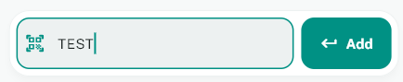

2. Press Enter or tap Add.
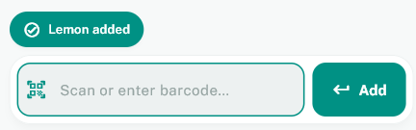
NOTE: This will automatically be entered when using the barcode scanner.

3. The item will appear in the cart.
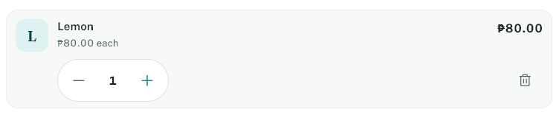

Option B: Select from the product list
1. Find the item on the dashboard.
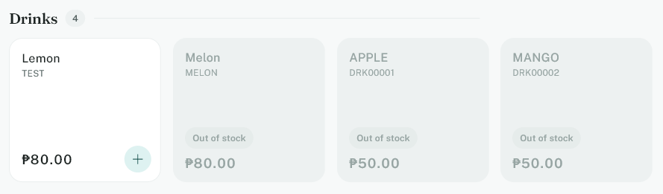

2. Tap the item to add it to the cart.
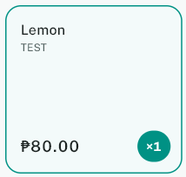

3. The item will appear in the cart with the quantity.
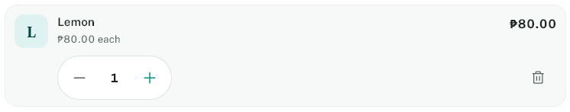

4. Change item quantity
In the cart, you can:
- add more quantity
- remove an item
- reduce the quantity
- delete the item if needed
Use the quantity controls on each item row. If a customer changes their mind, adjust the cart before payment.
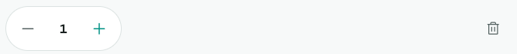

5. Apply a discount
To apply a discount:
1. Look at the cart area.
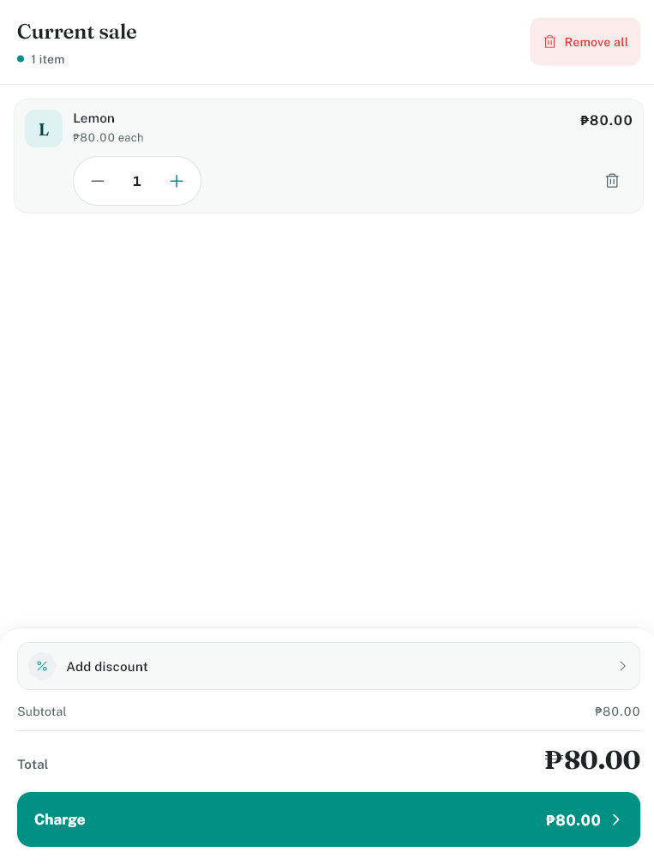

2. Tap the Add discount section.

3. Choose the discount from the list.
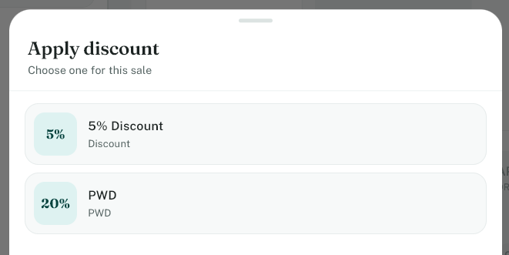

4. Confirm the discount.
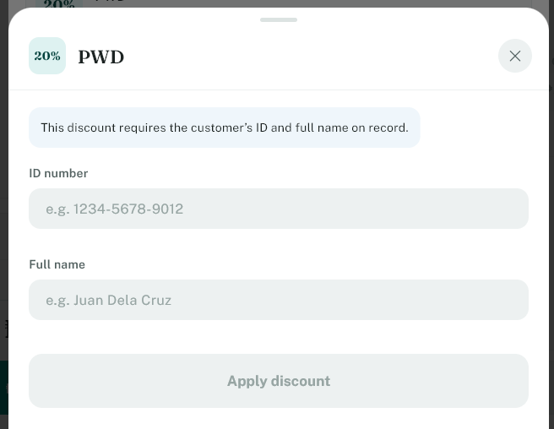
NOTE: PWD and Senior Discounts are required to have customer ID number and Full name to be entered.

The discount is then deducted from the total. You will see the discount amount in the totals area. If the discount needs customer information, the app may ask for a customer ID or name before applying it.

Remove a discount
If you need to remove it:
1. Tap the discount area again.

2. Tap Clear or Remove discount.
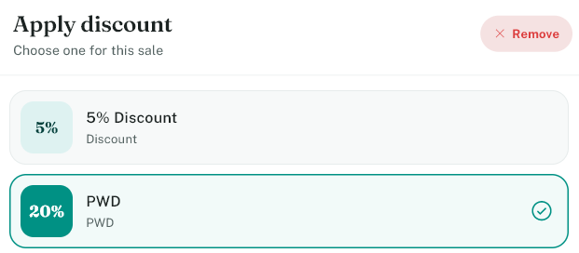

6. Check the total
Before charging, review:
- subtotal
- discount
- total amount due
Make sure the customer is charged the correct amount.
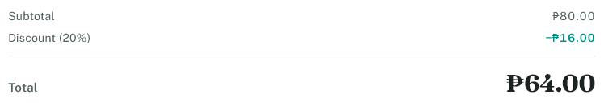

7. Charge the customer
When everything is correct:
1. Tap Charge.
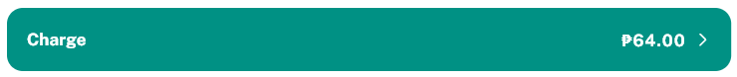

2. The payment screen will open.
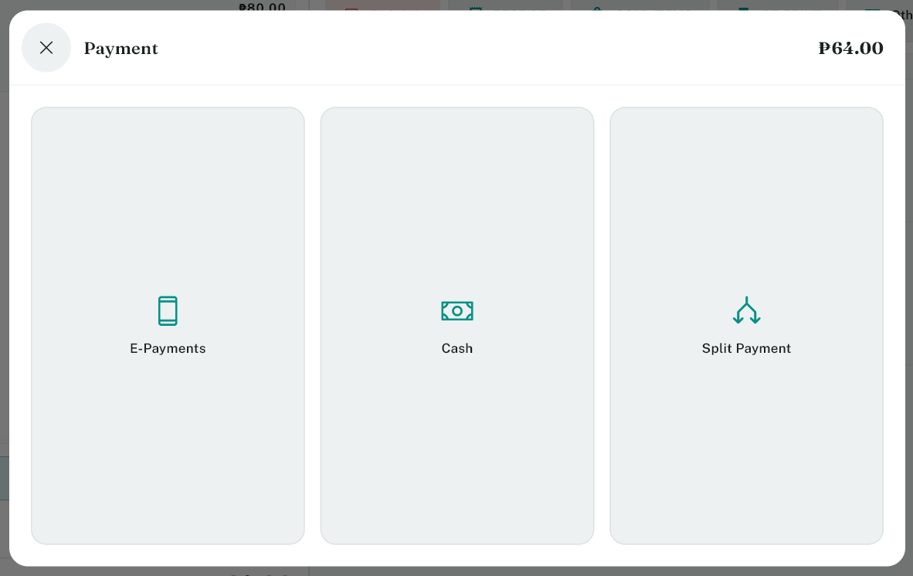

3. Choose the payment method.

You can use: Cash, E-payment, Split payment.

8. Cash payment
If the customer pays in cash:
1. Choose Cash.
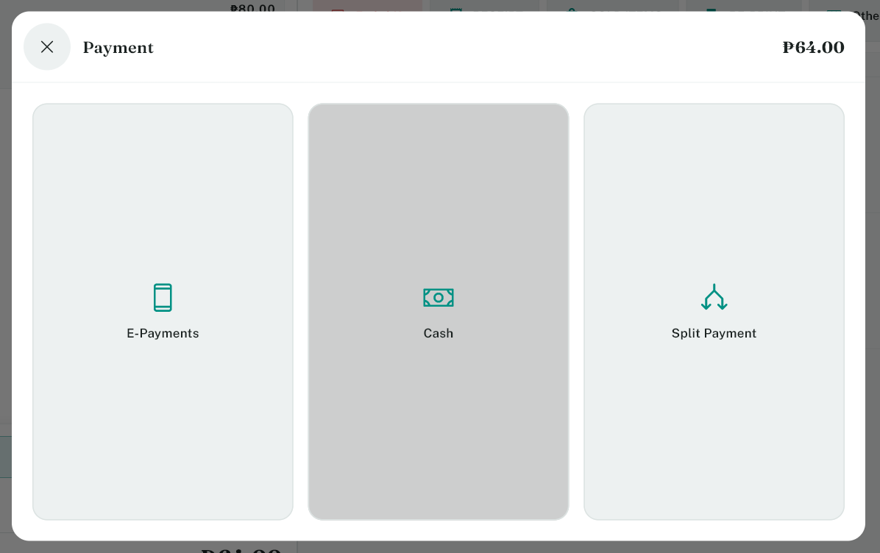

2. Enter the amount received.
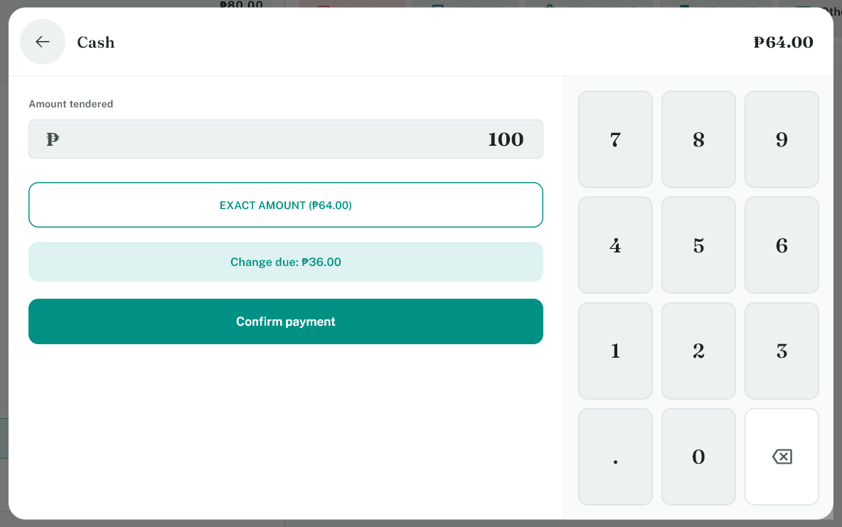

3. Confirm the payment.


The system will calculate: total due, amount received, change to return. If change is needed, return the correct amount to the customer.

9. E-payment
If the customer pays using an electronic payment method:
1. Choose E-Payment.
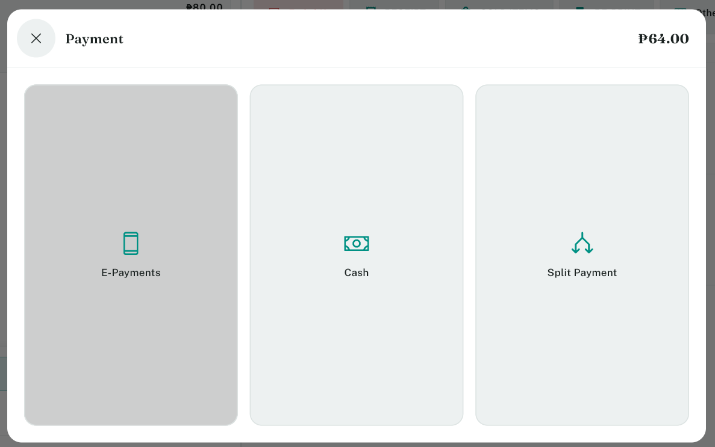

2. Choose the E-Payment provider.
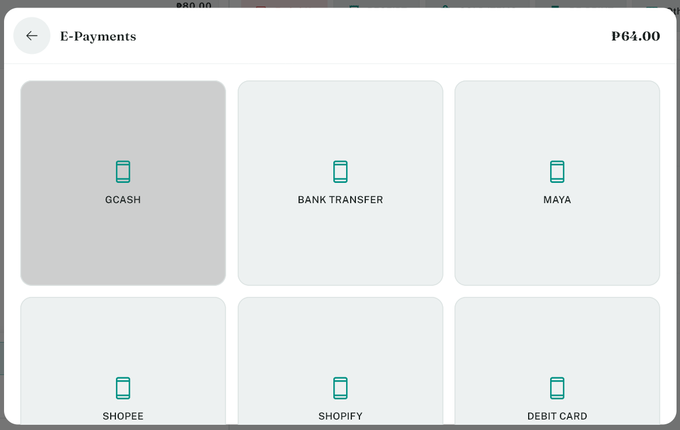

3. Enter Reference ID.
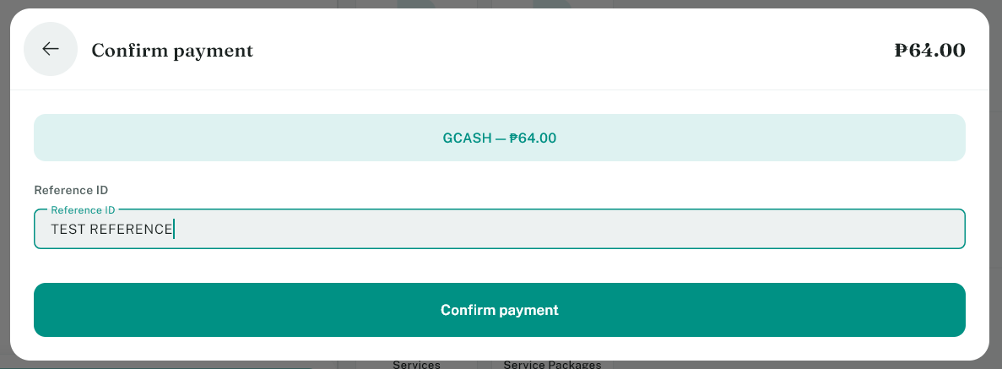

3. Confirm the transaction.

The receipt will then be printed if the printer is connected.

10. Split payment
Split payment means the customer pays using more than one method (e.g., cash part and card part).
How to do it:
1. Tap Split payment.
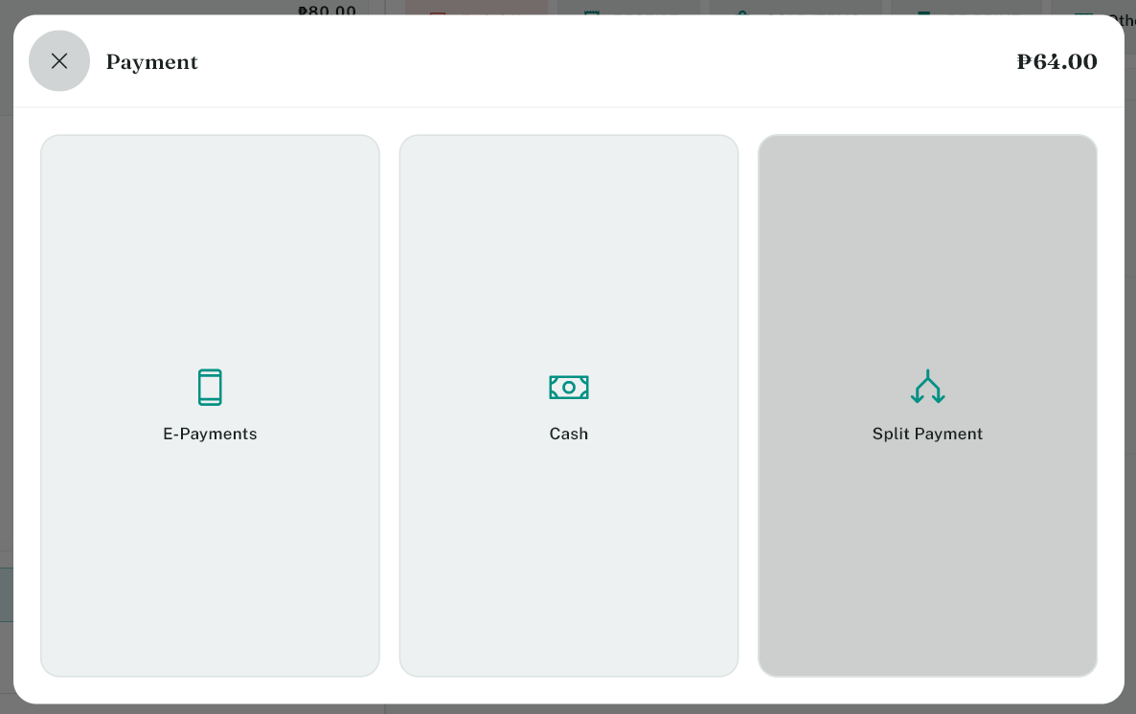
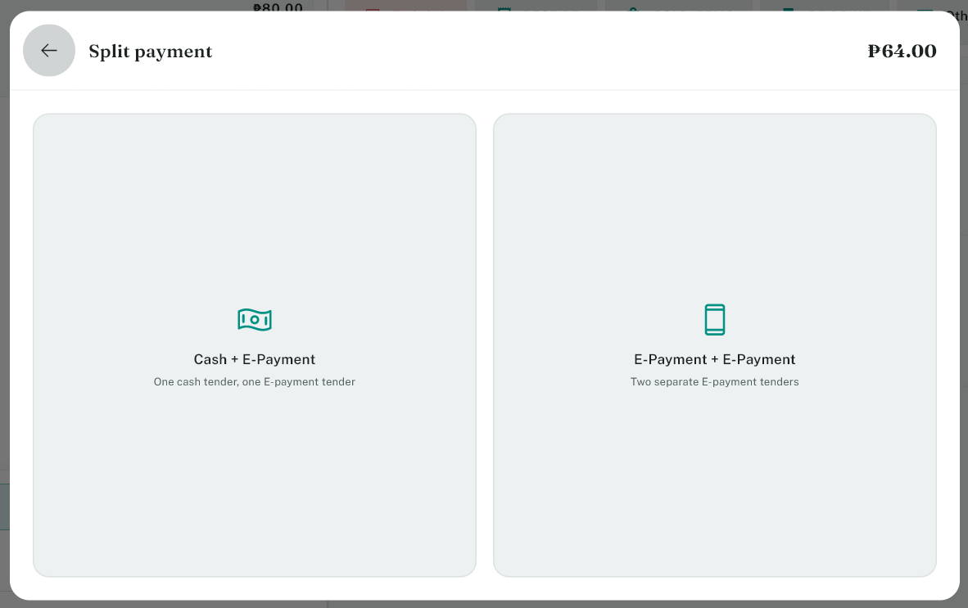

2. Choose how the total will be divided.
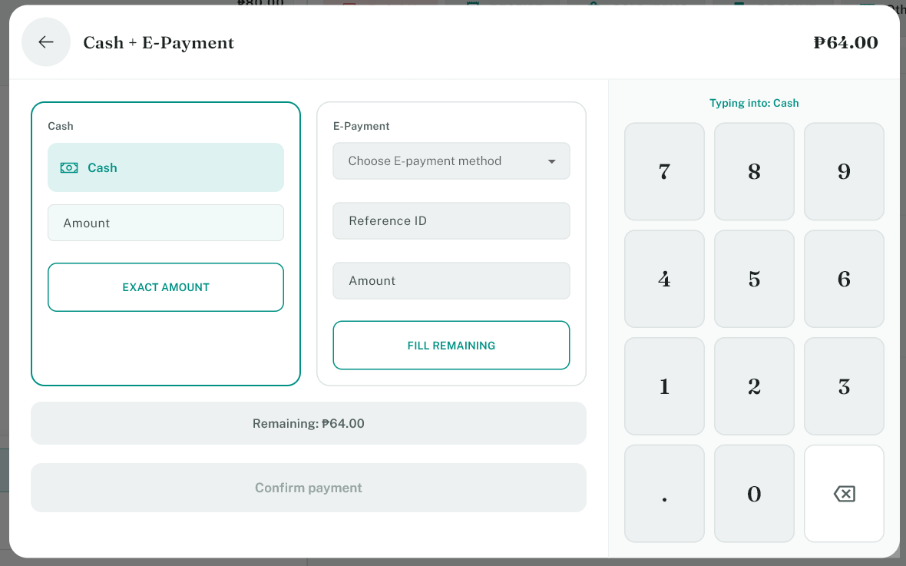

3. Enter the first payment amount.
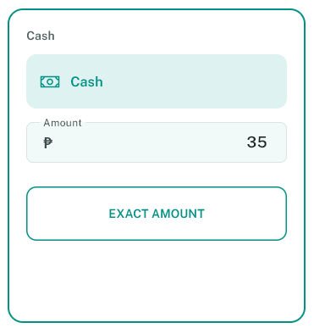

4. Enter the second payment amount.
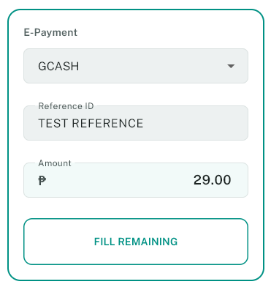

5. Confirm the transaction.


The app will check if the total matches the sale. If the amounts do not match, you must fix them before confirming.

11. Print the receipt
Once payment is complete, the receipt is usually printed automatically. If the printer is working, the customer receives a receipt.
If nothing prints:
- check the printer connection
- confirm the printer is configured
- check if the correct printer is selected

12. Use the Others menu
The Others menu contains extra actions used during daily operations. Tap Others on the dashboard. Some common options include:
- Reprint receipt
- Refund
- Send e-receipt
- Cash drop
- Open cash drawer
- Cash reports
- Receipts
- Reports
- Sold items
- Sync data
- Restart POS
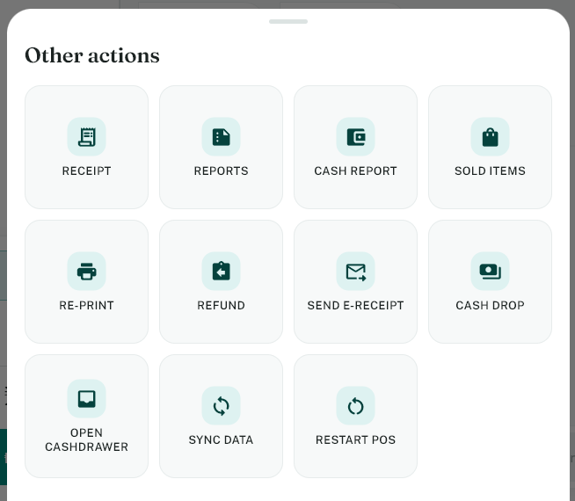

13. How to view and reprint receipts
Receipt is the screen where the user’s transactions are viewed. This will show all the previous and current transactions made on the POS machine.
- Tap Receipt.
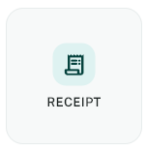

- Tap the Date on top of the screen to change the data.


- Tap the receipt to show the information.
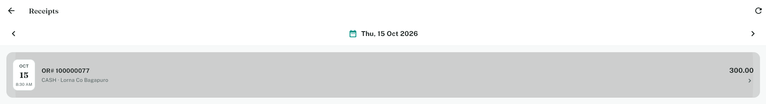
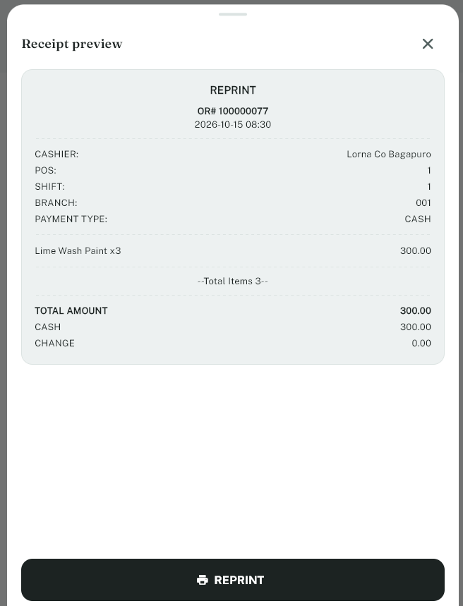

- Print the Receipt via the reprint button.


This will primarily be used to compare the digital receipt to the physical receipt and/or reprint receipts.

14. How to use reports
Reports is the screen to see the transactional information of each shift during the selected day.
How to view reports:
- Tap Reports
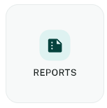

- Tap the Date above the screen to change transaction data.


- View the transaction information on the list.
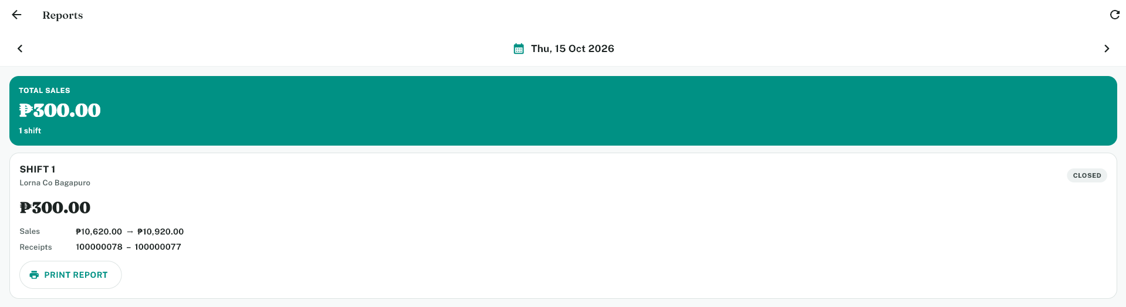

- Tap the print report button to print the shift report.
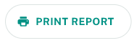

This is used to check the cashier’s shift report.

15. How to use cash report
Cash report is the cash denomination report of each cashier inside their shift.
How to view cash reports:
- Tap Cash Reports.


- Tap the Date to change the data of Cash Reports.


- Tap a shift to view the cash denomination.
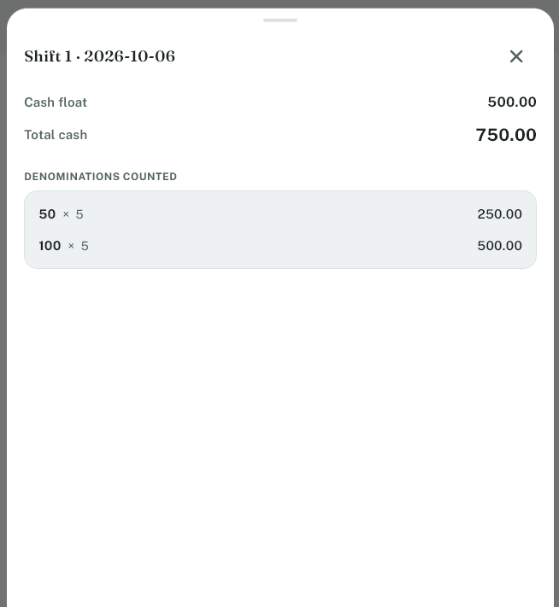

This will show all the denominations provided by the cashier during their shift.

16. How to use view sold items
Sold Items is the screen to view to check all sold items during the business day.
How to do it:
- Tap Sold Items.
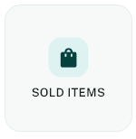

- Configure filters on the top to view specific data.
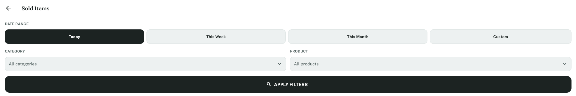
NOTE: You can simply click the Apply Filters to fetch the current business day’s sold items.

- View sold items inside the list.
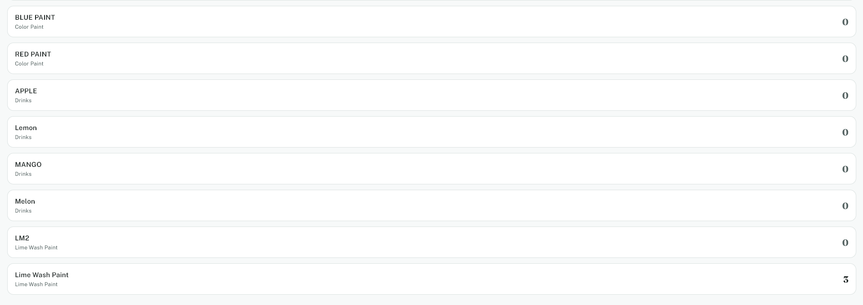

This will be used to check and compare inventory to sold items from the POS machine.

17. How to use re-print receipt
Re-print receipt is the feature that can be used by the user to immediately reprint a receipt via the OR-Number.
How to do it:
- Tap re-print receipt.
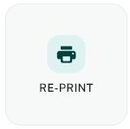

- Enter the OR Number.
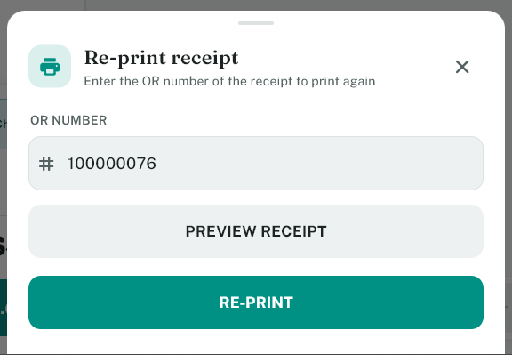

- Click Preview to view the Receipt.

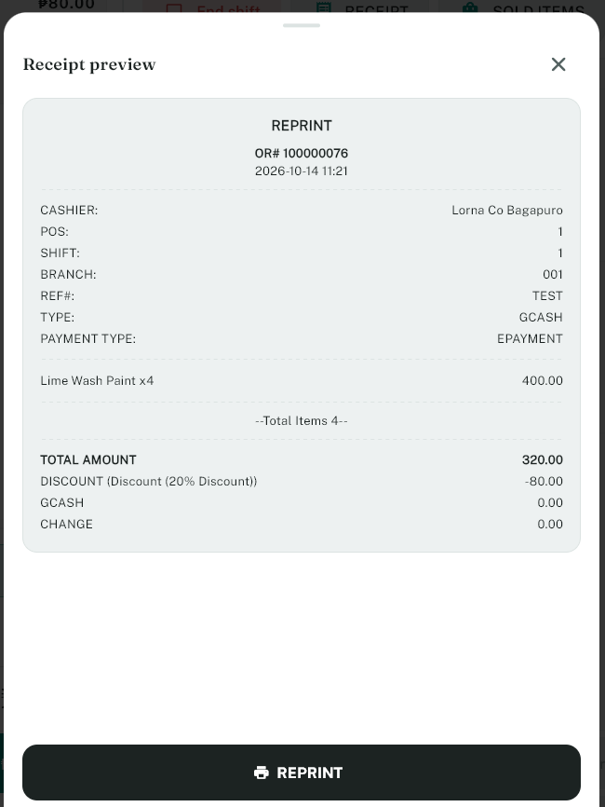

- Click the Re-Print button to re-print the receipt.


This is a quicker way to re-print older receipts than manually finding the receipt on the receipts screen.

18. How to handle refunds
If a customer wants a refund:
1. Tap Others.
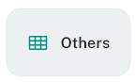

2. Tap Refund.
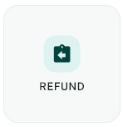

3. Follow the instructions on the screen.
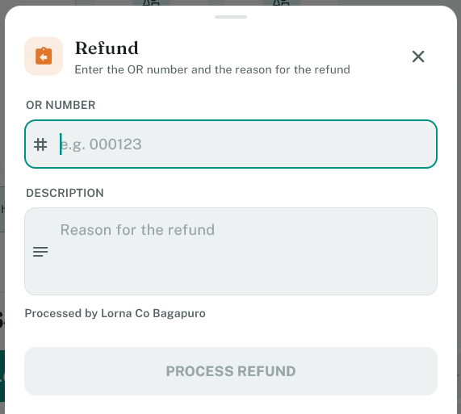

4. Confirm the refund.
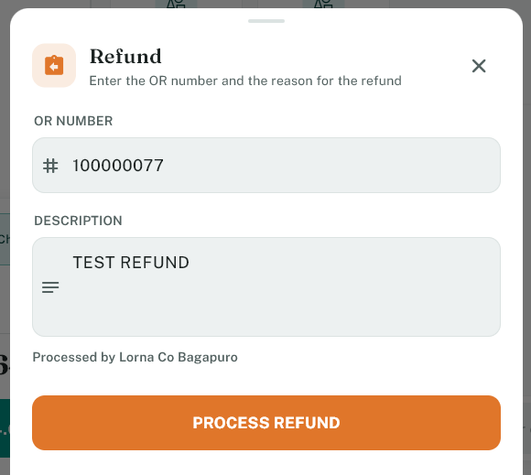

Make sure the refund is approved before you complete it.

19. How to send an e-receipt
If the customer wants a digital receipt:
1. Tap Others.
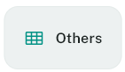

2. Tap Send e-receipt.
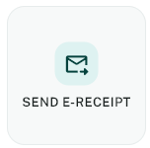

3. Enter the OR number and customer email.
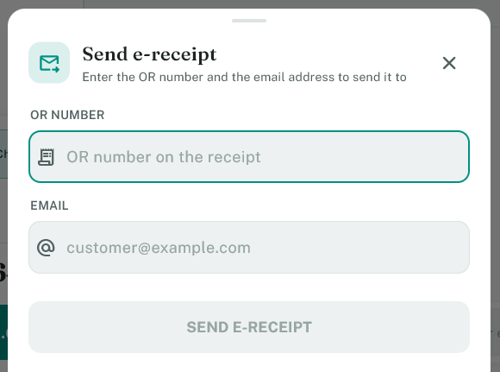

4. Send the receipt.

Note: Make sure that the email SMTP server is correctly setup.

20. How to use cash drop
Cash drop is used to remove money from the drawer for safe handling.
How to do it:
1. Tap Others.
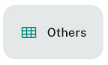

2. Tap Cash drop.
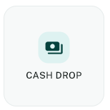

3. Enter the amount being dropped.
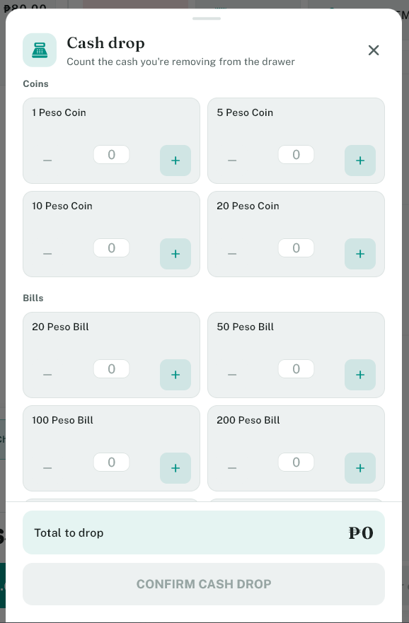

4. Confirm the action.
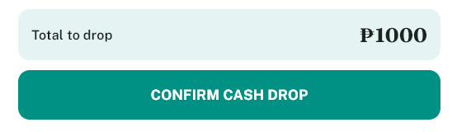

The system records the drop and prints a slip if required.

21. How to open the cash drawer
If the drawer needs to be opened manually:
1. Tap Others.
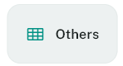

2. Tap Open cash drawer.
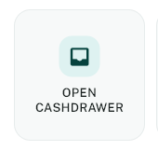

3. Confirm the action.

This is useful when you need to remove or count cash.

22. How to sync data
If the drawer needs to be opened manually:
- Tap Others.
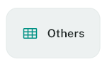

- Tap Sync Data.
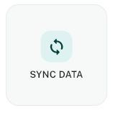

This should pull updated data on the server as well as upload all the stale data from the POS.

23. How to restart POS
If the drawer needs to be opened manually:
- Tap Others.
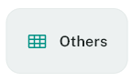

- Tap Restart POS.
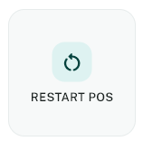

- Tap Proceed.
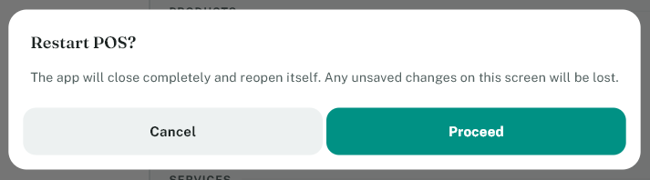

- This will enter a countdown.
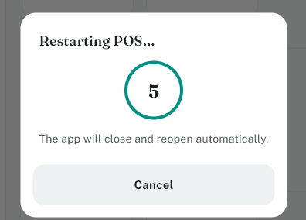
Note: This can be cancelled manually by the user.

This can improve performance of the POS if having slowdowns and/or could fix some bugs.

24. End of shift
At the end of the work period:
1. Tap End shift.
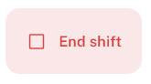
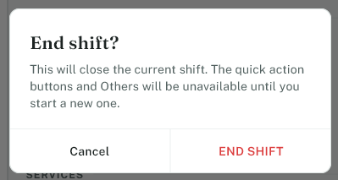

2. Count the drawer if asked.
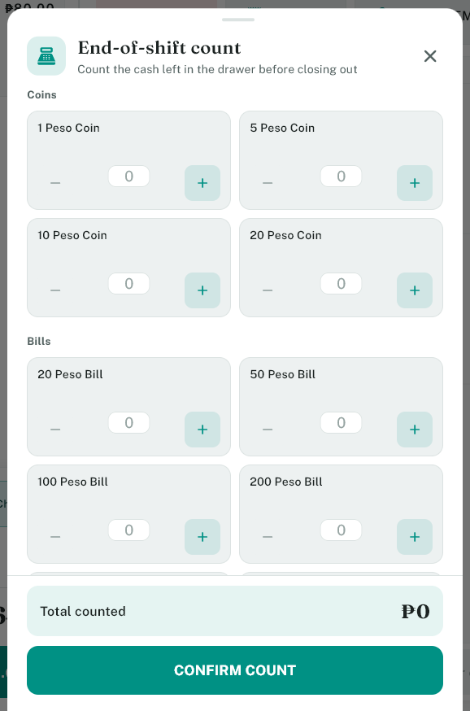

3. Confirm the closing process.
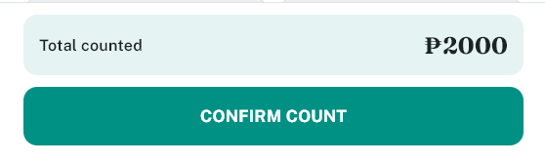

This closes the shift and records the sales summary. Do this before leaving the terminal.

25. Common cashier tips
- Always open the shift before selling.
- Check the cart before charging.
- Make sure the total is correct before confirming.
- Always confirm the payment method and exchange amount.
- If a printer is not working, check settings before continuing.
- If you are unsure, ask a supervisor.

26. Common issues and what to do

The item does not show up after scanning
- Make sure the barcode is correct.
- Check that the product is available.
- Try searching for the item manually.

The customer wants a discount
- Tap the discount button.
- Choose the correct discount.
- Confirm it before charging.

The customer wants to pay partly in cash and partly by card
- Use Split payment.
- Enter both amounts.
- Confirm the split total matches the sale.

No receipt printed
- Check the printer connection.
- Check if the printer is configured.
- Try a test print.

Shift cannot be opened or closed
- Check if the cash count is required.
- Make sure the shift is not already open or closed.
- Ask a supervisor if you are unsure.

27. Quick reminder
The main steps are:
- Open shift
- Add items
- Apply discount if needed
- Charge
- Choose payment method
- Print receipt
- End shift at the end of the day
This is the basic workflow for everyday POS use.

28. Final note
If you follow the steps above, you can complete most cashier tasks quickly and correctly. For anything more advanced, ask a supervisor or use the Reports and Others sections to review sales and payment details.

