GPOS Provantis
Setup & Configuration Guide
Initial Application Setup, Hardware Configuration, and System Settings
Document Version: 1.0
Provided by: 5L Solutions Supply & Allied Services Corp.
System Version: GPOS Provantis v1.0

Table of Contents
Contents
1. Initial Connection Setup 3
2. Printer Configuration 4
Managing Existing Printers 4
Adding a New Printer 5
Assigned Printers (Main & Sub Printers) 7
3. Transaction Settings 7
4. POS Configuration Details 8
5. Email & SMTP Configuration 9
6. Theme Customization 9
7. Counter Display Configuration 10

This setup guide walks administrators, developers, and first-time users through the initial connection setup, hardware configuration, and system parameters required to get GPOS Provantis up and running properly.

1. Initial Connection Setup
When launching the application for the first time, you must configure the connection parameters to link the POS terminal to your server or local environment.
1. Select the connection protocol from the dropdown menu (choose http:// for local development/localhost or https:// for secure production domains).
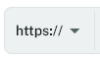

2. Enter the server address in the designated input field (e.g., localhost for developers or your specific server domain for live store deployment).
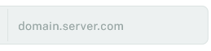

3. Specify the network port if required (optional, primarily used by developers for custom server configurations).
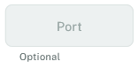

4. Enter the Branch ID supplied by the developer or product seller to properly identify your store location.
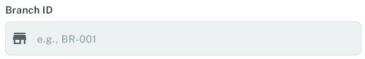

5. Enter the POS ID supplied by the developer or product seller to uniquely identify this specific terminal.
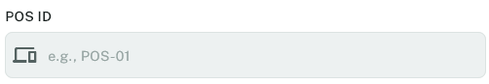

6. Click the Proceed button to validate and connect to the configured domain or server.


2. Printer Configuration
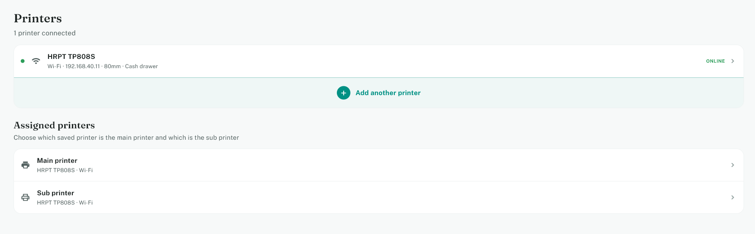

Configuring receipt printers is essential for daily store operations. Navigate to the Printers rail/tab in Settings.

Managing Existing Printers
1. Click on an existing printer in the list to open its management sheet containing options for Edit Printer, Disable Printer, Test Print, and Remove Printer.
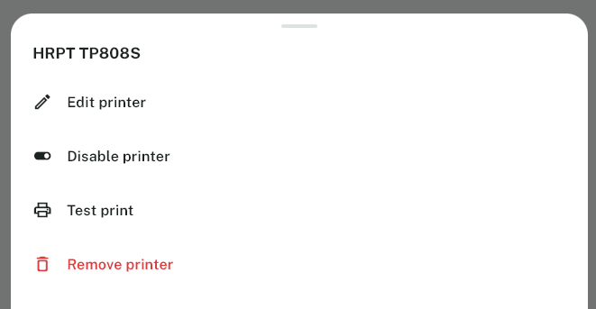

Inside the Printer Edit view, you can configure the following parameters:
- Printer Name: Custom identifier for the printer.
- Connection Type: Select from WiFi, Bluetooth (WIP), or USB. Clicking USB converts the input into a 'Scan for USB Printers' button to scan and bind connected USB devices from a list.
- IP Address / Mac Address: Static user input fields for network printers.
- Device Path / Port: Search feature that automatically scans the device for connected ports.
- Paper Size: Choose from 3 predefined buttons (58mm, 72mm, or 80mm).
- Toggles: 'Enabled' (to toggle printer activation) and 'Cash Drawer' (to send an automatic open signal to the cash drawer).
- Footer Actions: Cancel and Save Changes buttons.
External Printer Shortcut Controls:
- Disable Printer Shortcut: Quickly toggle the printer active state without entering full edit mode.
- Test Print: Sends a mockup receipt to verify printer functionality.
- Remove Printer: Deletes the printer configuration entirely.

Adding a New Printer
2. Click the Add Printer button to open the printer creation form, fill in the connection details, and click Save Printer in the footer.
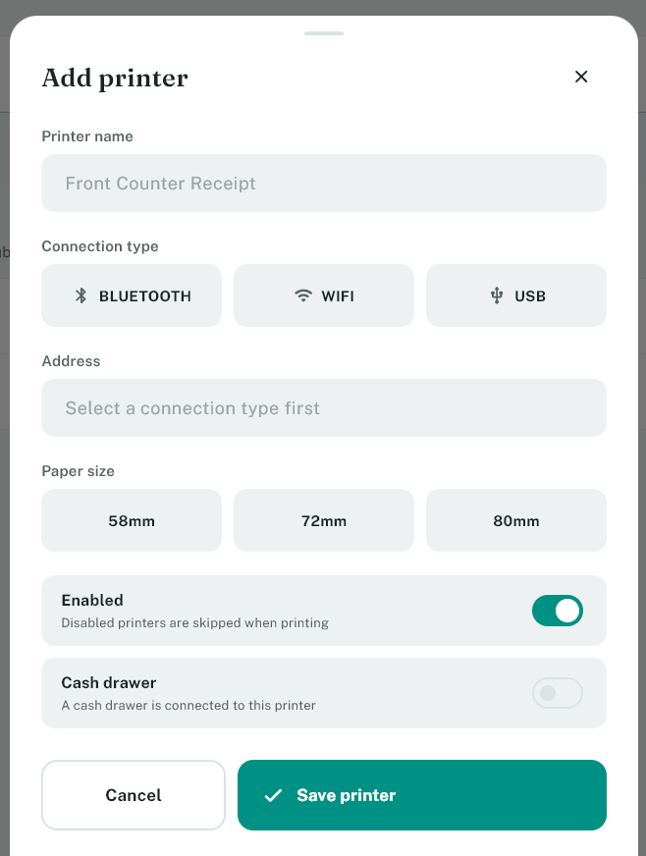

Assigned Printers (Main & Sub Printers)
3. Click on Main Printer to open a selection sheet showing all added printers, allowing you to assign your primary receipt printer or select 'None'.

4. Click on Sub Printer to open the secondary printer selection sheet for duplicate or secondary receipt routing.

3. Transaction Settings
The Transactions tab/rail contains crucial workflow toggles for customer sales and receipts.
1. Toggle 'Show VAT on receipt' to display Value Added Tax breakdown on customer receipts.

2. Toggle 'Show official receipt message' to include mandatory statutory messages on receipts.

3. Toggle 'BIR Accredited' to reflect official BIR accreditation compliance on transactions.

4. Toggle 'Show Receipt Preview' to prompt a visual preview before finalizing print jobs.

5. Toggle 'Add Customer to Transaction' to enable mandatory or optional customer tagging during checkout.

6. Toggle 'Add Purchase Order to Transaction' to allow PO number input during sales processing.

4. POS Configuration Details
The POS Config tab/rail manages legal business entities and machine registration details.
1. Enter the registered Company Name.

2. Enter the official business Address.

3. Enter the official Accreditation No.

4. Enter the system Valid Until expiration date.

5. Enter the VAT Reg TIN number.

6. Enter the Permit to Use (PTU) number.

7. Enter the Machine Identification Number (MIN).

5. Email & SMTP Configuration
Configure automated e-receipt dispatching under the Email tab/rail.
1. Enter the sender Email address.

2. Enter the corresponding email Password.

3. Enter the SMTP Server address and port settings.

4. Use the Hide Password button to toggle password visibility security.

6. Theme Customization
Manage application appearance under the Theme tab/rail.
1. Select your preferred display mode using the three side-by-side buttons for System, Light, or Dark mode.
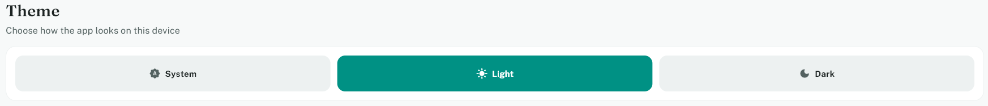

7. Counter Display Configuration
Control which product categories appear on the POS counter display under the Counter Display tab/rail.
1. Use the Show All / Hide All master buttons to quickly toggle category visibility in bulk.


2. Review the category list and use the individual toggle on the far right of each row to enable or disable specific categories on the POS machine.
